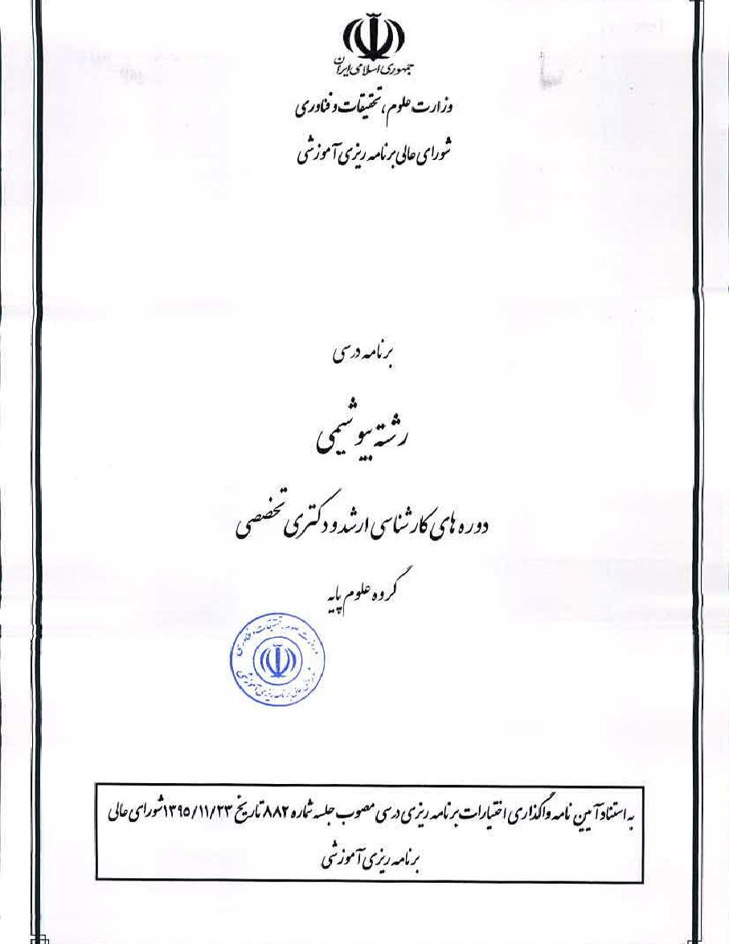
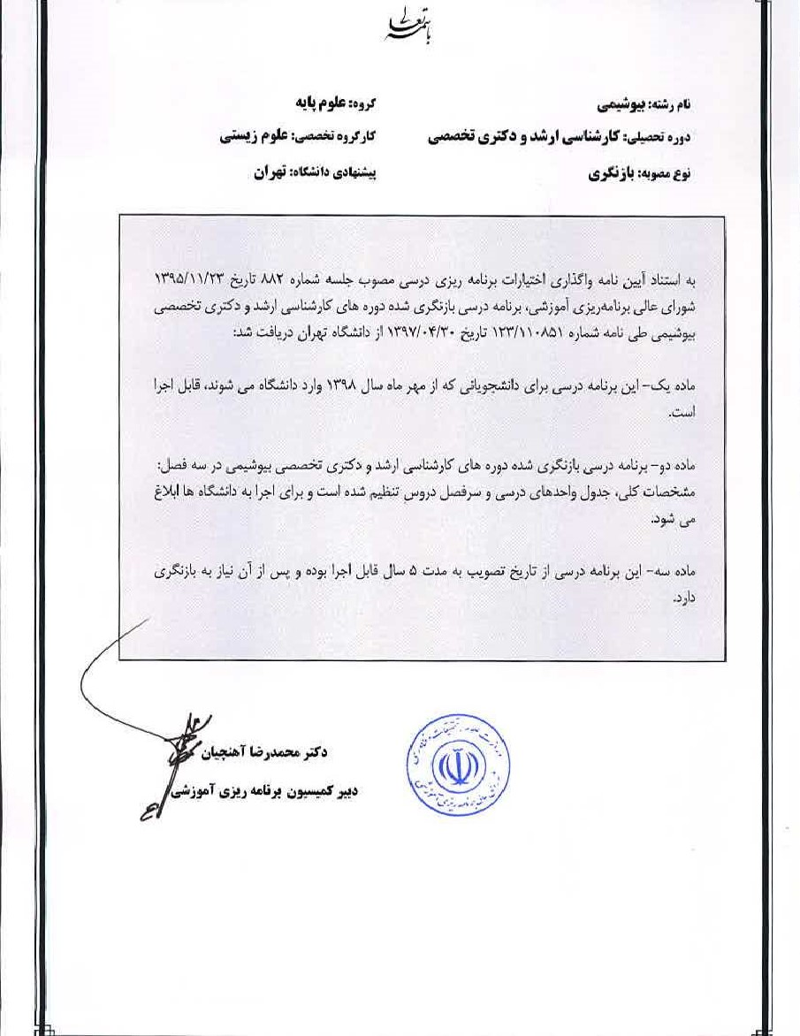
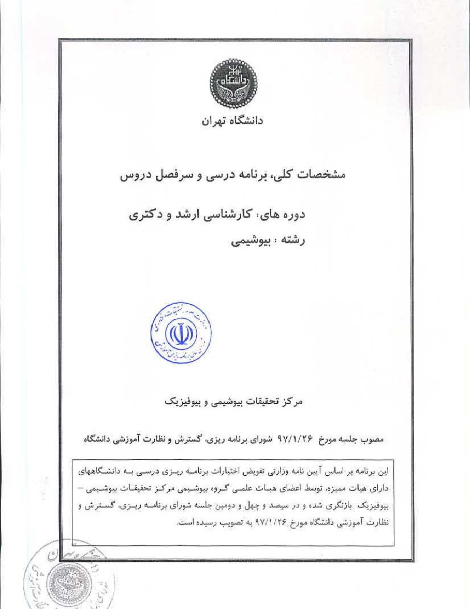
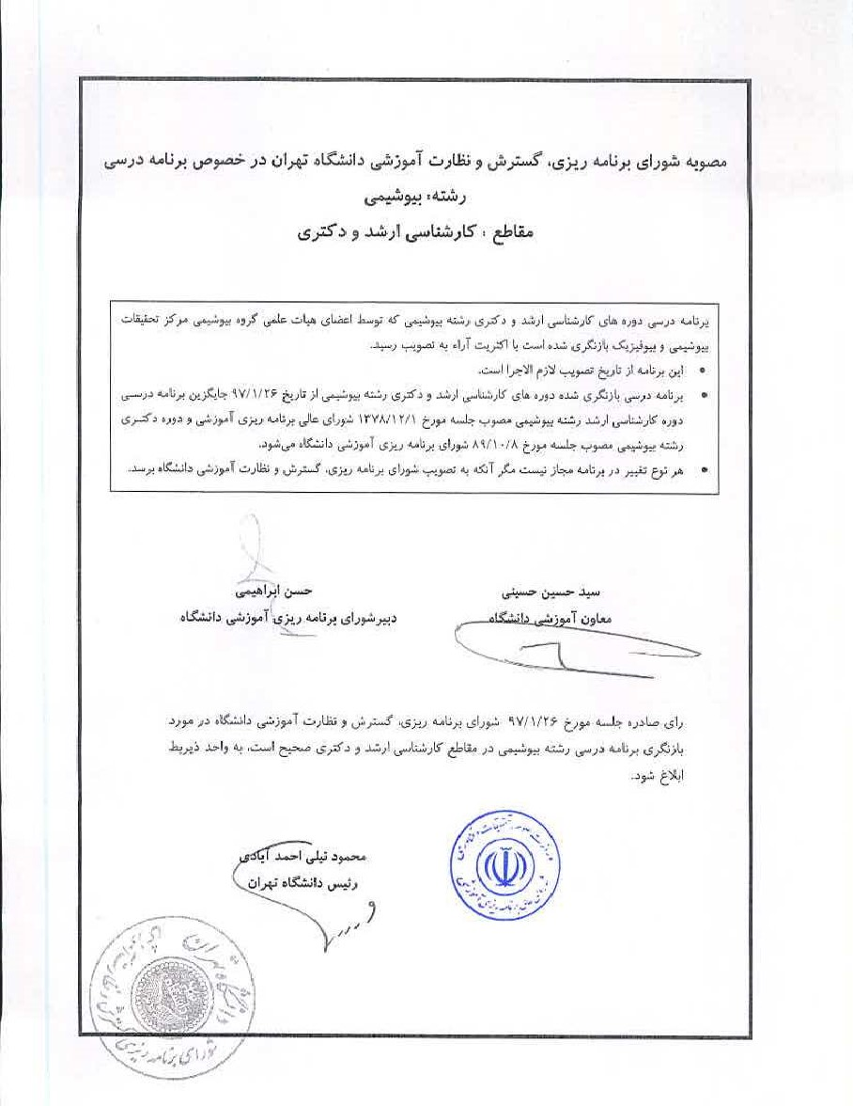
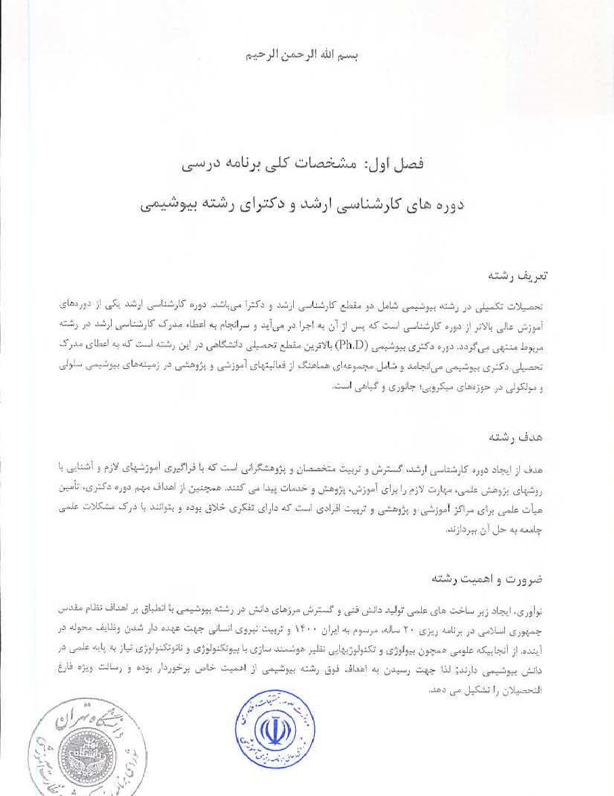
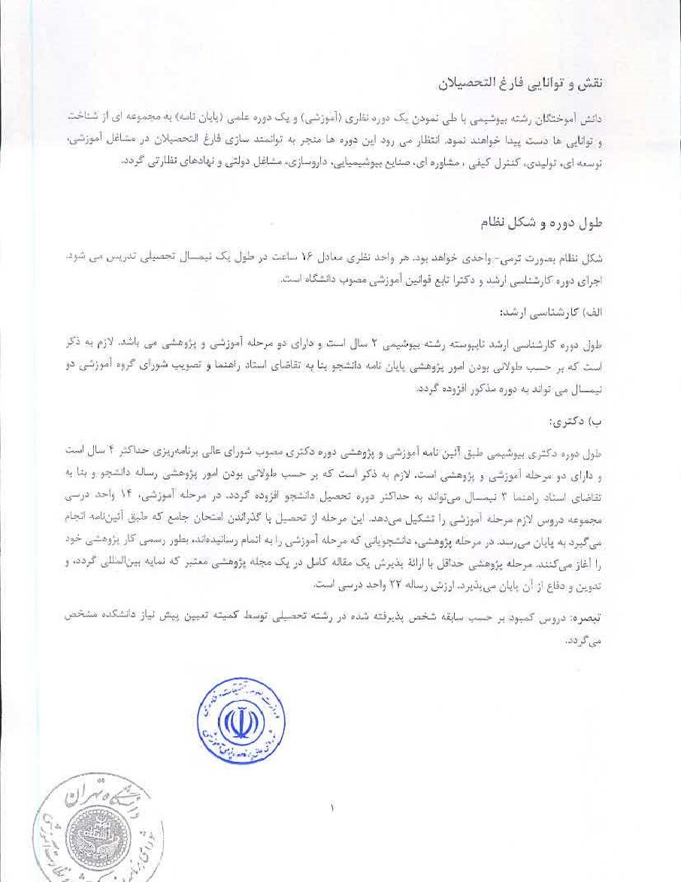
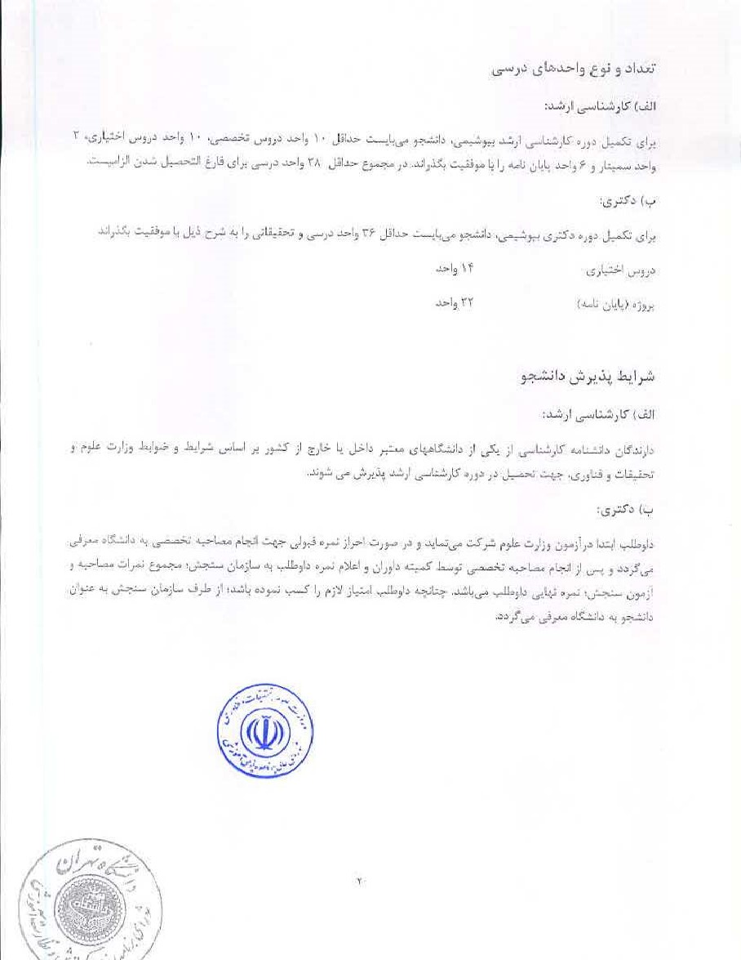
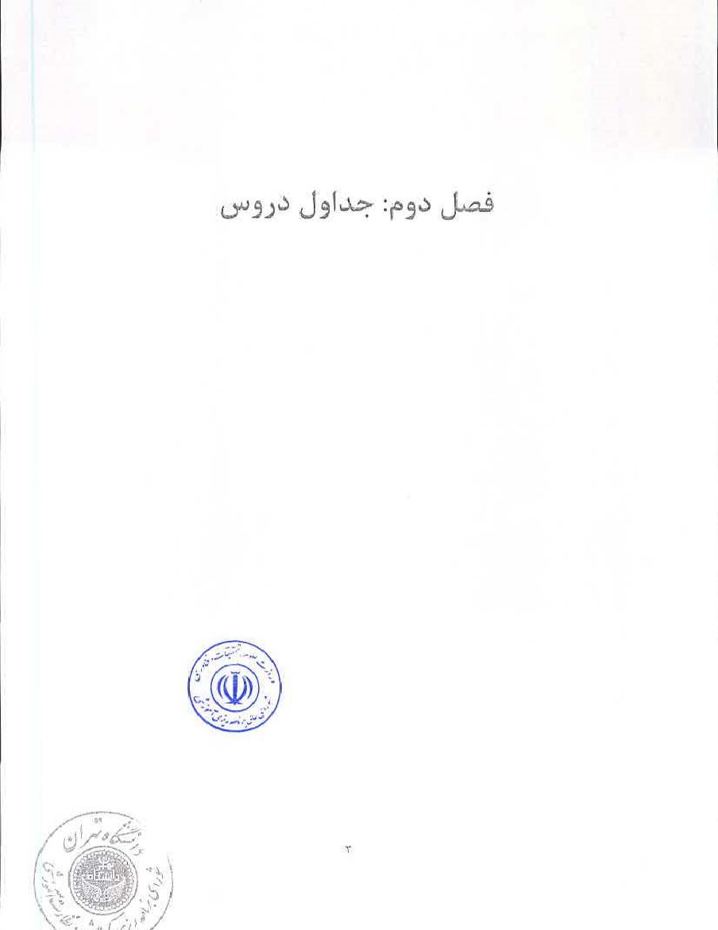
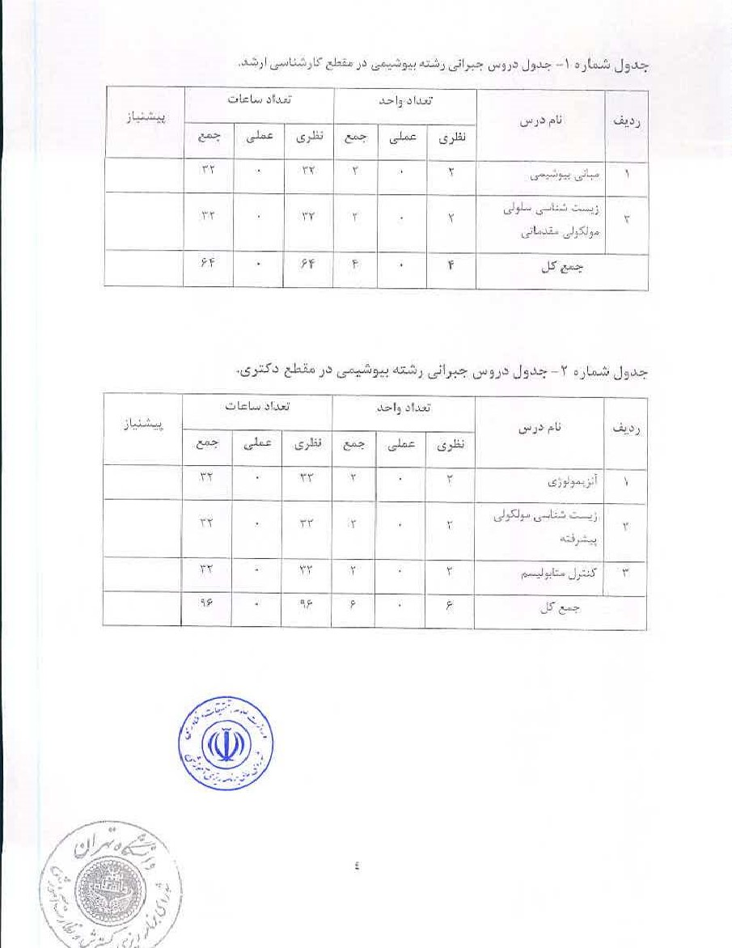
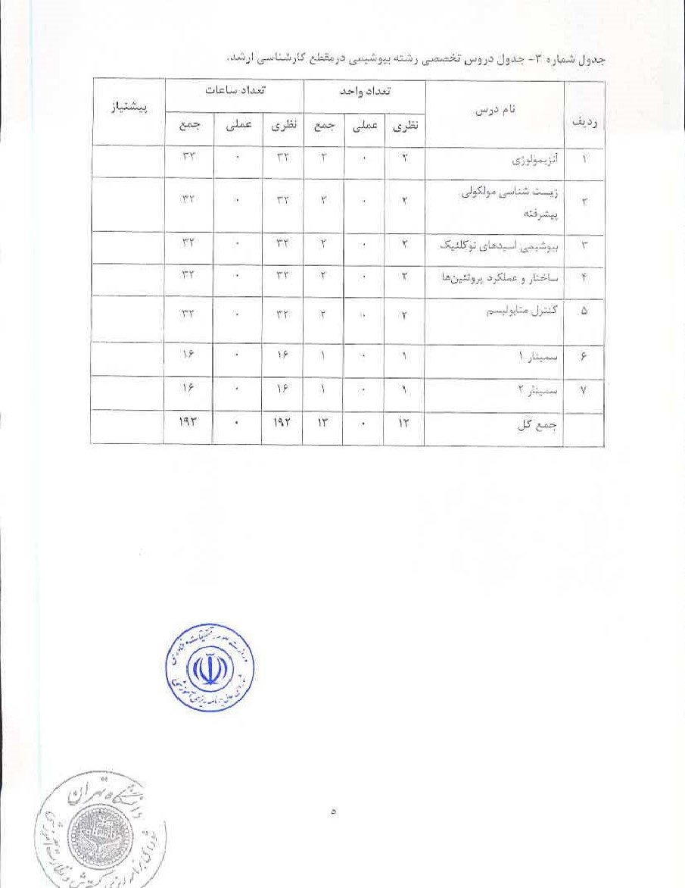
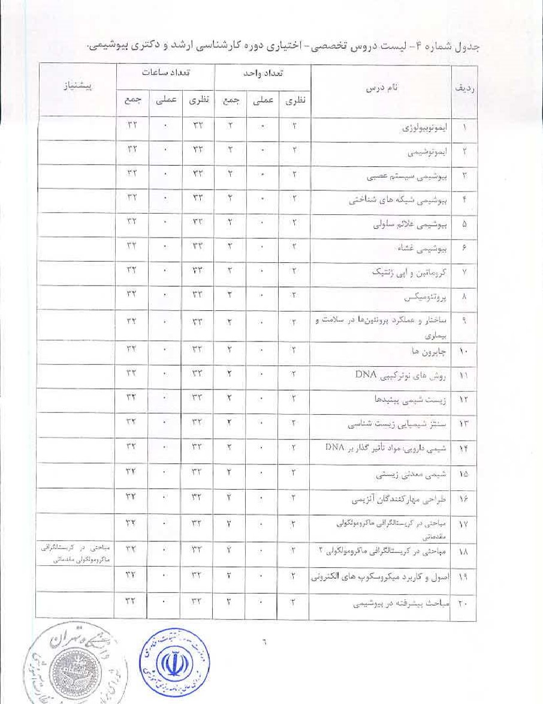
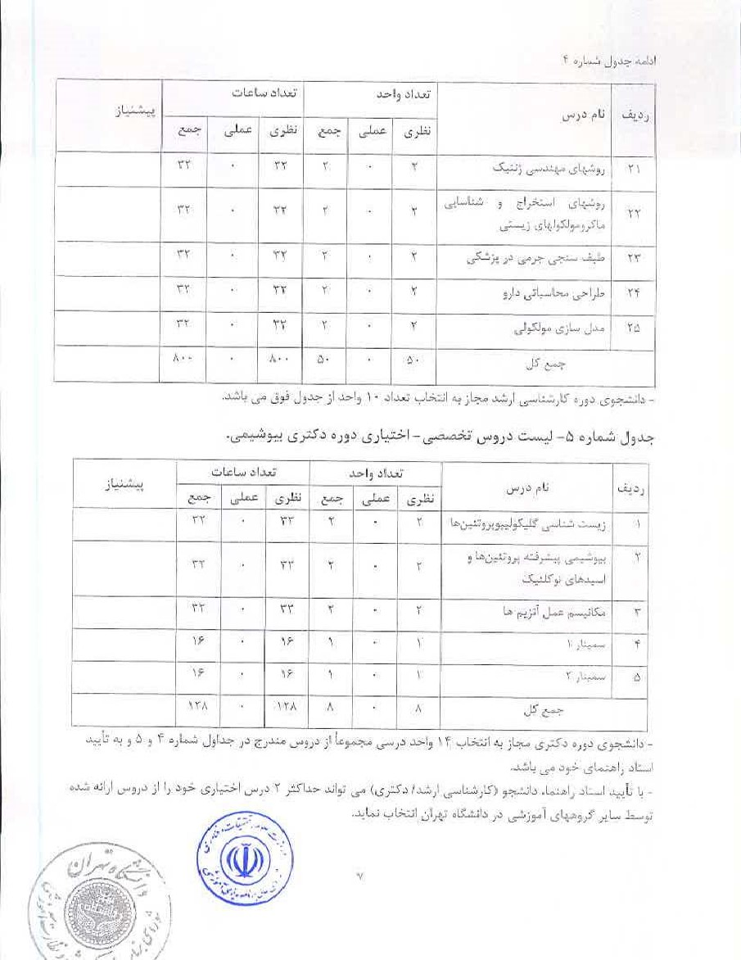
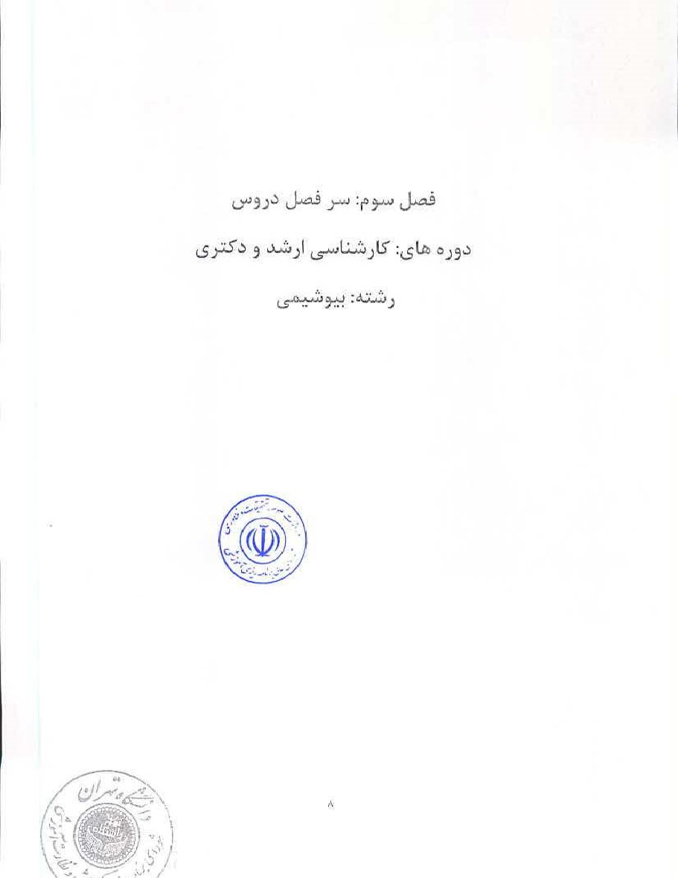
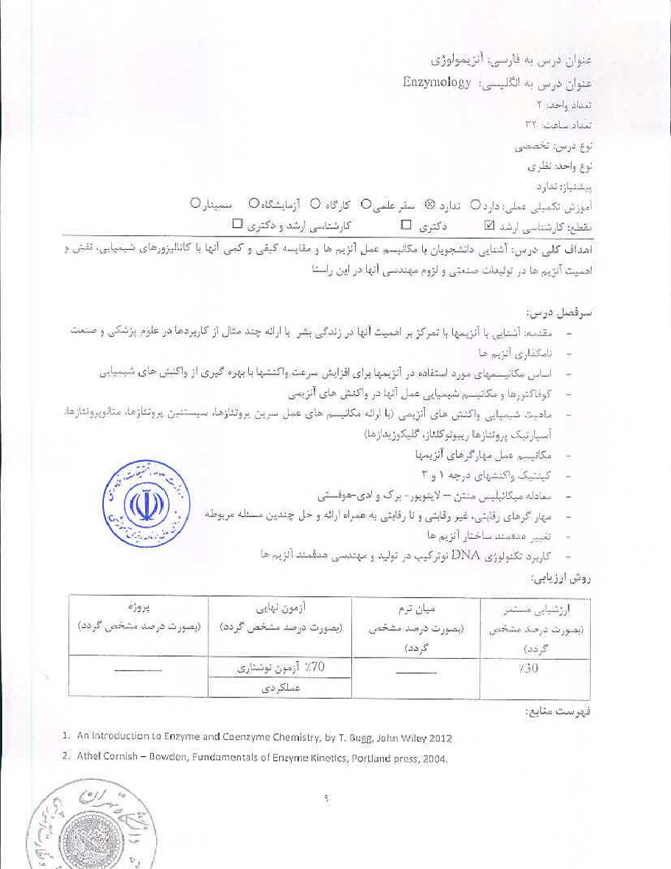
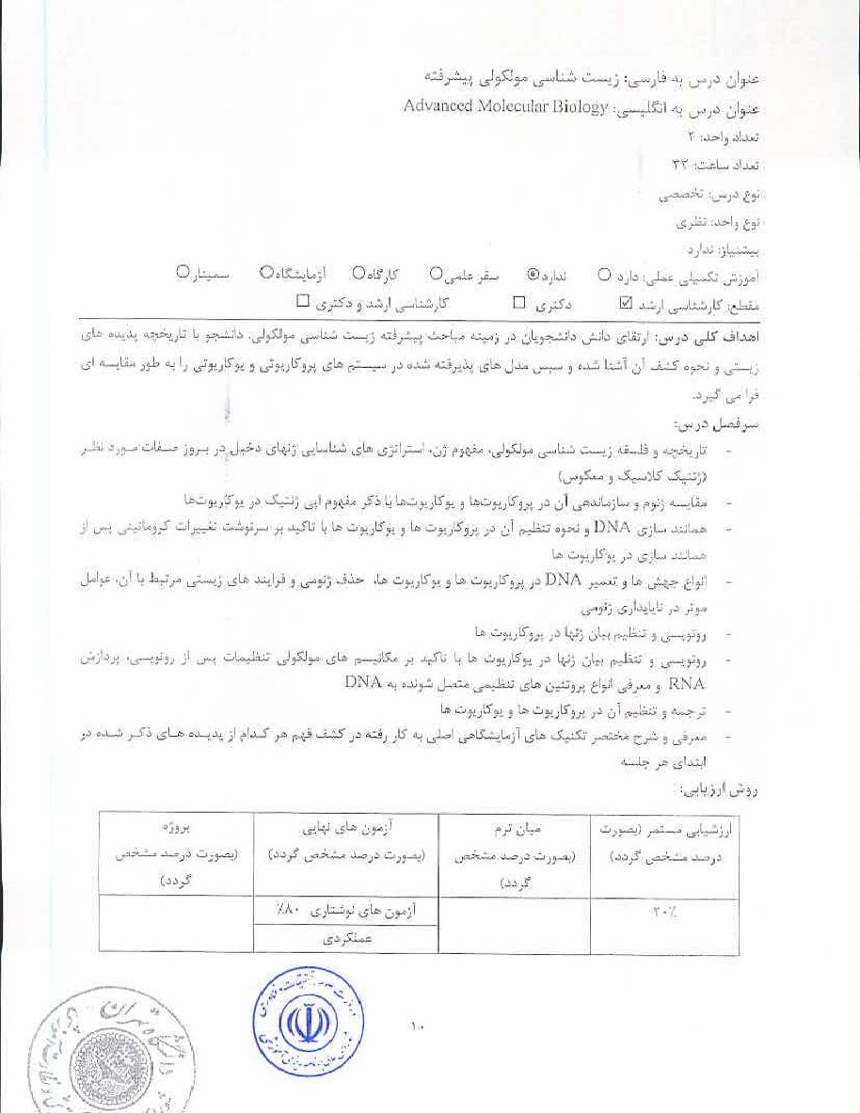

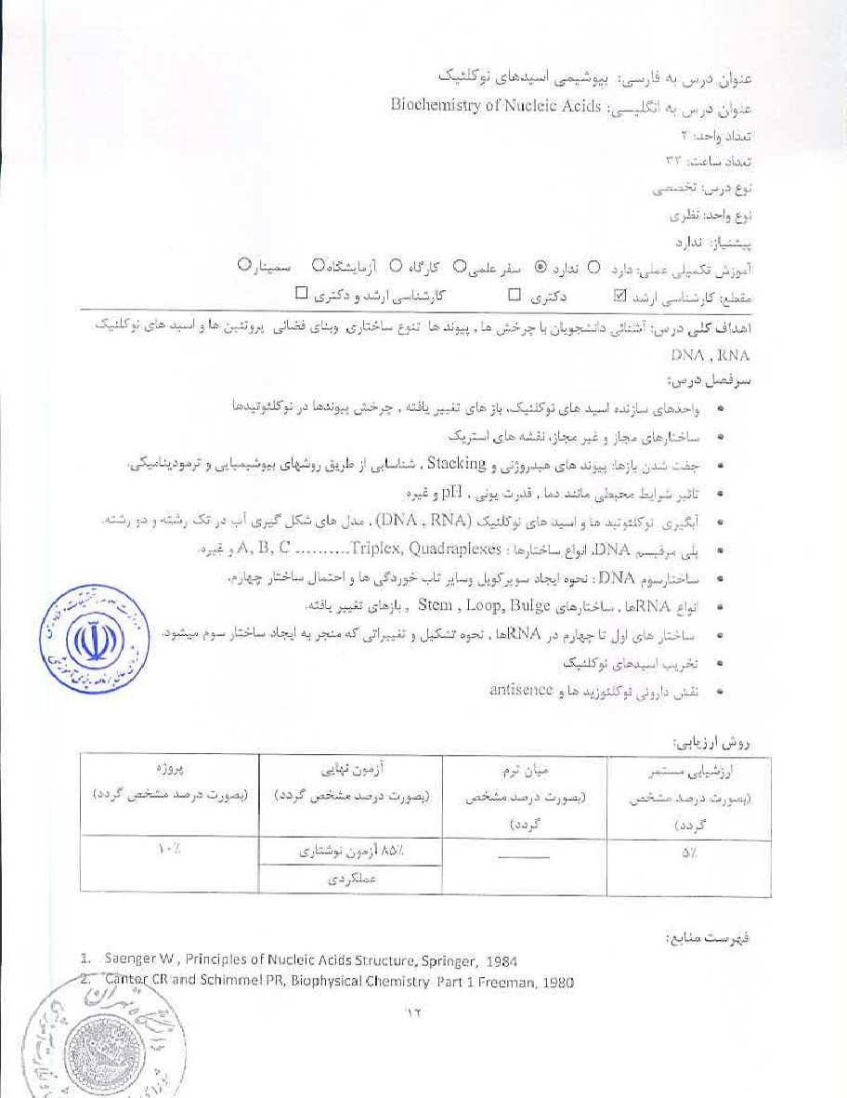
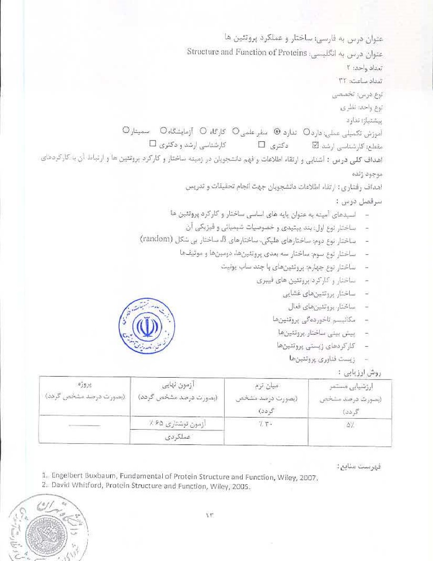
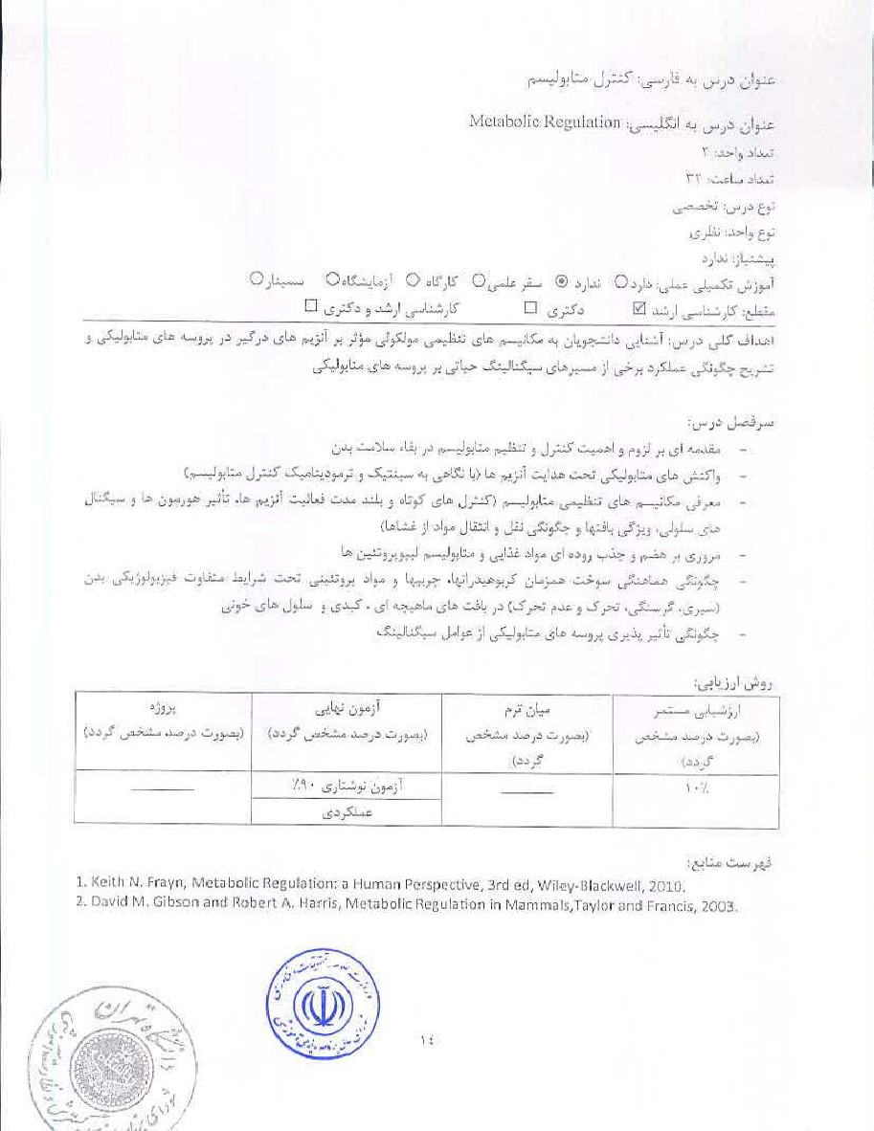

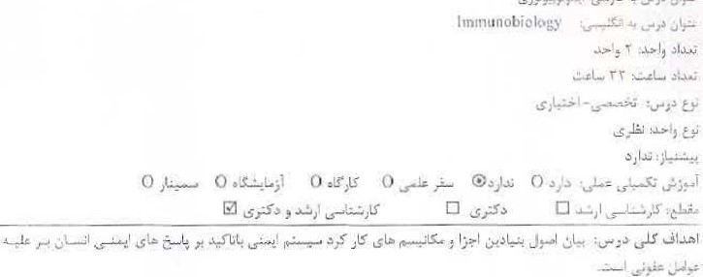
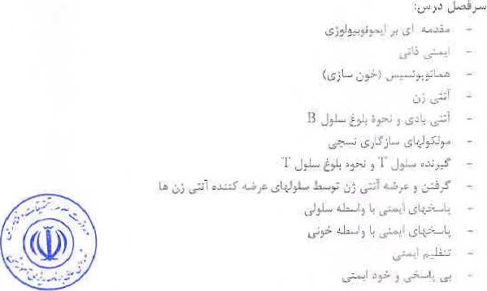

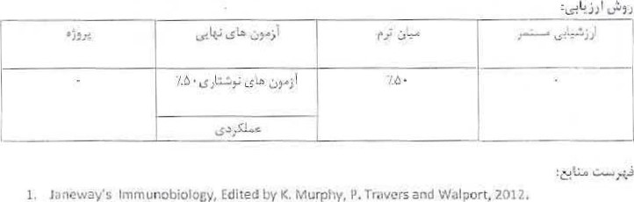Innmunobiolocy, Edited
Murphy,
Tiavers
and
Walport,
2012.
2. [Inmvnolagy, Edited by Kuby, 2013

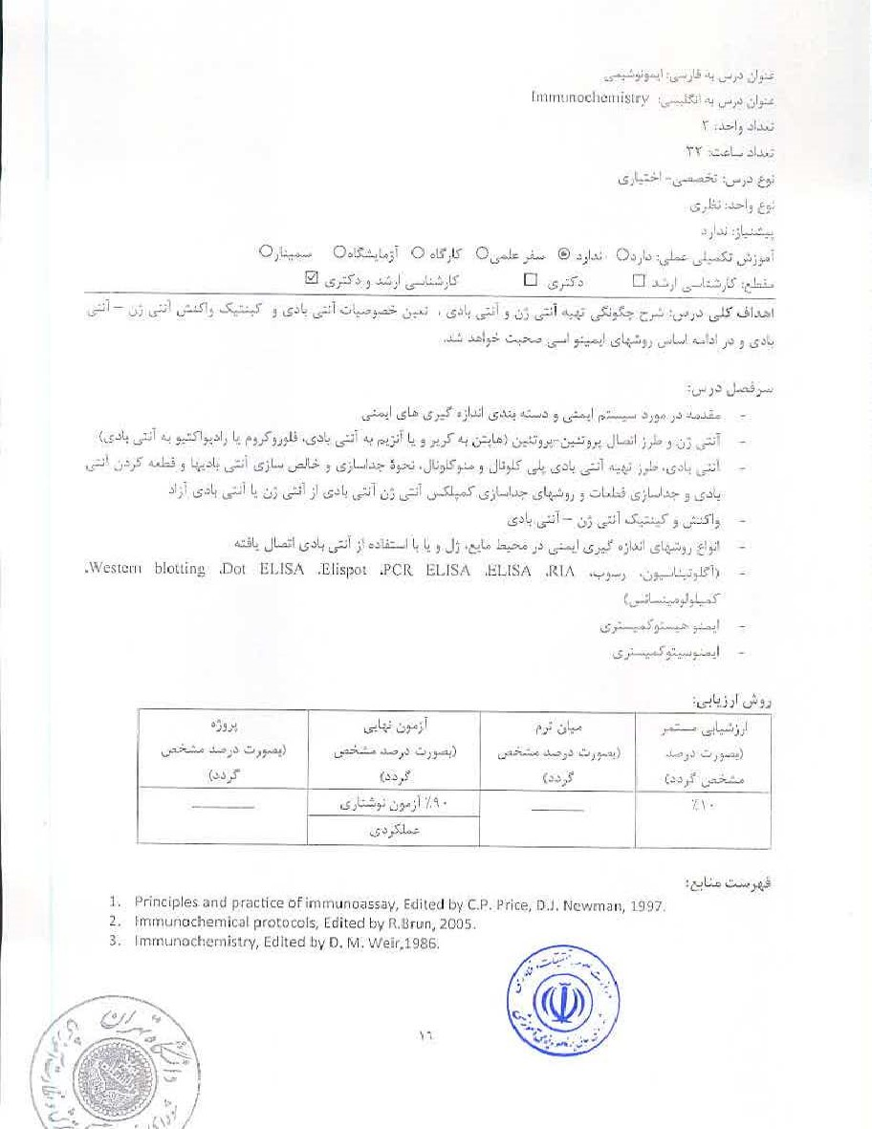
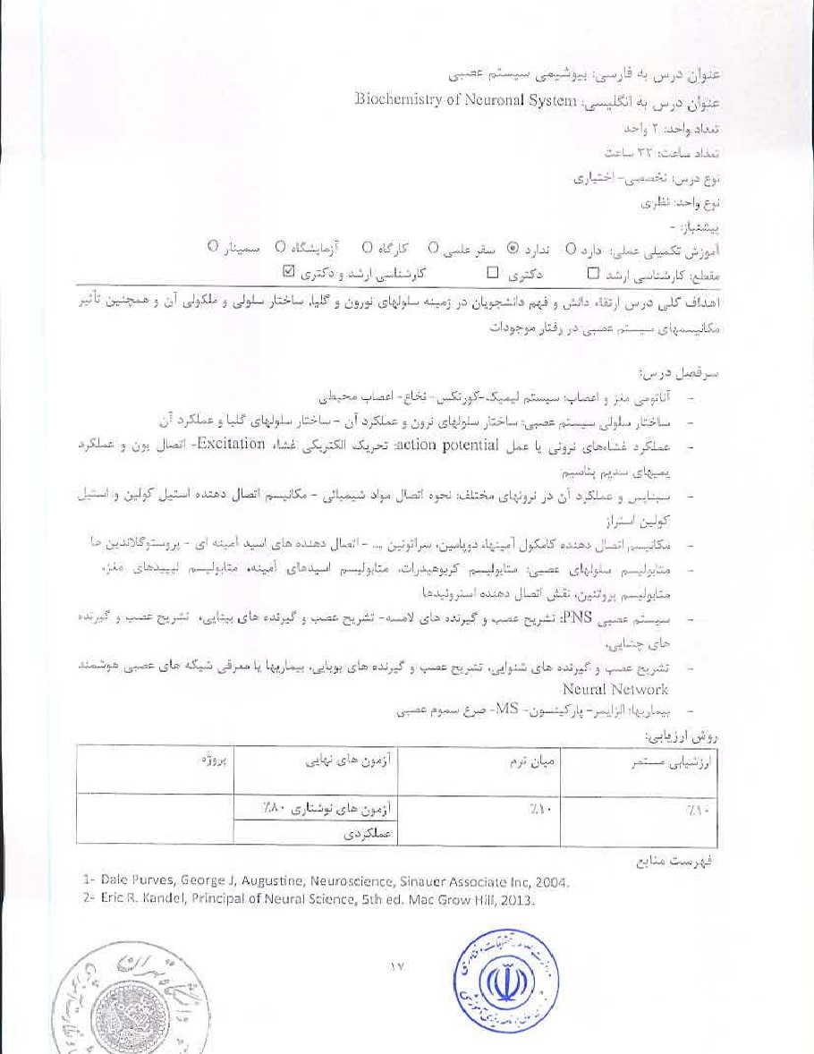
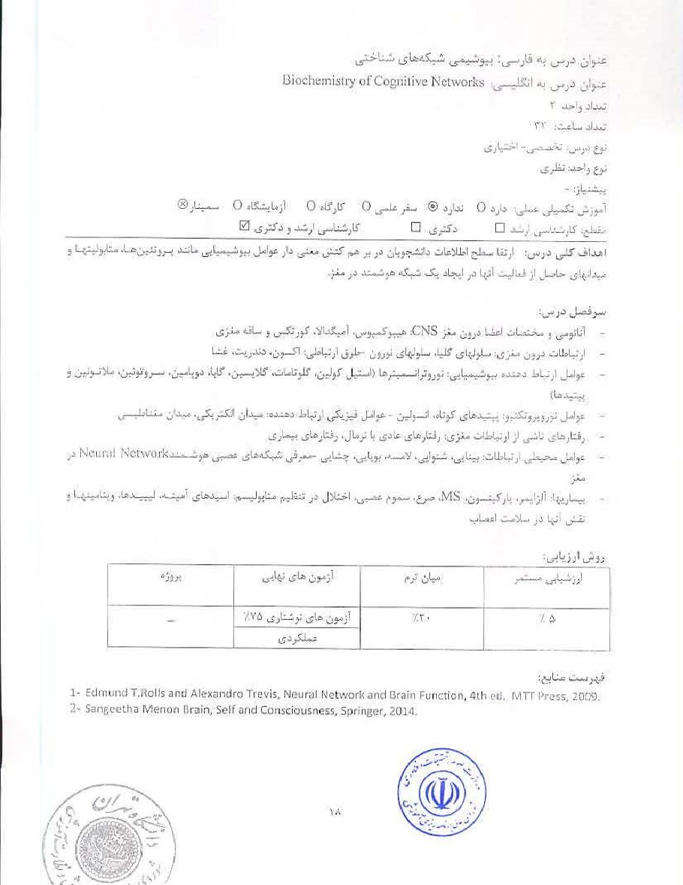
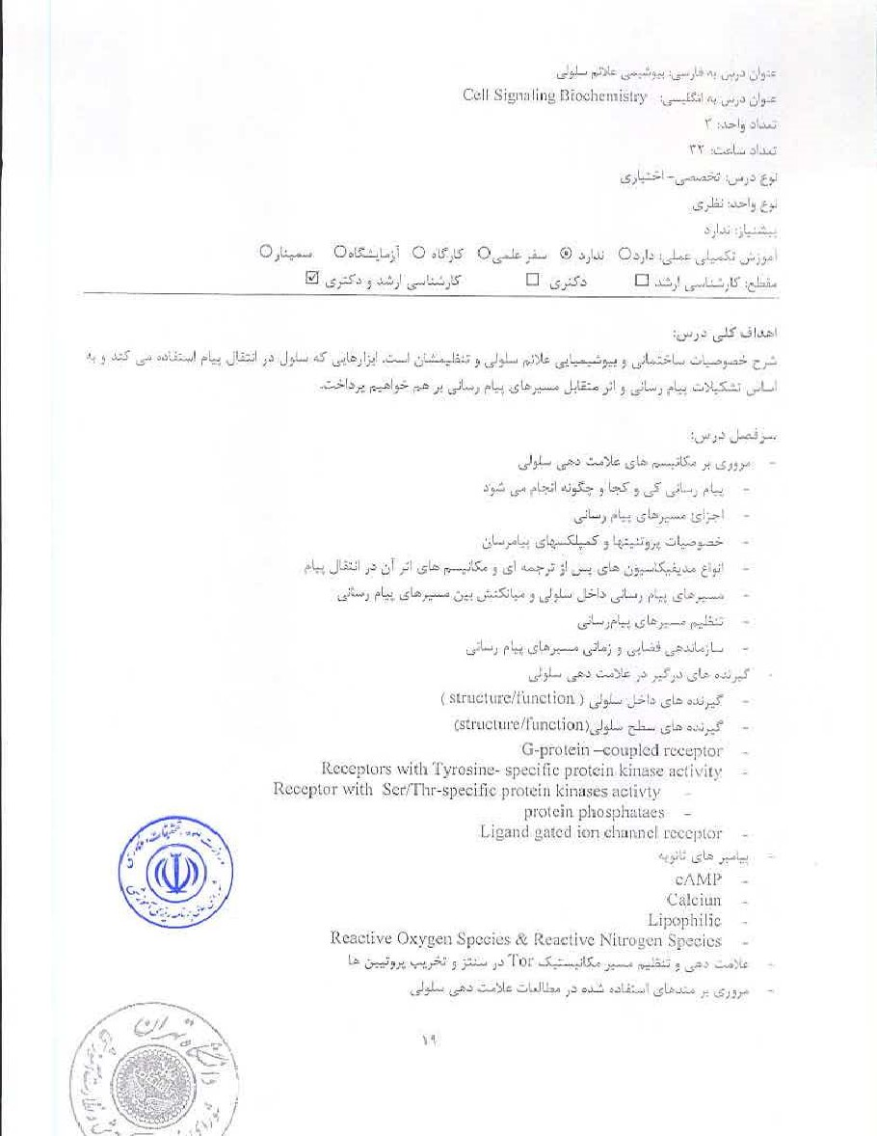



1.Cell Signaling Biology, Edited by Michael J. aeriidge 2014 ofSienai Transduction anti Edition, Edited by G. Krauss 2014


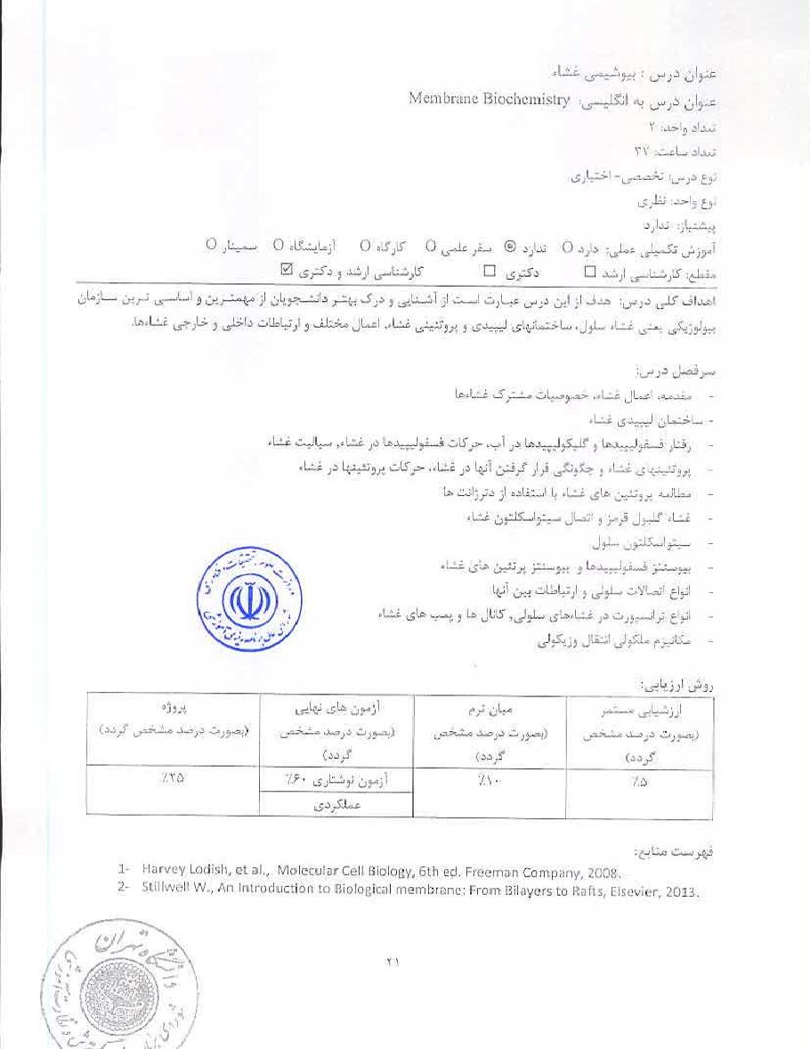

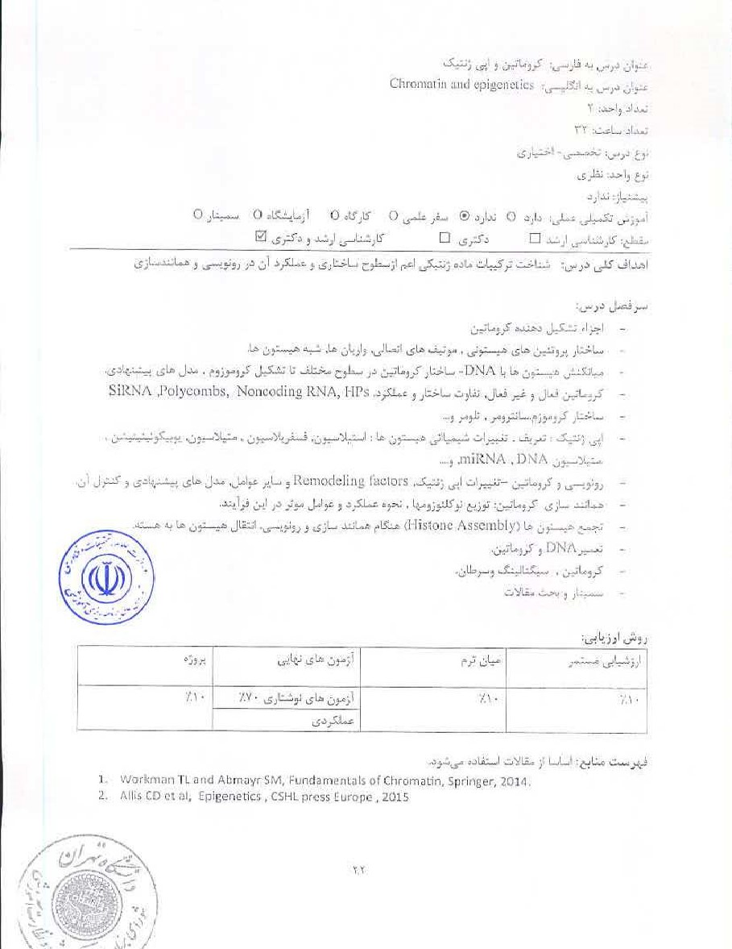

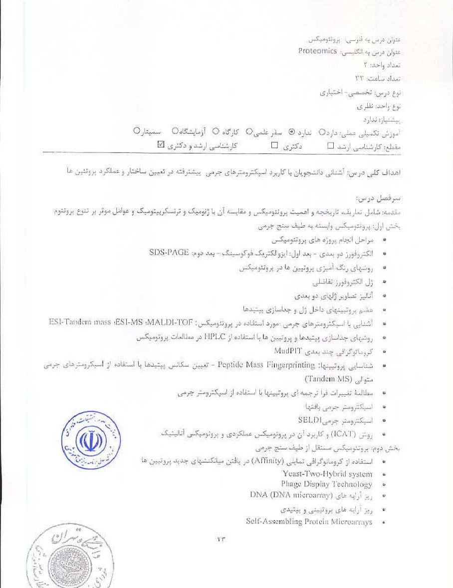


. ptpteamics D, Libler,
- Principals of proteomics (R.

- in protein biochemistry *LI, rschesche (2012)
Current protocols in proteinscien.ce 13. P. Taylor (20161
5. Protein-Protehu Interactiorls: A Molecular Cloning Marli-al, SedonC Ecjitioin bv Gotemi% P. O. Adams (20051


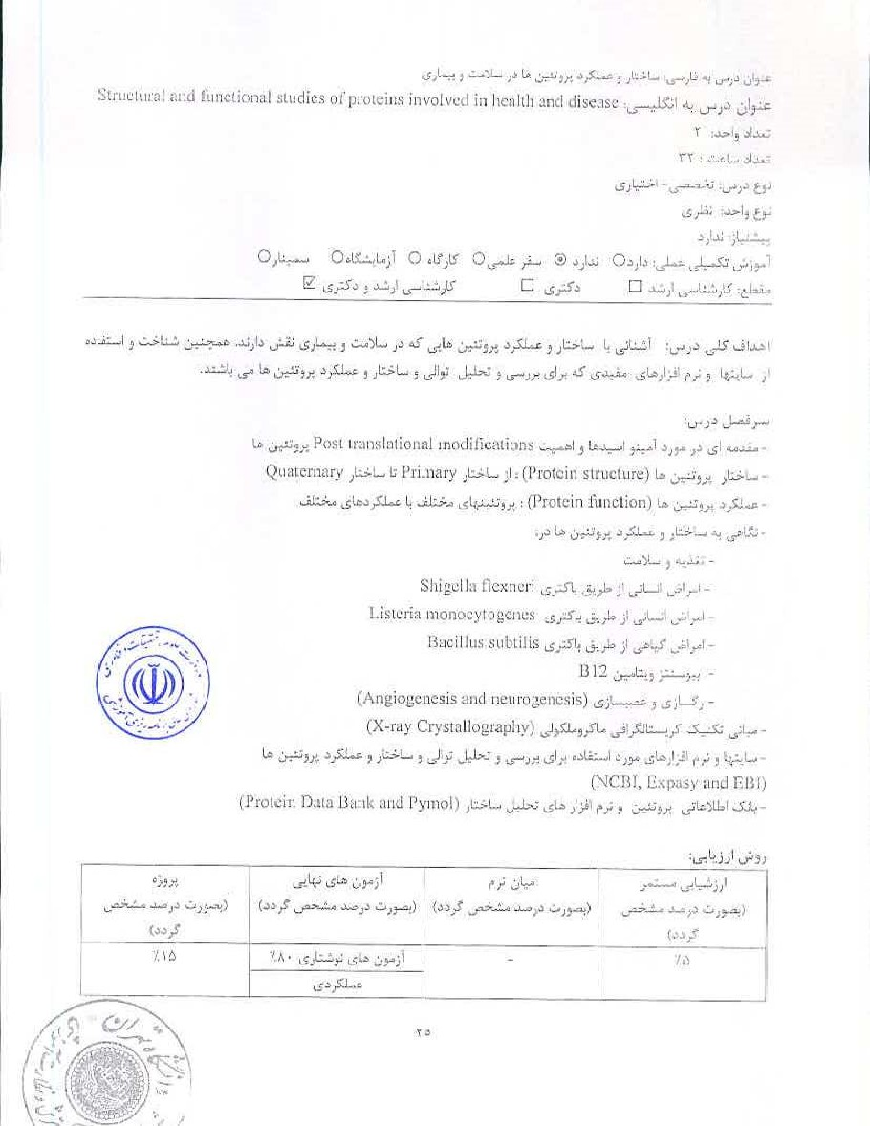


1. Arthur M. Lesl<, Introduction to Protein Science, Architecture, Function and Genomics 2nd ed. OA{^{Z}ord university Press, 2010,


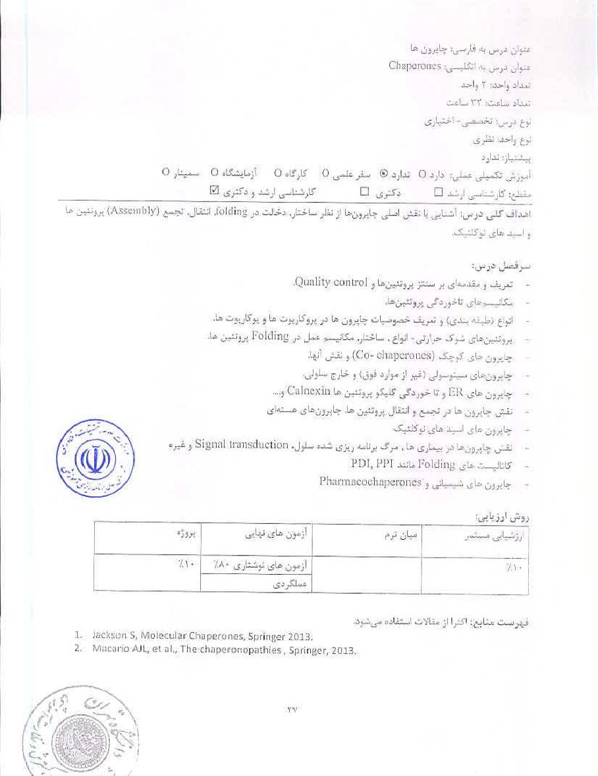
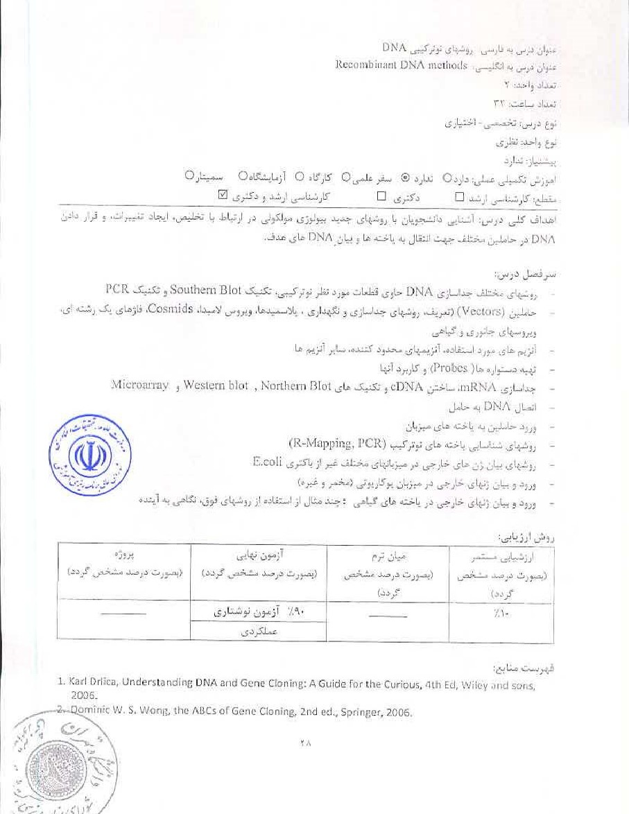

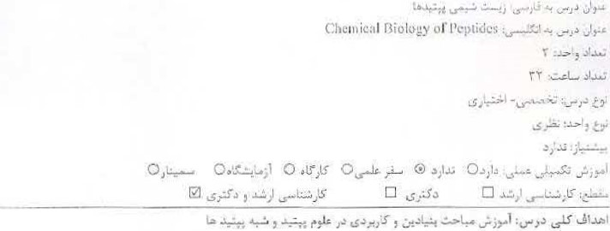
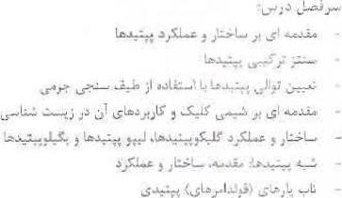



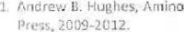Acids, Peptides and Proteirtsuin Organic Cilernistty, 1-5,. Wiley' VCS*
いーこ、:-ー叮L、,」気一:、に上し′卩もし上 0にに引Sy日市朝0おi引0 : = れ. 戸」,
わ
一
o洋一一0。よをしゞ0。げ0 ′上よし6ら上0。第。・う=↓ー0ツ・3


ロ ゞ当
上
:
長
新
ゴ
↓」ごじこらし第上
三
し
第
」
、
三
わ
こい長い亠、い53ドー:ー+をニ=し)-一当、=れい洋
~ニ」一ドなこト
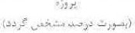 |  | 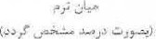 | 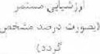
 | %V•当」に・:こ
を 円当にL気田"d ⅱ新0ロ1をbにⅢ , 0町庇物に例:第wⅱ色たv〔はp民戞. 2エ

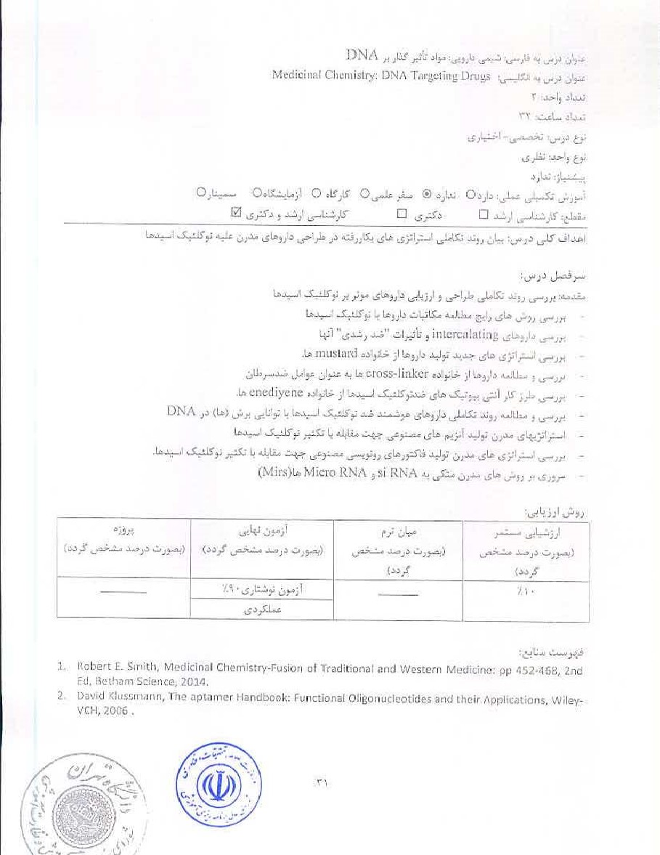
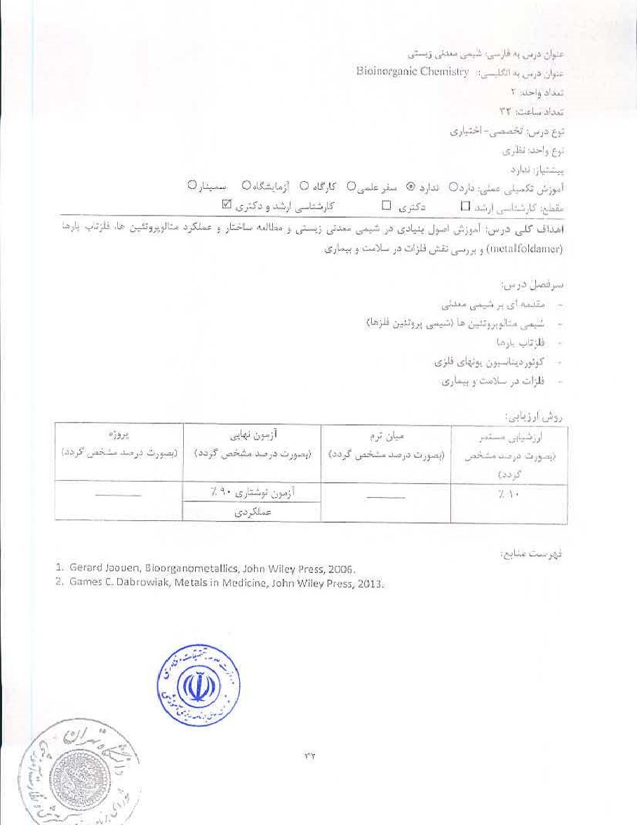

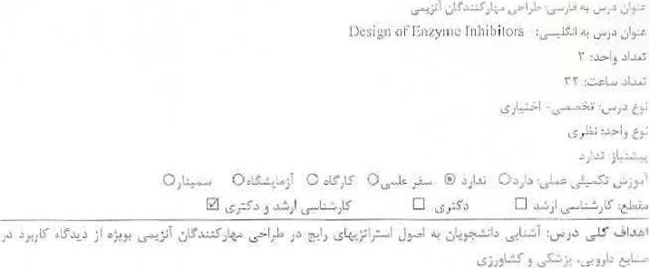
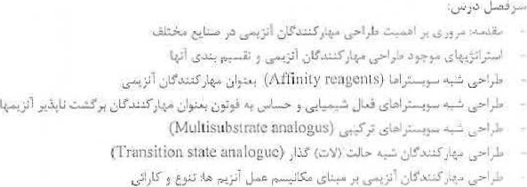


Wang, et al. Eri2Vme Technologies: Pluripotent Discoverinn Therapeutic Agents, John Wilev artLfS0r15, 201'1.
2, Robert A, Copeland. 'Evaluation Of Enzyme Irihibitors jin Drug-DistOvecy: foiChemists and Pharmacologists, 2nd John Wiley and Sons 2013.

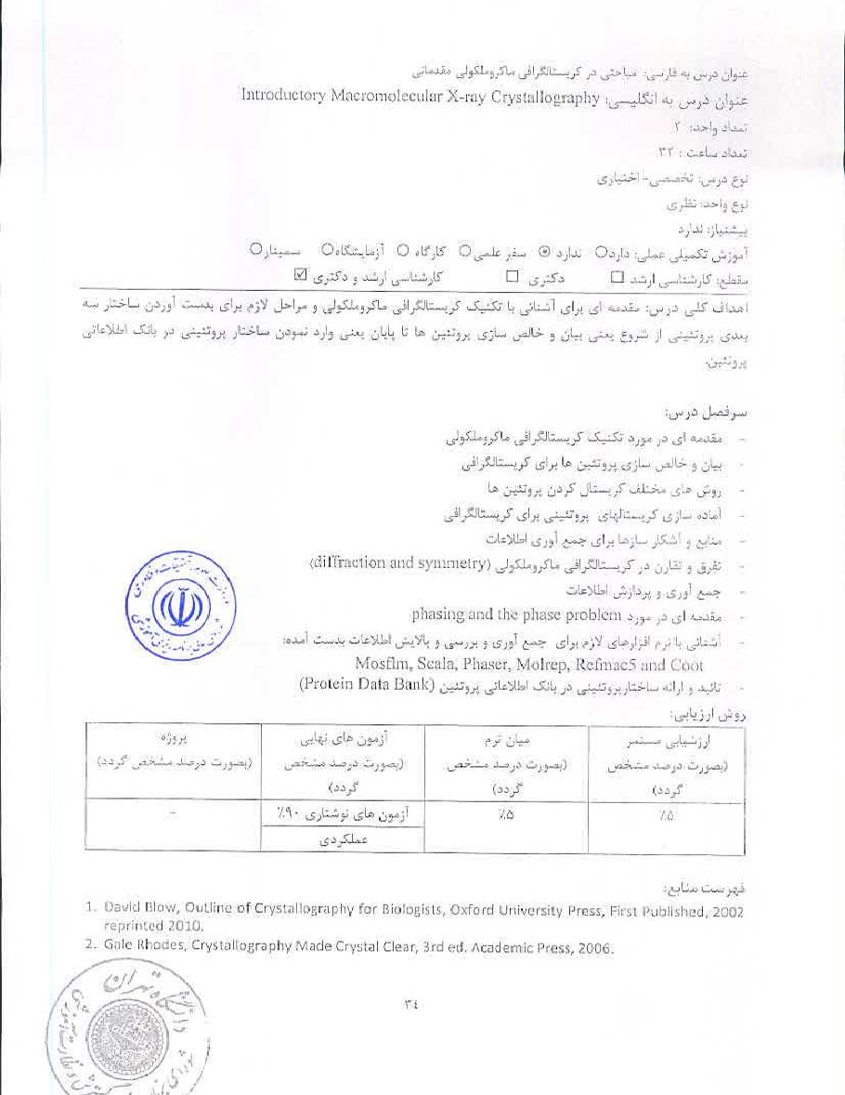
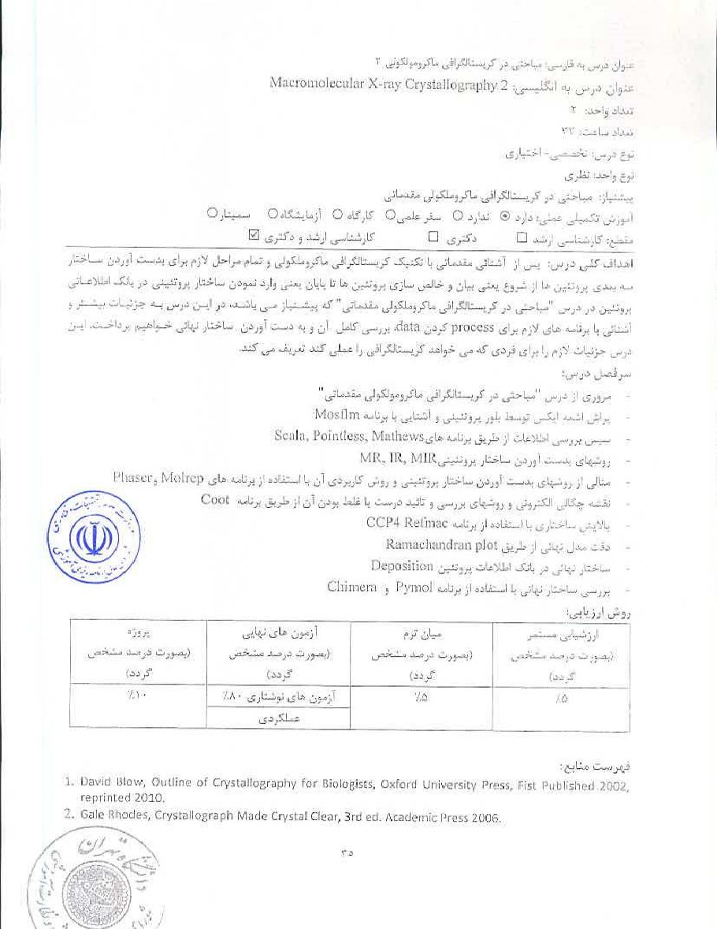


し当/ぷ』びッ、。箞一わしげ) dラ」,ー)し」= 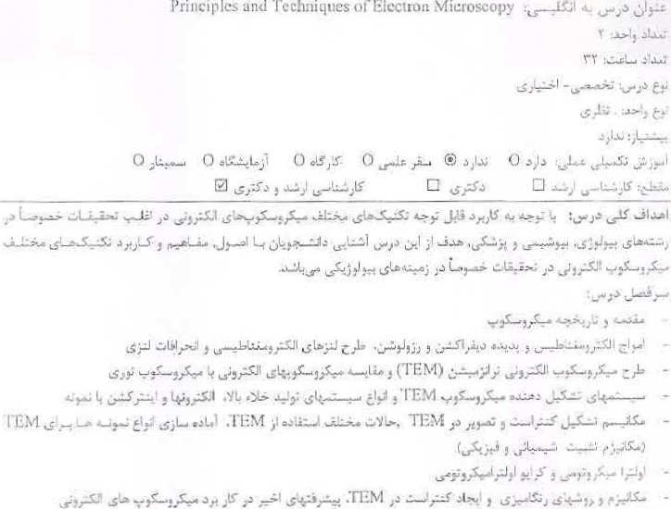Microscopy朝
Principles
れ
朝
TEM、虫第第や。,物3-ミにの洋←宀」、トい
ぃ1ーを′こぉニ0:三ぃ第は"ャ、—・!し」声第」」 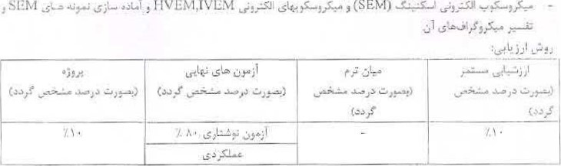:日Ⅵ三M ,ⅣしM』」いゎ第”いEMい」罰.
工 地h良」. 30引第第Id Lonⅱ1ごけ.い第elんE厄「troロMに「05(opら円物に朝田コ朝qい当川0 :0第.
2祠.」いro鮎田"d Ba川0比ドhe既1999.
ム MAトいをしⅲ ci田朝10朝ⅲ叩~第に「0ロMに叩めい第第市いⅱ0 4いed.

U Juhli Kuo. Electron Microg:copv, [nethod%in Tilirti edition, l're%S., 201".


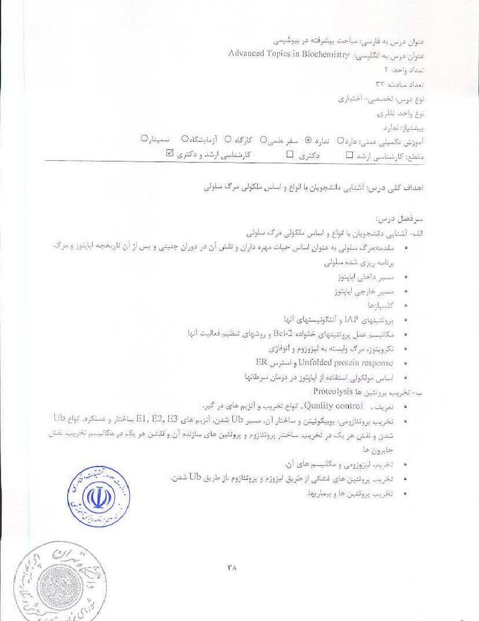
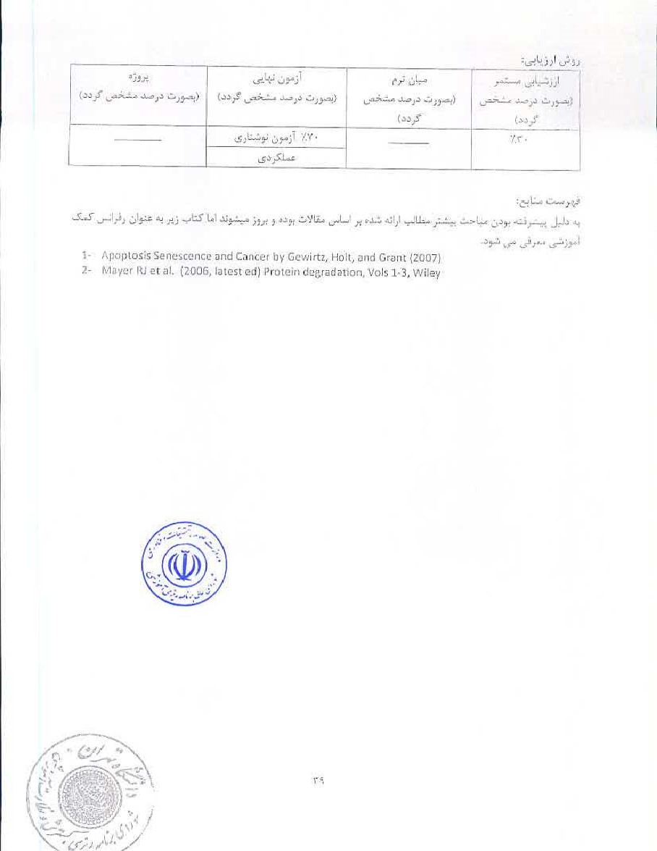

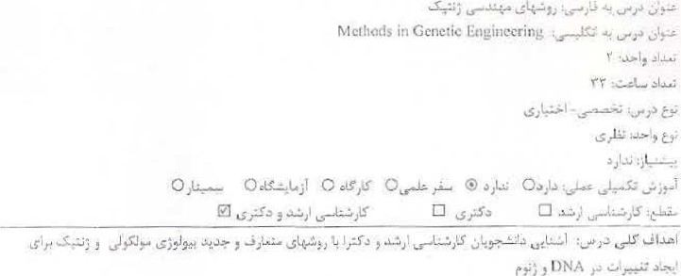
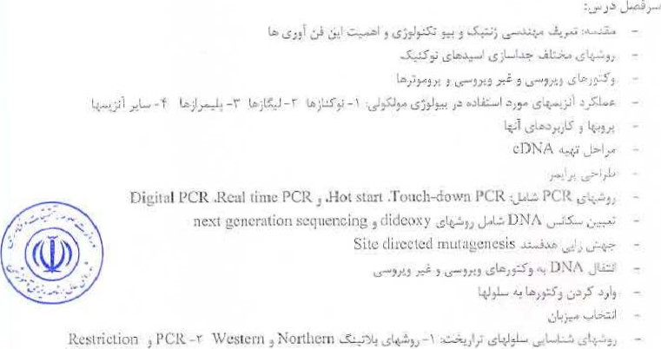

'napping
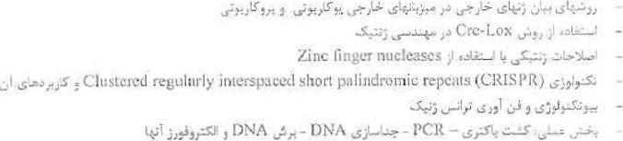
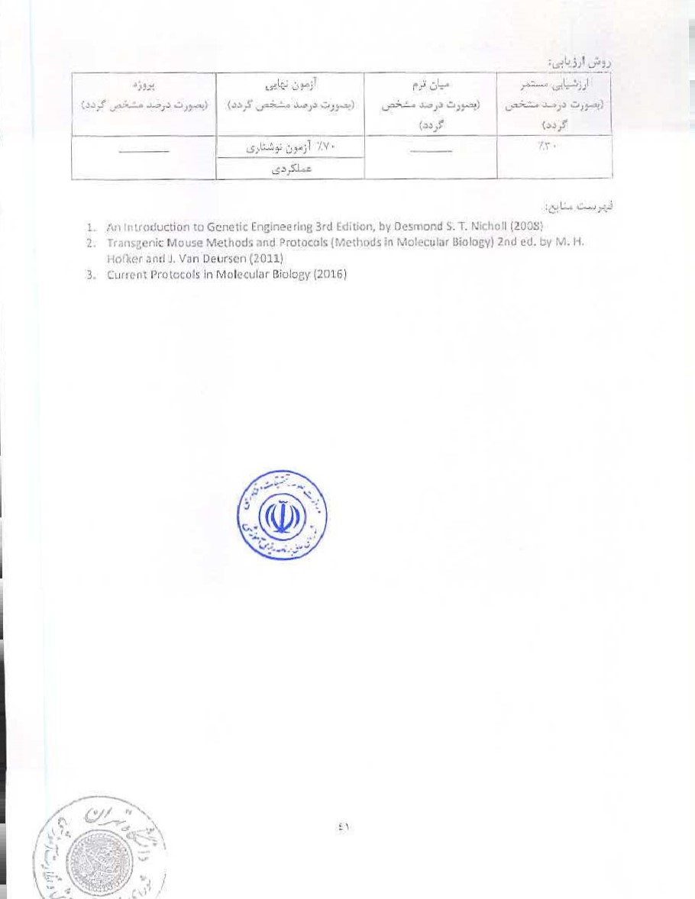

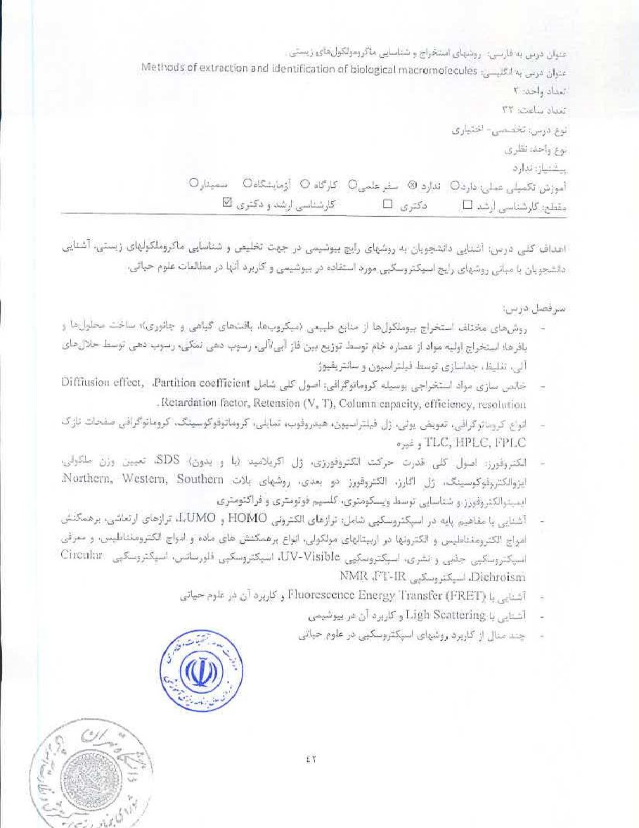

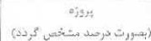 | 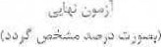 |  | 
 |  |  | 1.1 .
I, Techniques in Biochemi511A,' and Molecular biology,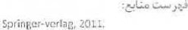

GordonG. Harnmes, Spectroscopy far the Sciences, Witew, 200%
I, Hofmann, Methods of Molecular in the Lilescienccs, ContbriUge IJr'iüarsiUy press, 201-4.


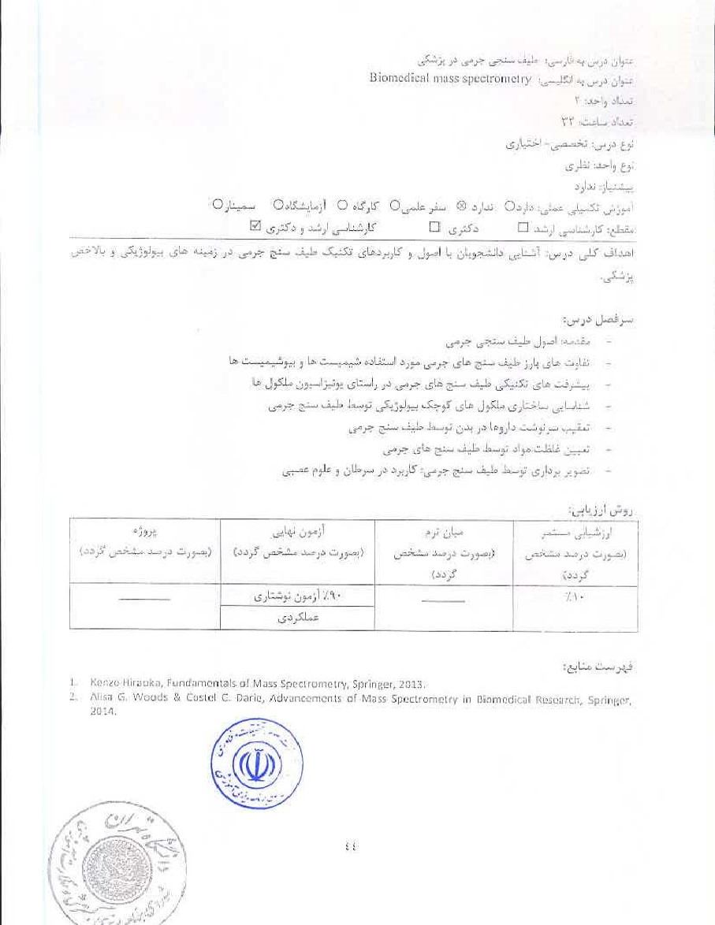
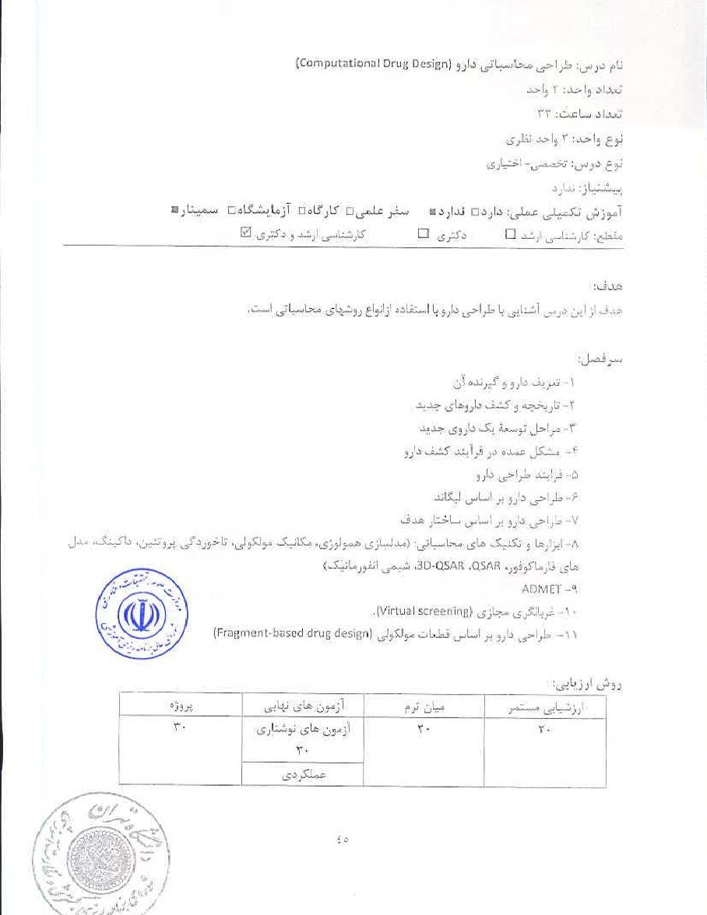

- DOC. Compulatjo'nal Design: for Computotional and Medicinat Chemists, Wilévinterscienc2. 2009

2• Bultinck P., Tollertaere Langenaeker W., Winter Cnrnputational Meoicinal Clvérnistr•v Discovery. CRC. 2003.
3• Zheng, Y., national Drug Design Metheds and Protocols, Sprinter. 2012. iTuri. W. Drug Discovery, Springer. 2012.


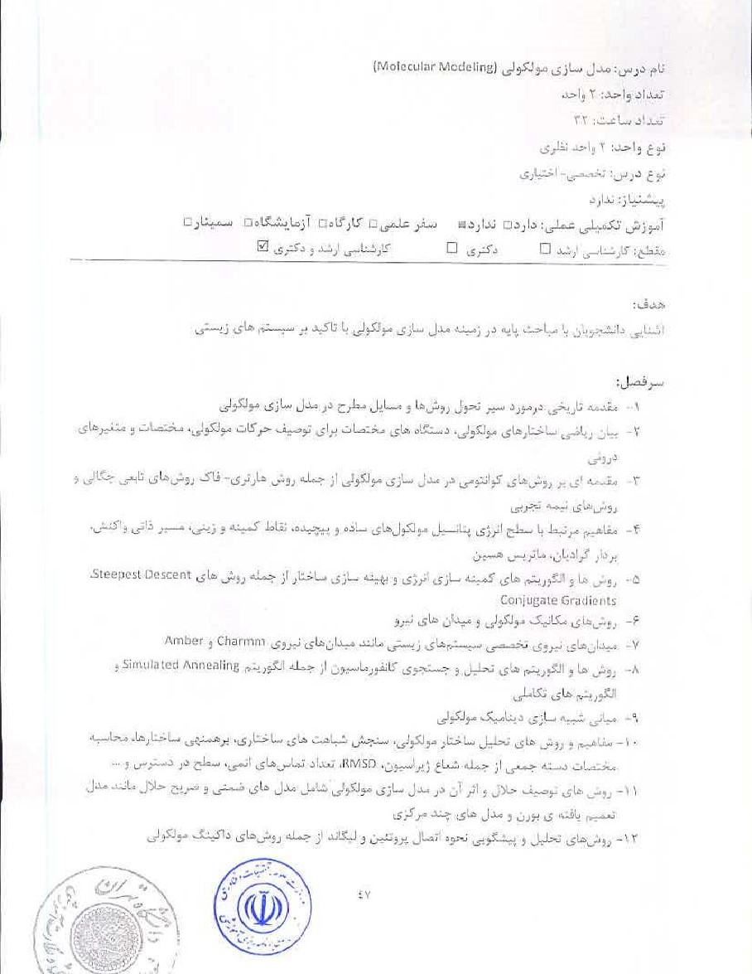

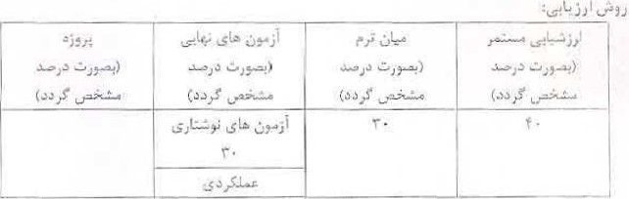
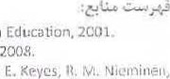
Molecijbar Modeling Principles and Applications, Andrew R. Leach, Pearson
Griebel.
D.
- Molecular Modeling of Proteins, Aradrees l<ukol, Springer (blumarva Press), 3- Nev./ Algorithms for Macromolecular Simulation, D. Springer; 2006.
T,



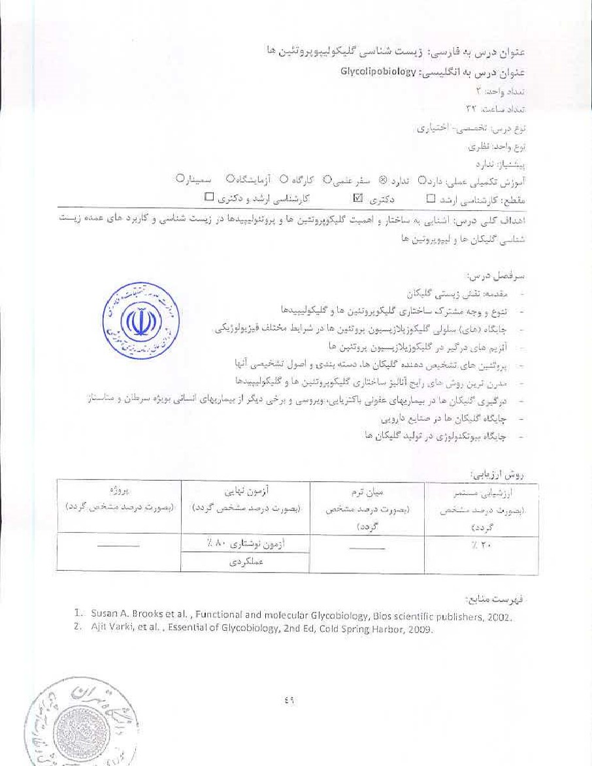

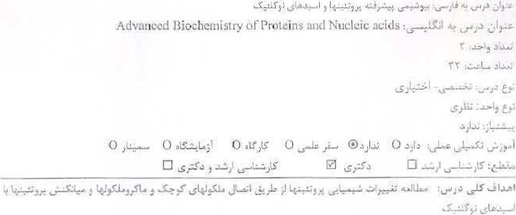
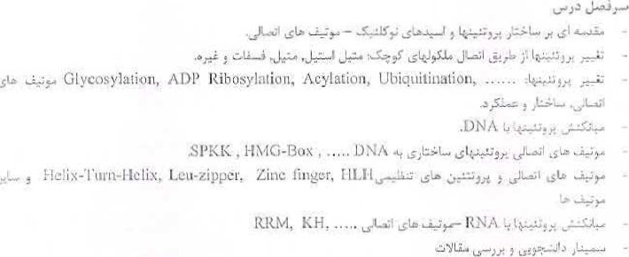

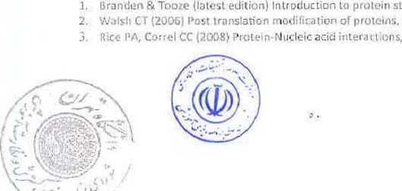
Garland P'JŁJ
protei')î.
RC
Pui.
Structura' RSC

