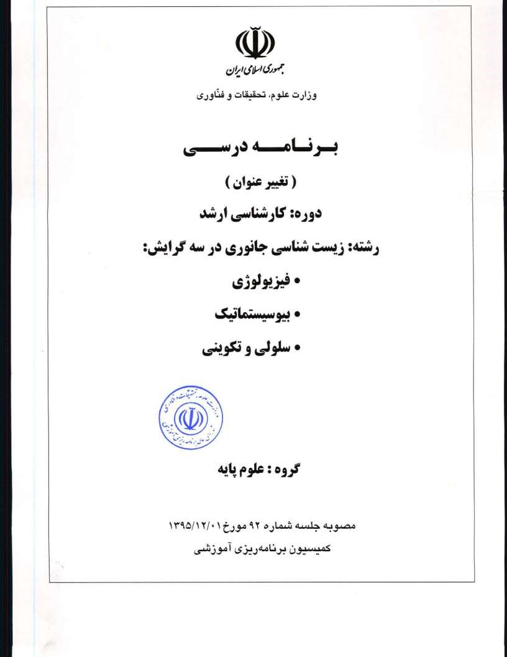
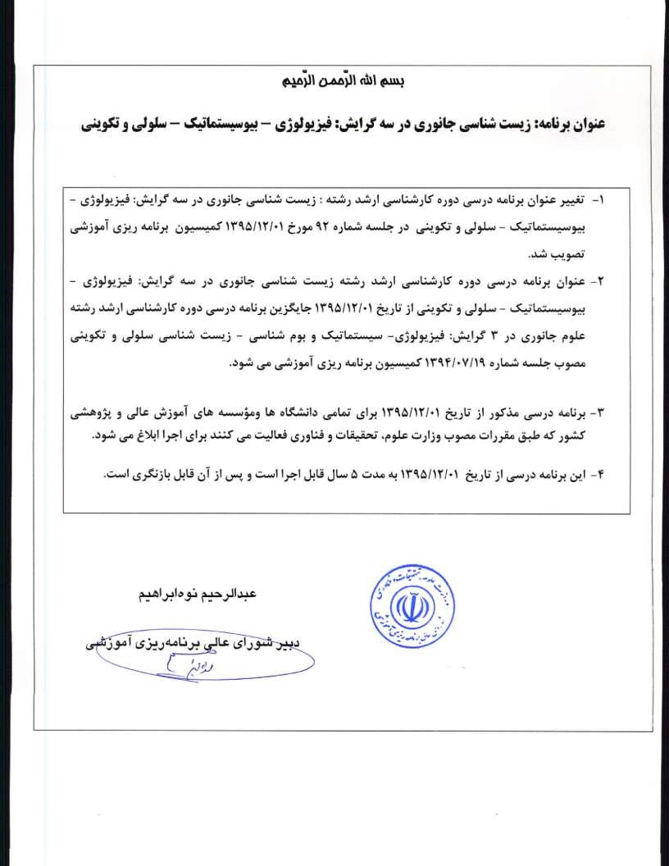


J31 


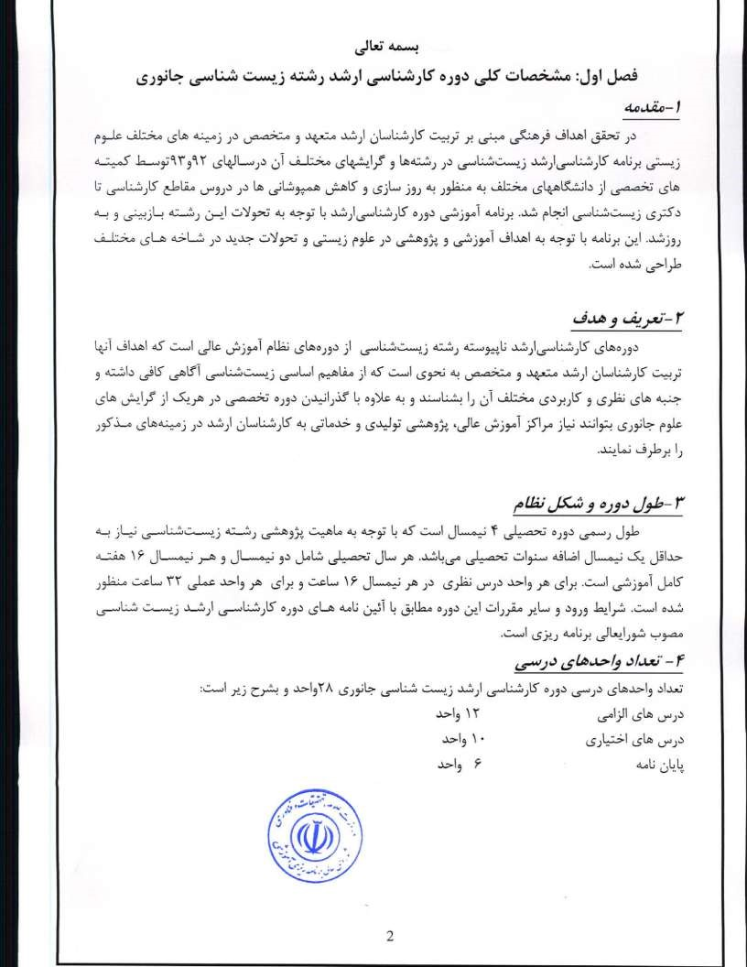
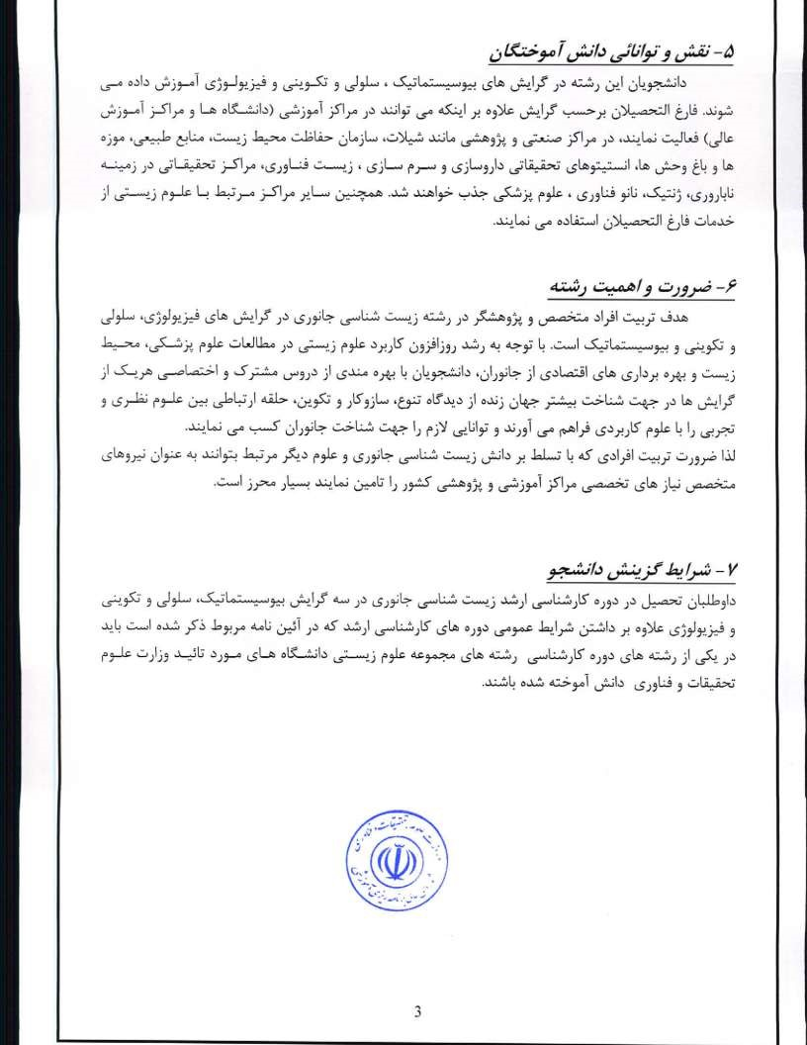
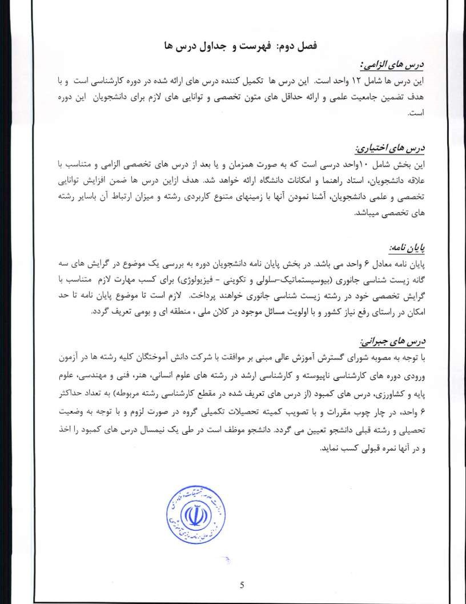
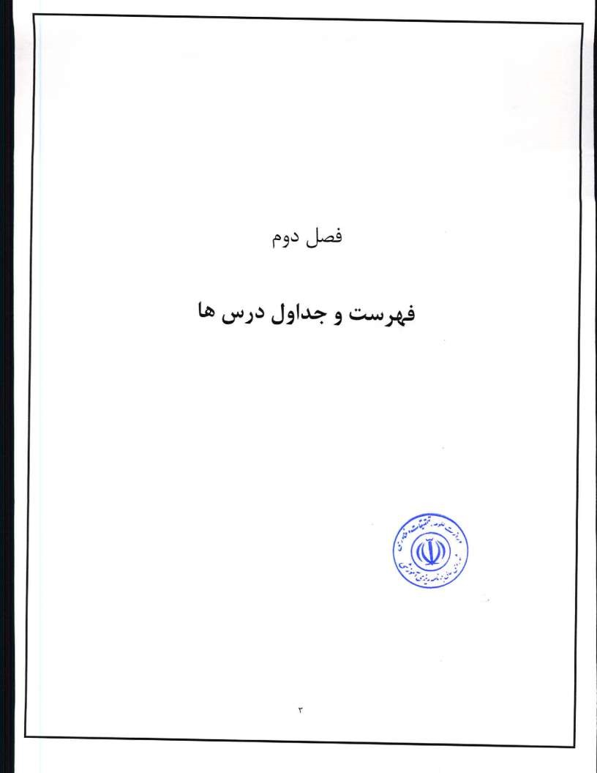
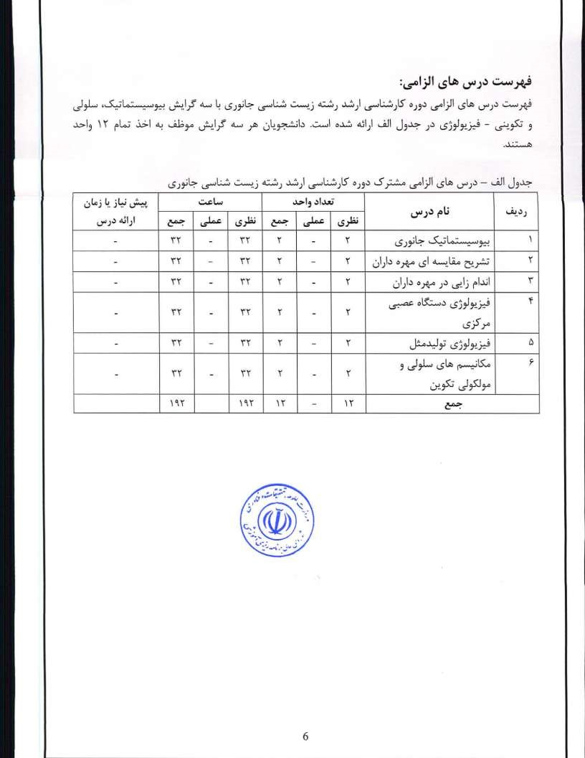
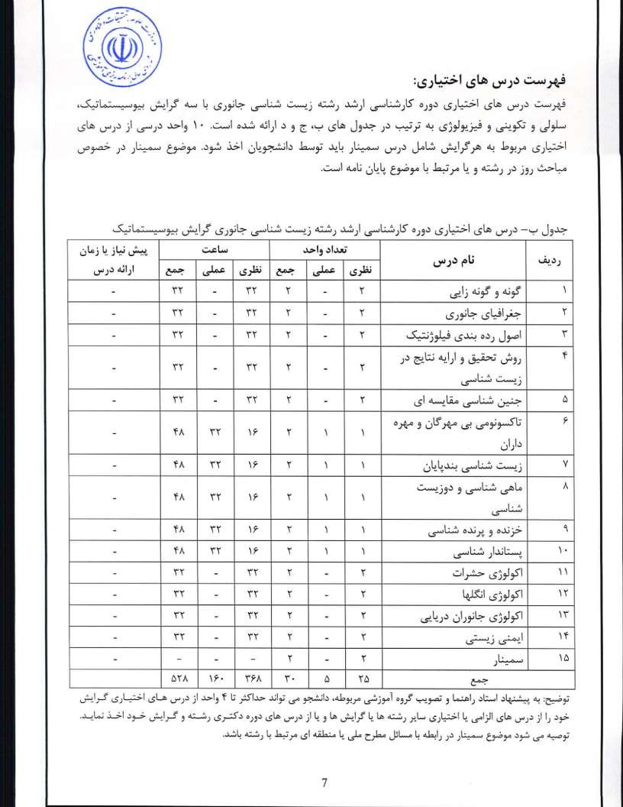
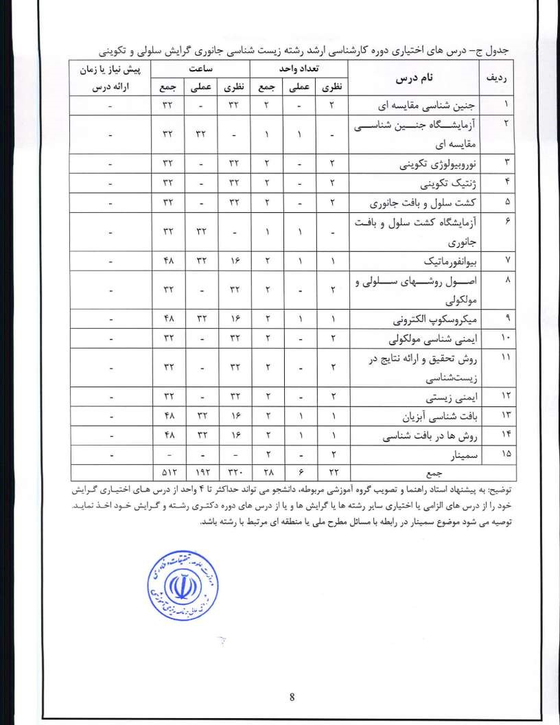
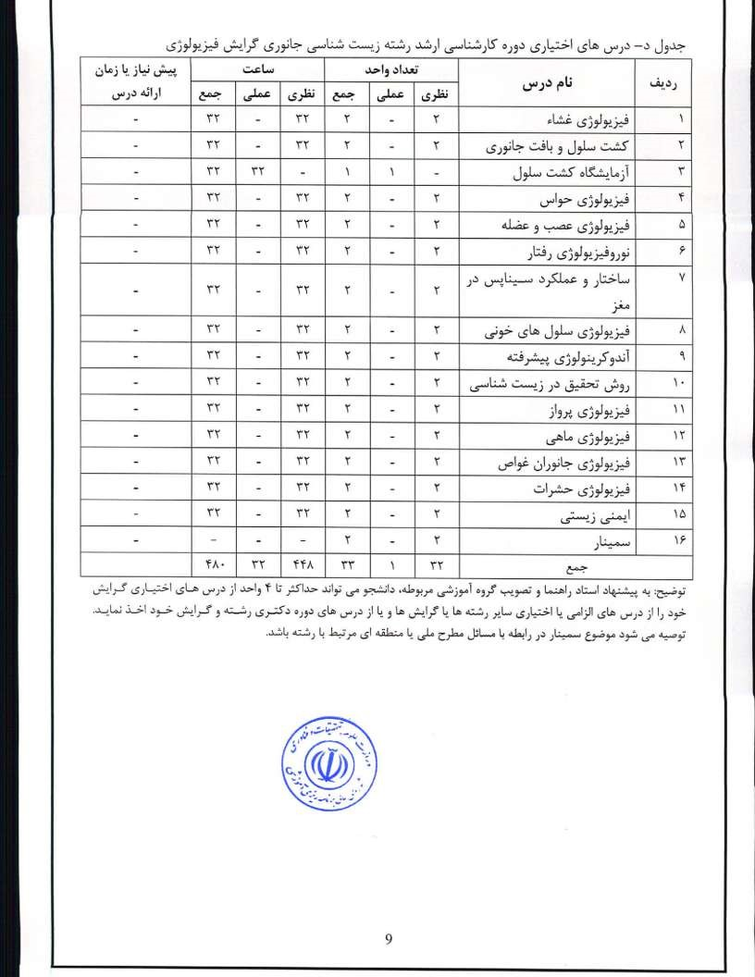
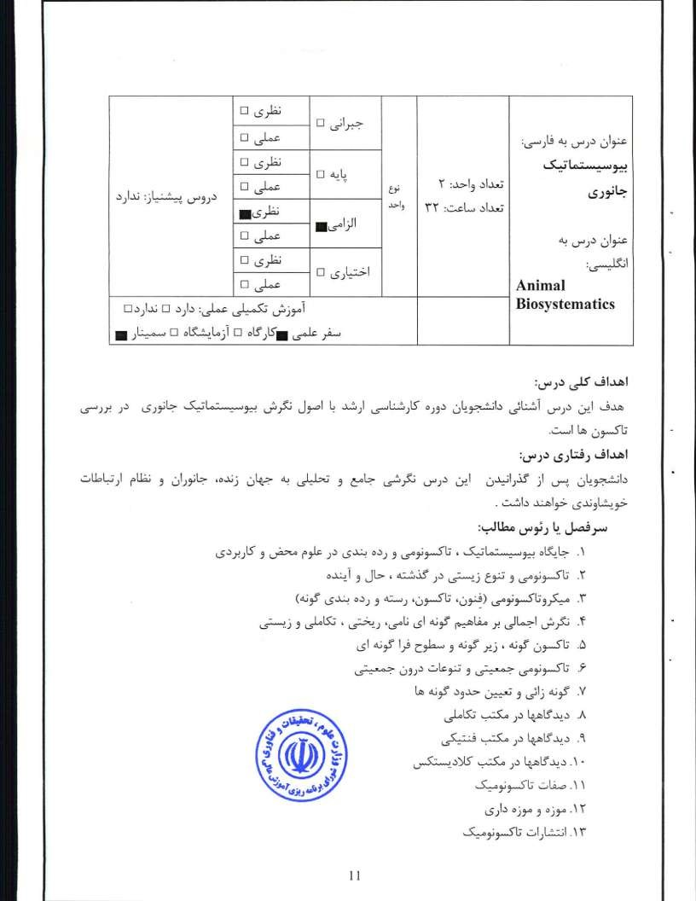

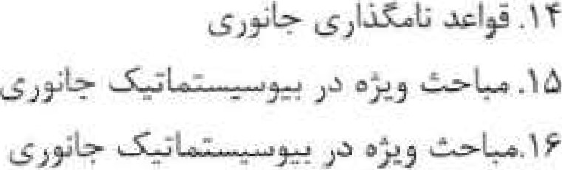
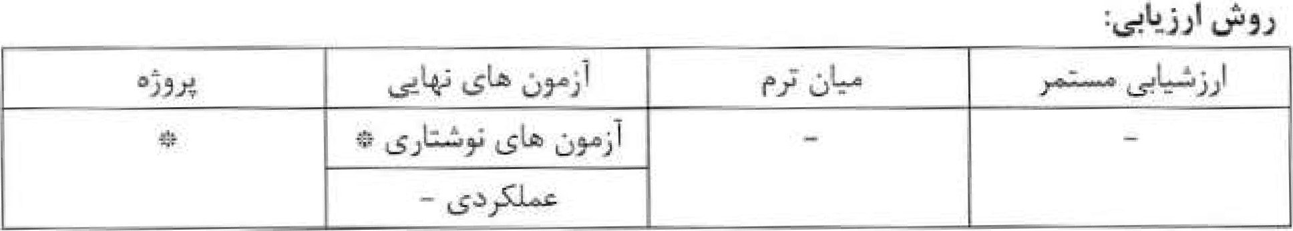
- ICZN (1999) International Code of Zoological Nomenclature , edition. ICZN ( International Commission on Zoological Nomenclature). London, Berkeley ..
- Mayer, E, and P.D, Ashlock (1991) Principles of Systematic Zoology. MacGraw•Hill Singapore. Second edition .
- Minetli, A. (1993) Biological Systematics: The state of Art. Chapman & Hall, London.

'1 2

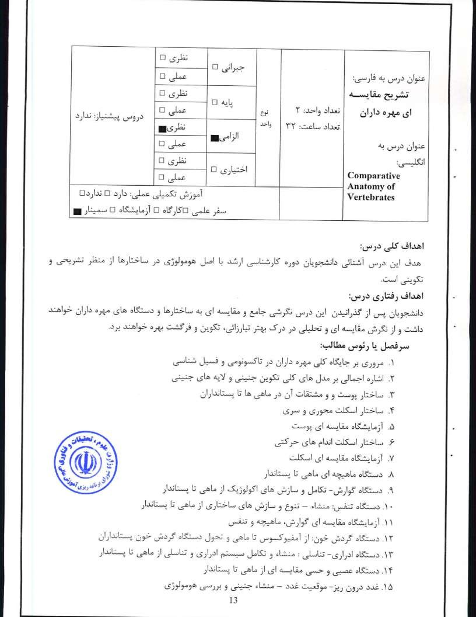
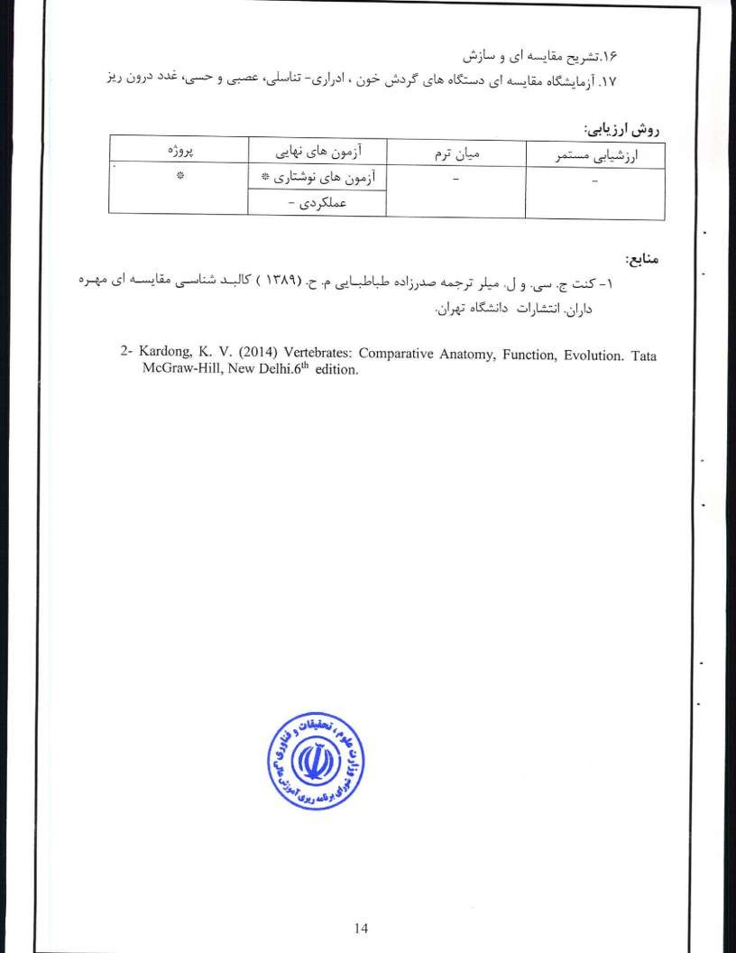
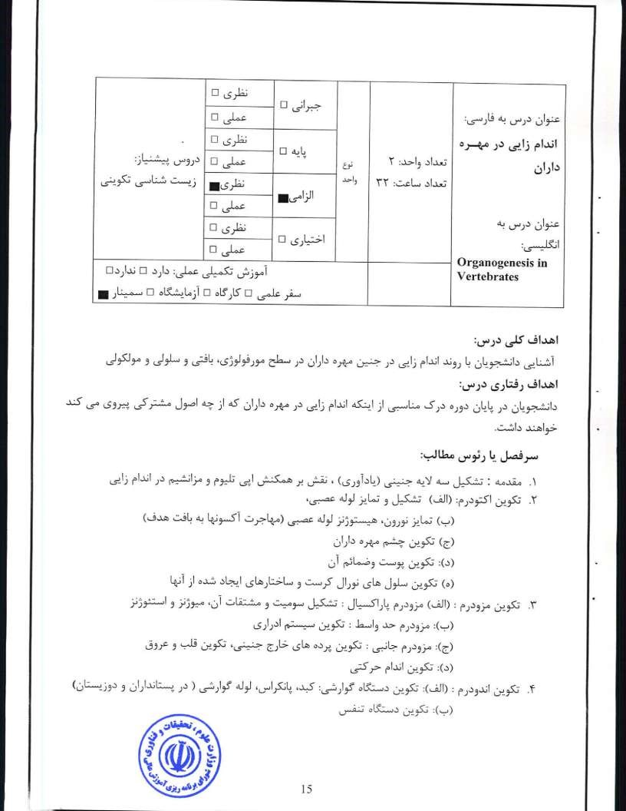


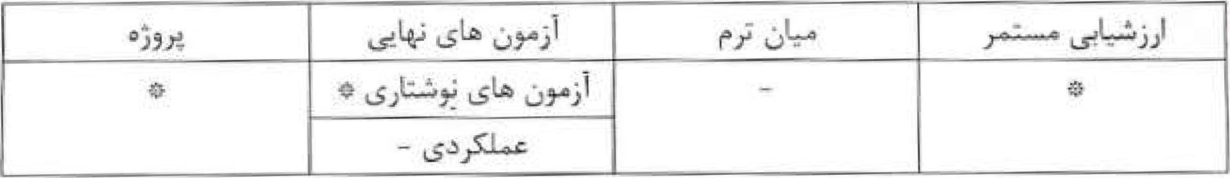
l- Gilbett, S. F. (2013) Developmental biology, tenth editiom Sinauer Associates, Sundcrlaud,
- Kalthofft K. (2001) Analysis of Biological development. Second edition. Mc Graw Hill, New York-
- Wilt F. Il. and Hake S. C. (2004) Principles of devclopmental biology. First edition, Norton & company, Inc. New York

16

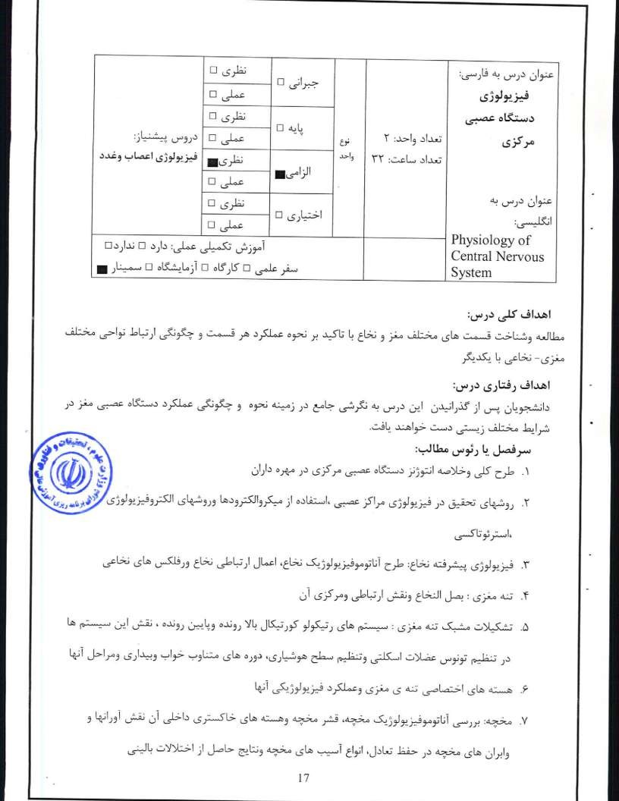
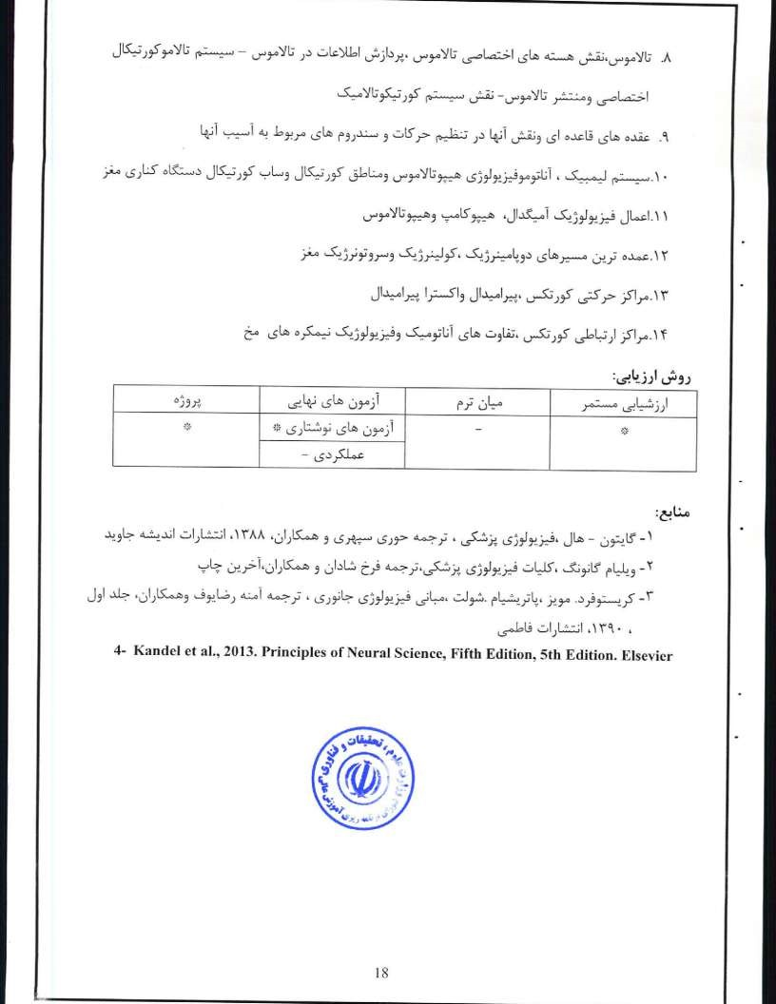
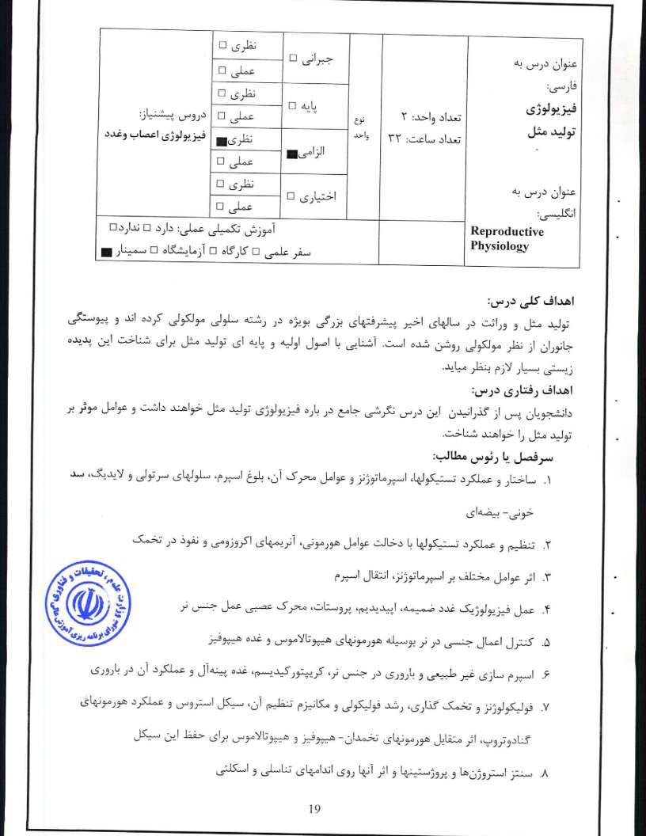
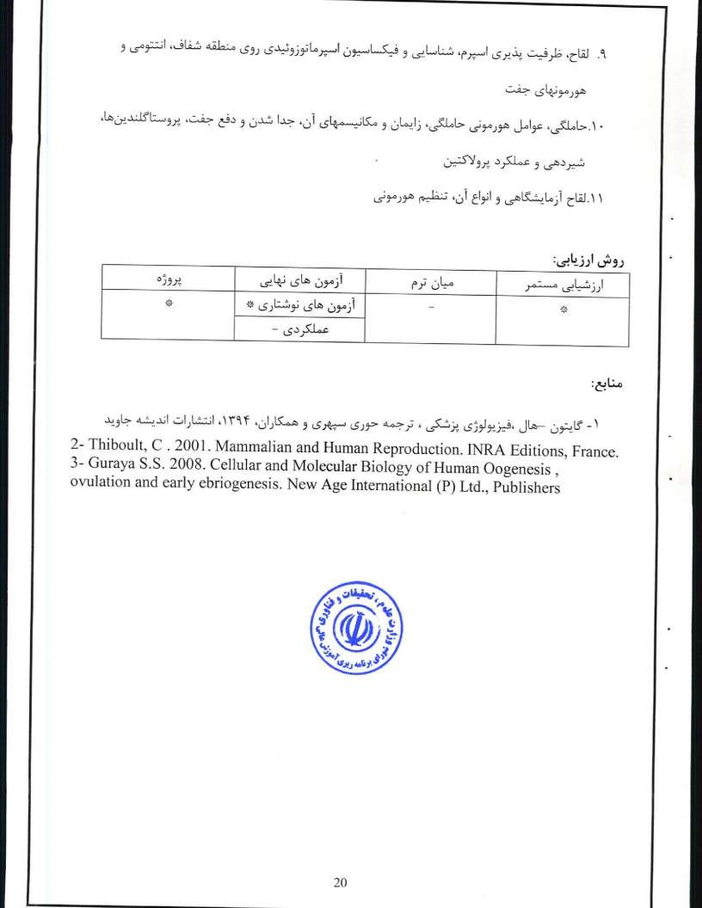
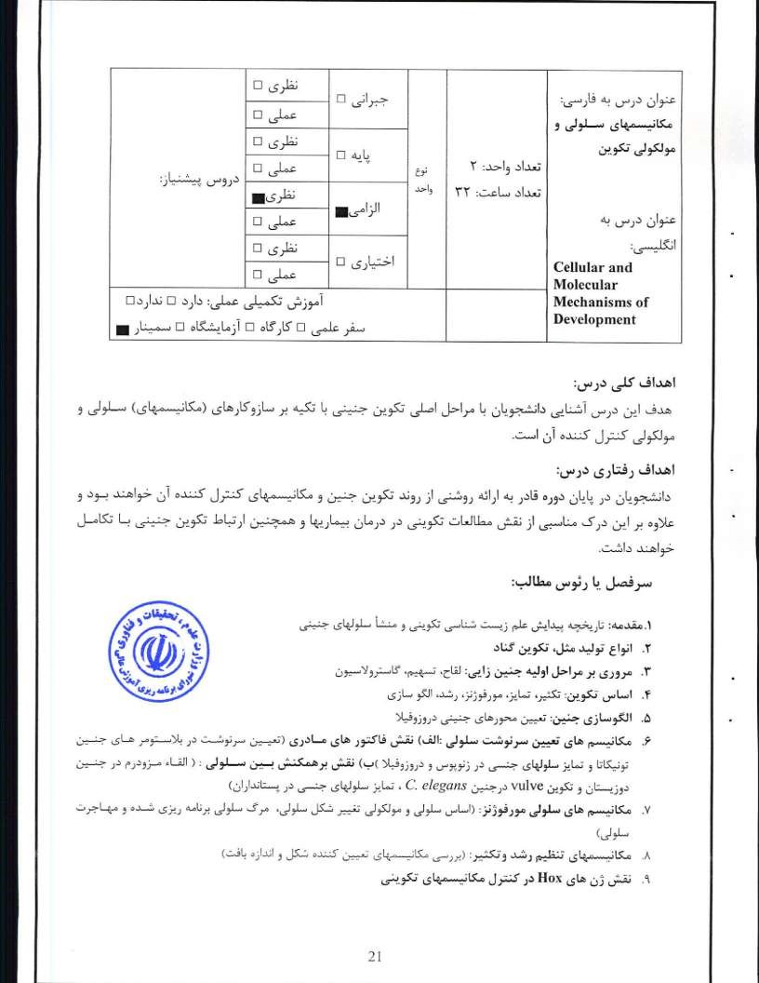

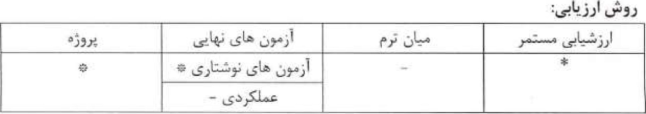
I ^{A} Gilbert, S. F. (2013) Developmental biology, tenth edition, Sinauer Associates, Sunderlaud, MA2- Wolpert, Beddington, R., Jessell, Tv, Lawrence, P.t Meyerowitz, E. and Smith, J. (2011) Principles of development. fourth edition, Oxford University Press.
- Slack, L (2012) Essential developmental biology. Third edition, Blackwell Science Ltd, Oxford.
- Wilt F. H. and Hake S. C. (2004) Principles of developmental biology. First edition, Norton & company, Inc. New York.

22

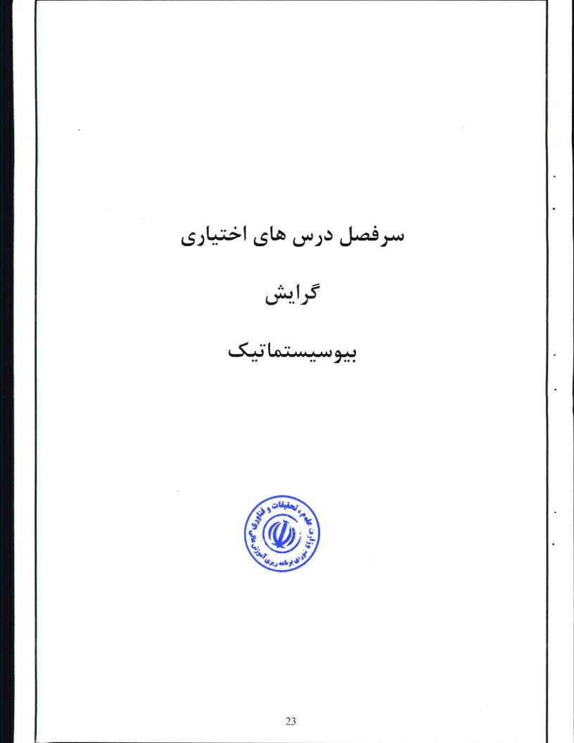
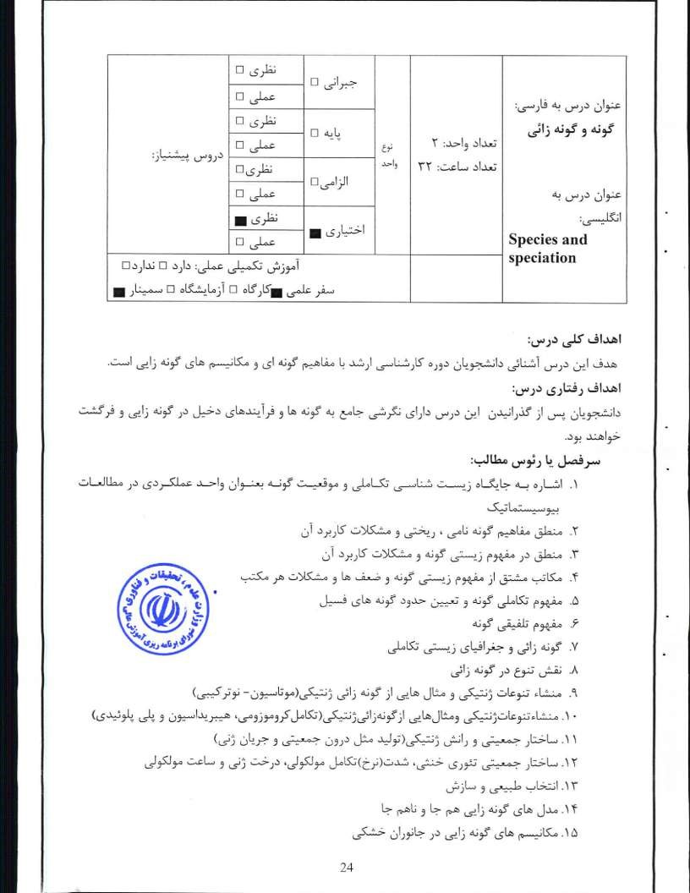

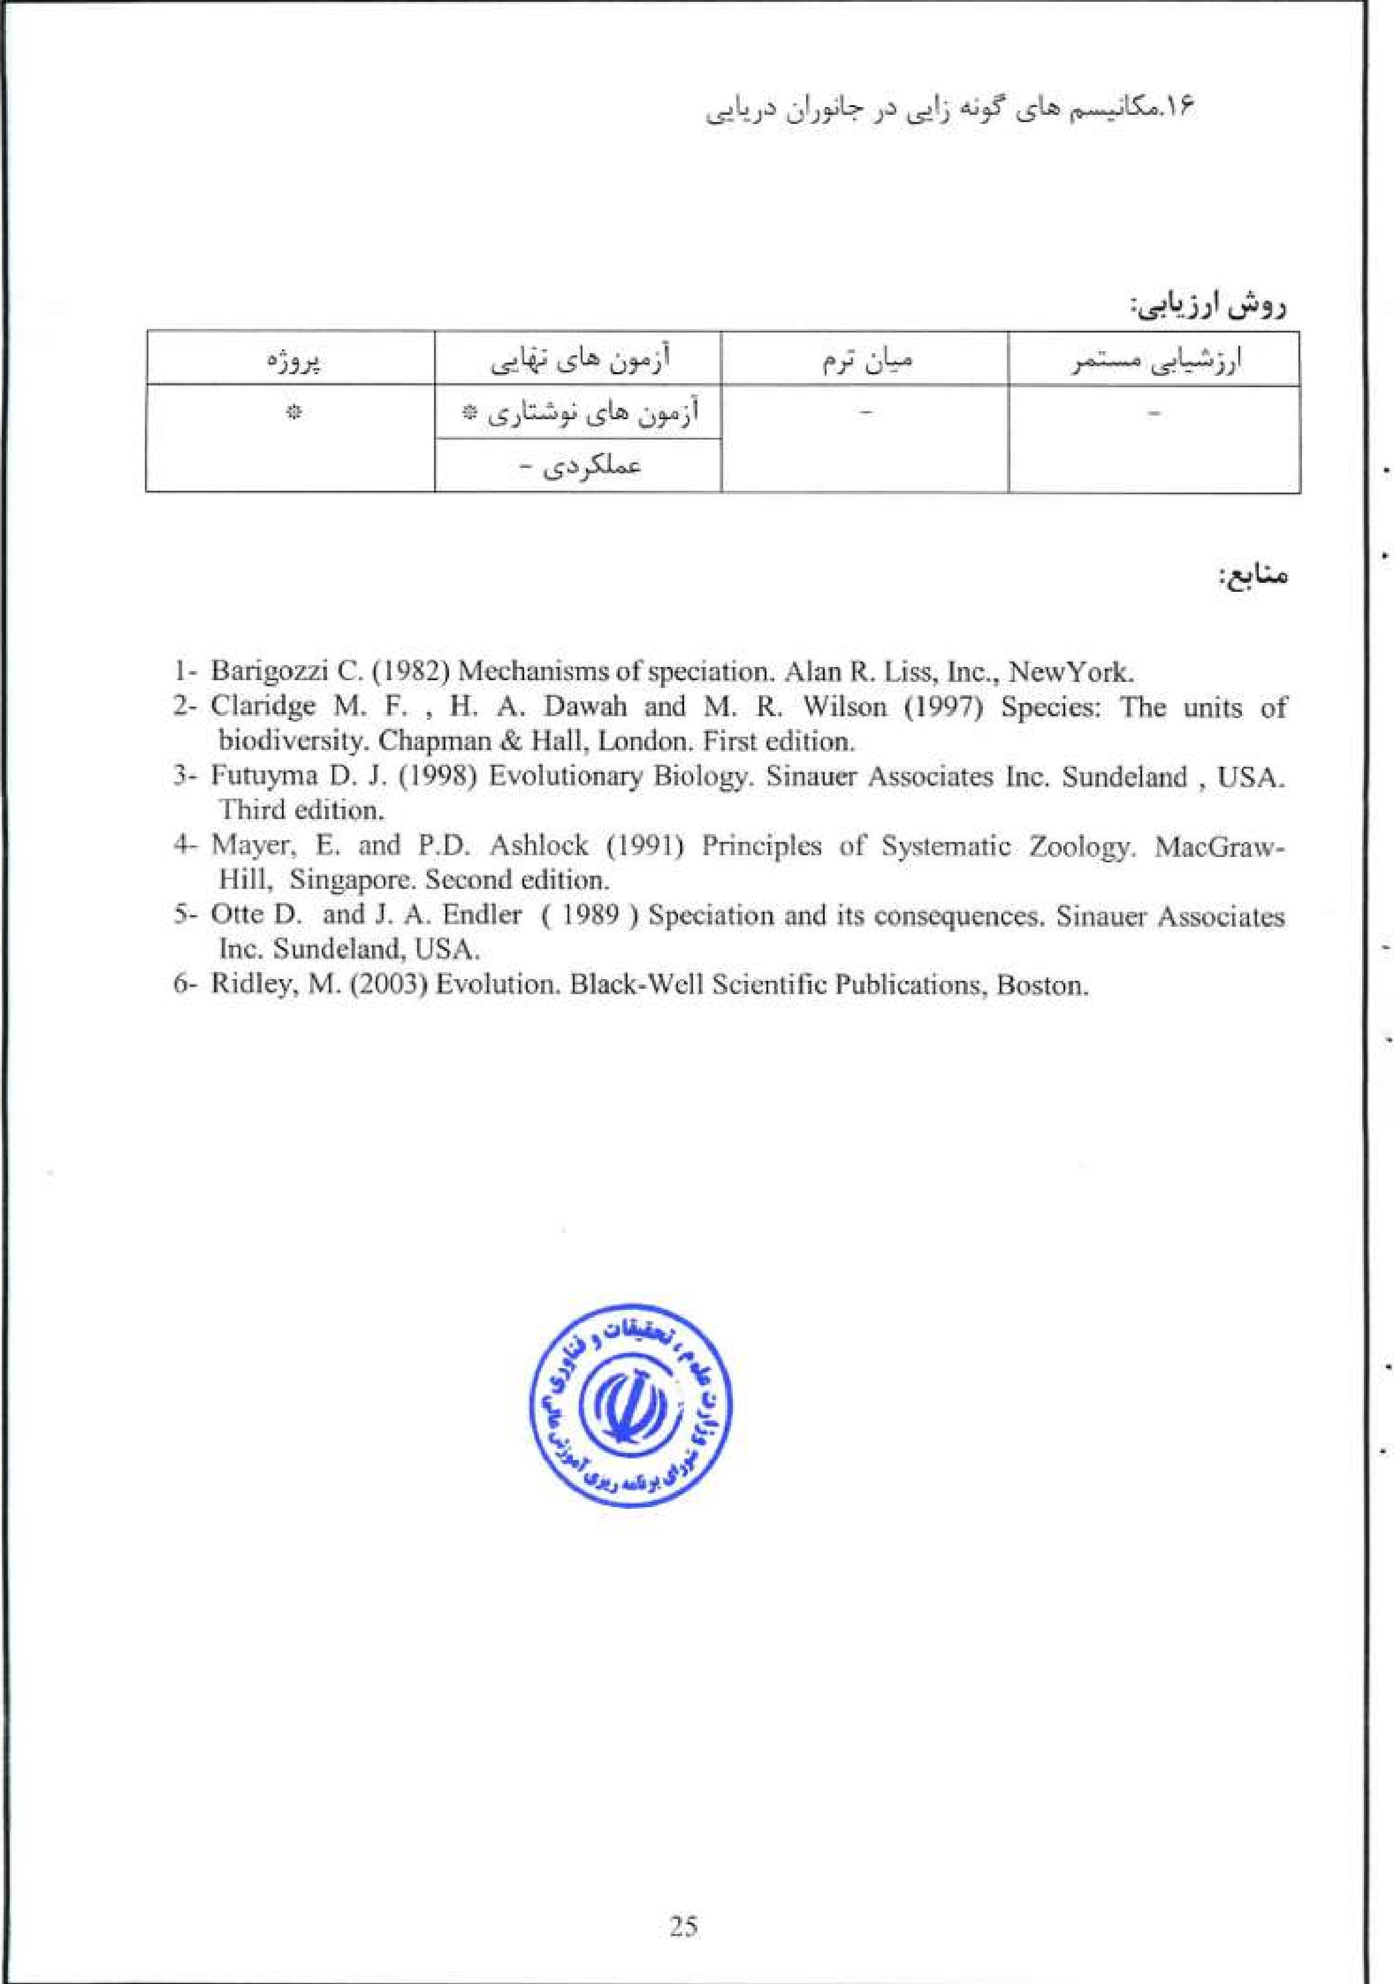

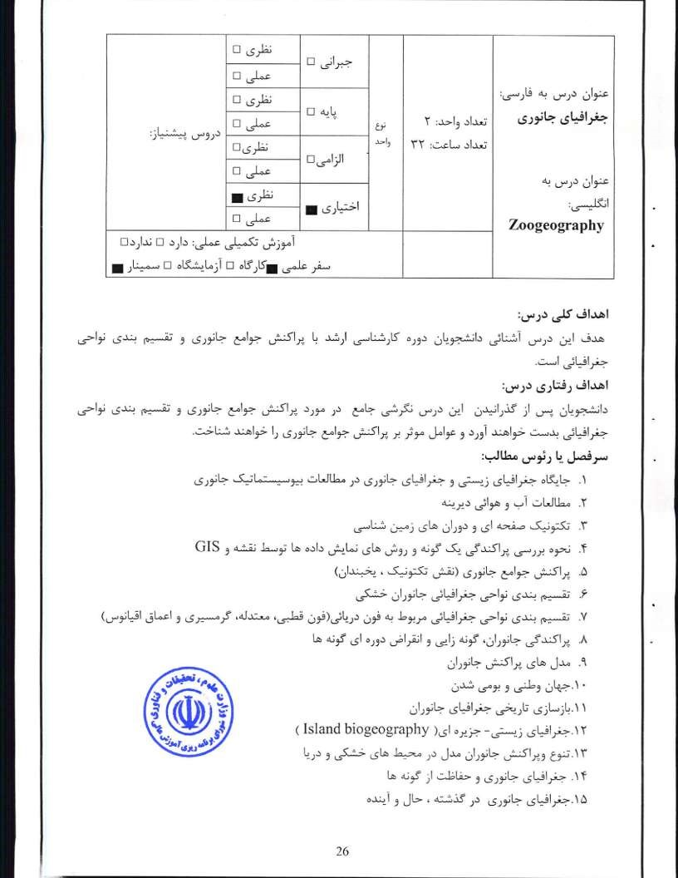
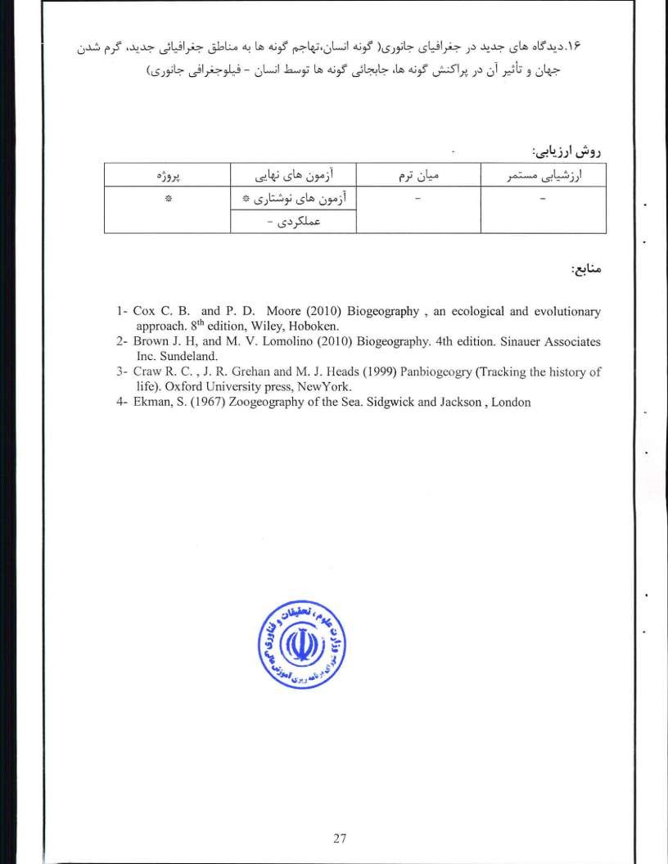
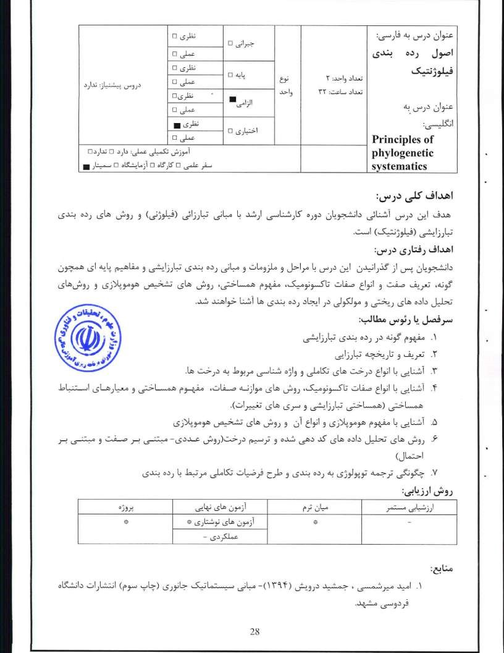

  - Hennig, W. (1999), Phylogenetic systematic, 3rd edition, Urbana: University of Illinois Press.
  - Hull, D (1988), Science as a Process, University ofChicago Press.
  - Mayr. Ernst (1974), "Cladistic analysis cladistic classification?", Zeitschrift flir Zoologisehe Systematik und Evolutionforschung 12: 95—128.
  - Wiley, E.o.; Siegel-causey, D.; Brooks, DR. & Funk, V.A- (1991), The Compleat Cladist: A Primer of Phylogenetic Procedures, The University of Kansas Museum Natural History

29

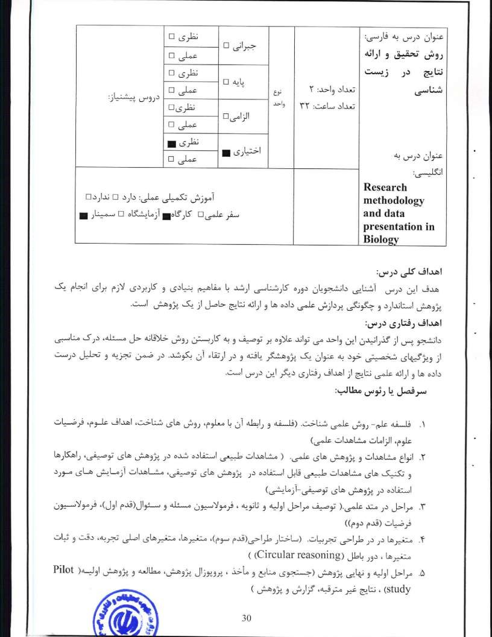

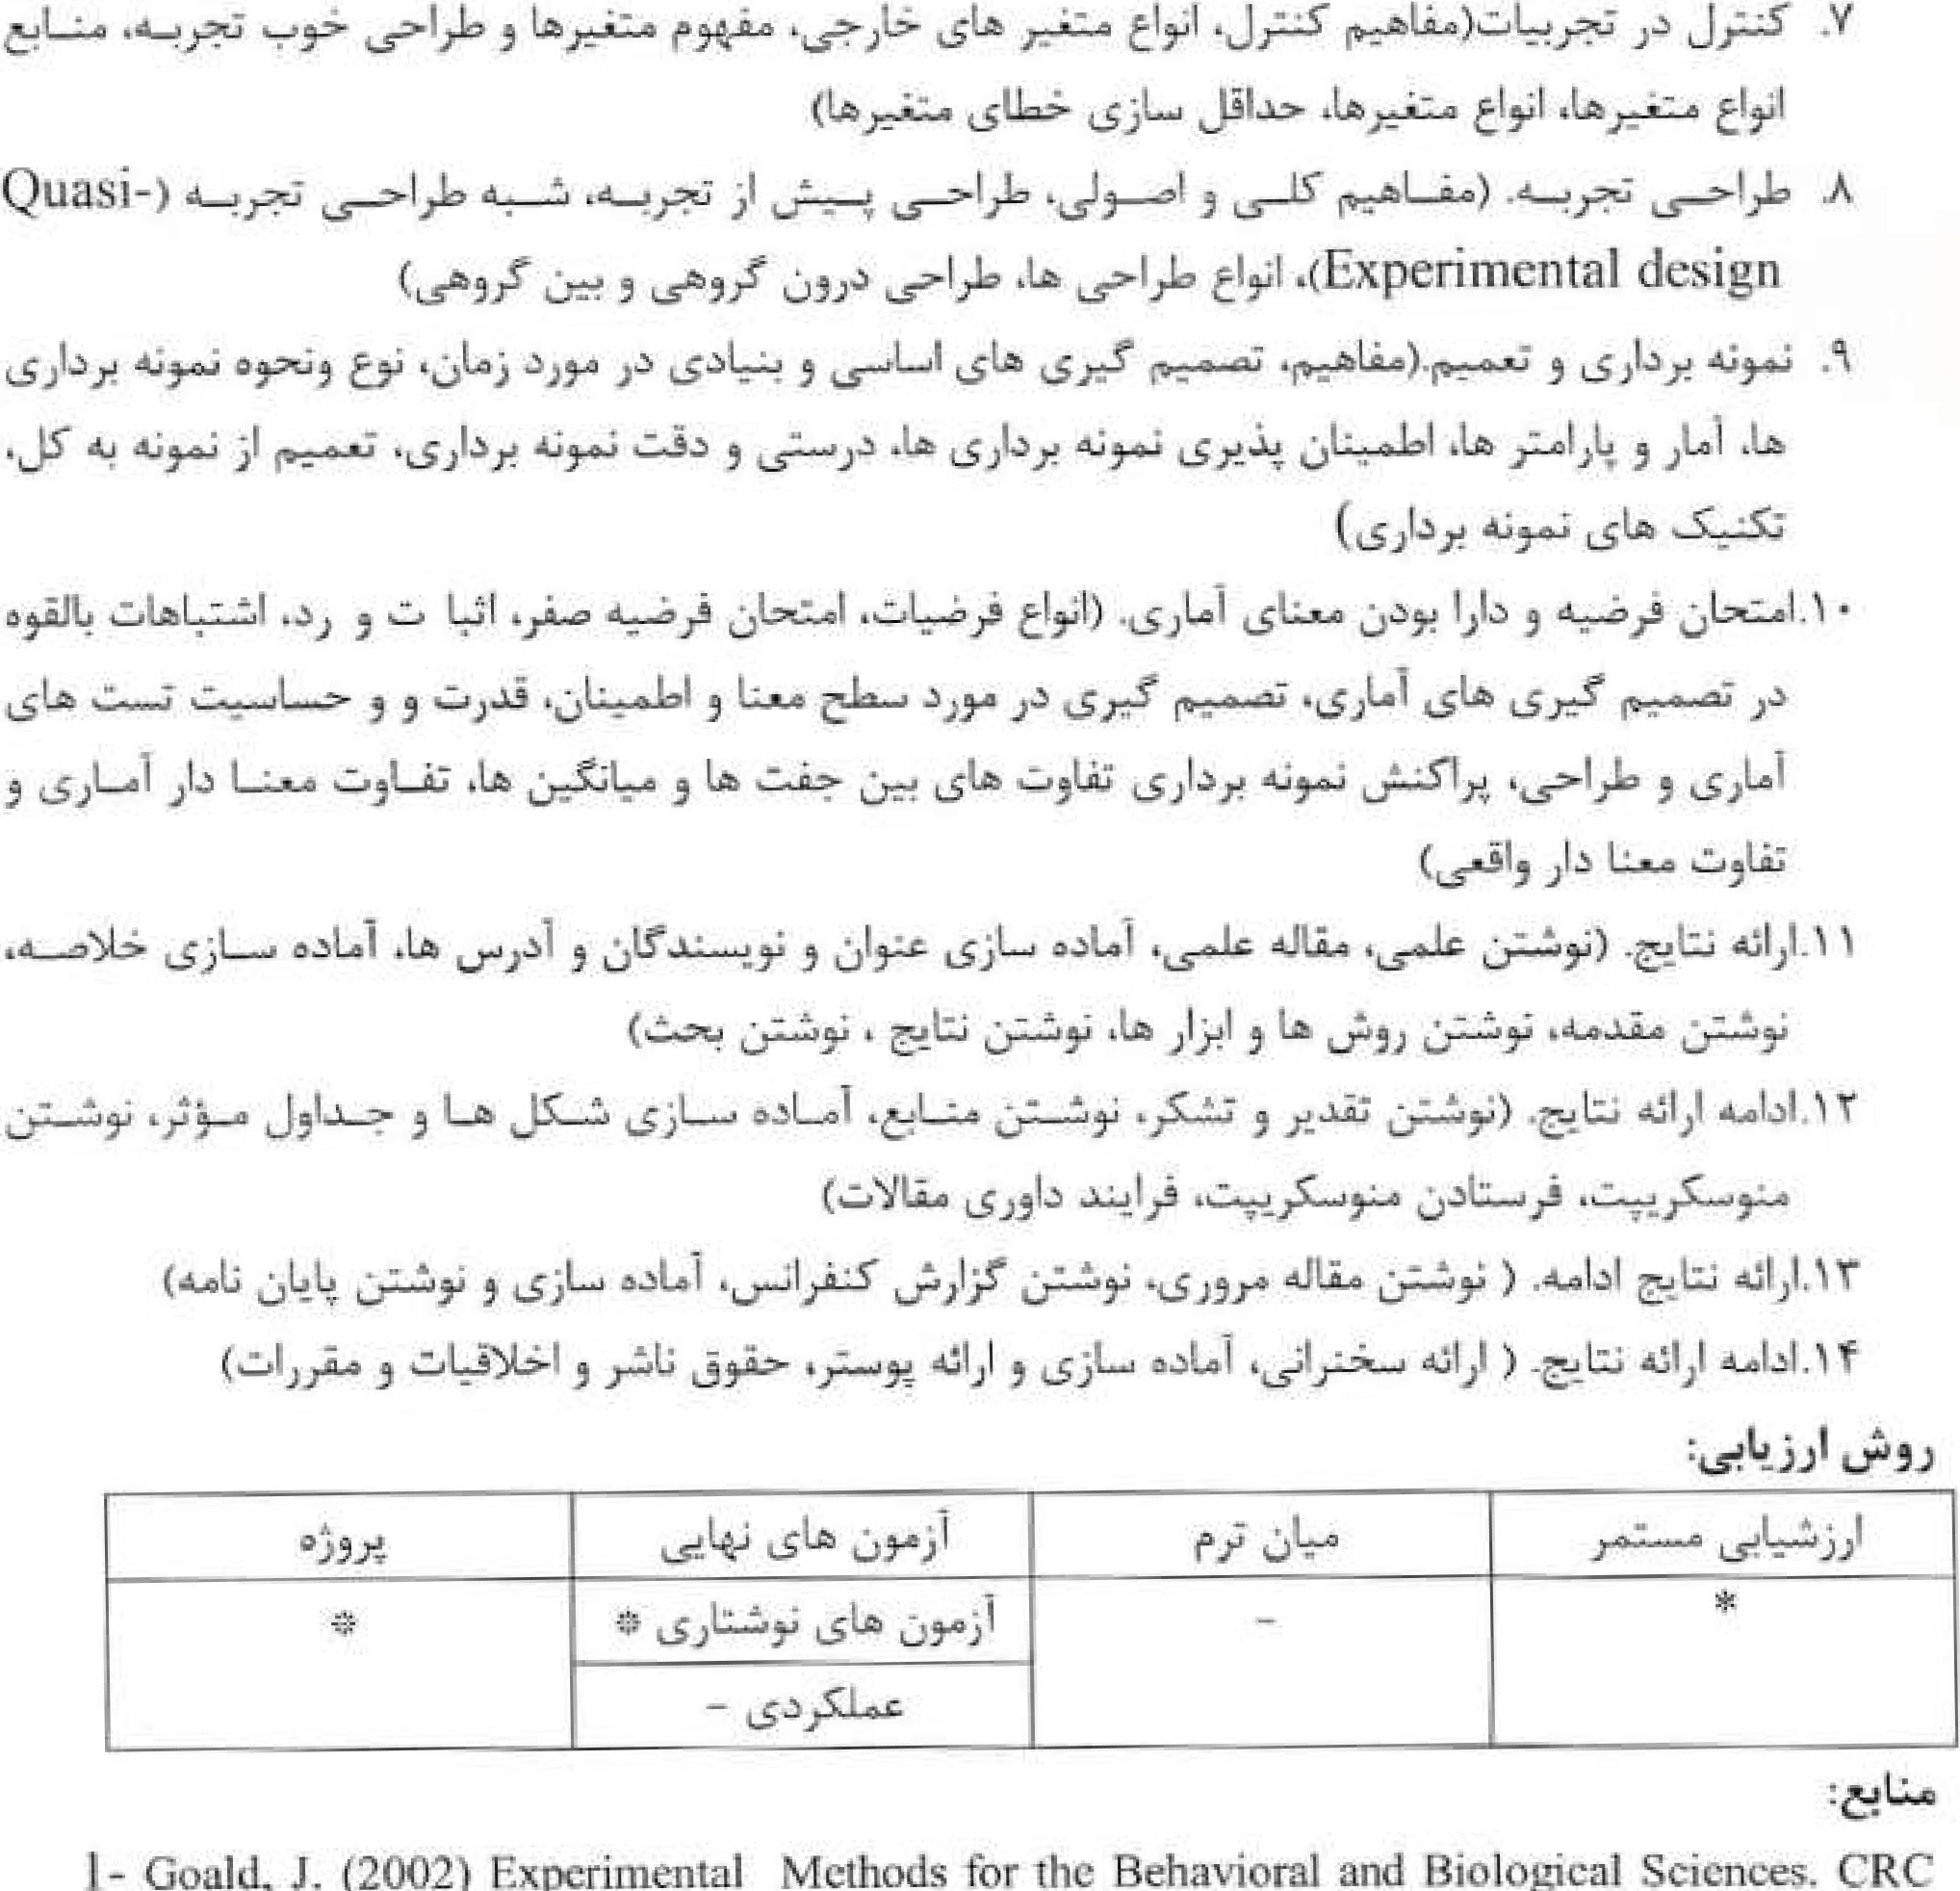
Gould,
J.
(2002)
Experimental
Methods
for
ffe
IBehavioral
and
Biological
Sciences,
CRC
press, Boca Ratom
- Mepham B. (2005) Bioethics, An introduc'tion the Biosciences. Oxford University Press, Oxford.
- Jones A.t R. Rreed and J. Weyers (1998) Practical Skills in Biology. Longman, Essex.
- Zar L EL (1998) Biostatistical Analysis. 4th Edition. Prentic Hall Intemational Inc. New Jersey.
- Sokal, R. R. and F. J. Rohel (1995). Biometry. 3 ^{rd} Edition. Freeman, New York,
Booth, V. (1990) Communicating in Science: writing and speaking. Cambridge University Press. Cambridge.
Day, R. (1991) HOW to write and publish Scientific Paper. 3"! Edition. Cambridge University Press. Cambridge.
 31

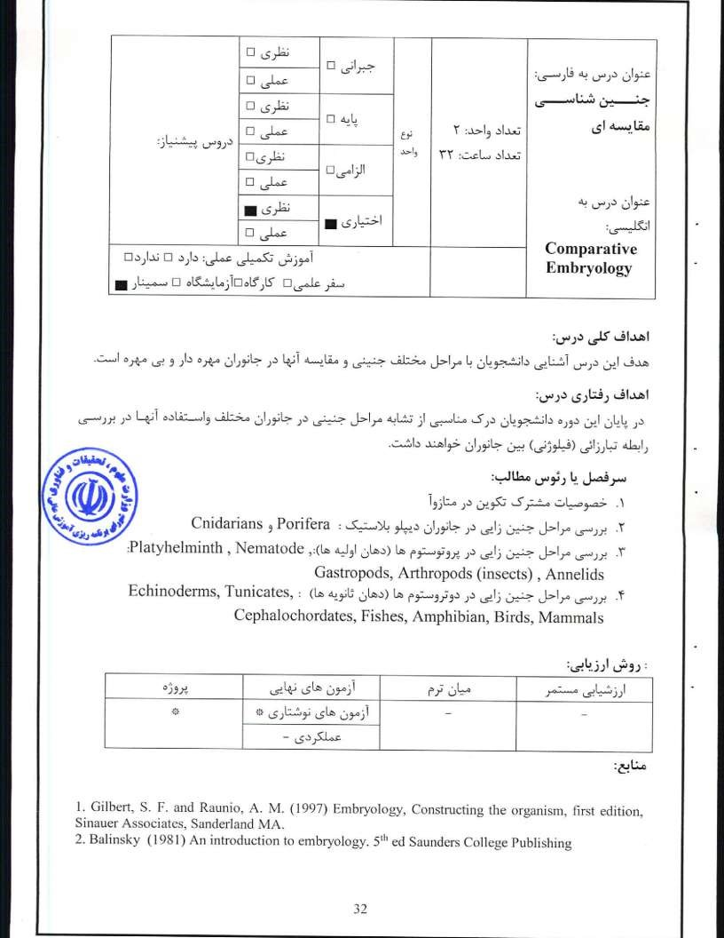
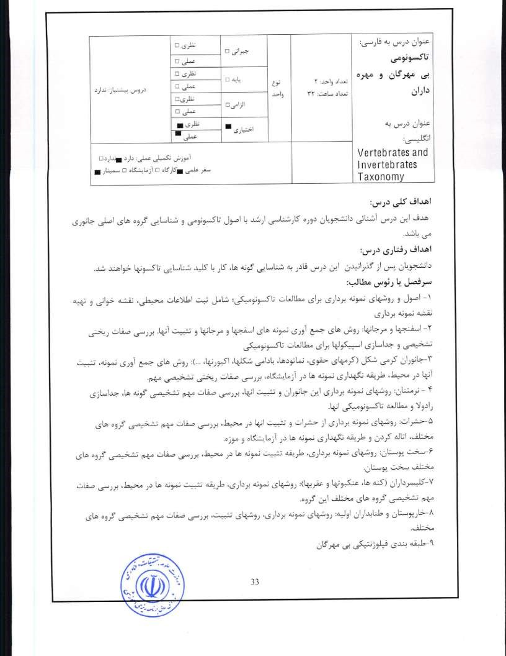
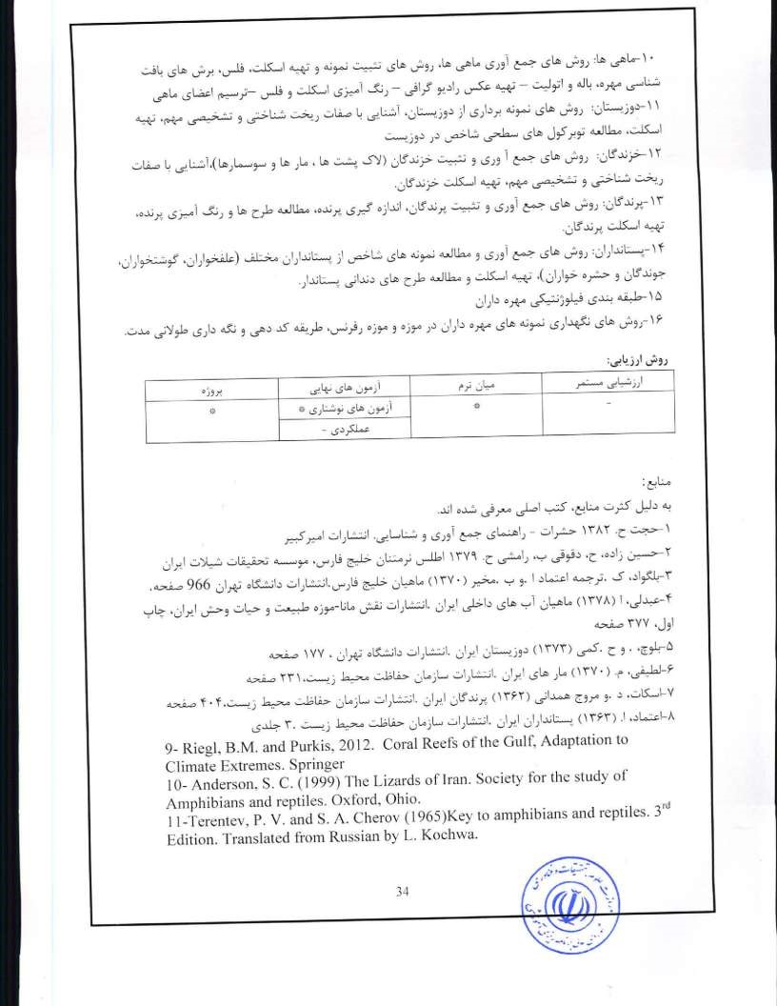
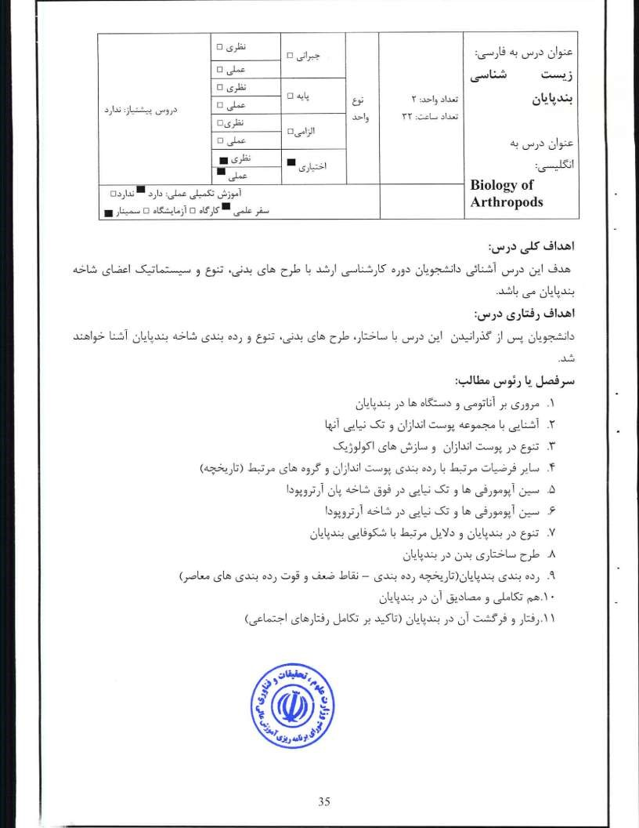

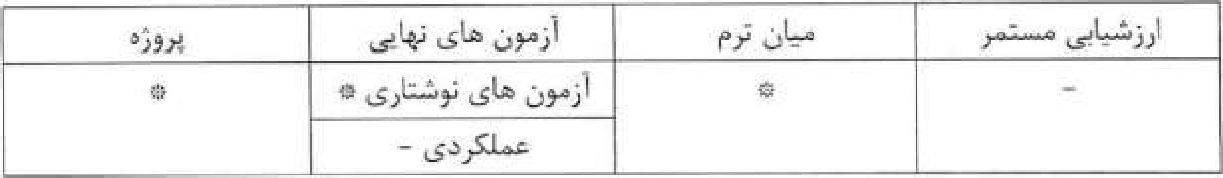
l- Anderson, D. T. (1973) Embriology and Phylogeny In Annelids and Arthropodes. Pergamon Press, Oxford.
- Forty R. A. and R. H. Thomas(1997) Arthropod relationship. Chapman & Hall, London.
- Koenemann, S. and R. A. Jenner (2005) Crustacea And Arthropod relationships. Taylor & Francis, Boca Raton.

4. Ruppert, E. E., R. S. Fox & R. D Barnes (2004), Invertebrate Zoology (7th ed.), Brooks/Cole.
- Schram,F. R. (1980) Crustacea. Oxford University Press, Oxford.
- Schram.,F, R. (1983) Crustacean Phylogeny. Crustacean Issues, No. It A. A. Balkema, Rotterdom.
- Scoltz, G, (2004) Evolutionary developmental biology of Crustacea. A. A. Balkema Publishers, Lisse.


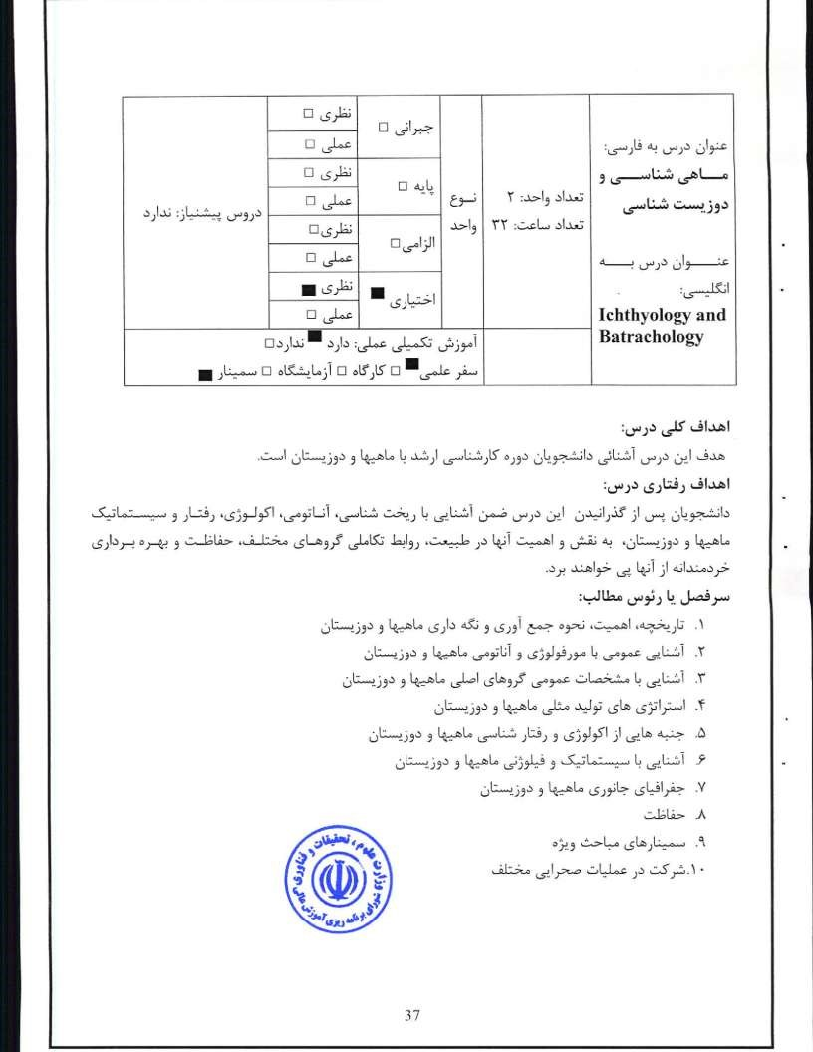

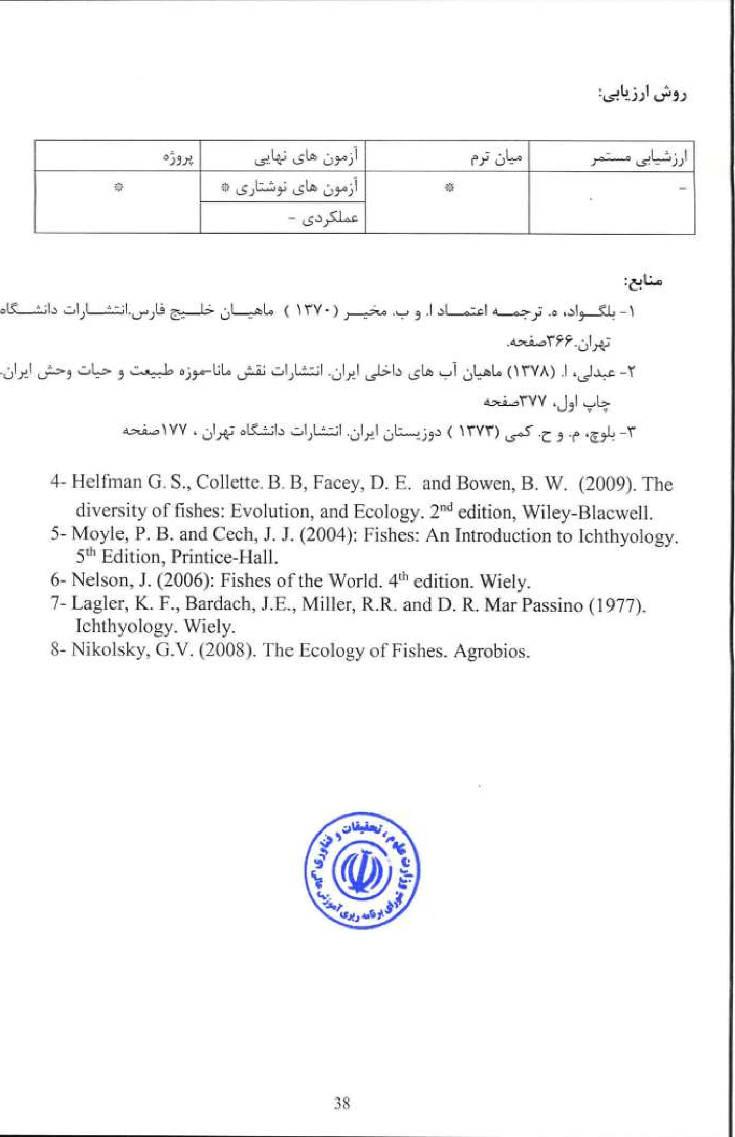

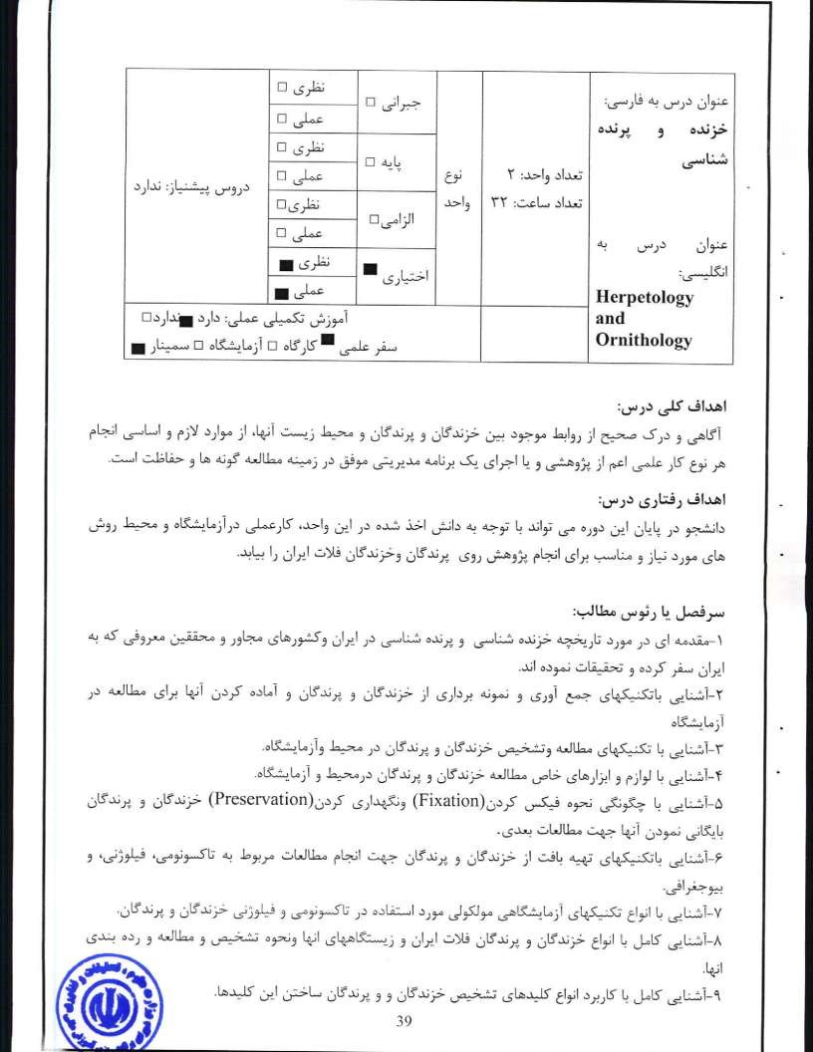

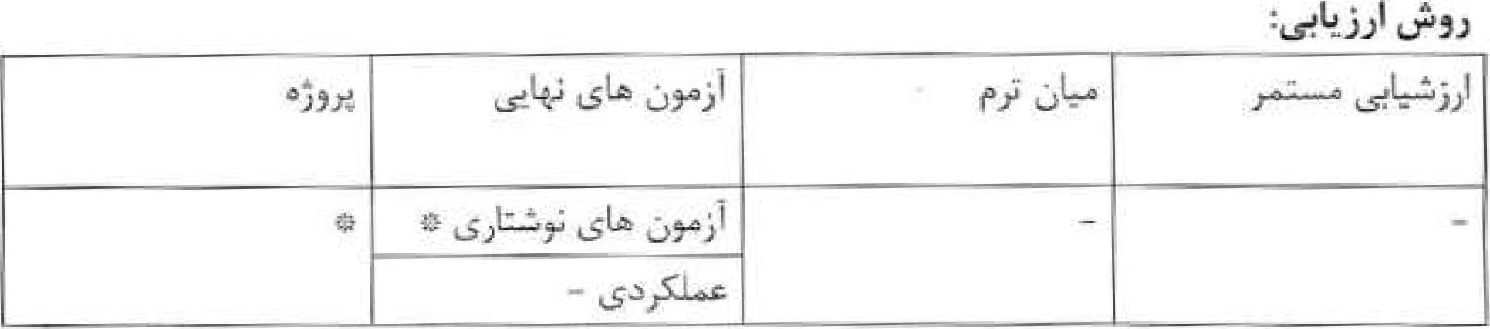
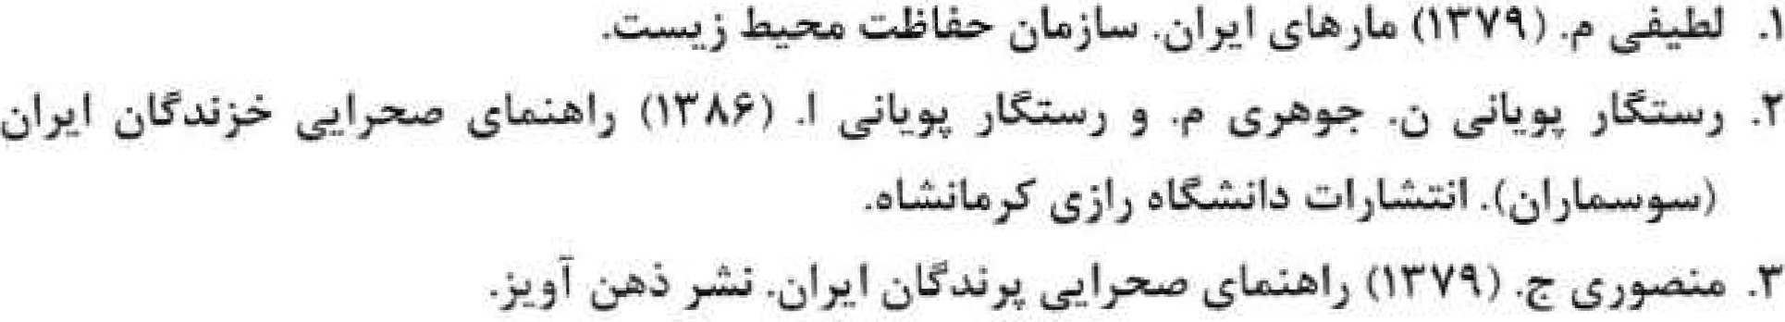
- Anderson, S.C. (1999). The Lizards of Iran. Society for the Study of Amphibians and Reptiles. Oxford, Ohio.
- Arnold, E.N., LA. Burton, and I). ISV. Ovenden (1978). Reptiles and Amphibians of Britain and Europe. Ilarper Collins Publishers.
- Leviton, A. S.C. Anderson, K. Adler, S.A. Minton (1992). Handbook to Middle East Amphibians and Reptiles.
- Nikolski, A.M. (2015). Fauna of Russia and Adjacent Countries.
Published for the National Science Foundation, Washington DC. , by the Israel Program for Scientific Translations, Jerusalem 1963.


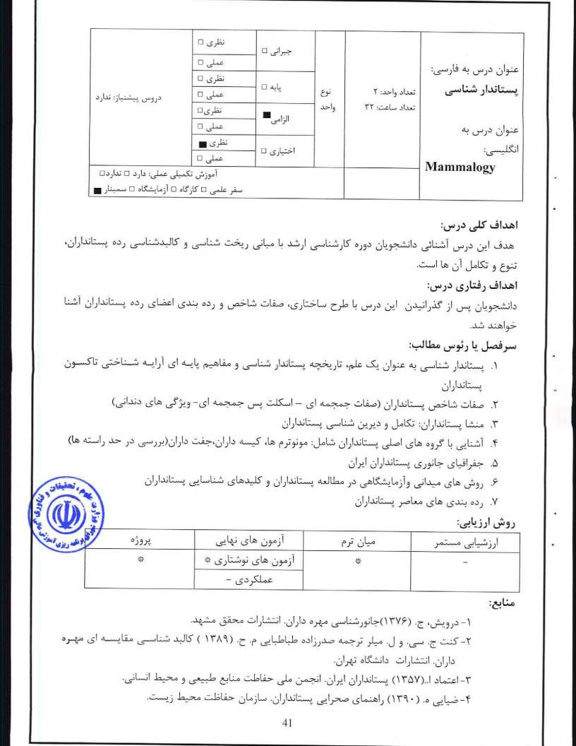
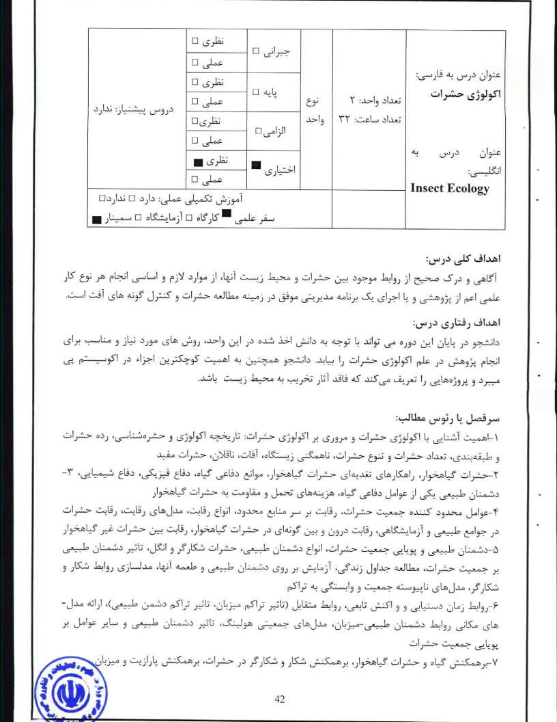
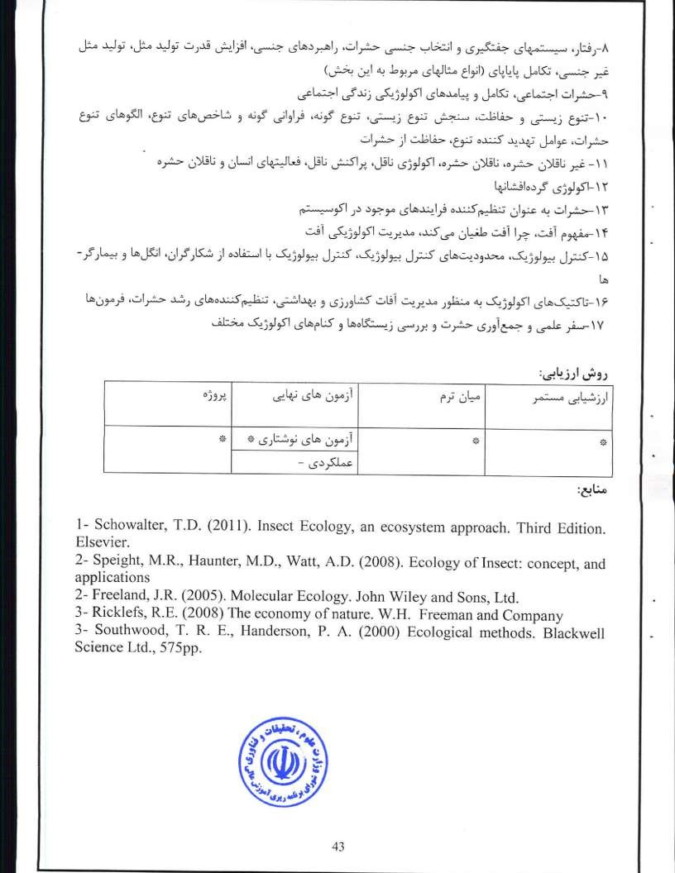
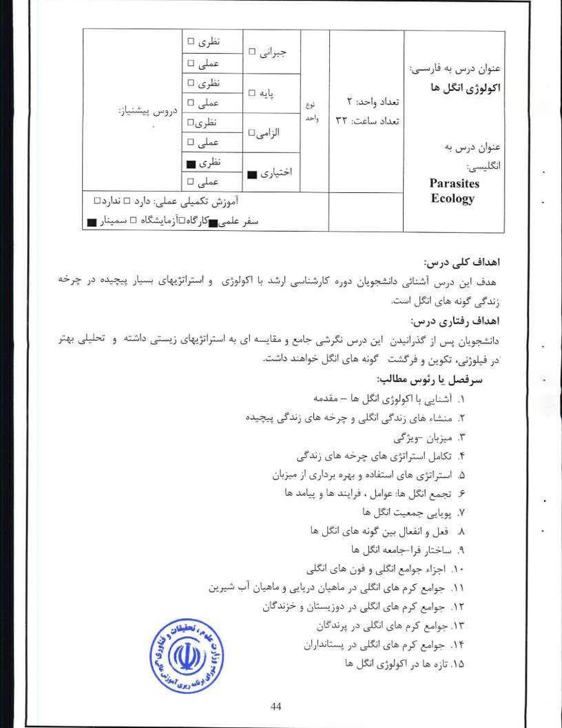

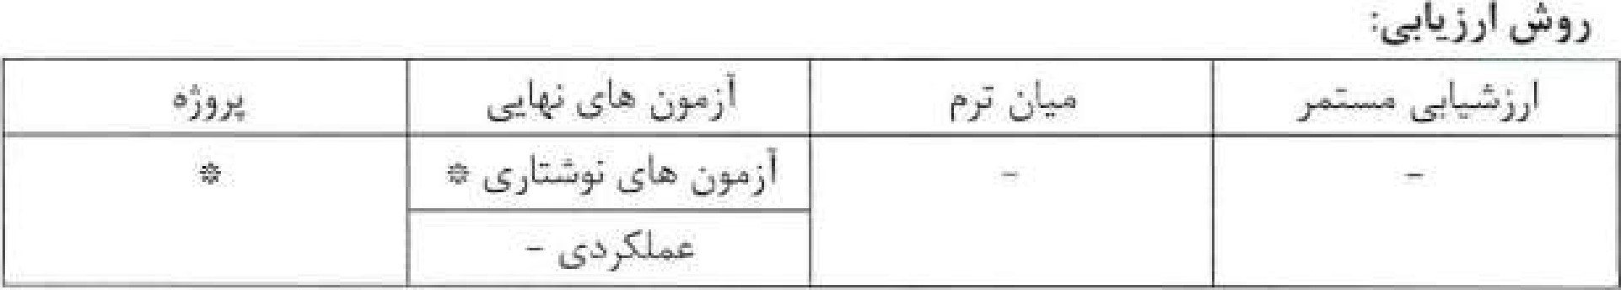
Esch G- W, , A. O. Bush and J, M. Aho (1990) Parasite Communities: pattems and processes. Chapman & Hall, London.
2. MacKenzie A. S, Ball and S. R. Virdee (2000) Instant notes in Ecology. BIOS Scientific Publishers Ltd. Oxford, UK.
- Foulin R. (1997) Evolutionary Ecology of Parasites. Chapman & Hall, London.
- Roberts L. S. and J. J. (2008) Foundation of Parasitology. McGrawHi11 Higher education, Boston-S^{ih} edition.

45

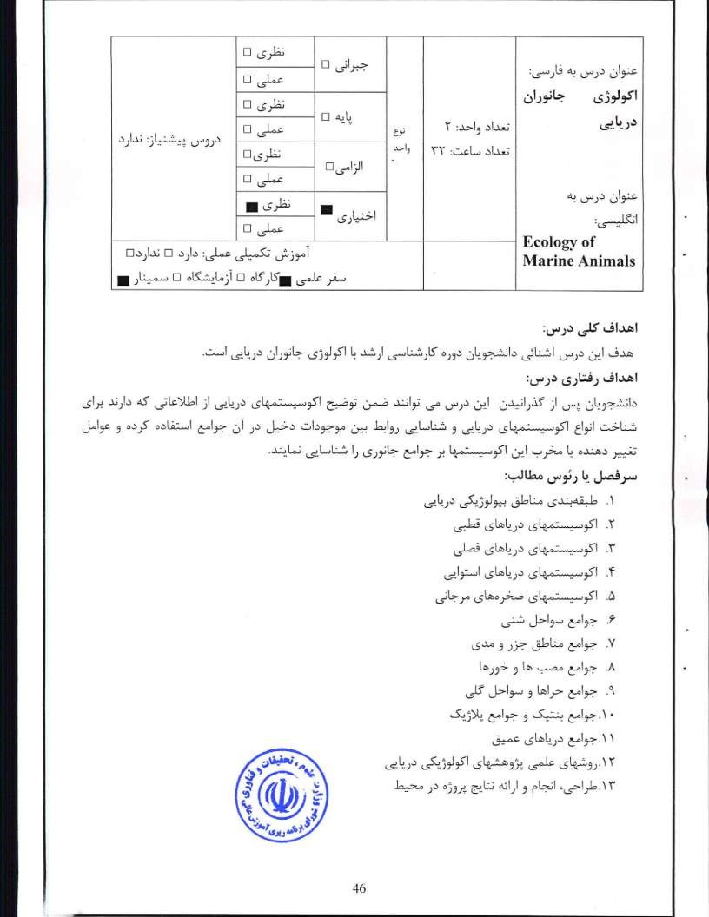

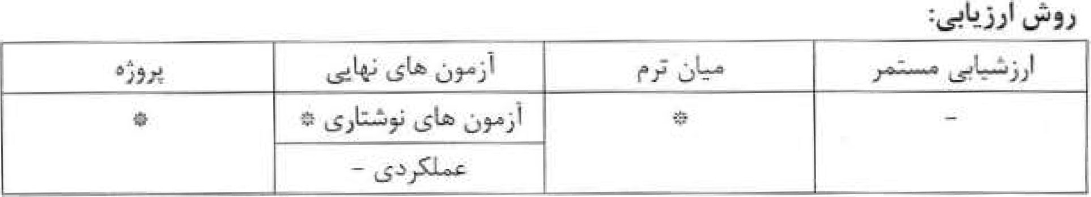
I - Elefiheriou Am, 2013 Methods for the study ofmarine benthos, Hellenic Centre for Marine Research, Crete, Greece and Department of Biology, University of Crete, Greece. ^{s}— Fourth edition.
- Clarke K. R., Warwick, R. Mi, 1994 Changes in Marine communities: an approach to statistical analysis and interpretation Natural Environment Research CounciL UK.
- Bakes G.J. 2007. Quantitative Analysis of Marine Biological Communities Field Biology and Environment. John Wiley & Sons, Inc., Hoboken, New Jersey.
- Wahl M, (2009) Marine Hard Bottom Communities. Springer
- Gray J.S. and Elliott M, 2009. Ecology of Marine Sediments. Oxford University Press.

47

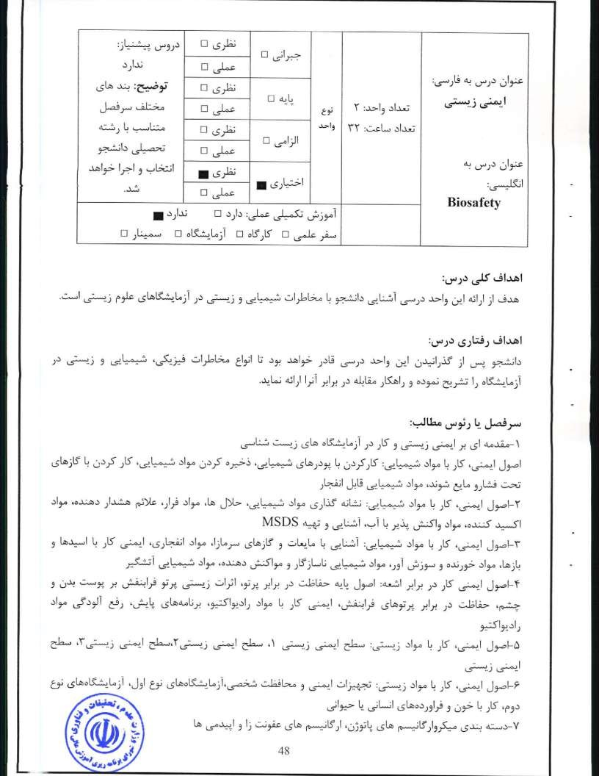
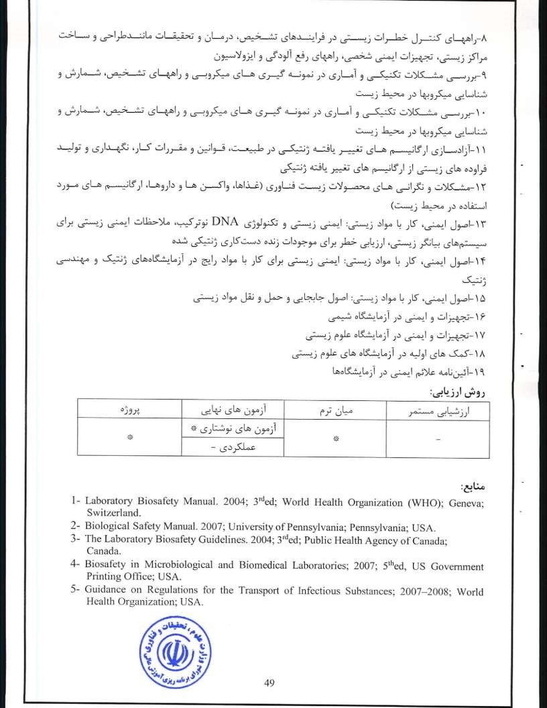
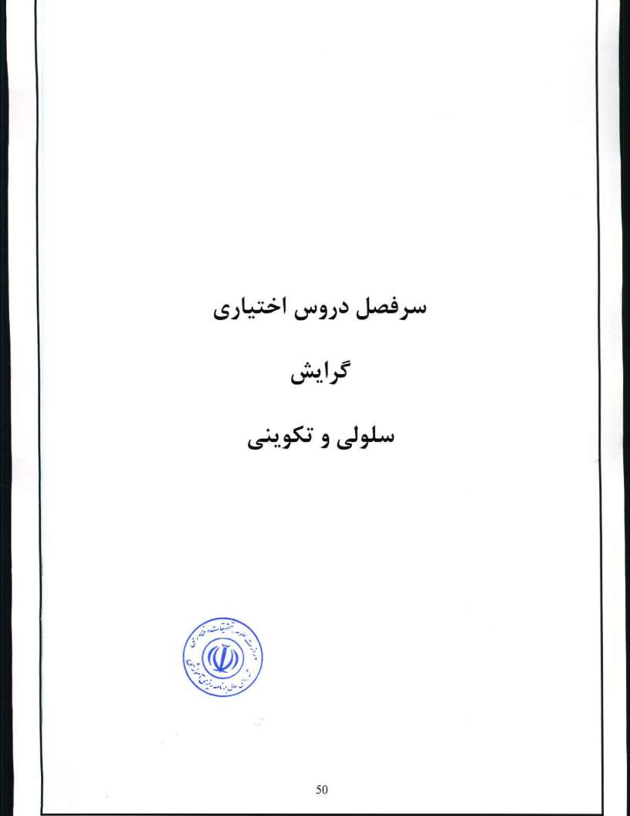
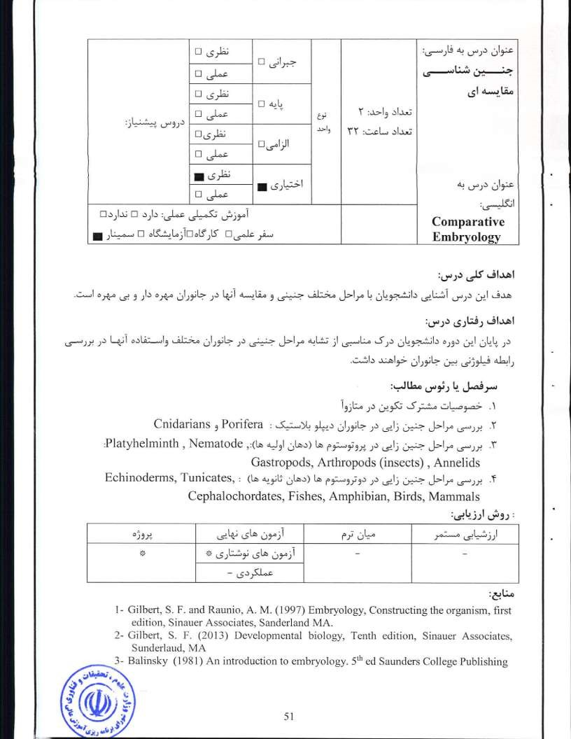
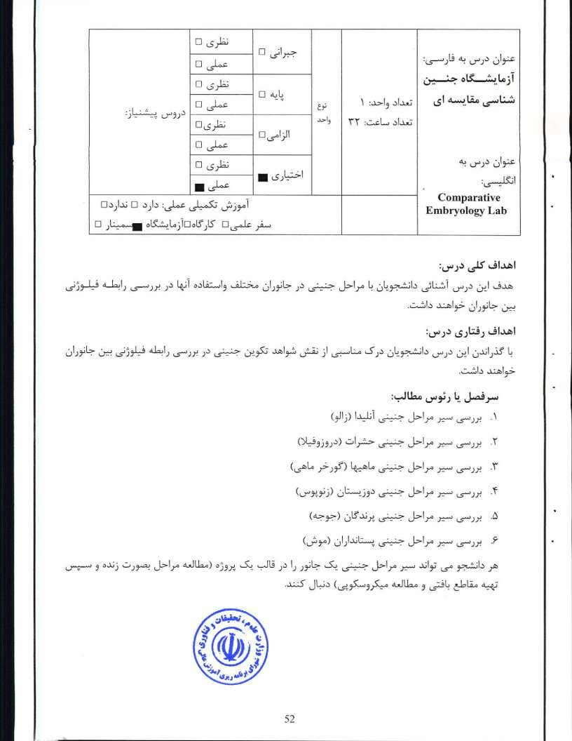

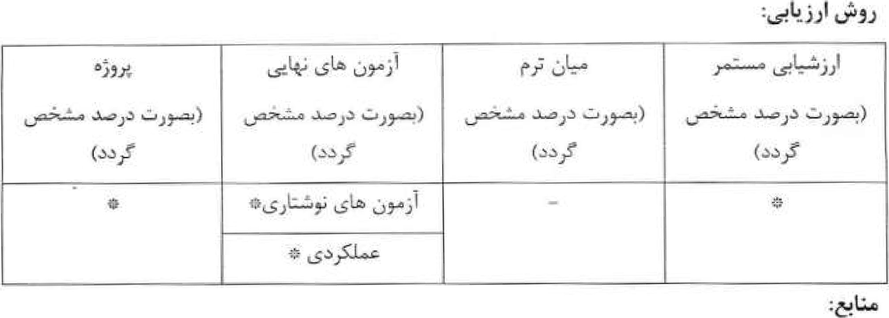
1• Gilbert, S. F. and Raunio, A. M. (1997) Embryology, Constructing the organism, first edition, Sinauer Associates, Sunderland MA.
- Gilbert, S. F. (2013) Developmental biology, Tenth edition, Sinauer Associates,
'Sunderlaud, MA
- Balinsky, B. (1981) An introduction to embryology 51b ed Saunders College Publishing.

53

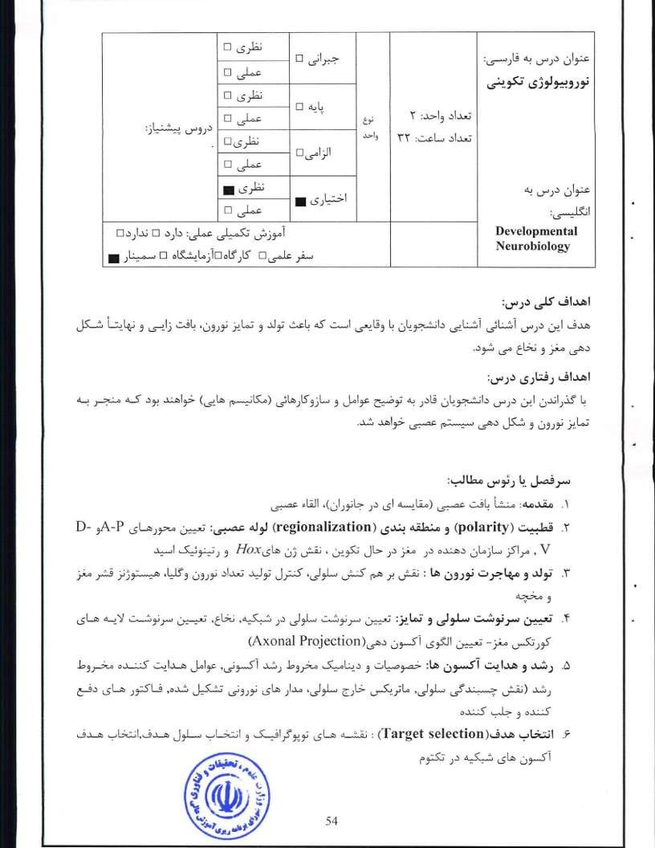
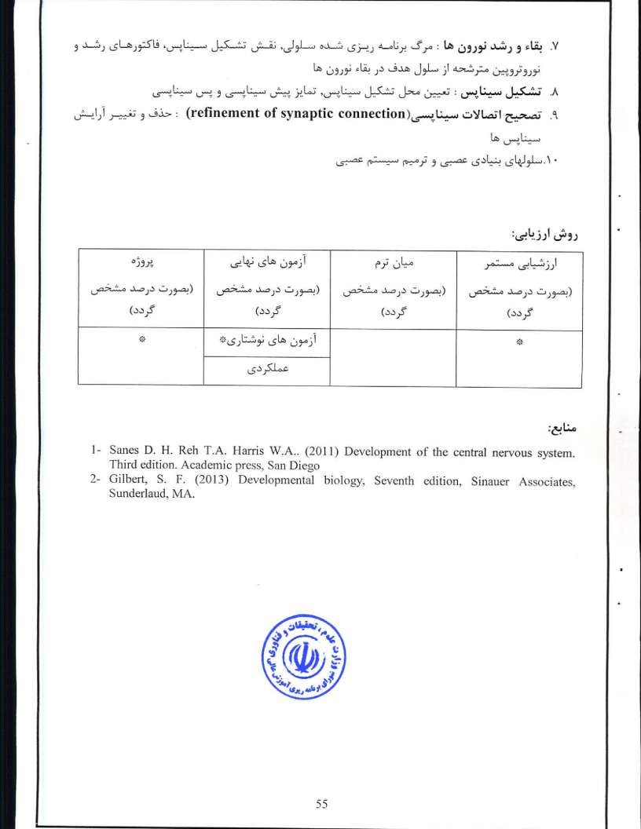
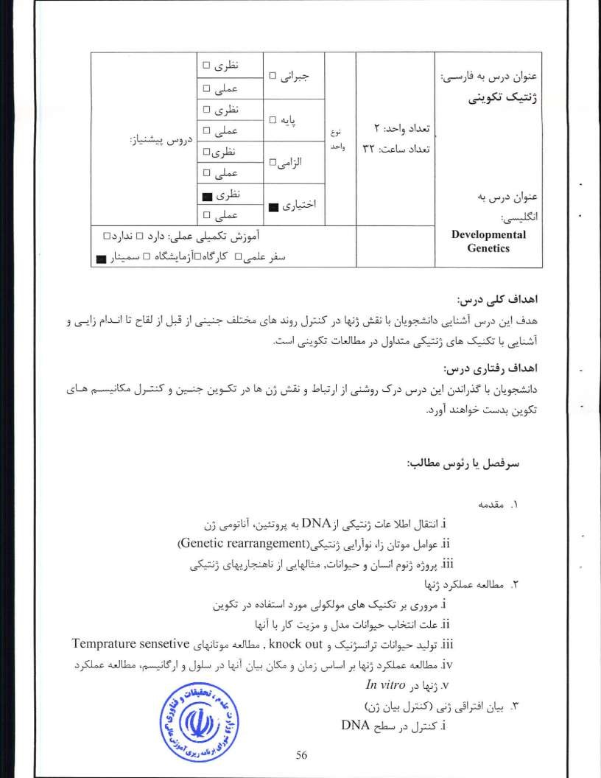
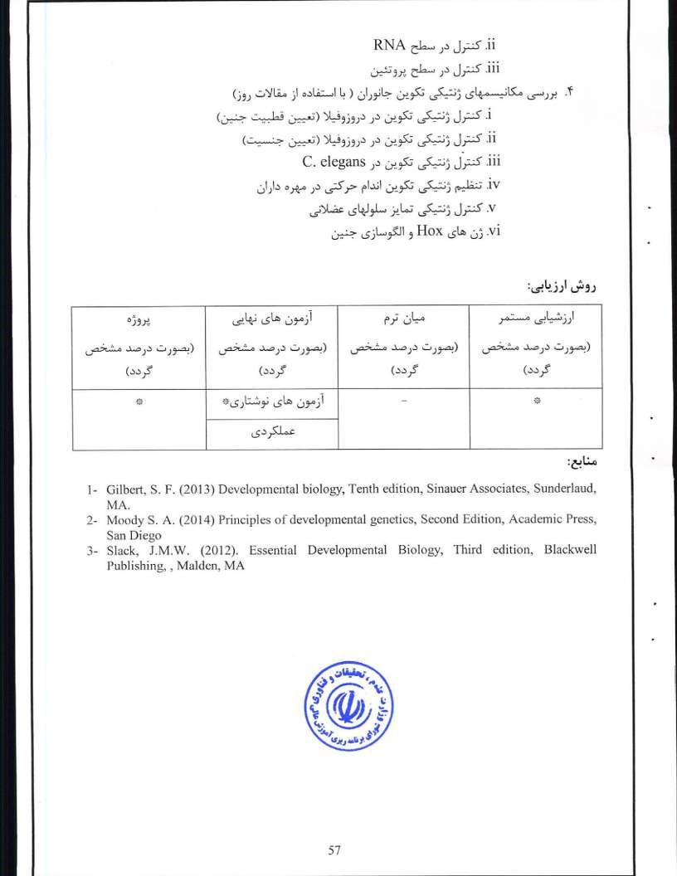
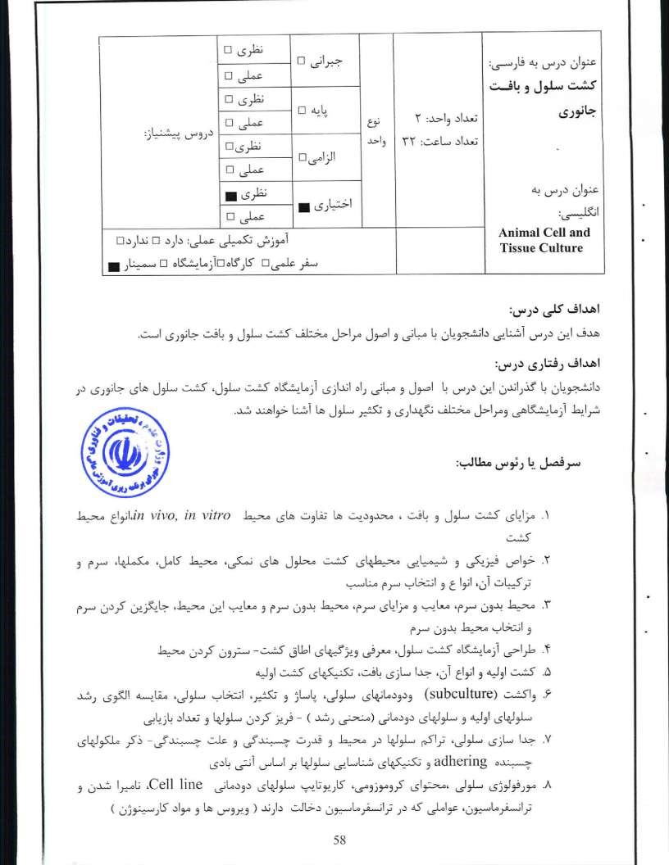
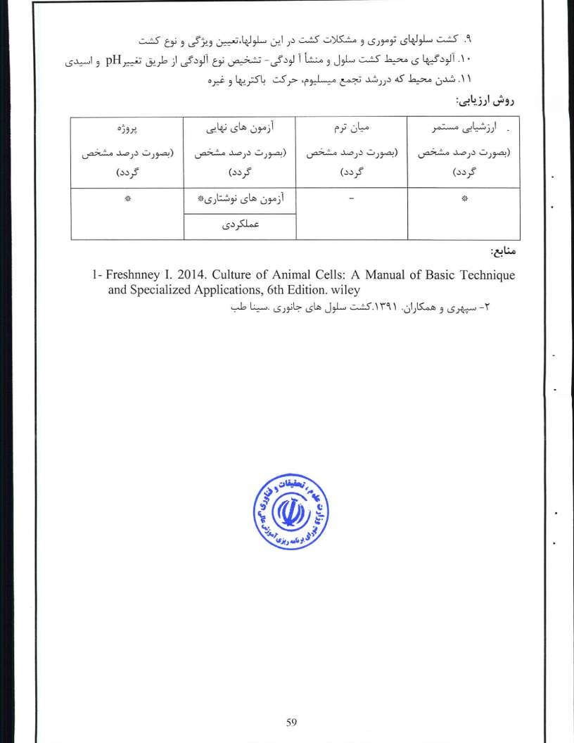
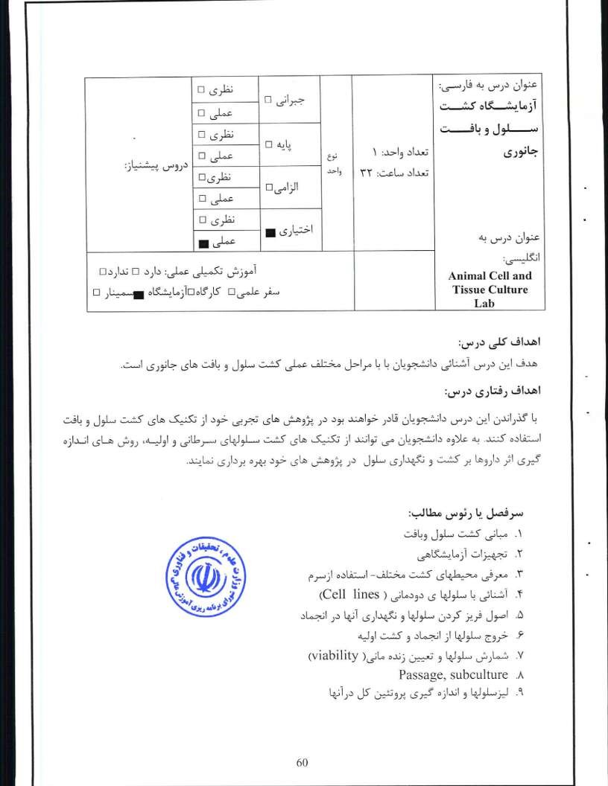

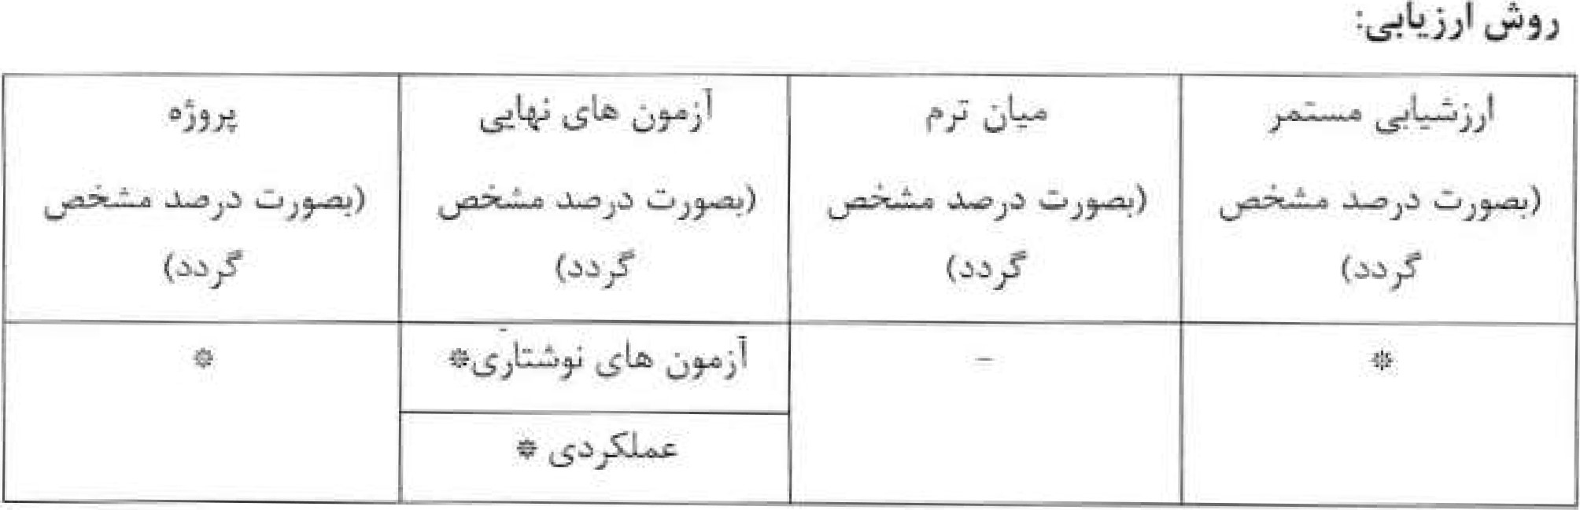
l. Aschner, Me, Sunol, C. and Bal-Pricem, A. 2009, Cell Culture Techniques, Springer.
- Maureen A. Harrison and Ian F, Rae, 2010, General Technique ofCell Culture, Cambridge University Press.
- Freshney I Re, 2014, Culture of Animal Cells: A Manual of Basic Technique and Specialized Applications, Sixth Edition, Wiley.

61

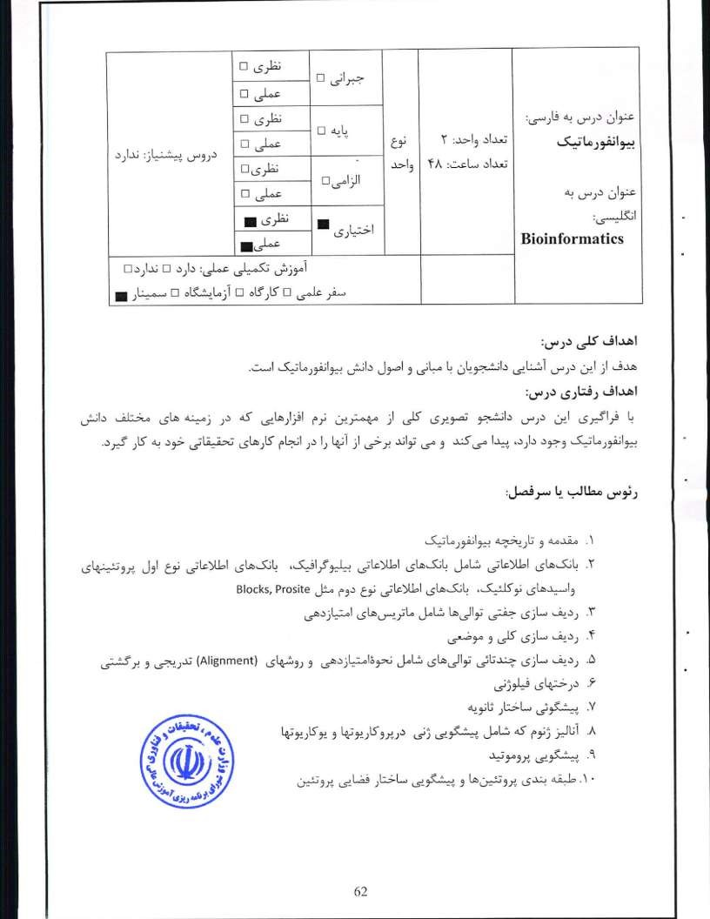

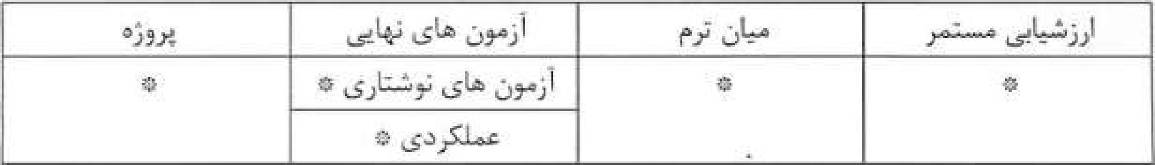
I - Baxevanis, A.D., Ouellette, F.F.F., Bioinforma/ics: A Practical Guide the Analysis of Genes and Proteins, Wiley-Interscience, New York, 2001.
2- Lesk, A.M., Introduction io Bioinformatics, Oxford, New York, 2002. 3- Mount, D. W., Bioinformatics: Sequence and Genome Analysis, Cold Spring Harbor Laboratory Press, New York. 2001.
- Tsai, C.S., BIOMACROMOLECULES Introduction to Function and Informatics, A John Wiley & Sons, Inc., Publication, New York, 2007.

- Tsai, C.S., Biomolecules, Introduction fo Structure, Function and Informatics, A John Wiley & Sons, Inc., Publication, New York, 2007.

63

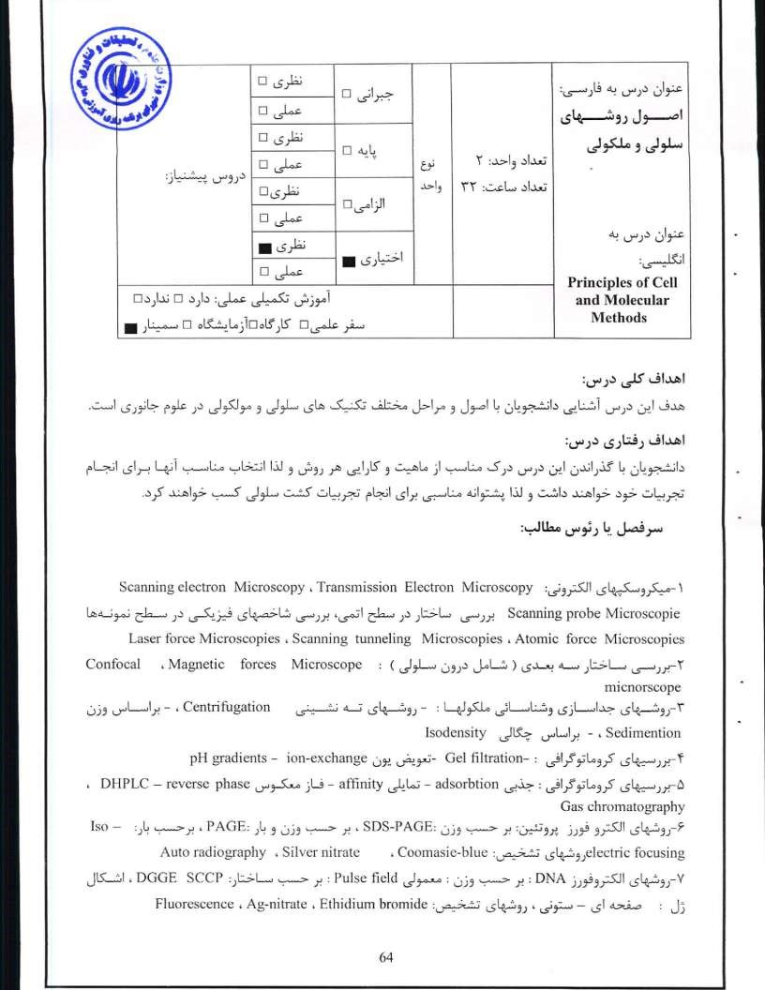
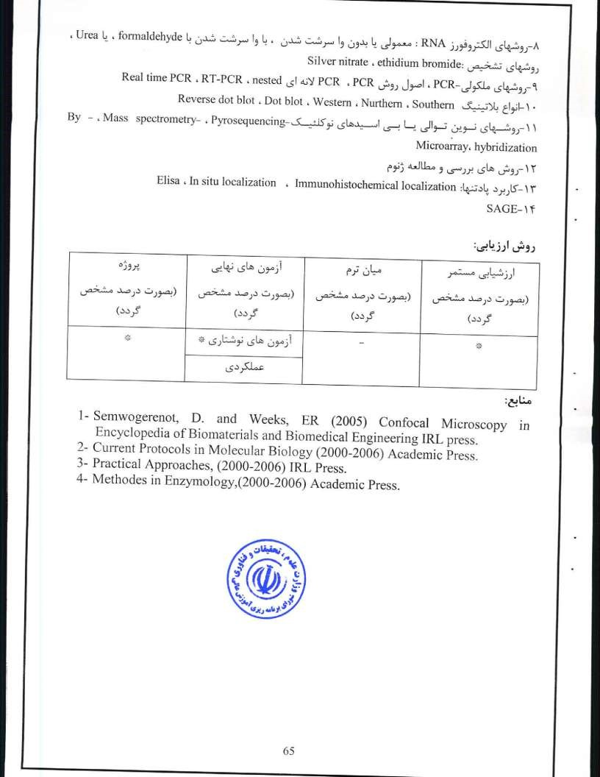
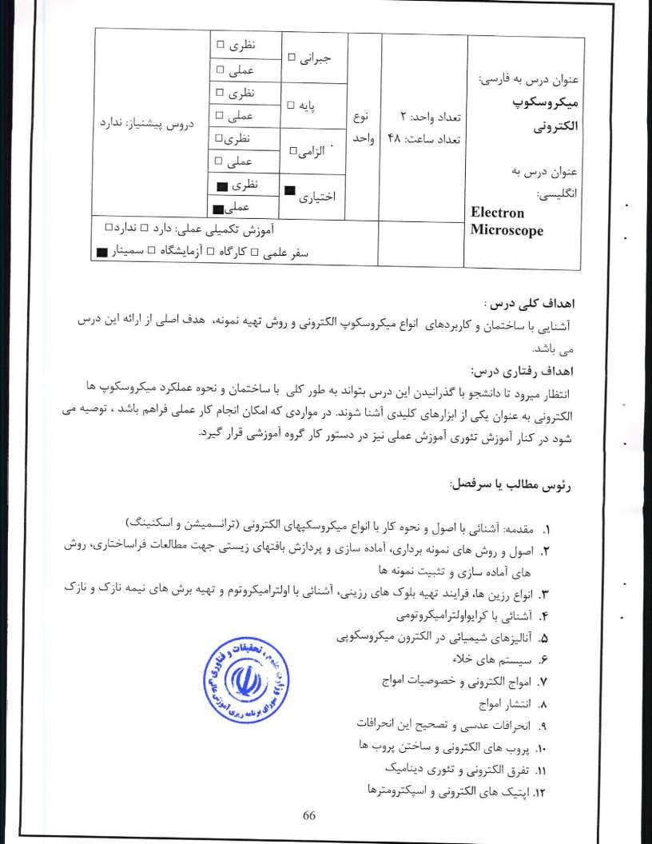

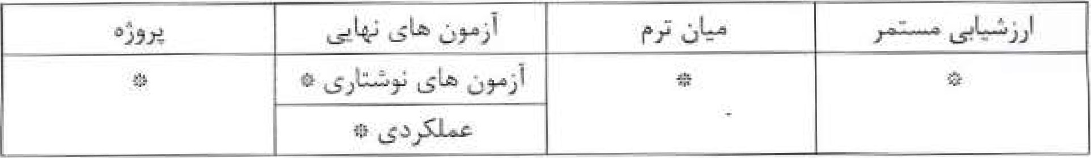
Ayache .L, Beaunicr L, Boumendil B.t Ehret Ct., and Laub, D. , 2010, Sample Preparation, Handbook for Transmission Electron Microscopy: Methodology, vol. l. Springer.
2- Ayache L, Beaunier L.. Boumendil 13., Ehret and Laub, D. , 2010, Sample Preparation.
Handbook for Transmission Electron Microscopy:Techniques, vol. 2.. Springer.
3- Bhushan B., 2011 , Scanning Probe Microscopy in Nano science and Nano technology, Springer.
4- Kuot .1., 2007, Electron Microscopy, Methods and Protocols. Humana Press. 5- Pawley 2012, I-kwndbook of Biological Confocal Microscopy, Springer.
- Rogers K., 2006, The Usborne Complete Book of the Microscope

- Williams D, B.200{i'I Transmission Electron Microscopy: A Textbook for Materials Science, Springer

67

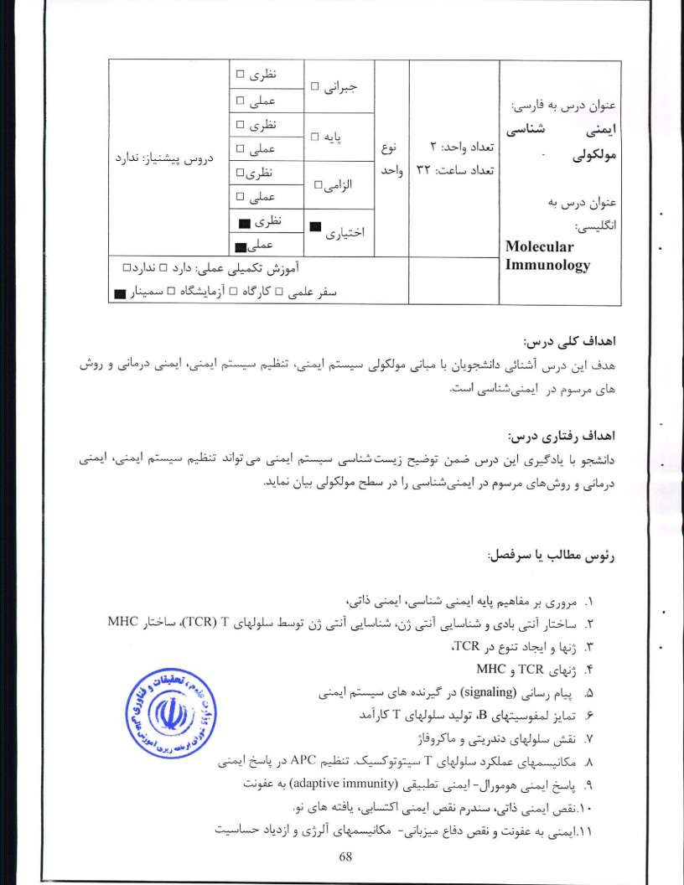
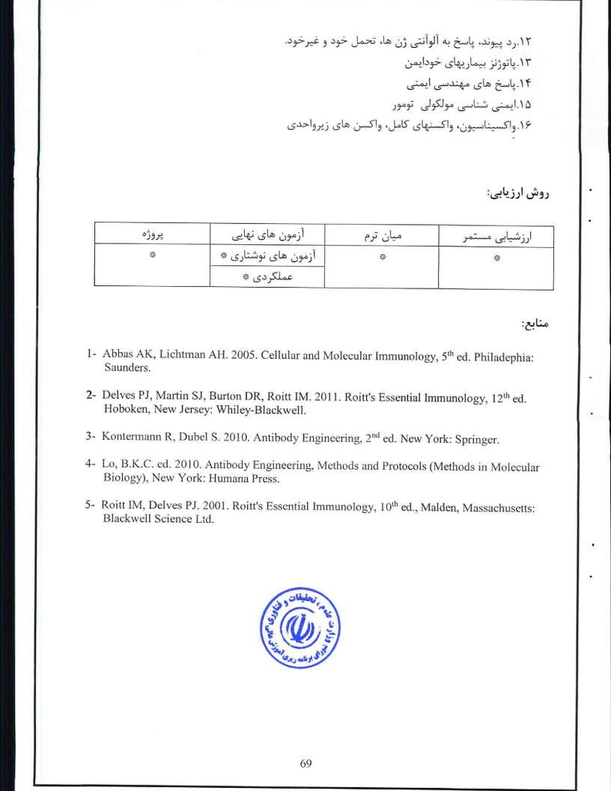
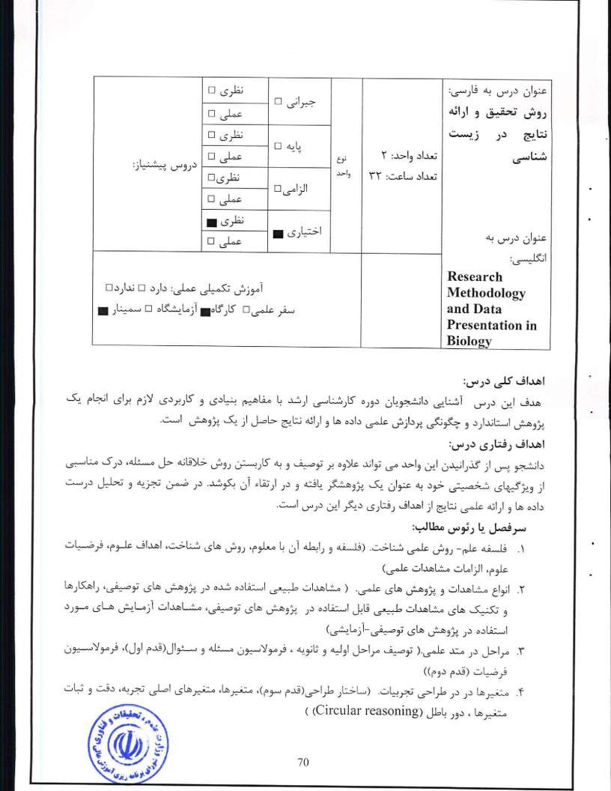
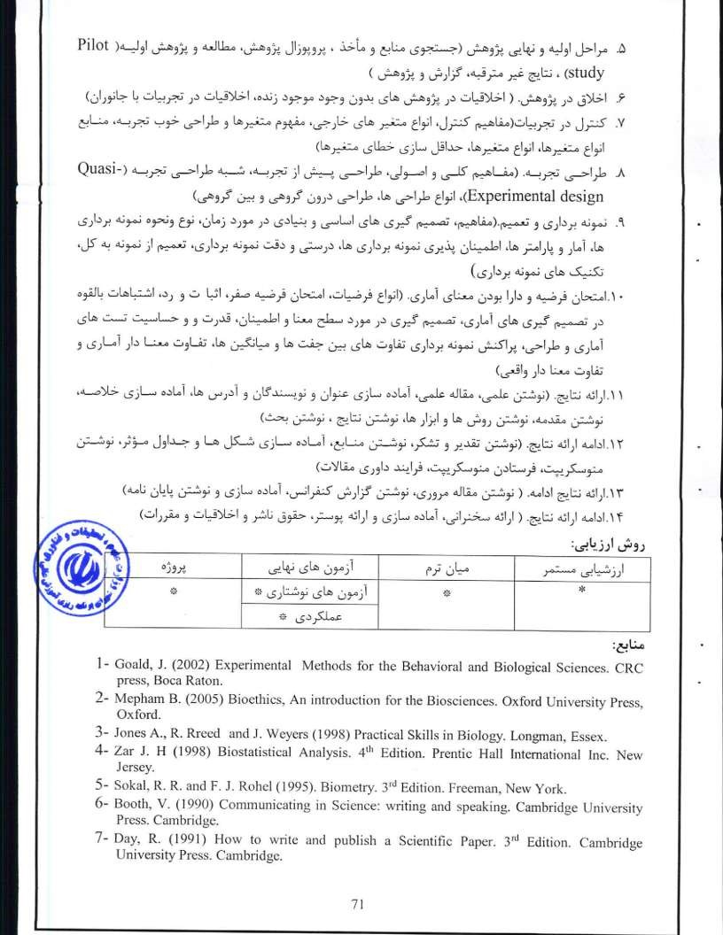
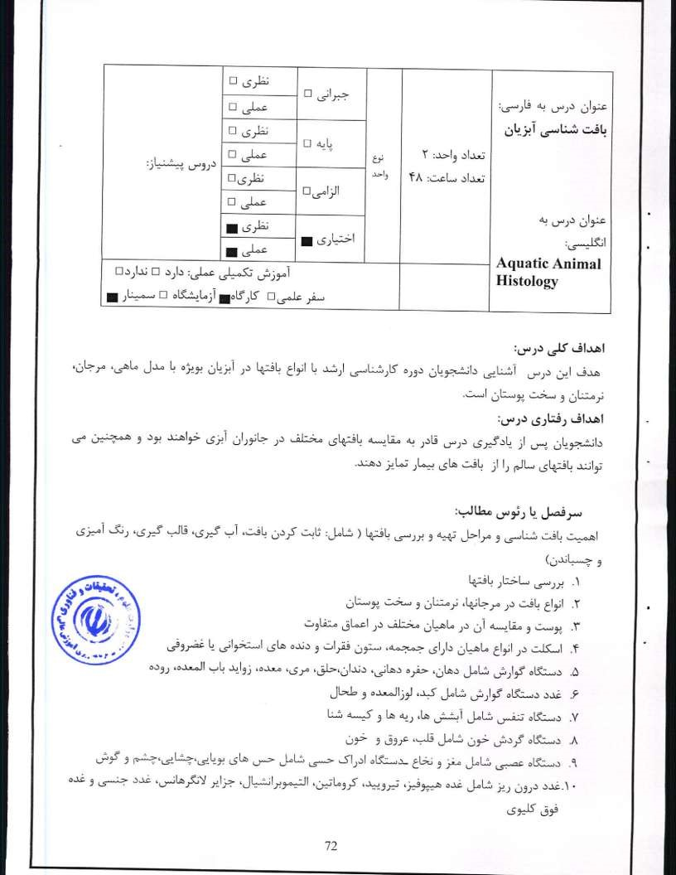

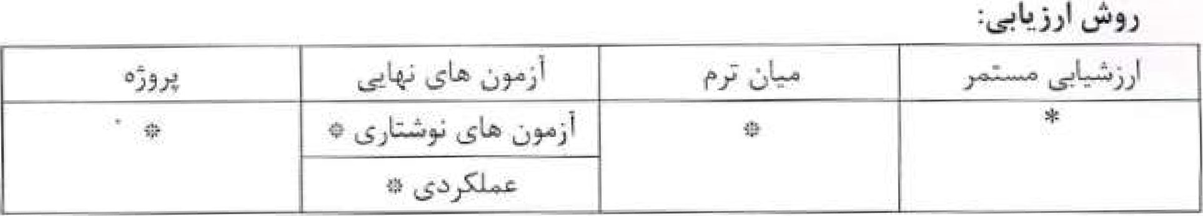
l- Johnson I^{S} ,T. (1980) Histology ofthc Blue Crab, Callinectes sapidus: a model for the Decapoda, Praeger Publishers Inc.
- Galloway S. B., Work T. NL, Bochsler V, SAS Harley R. A., Kramarsky•Winters E.,
McLaughlin S. M., Meteyer C. Morado J. F., Nicholson J. H.t Parnell P. G., Peters E, Ct.,
Reyllolds T. L.. Rotstein D. S., Sileo L, and Woodley C. M. (2007) Coral Disease and Health Workshop: Coral Histopathology Il. NOAA Technical Memorandum NOS
56 and NOAA Technical Memorandum CRCP 4. National Oceanic and Atmospheric Administration, Silver Spring,
- Genten Terwinghe E. and A. Danguy (2009) Atlas of Fish Histology, CRC press,
- Howard D,w., E.J. Lewis B,J. Keller and C.S. smith (2004) Histological techniques for marine bivalve mollusks and crustaceans, NOAA Technical Memorandum 5, National Oceanic and Atmospheric Administration, Silver Spring.
- Kim Y., K. A. Ashton-Alcox and Ei N. Powell (2006) Histological Techniques for Marine Bivalve Molluscs: Update. NOAA Technical Memorandum 2t National Oceanic and Atmospheric Administration, Silver Spring.

73

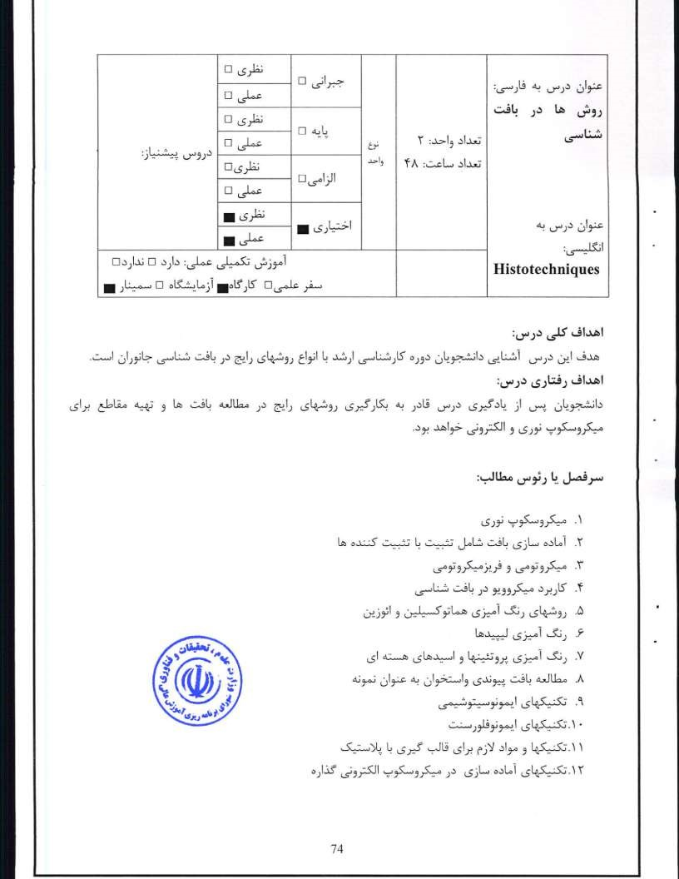

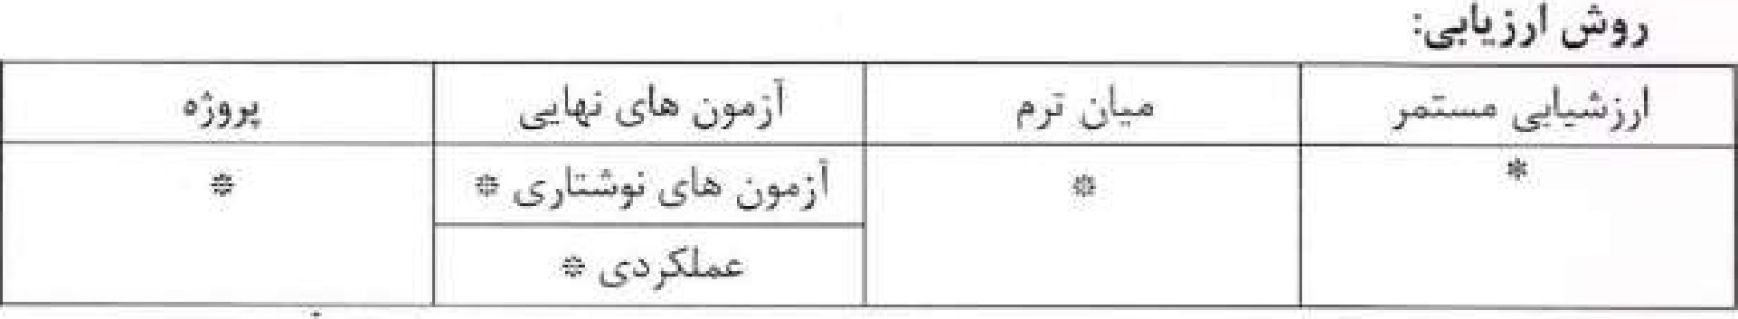
Ayache JA, Beaunier 1..„, Boumendil B., Ehret G., and Laubt De 2010, Sample Preparation. I landbook for Transmission Electron Microscopy: Methodology, vol. l. Springer.
2- Ayache Beaurller Boumendi_l B., Ehrct Cir, and Laub, D. 2010, Sample Preparation, Handbook for Transmi•sion Electron Microscopy:Techniques, vol. 2.. Springer.
3- Bancroft, J. D. and M, Gamble (2007) Theory and Practice of Histological Techniques, 6th Edition, Churchill Livingstone
- American Society for Clinical Pathology.
- Carson, Fi L. and C. (2009) Histotechnology: A Self-instructional Text 3rd Edition, American Society for Clinical Pathology.
- Dykstra M. L (1993) A Manual of Applied Techniques for Biological Electron Microscopy Springer.
- Giberson R. T. and R. S. Demaree Jr. (2001) Microwave Techniques and Protocols, Humana press.
- Kiernan J. (2000) Histological and histoehemieal methods 3 ¹⁰ Edition. CRC Press.
- Smith K. C., Oloff C. Mi and L E. Kazarian (1983) Cryomicrotome Applications:
Techniques for the Study of Skeletal Materials, Defense Technical Information Center. 10-Suvarna S., C. and J. D. Bancroft (2012) Bancroft's Theory and Practice of
Histological Techniques. 7th Edition, Churchill Livingstone.

75

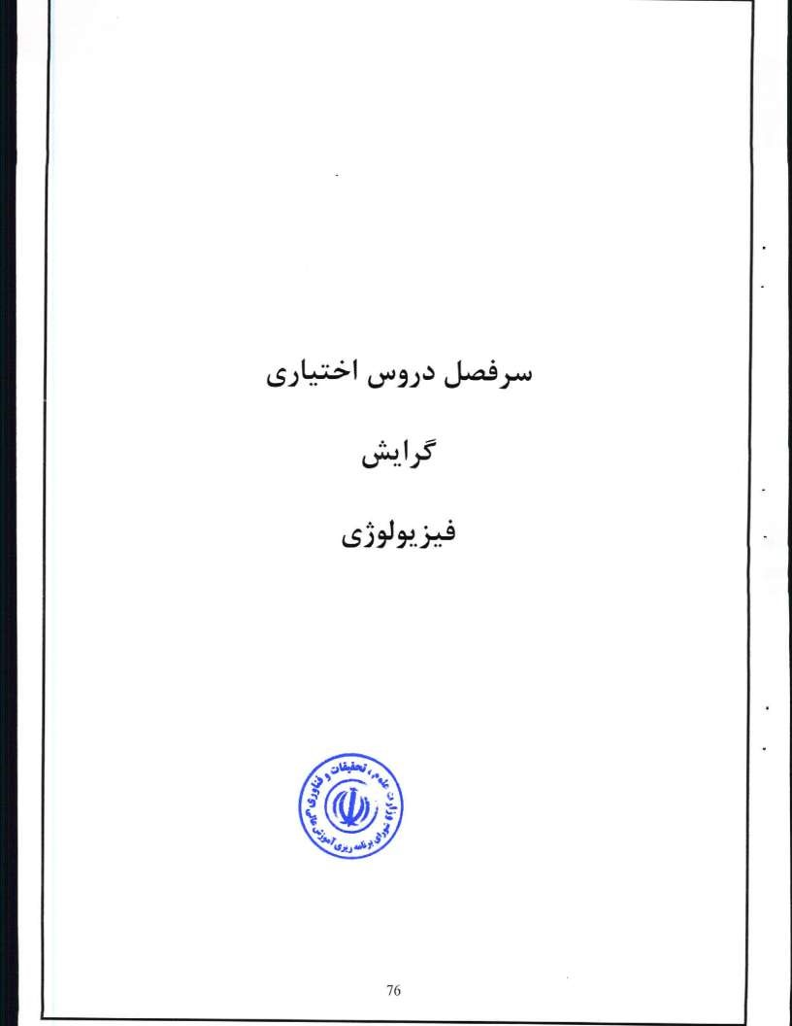
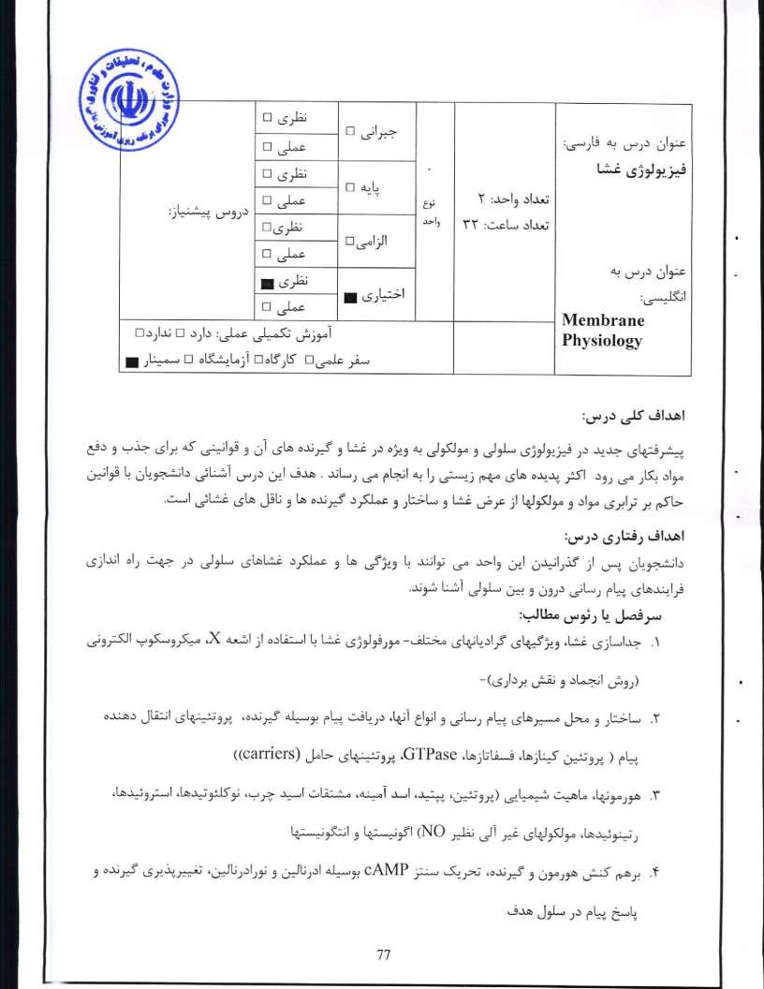
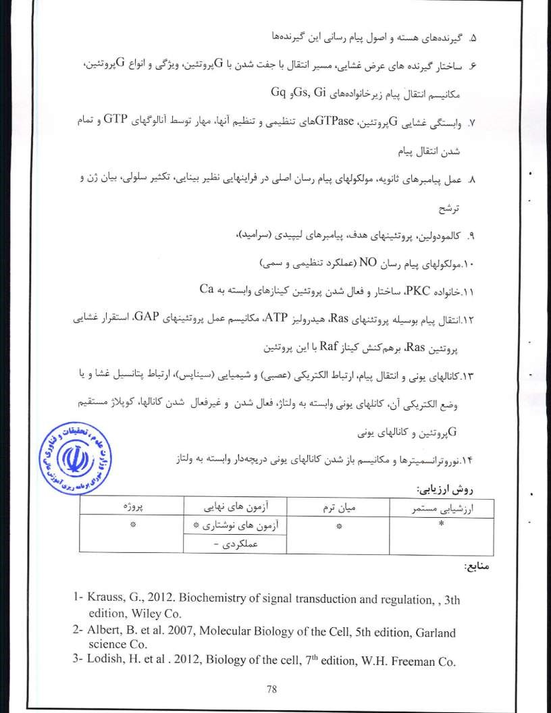
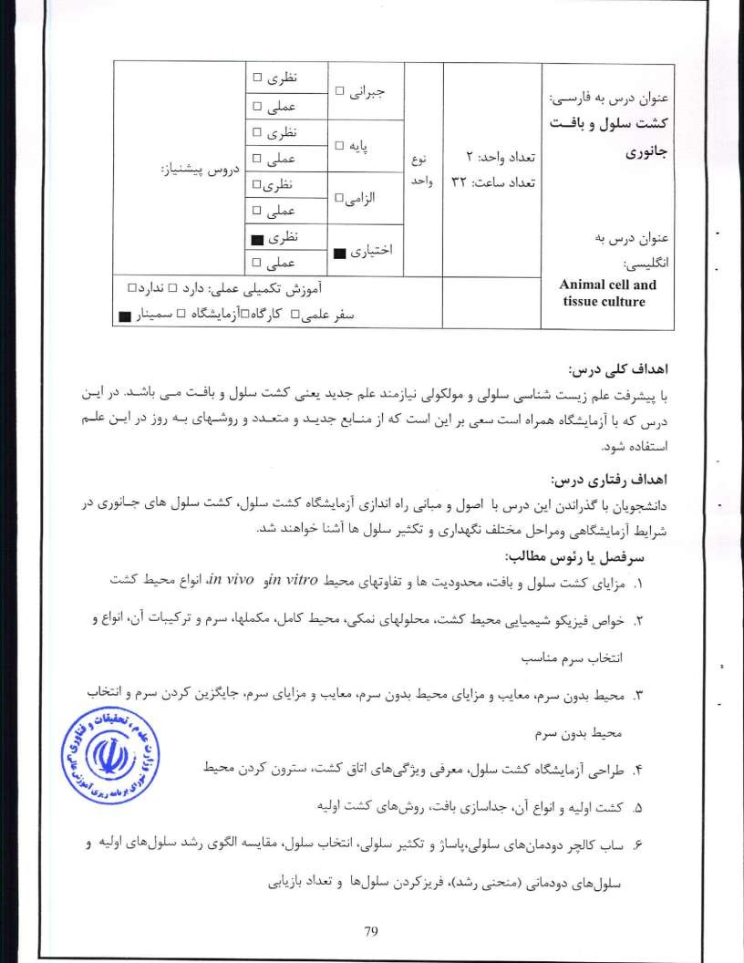
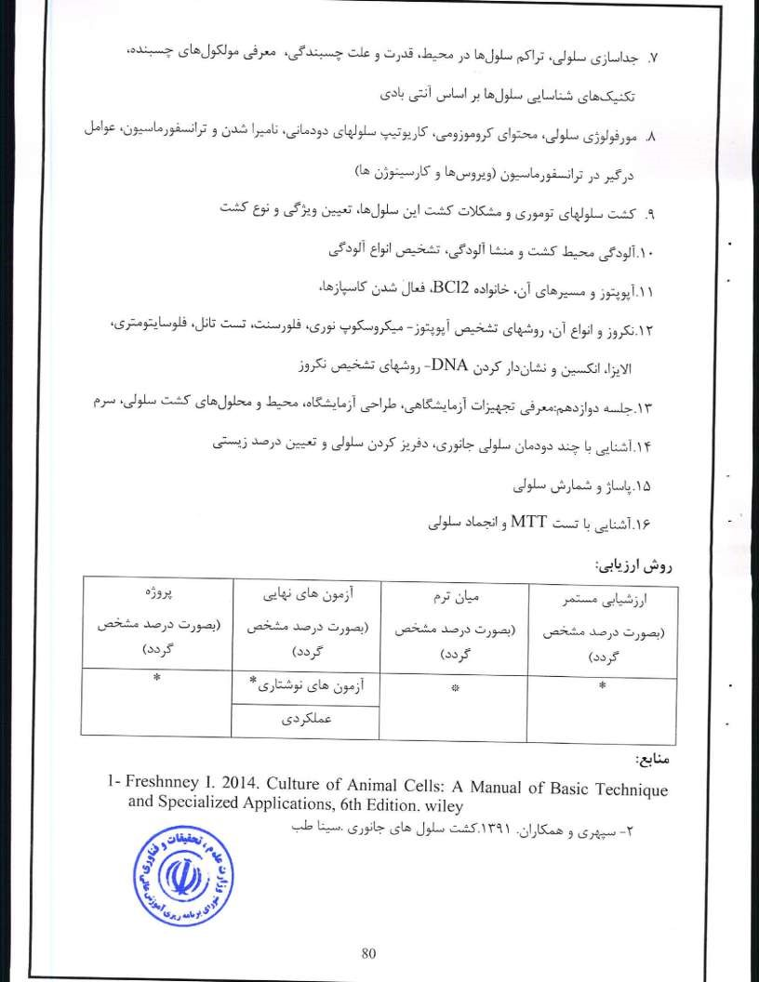
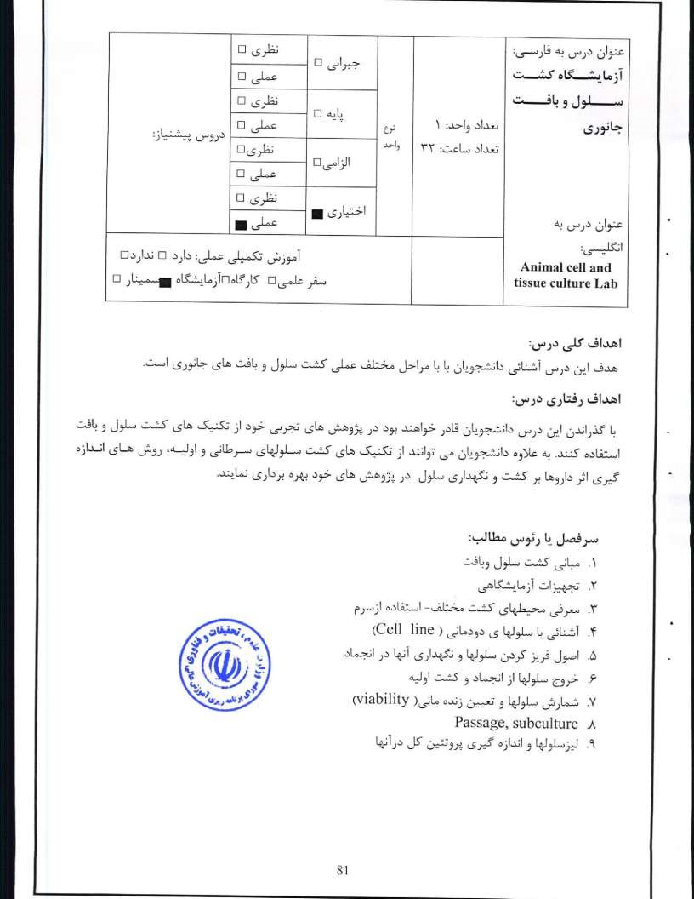

  (oof |  |  | 
 | 
 | 
l. Aschner, M., Sunol, C. and Bal-Priccm, A. 2009, Cell Culture Techmques, Springer.
- Maureen A Harrison and Ian F. Rae, 2010, General Technique of Cell Culture, Cambridge University Press.

- Freshneyl Re, 2014, Culture of Animal Cells: A Manual of Basic Technique and Specialized Applications, Sixth Edition, Wiley,

82

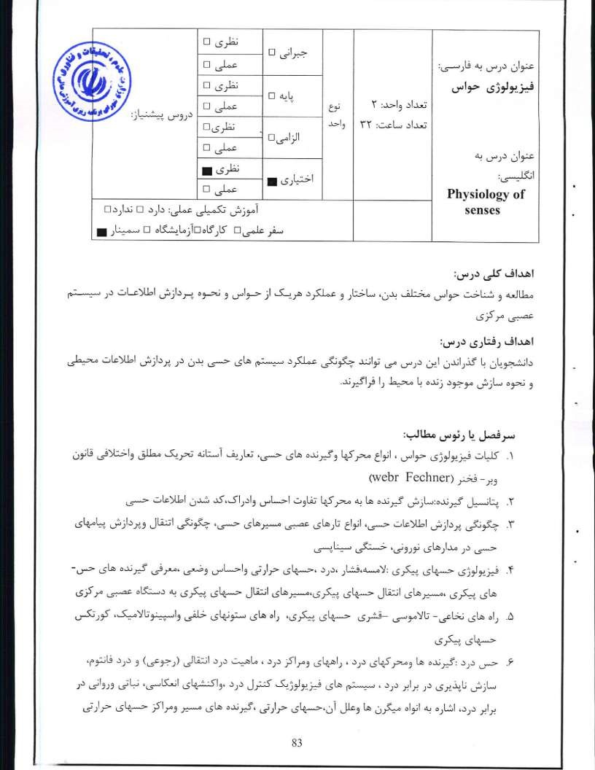
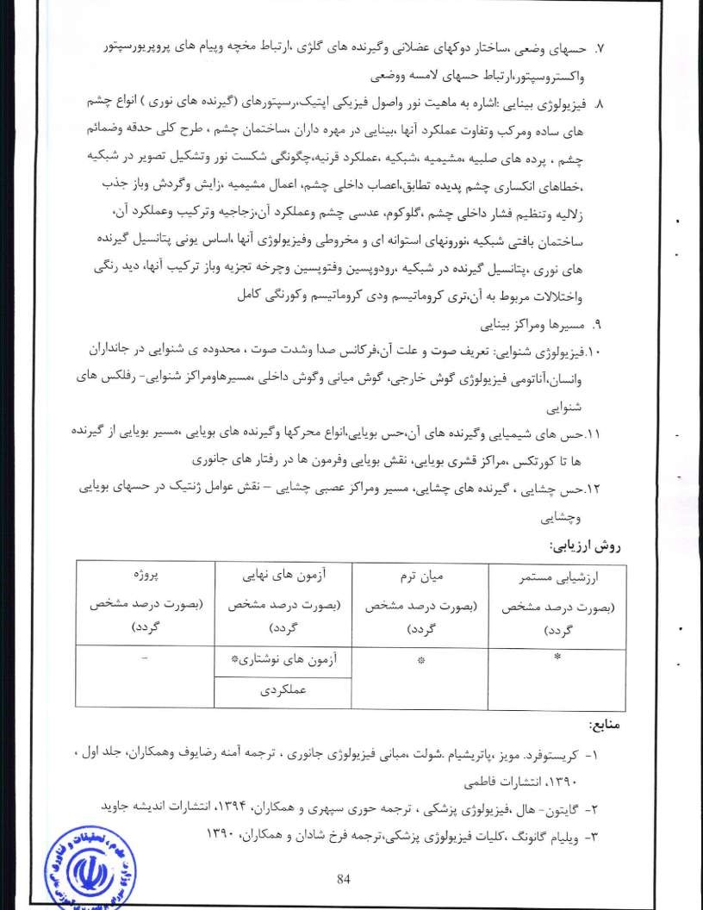
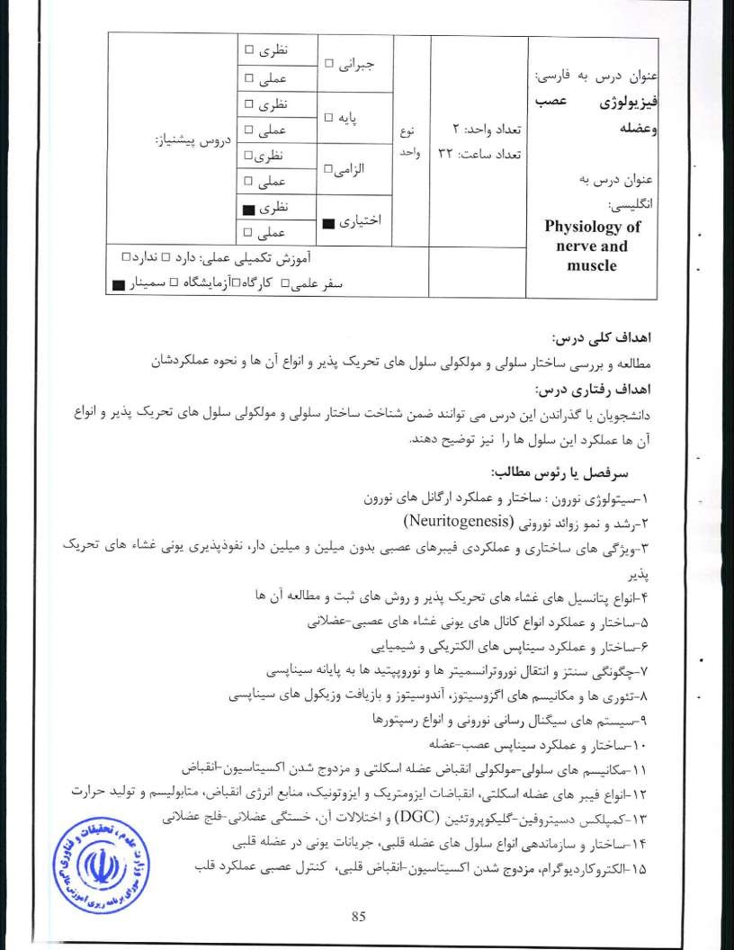
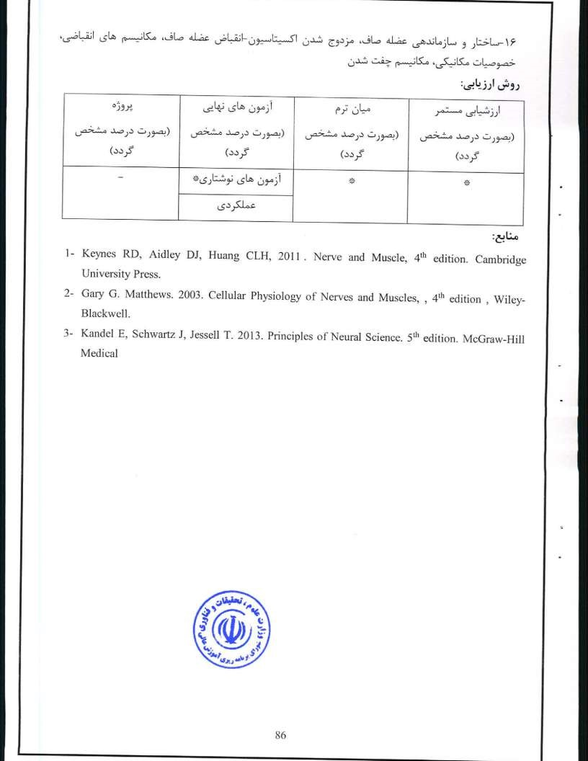
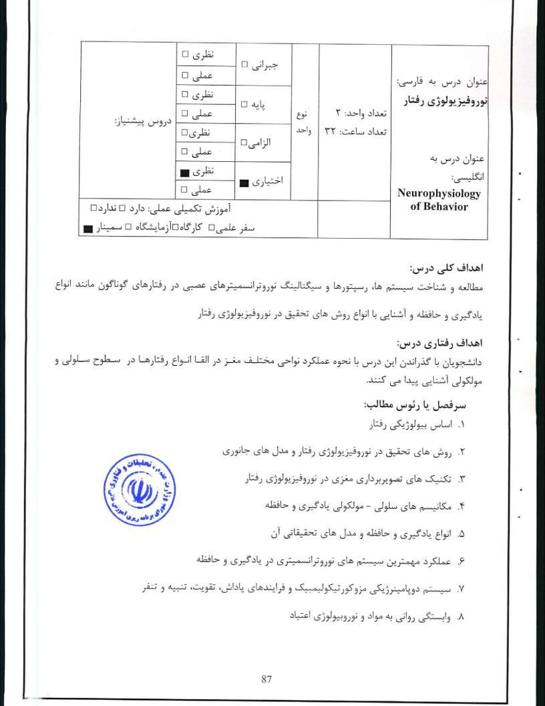
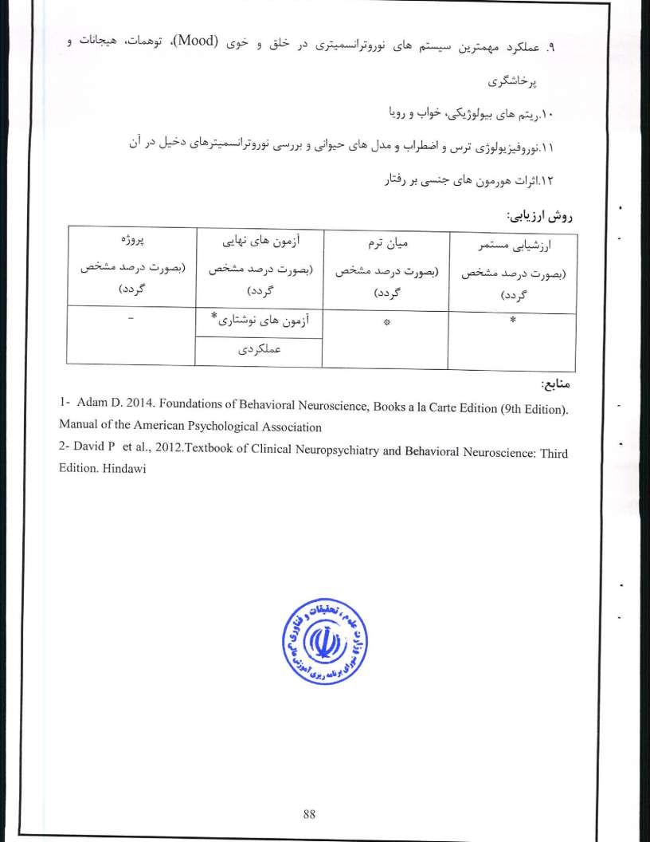
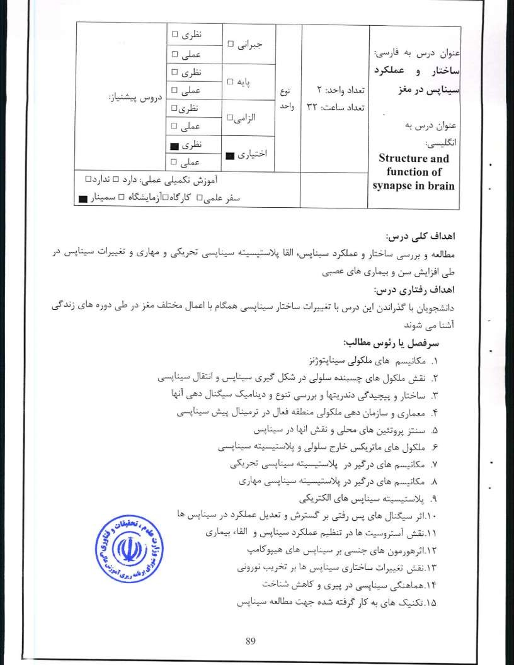

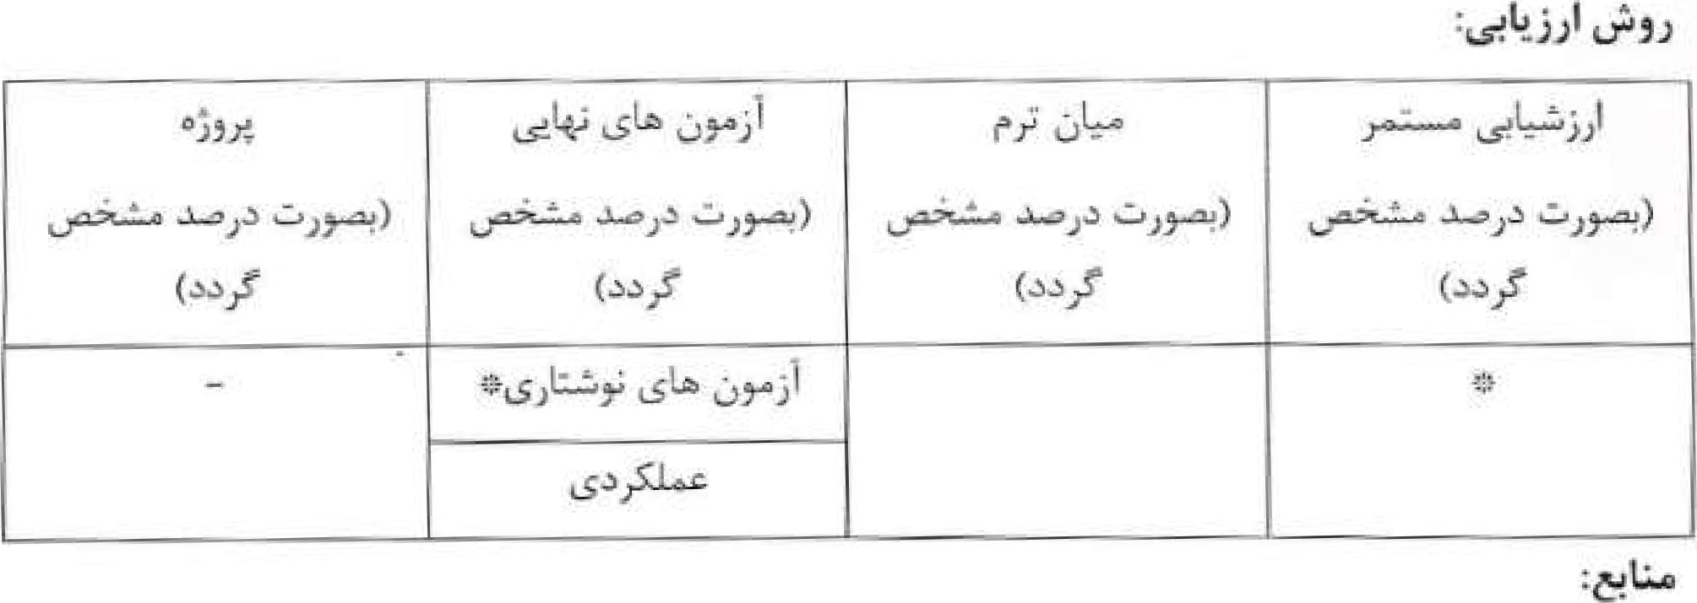
l- Hell JW, Ehlers MD. 2008. Structural and Functional Organization of The Synapse. Springer.
2- Pickel V, Segal M. 2010.The synapse: structure and function. Cornell University.

90

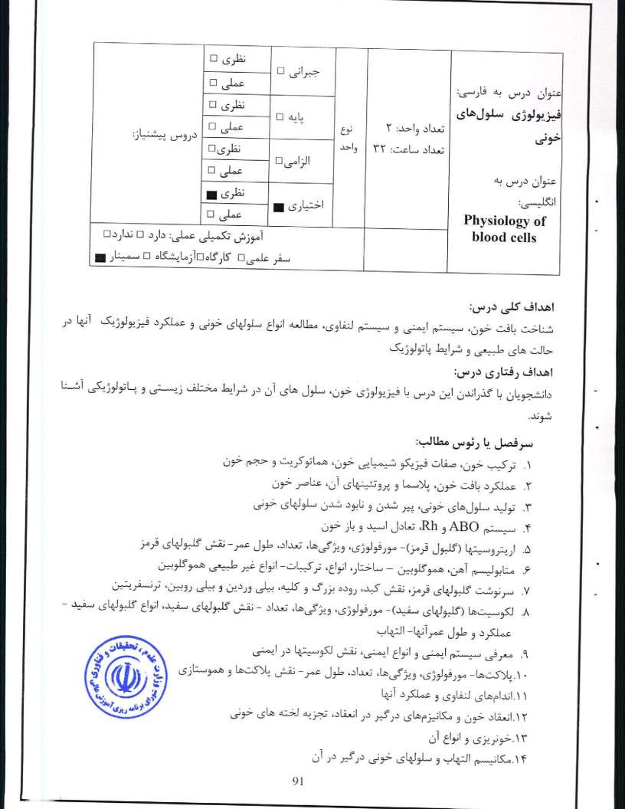
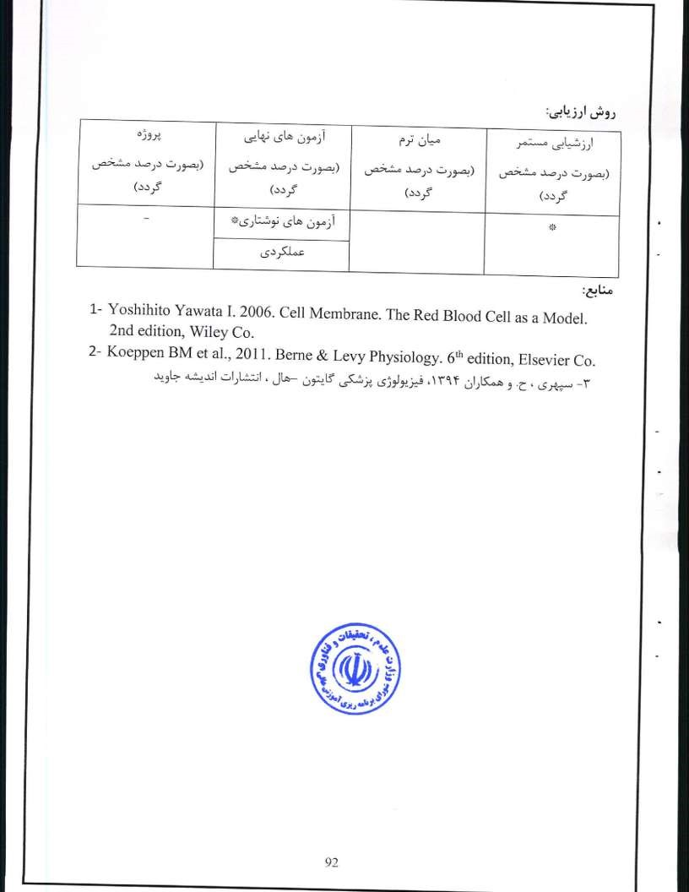
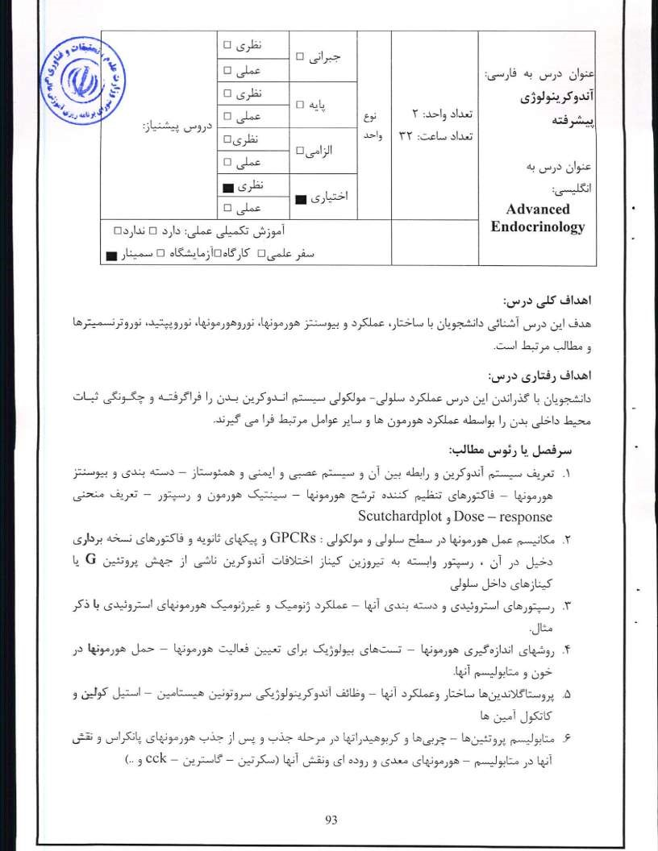
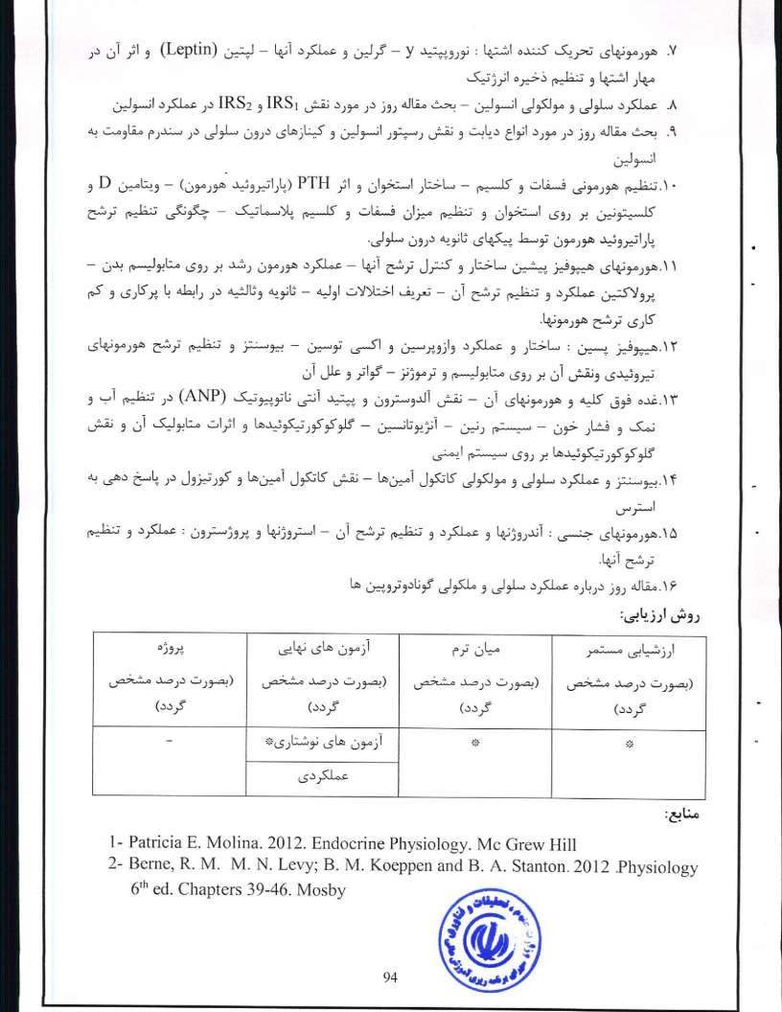
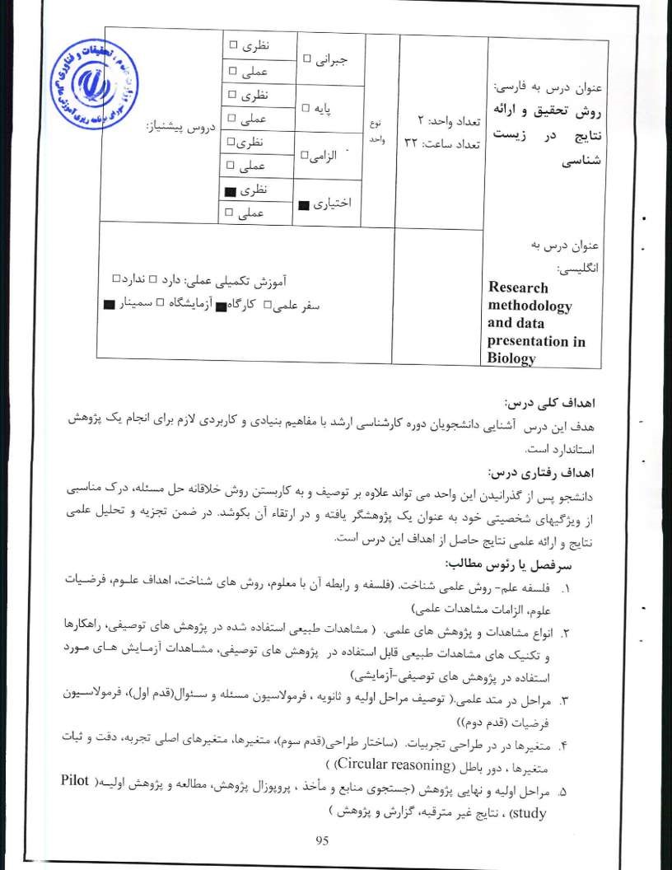
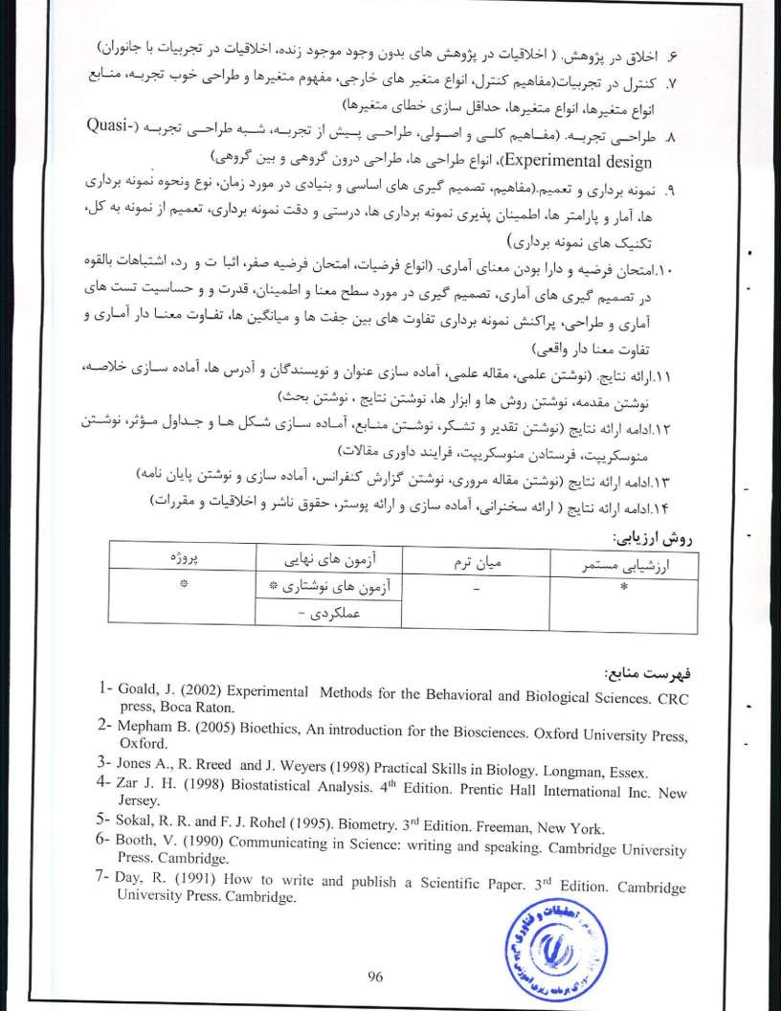
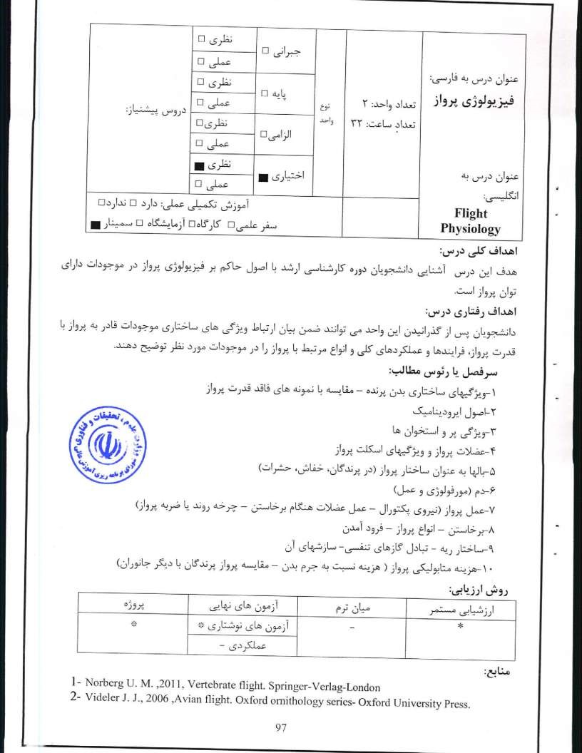
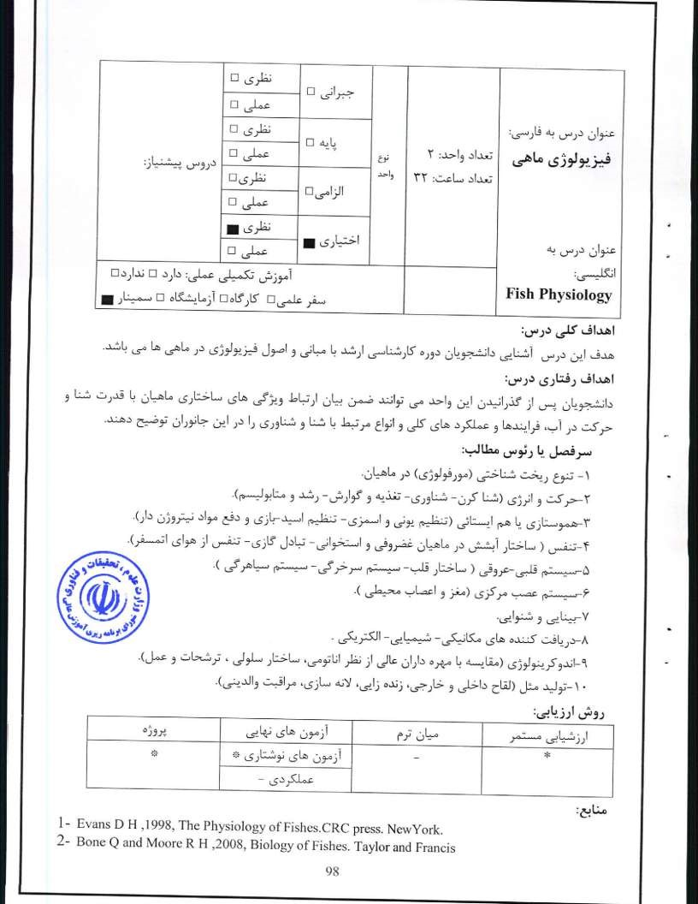
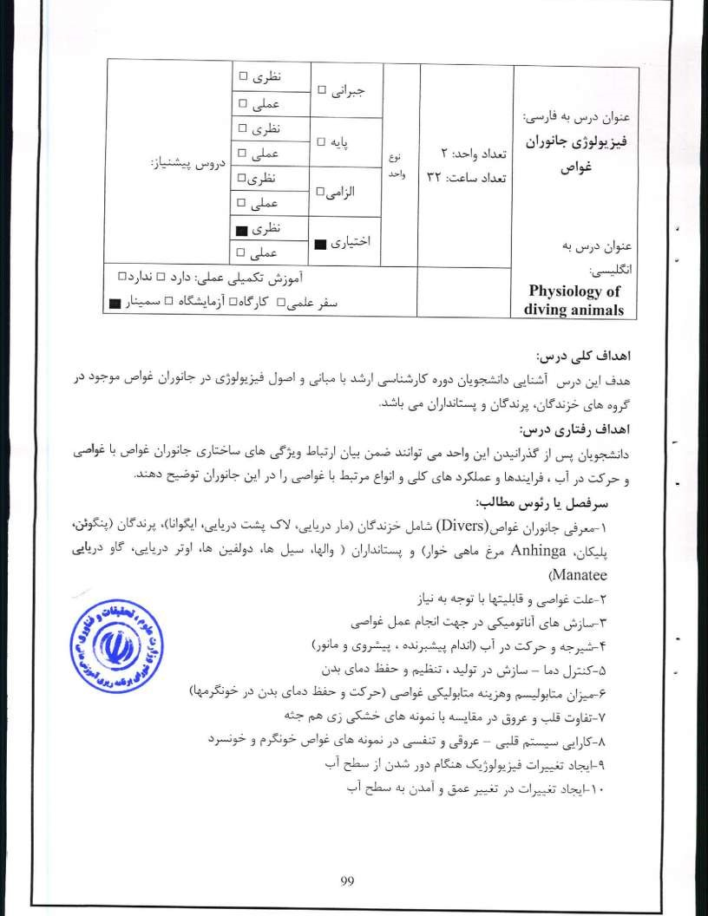

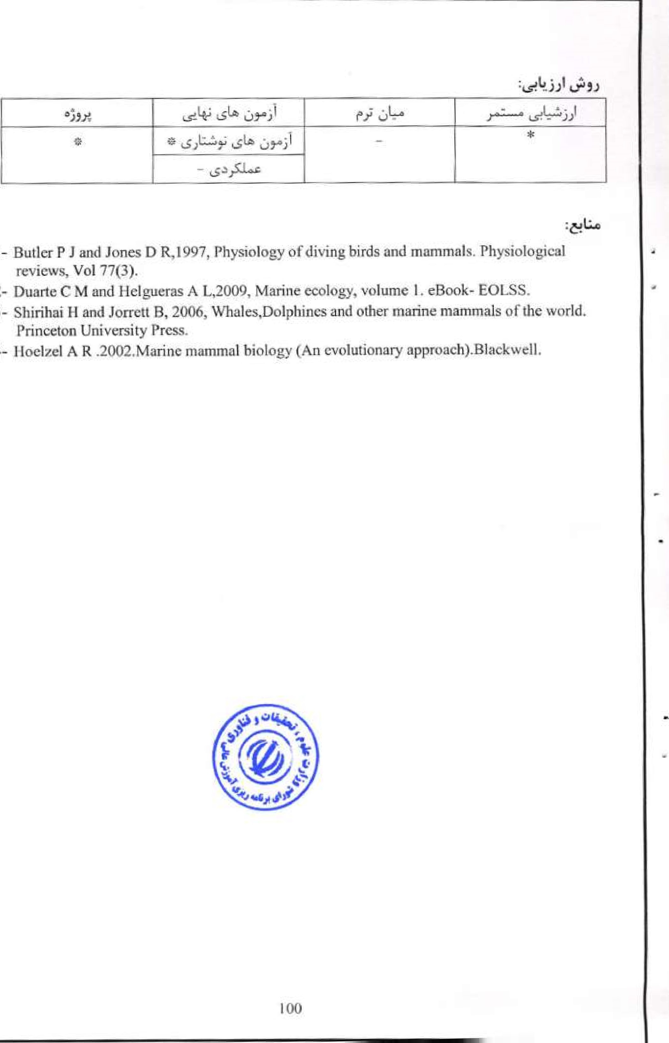
I
2-
3-
4-

