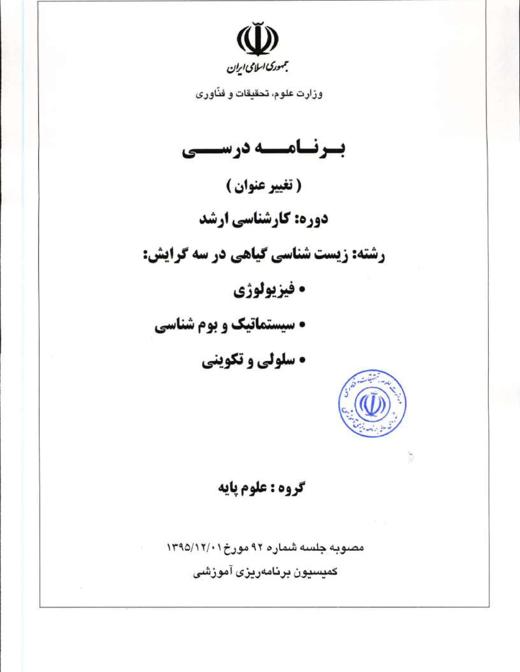
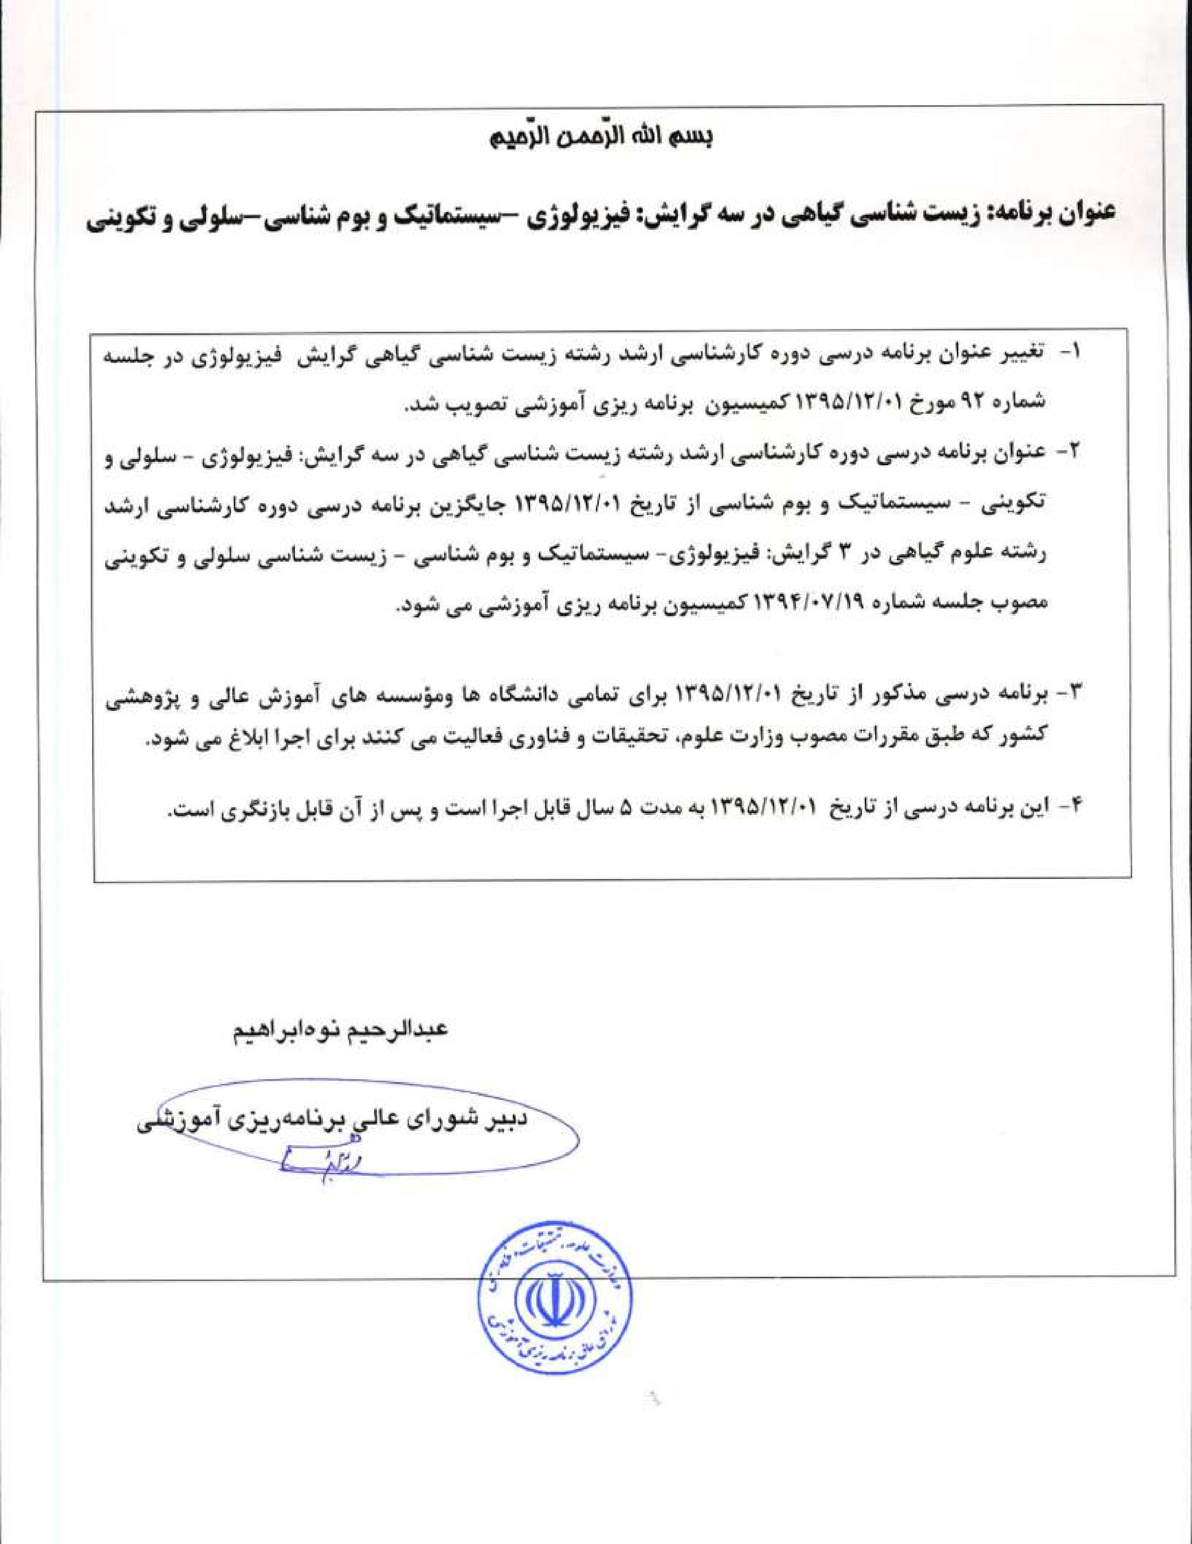
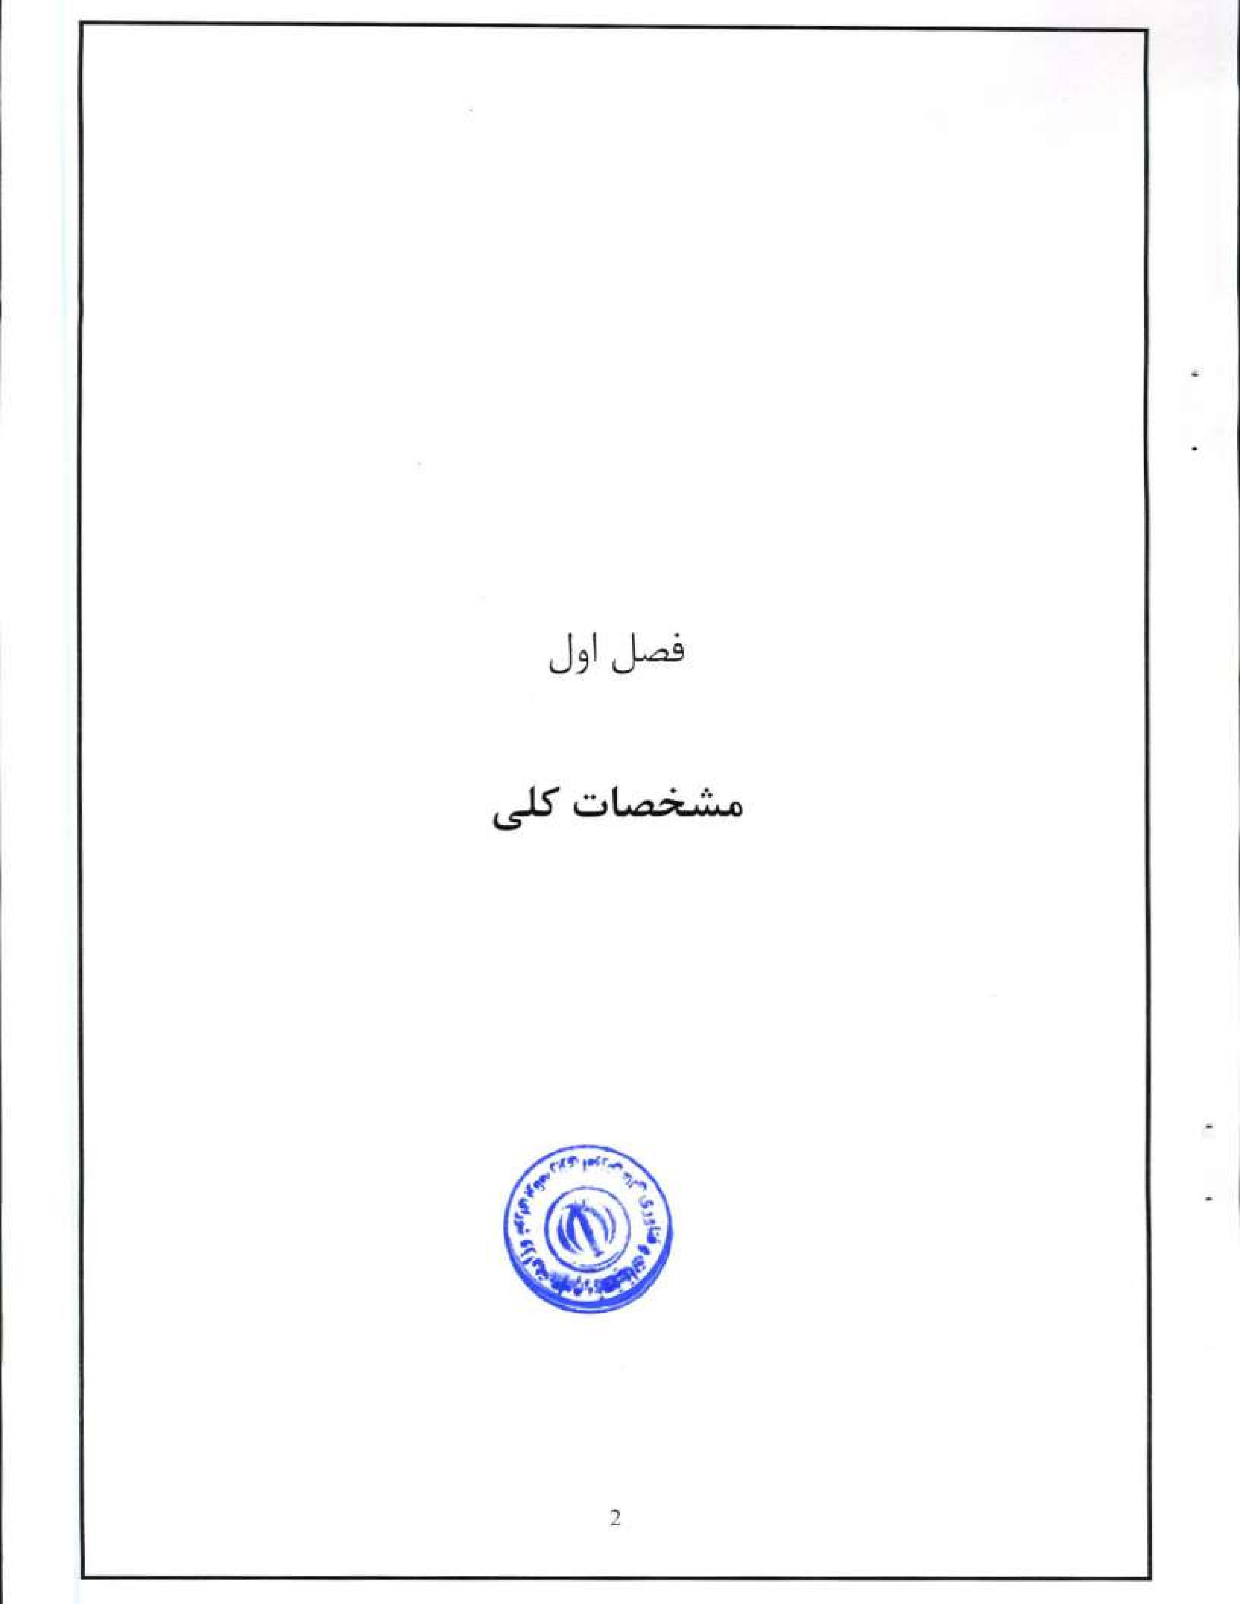
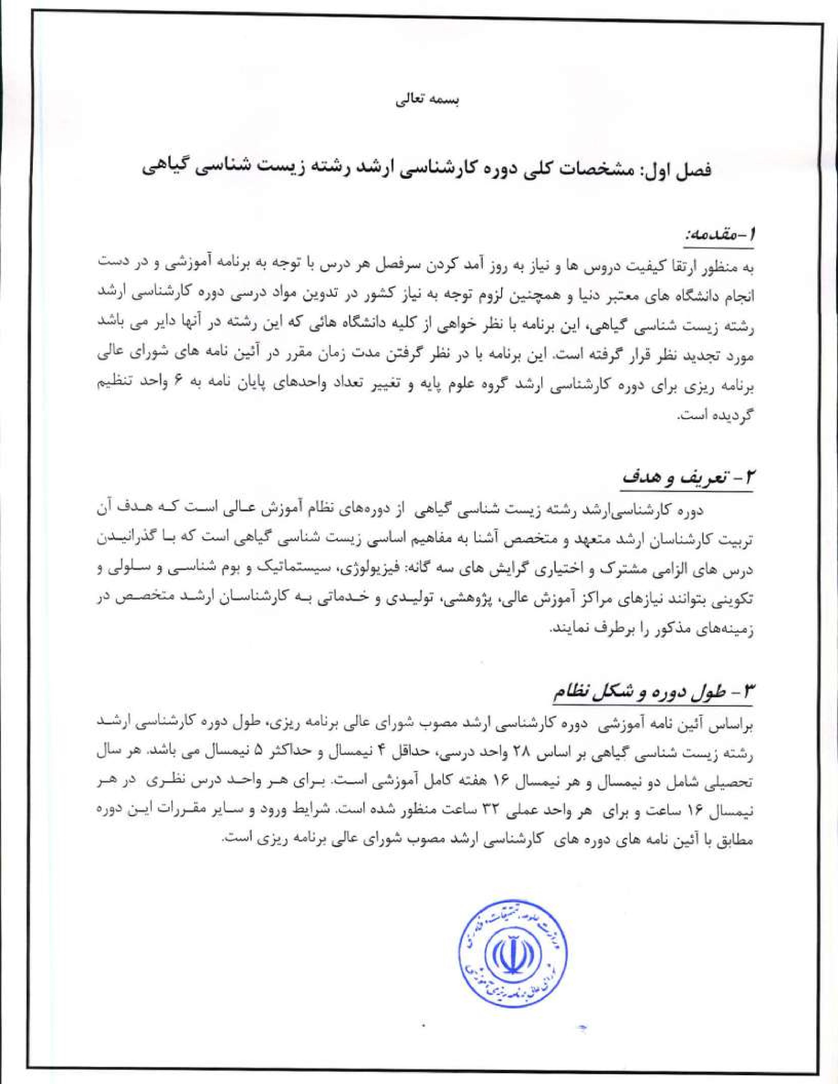
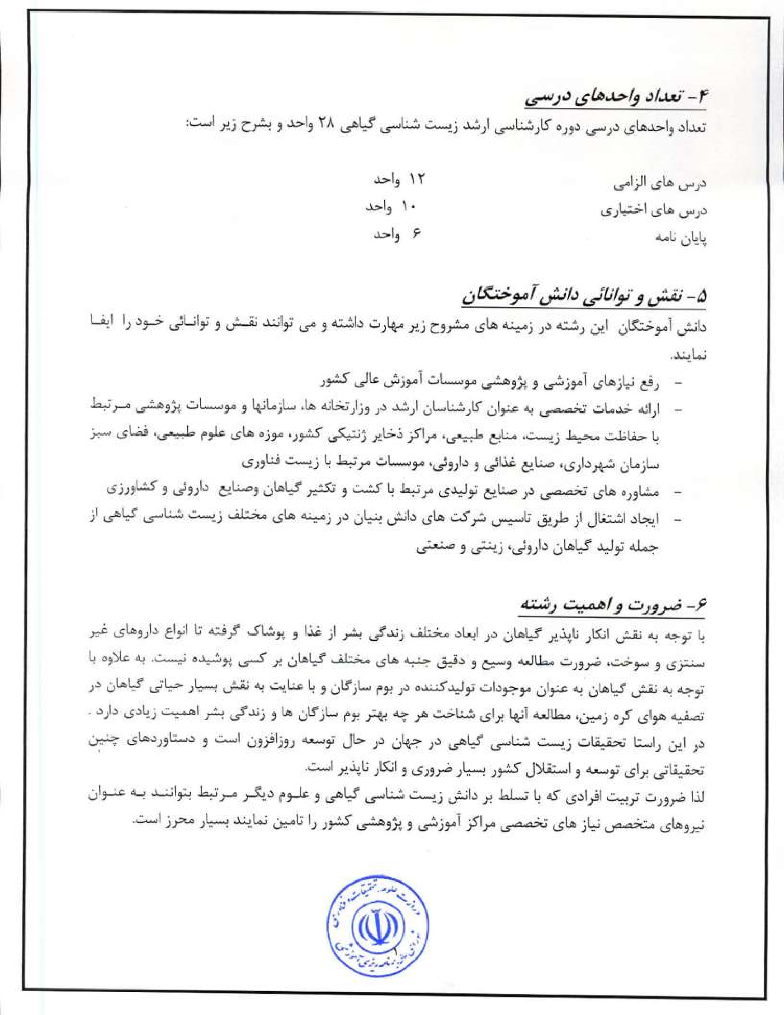

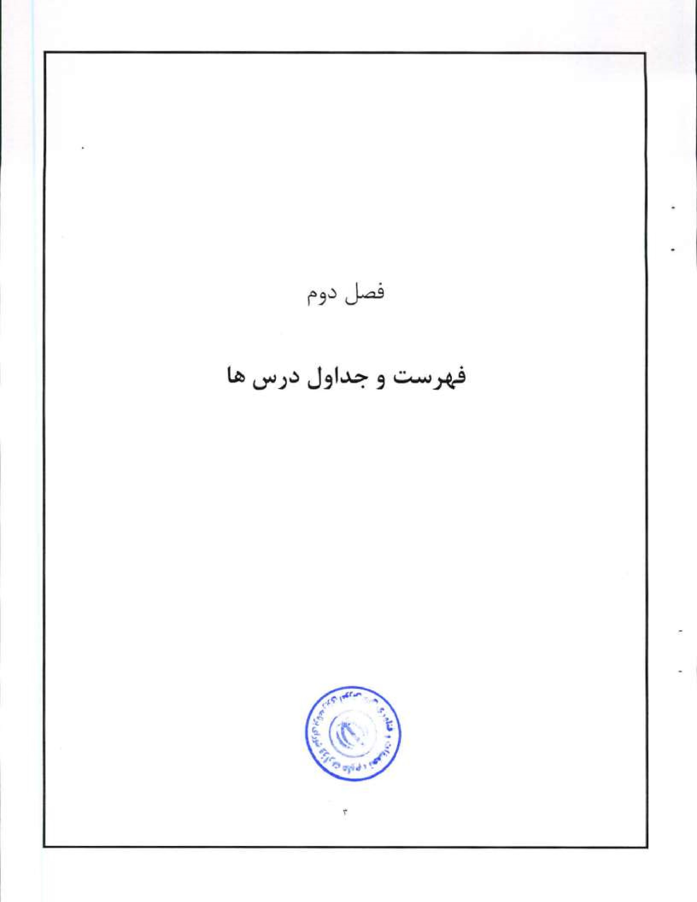
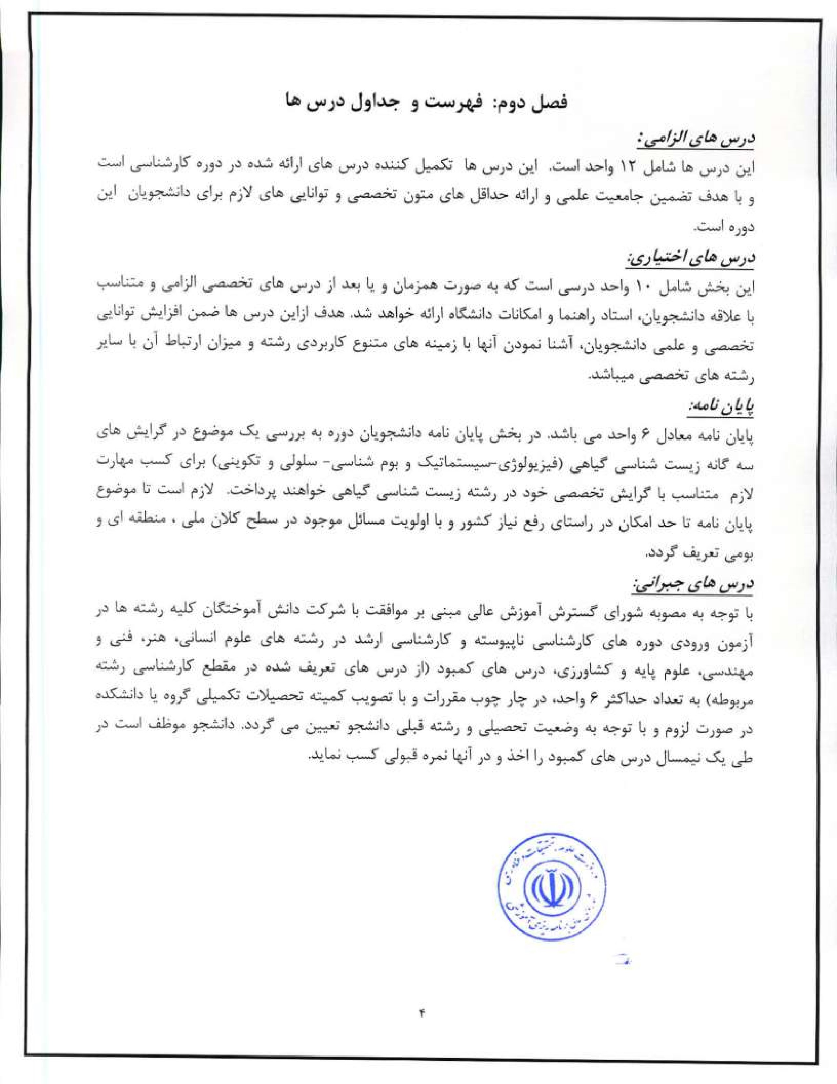
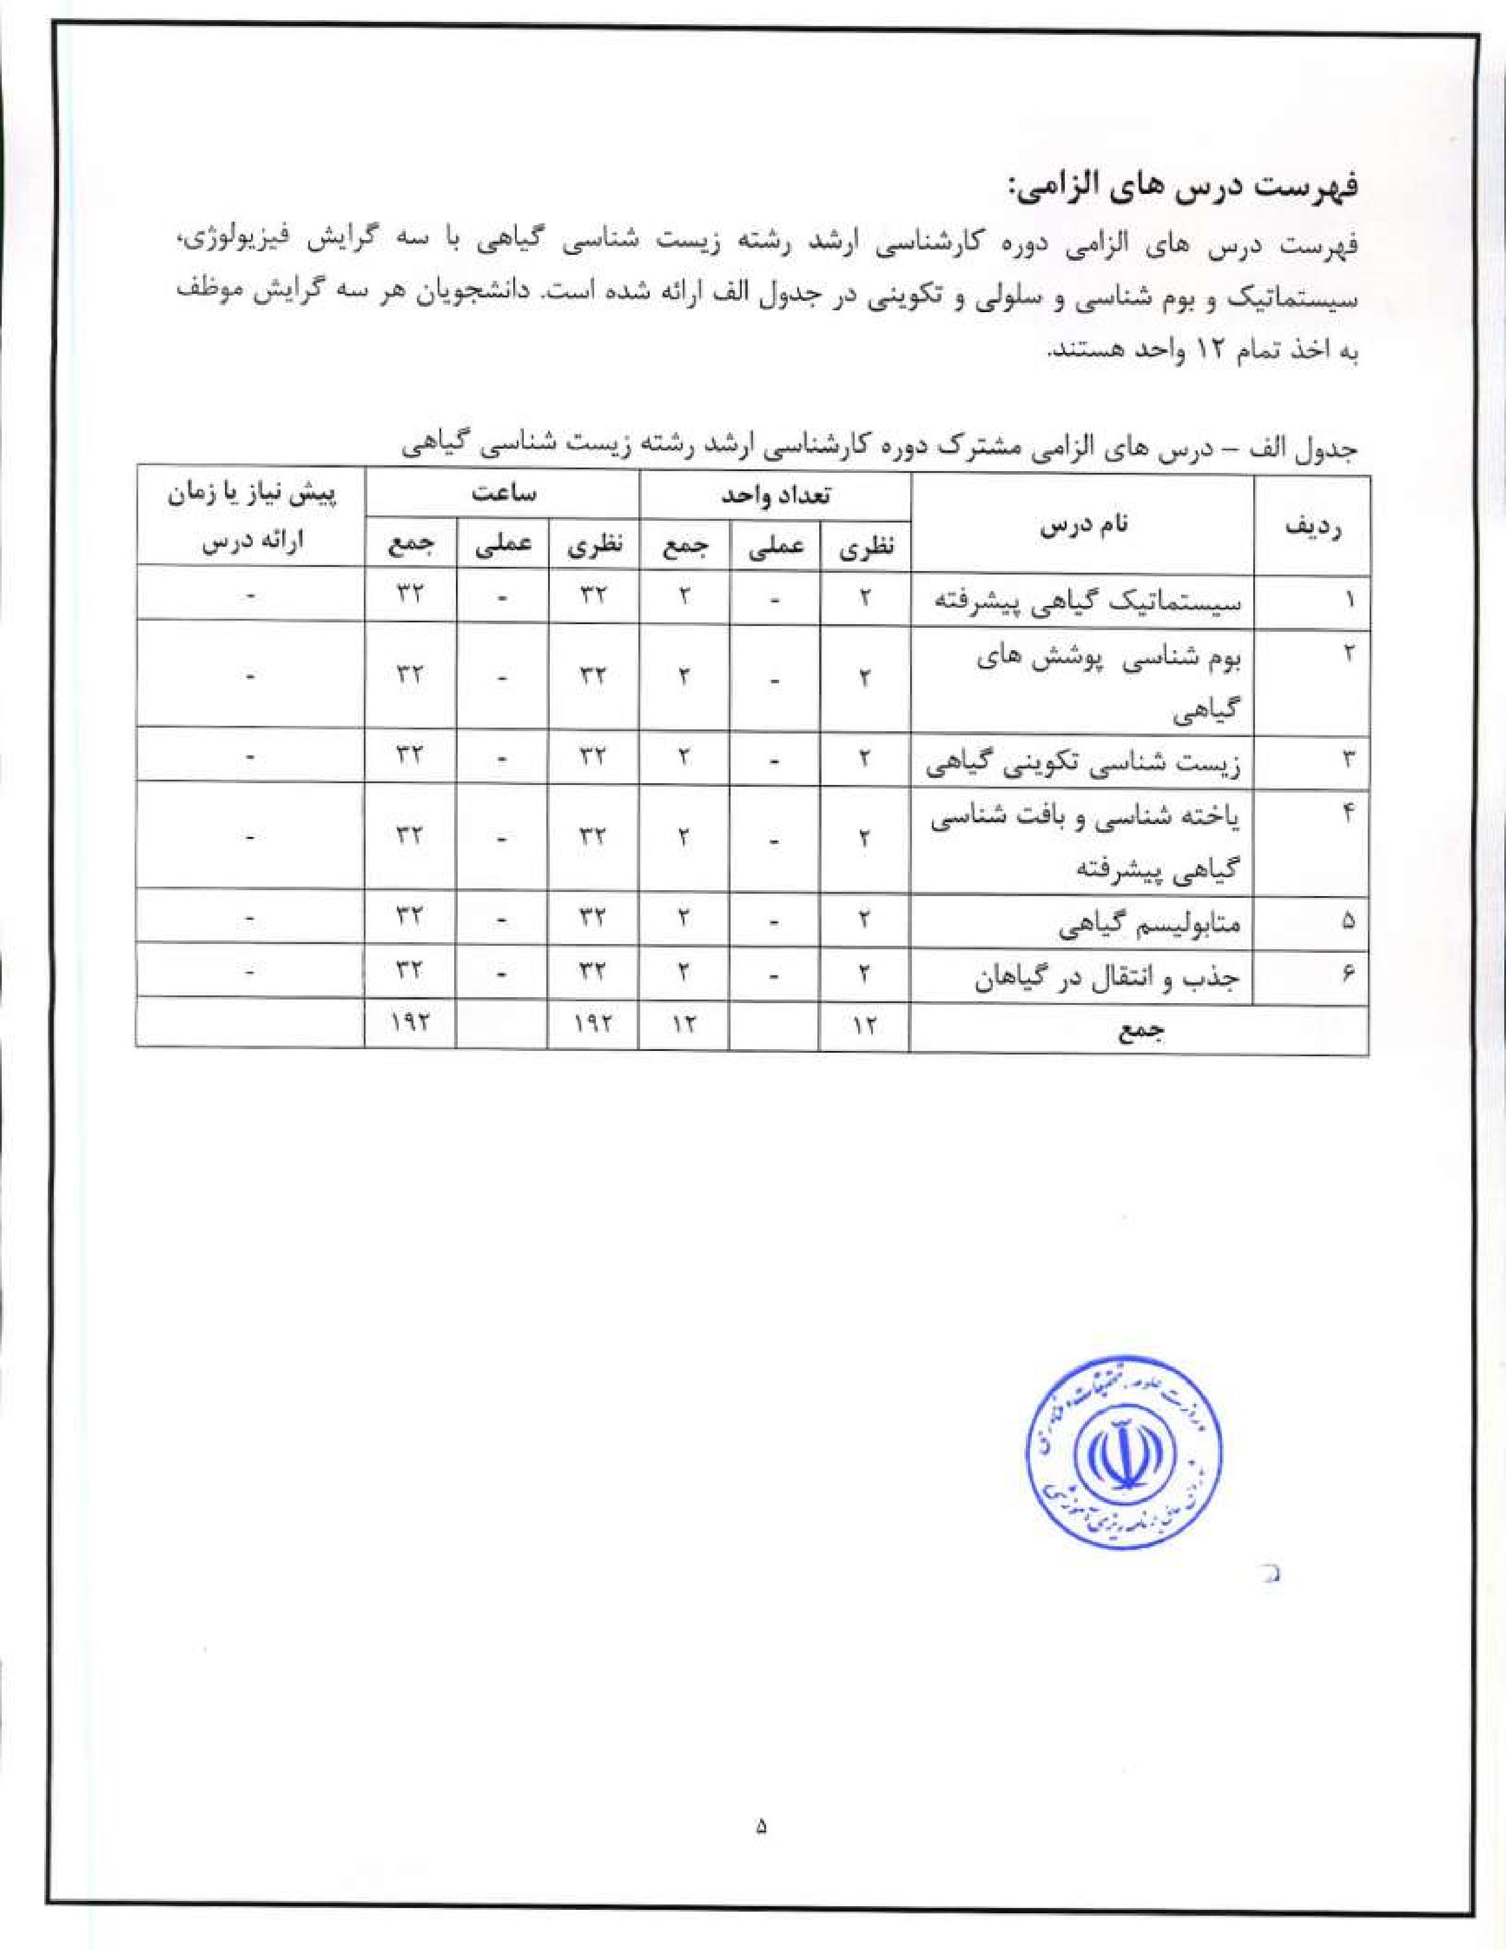
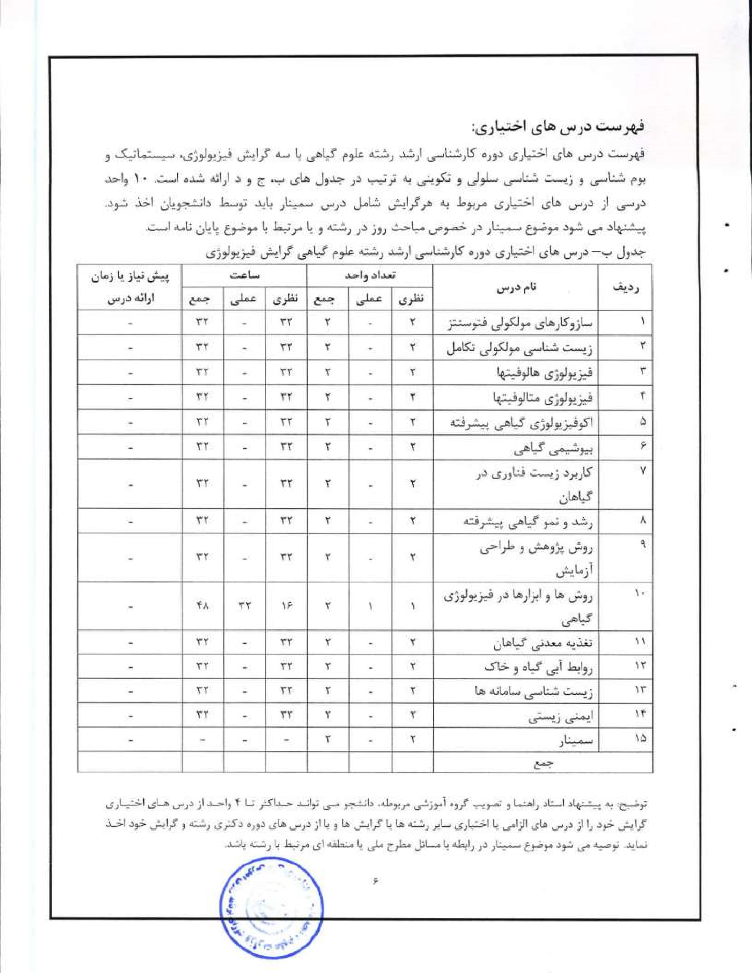
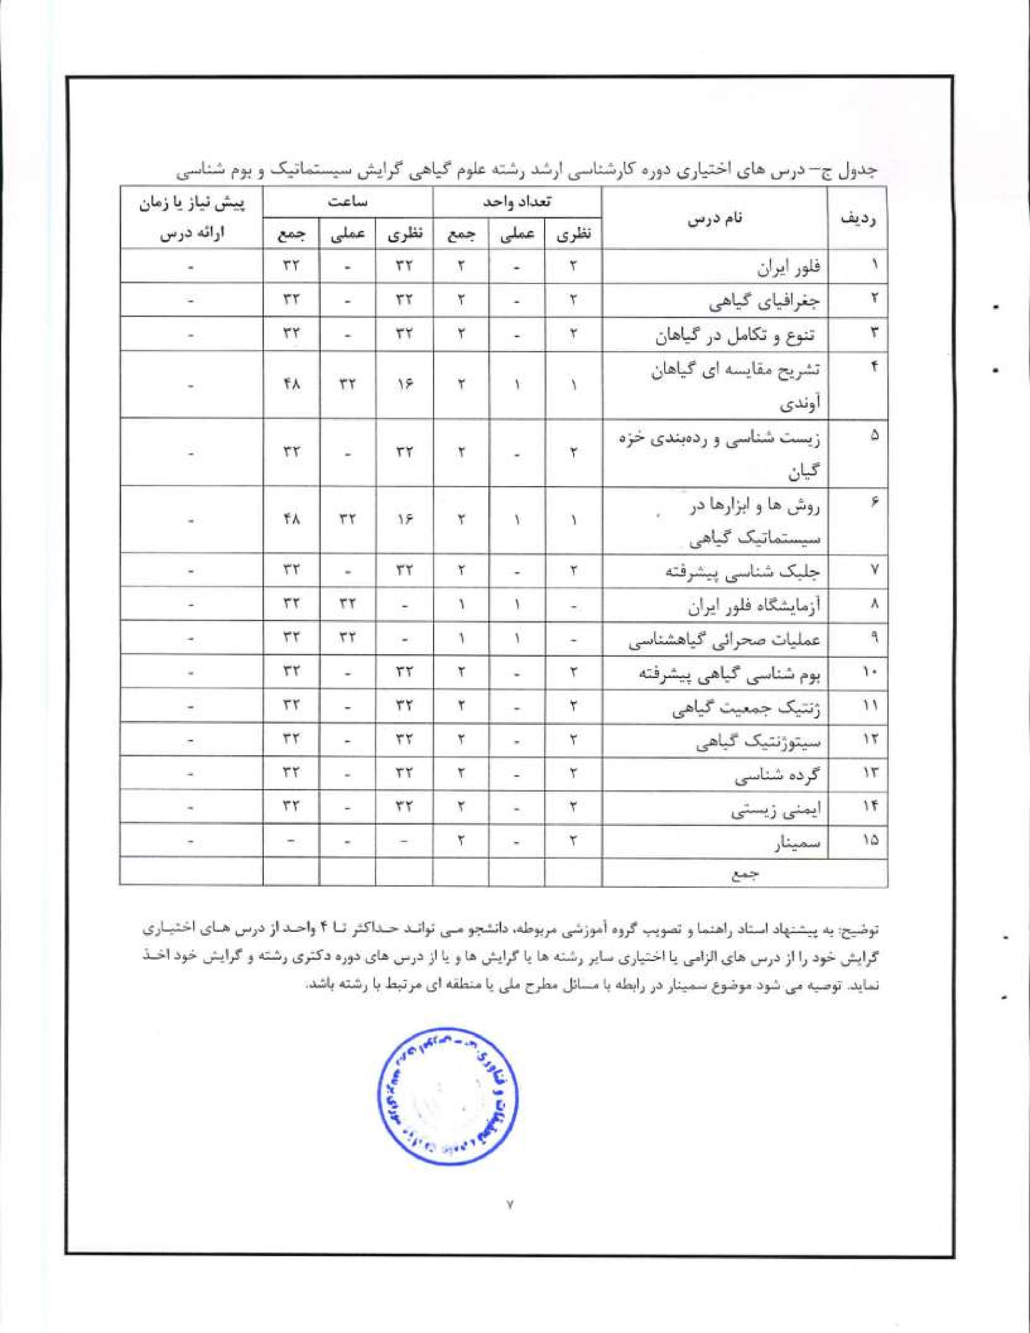
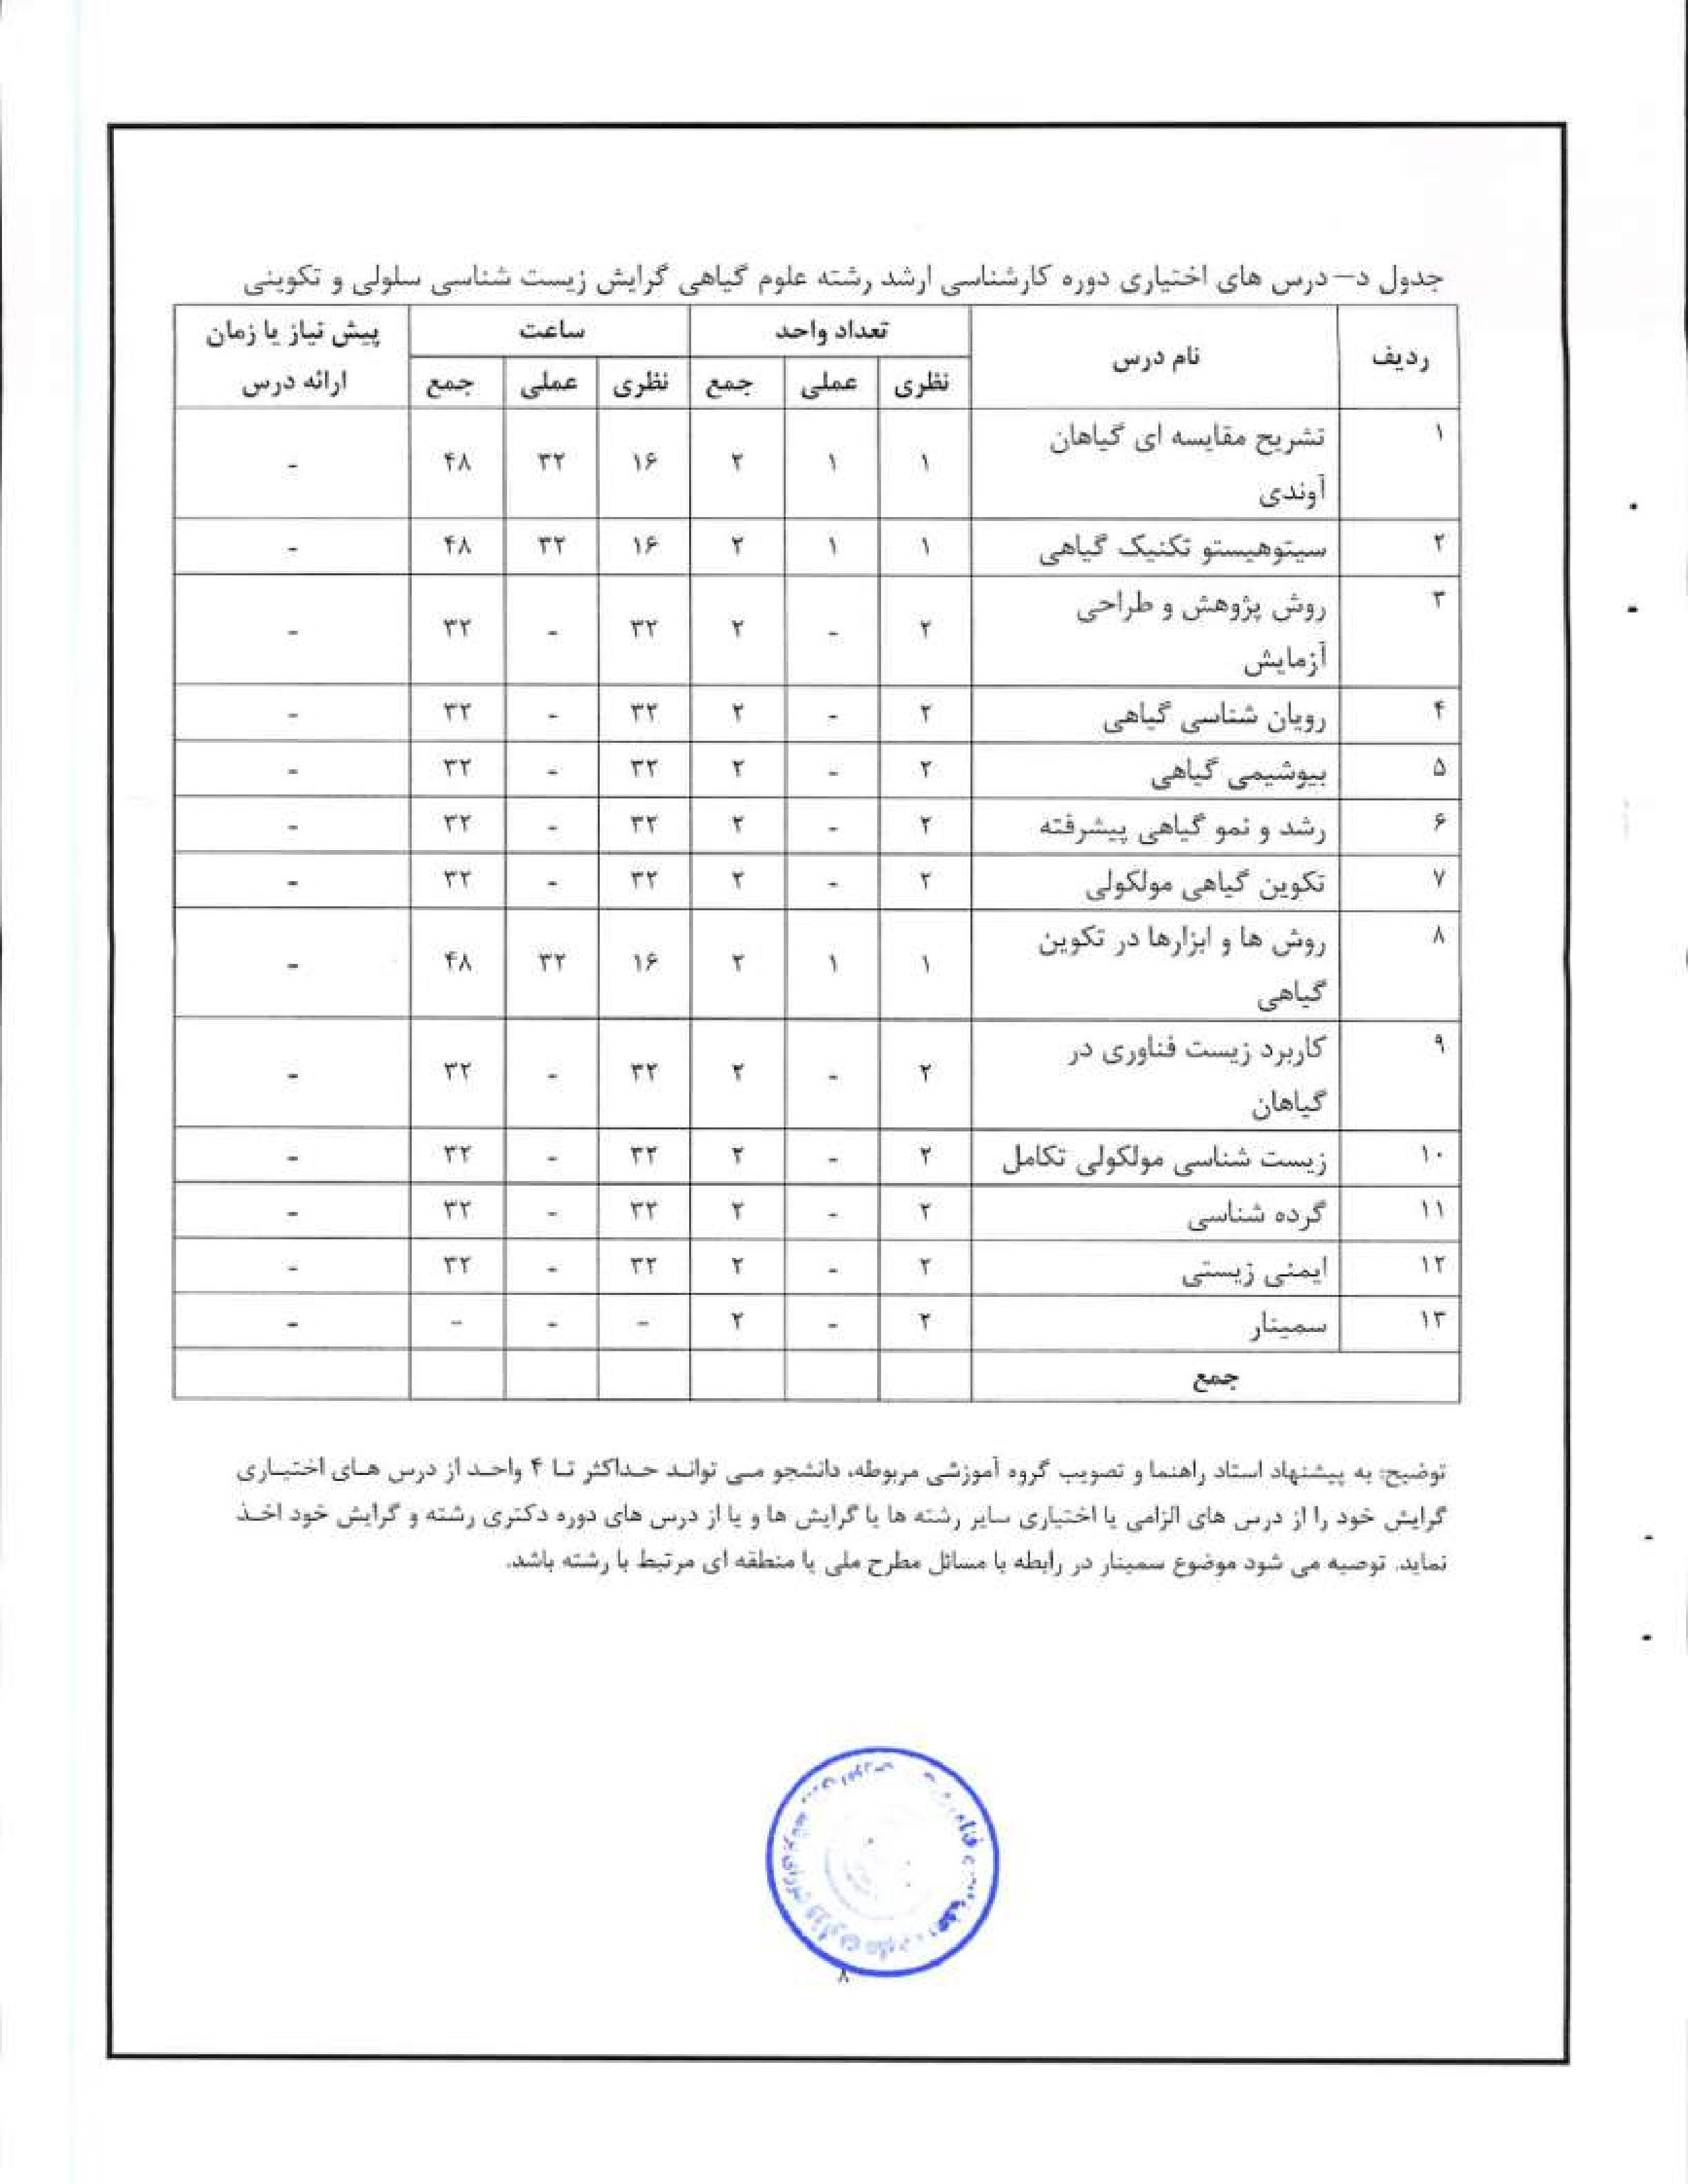

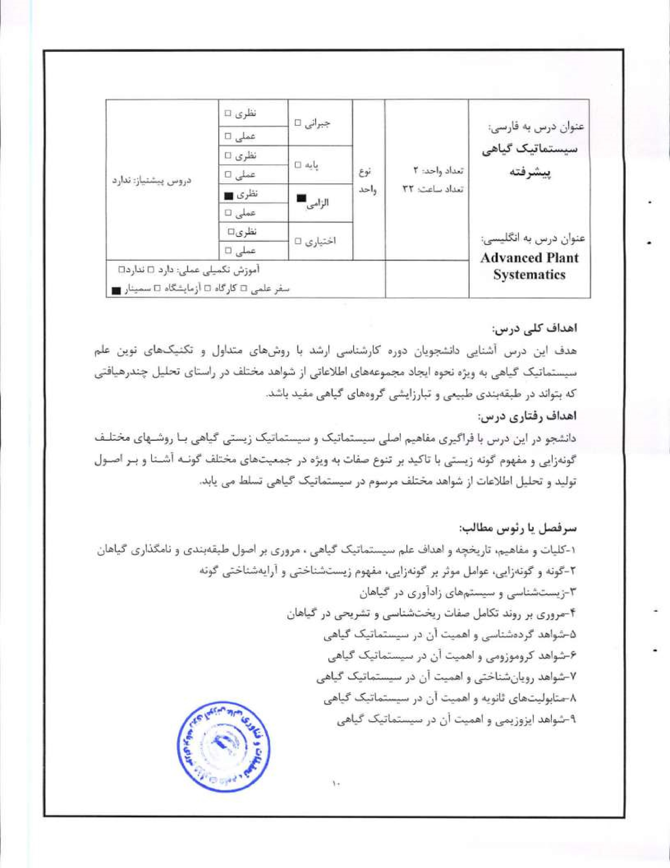
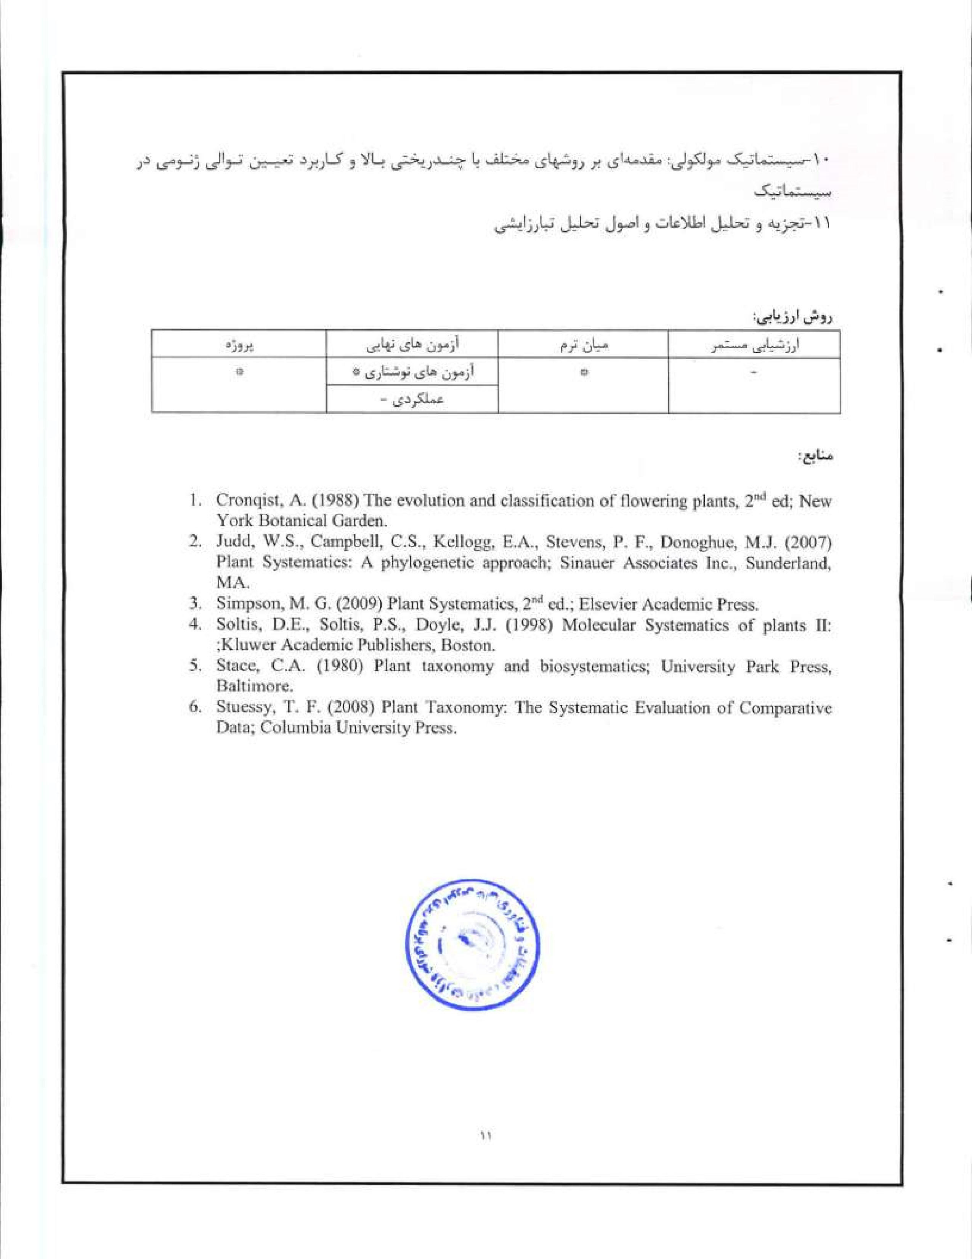
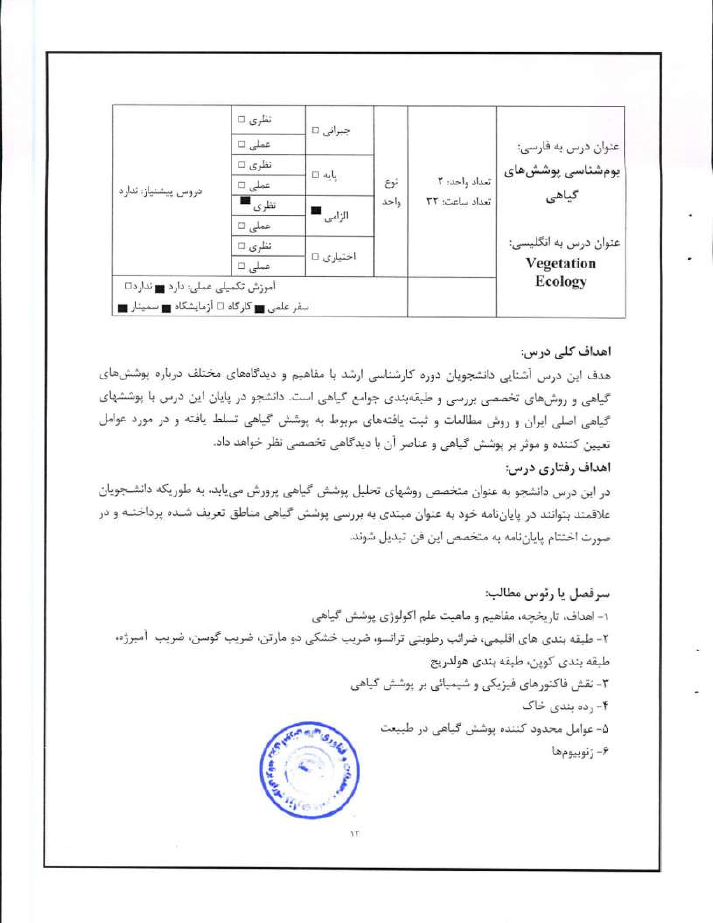
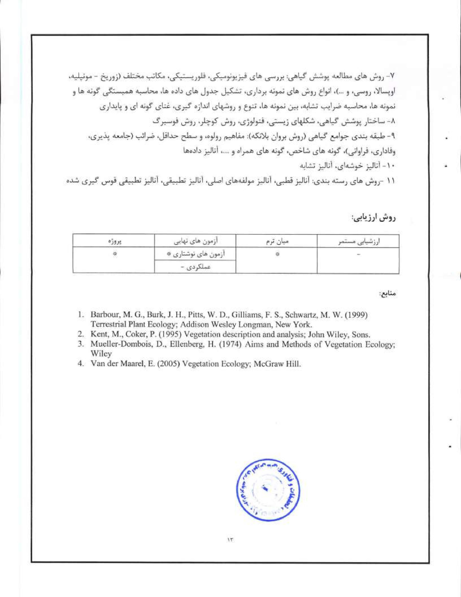
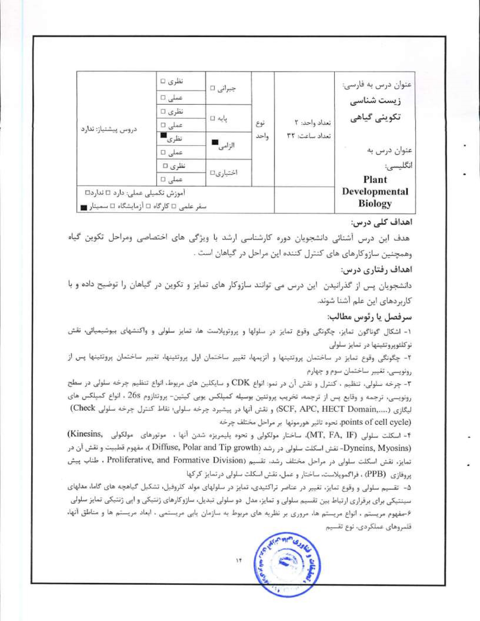
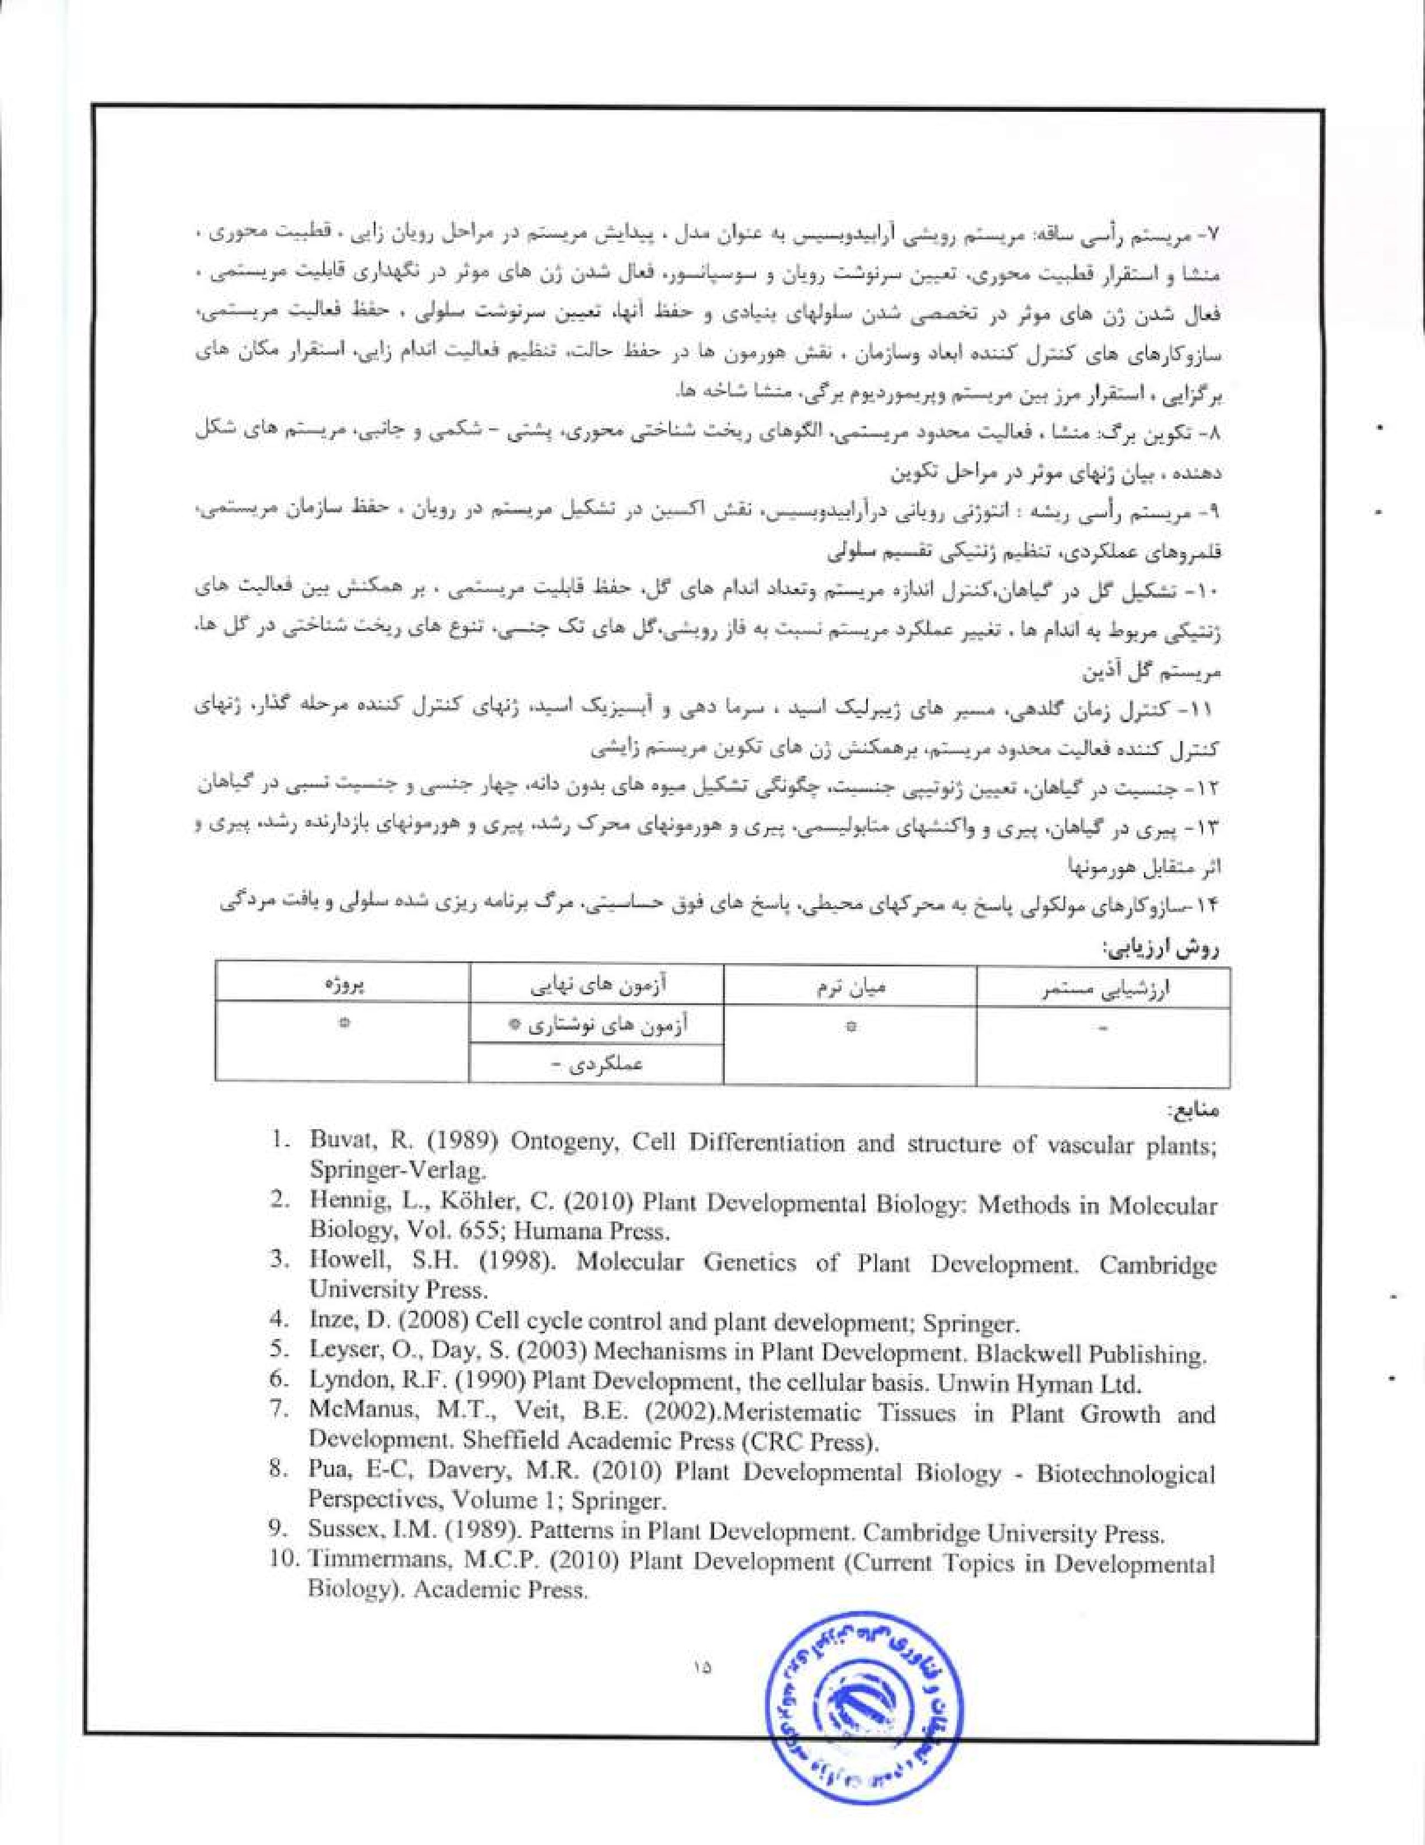
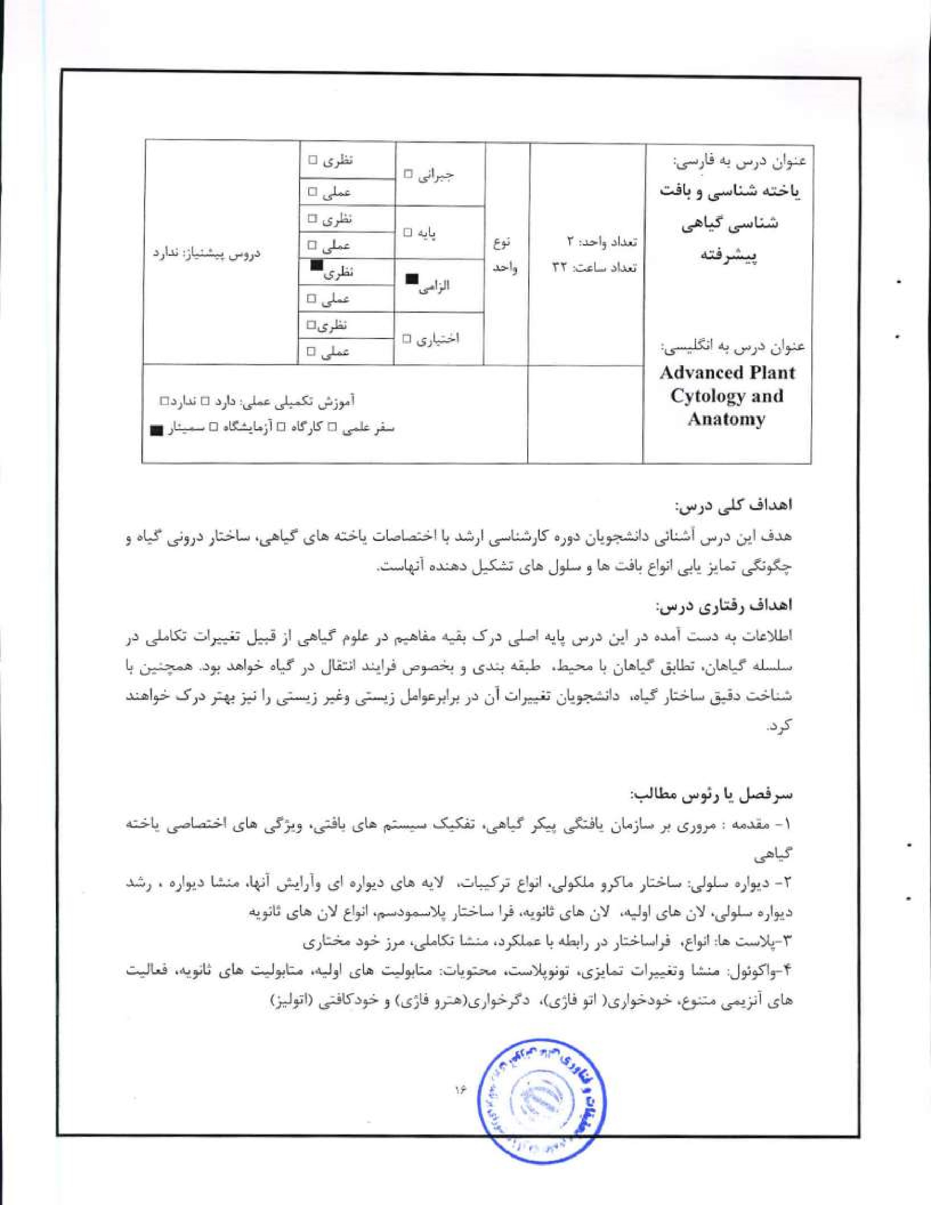
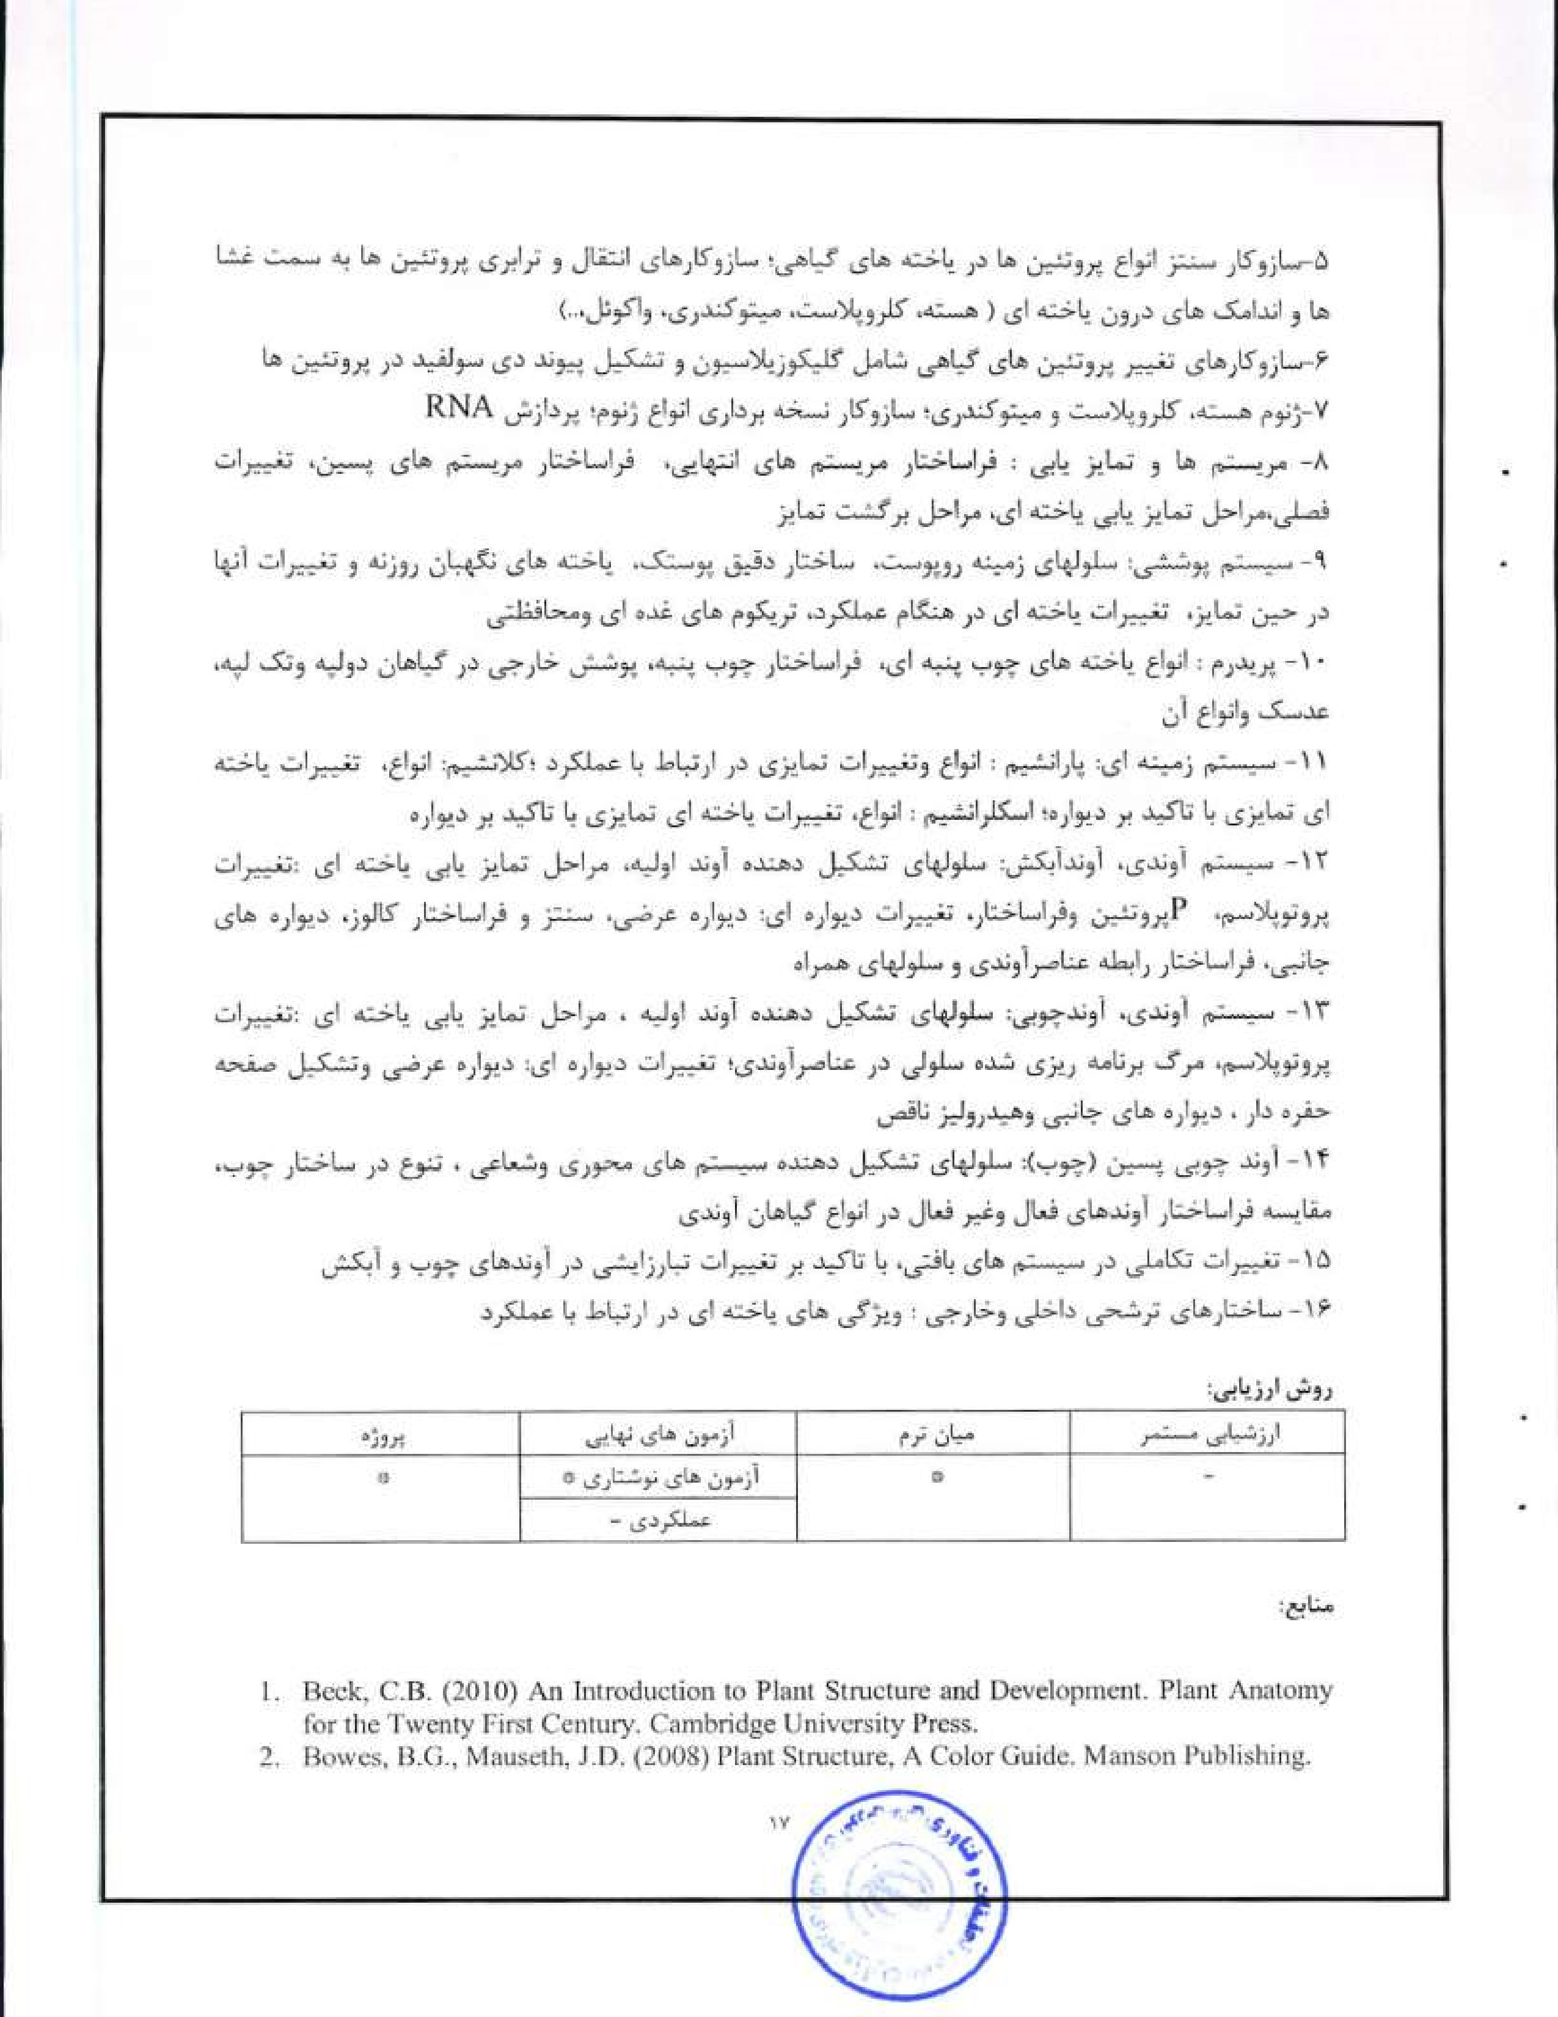

3, Buchanan. B, 'By, Gruissem W Jones R. L (2000) Biochemistry and Molecular Biology of Plants. John Wiley & Sons.
4. Buvat, R, (1989) Ontogeny, Cell Differentiation and Structure of Vascular Plants-Springer-Verlag.
15, Cutler, D.F.. Botha, Stevenson. (2008) Plant Anatomy. An applied approach. Blackwell Publishing.
- Evert, R.F. (2006) Esau's Plant Anatomy: Meristemst Cells and Tissues of the Plant Body-Their Structure, Function and Development-Wiley Interseience.
- Fahn, A. (1990) Plant Anatomy. Pergamon Press,
- Harrison, M.. Dashek W. V. (2006) Plant Cell Biology Science Publishers.
9, Robinson D, (2003) The Golgi Apparatus and the Plant Secre'tory Pathway-Blackwell
Publishing Ltd
10. Rudall, P. (2007) Anatomy of Flowering Plants. An Introduction to Structure and Development. Cambridge University Press.


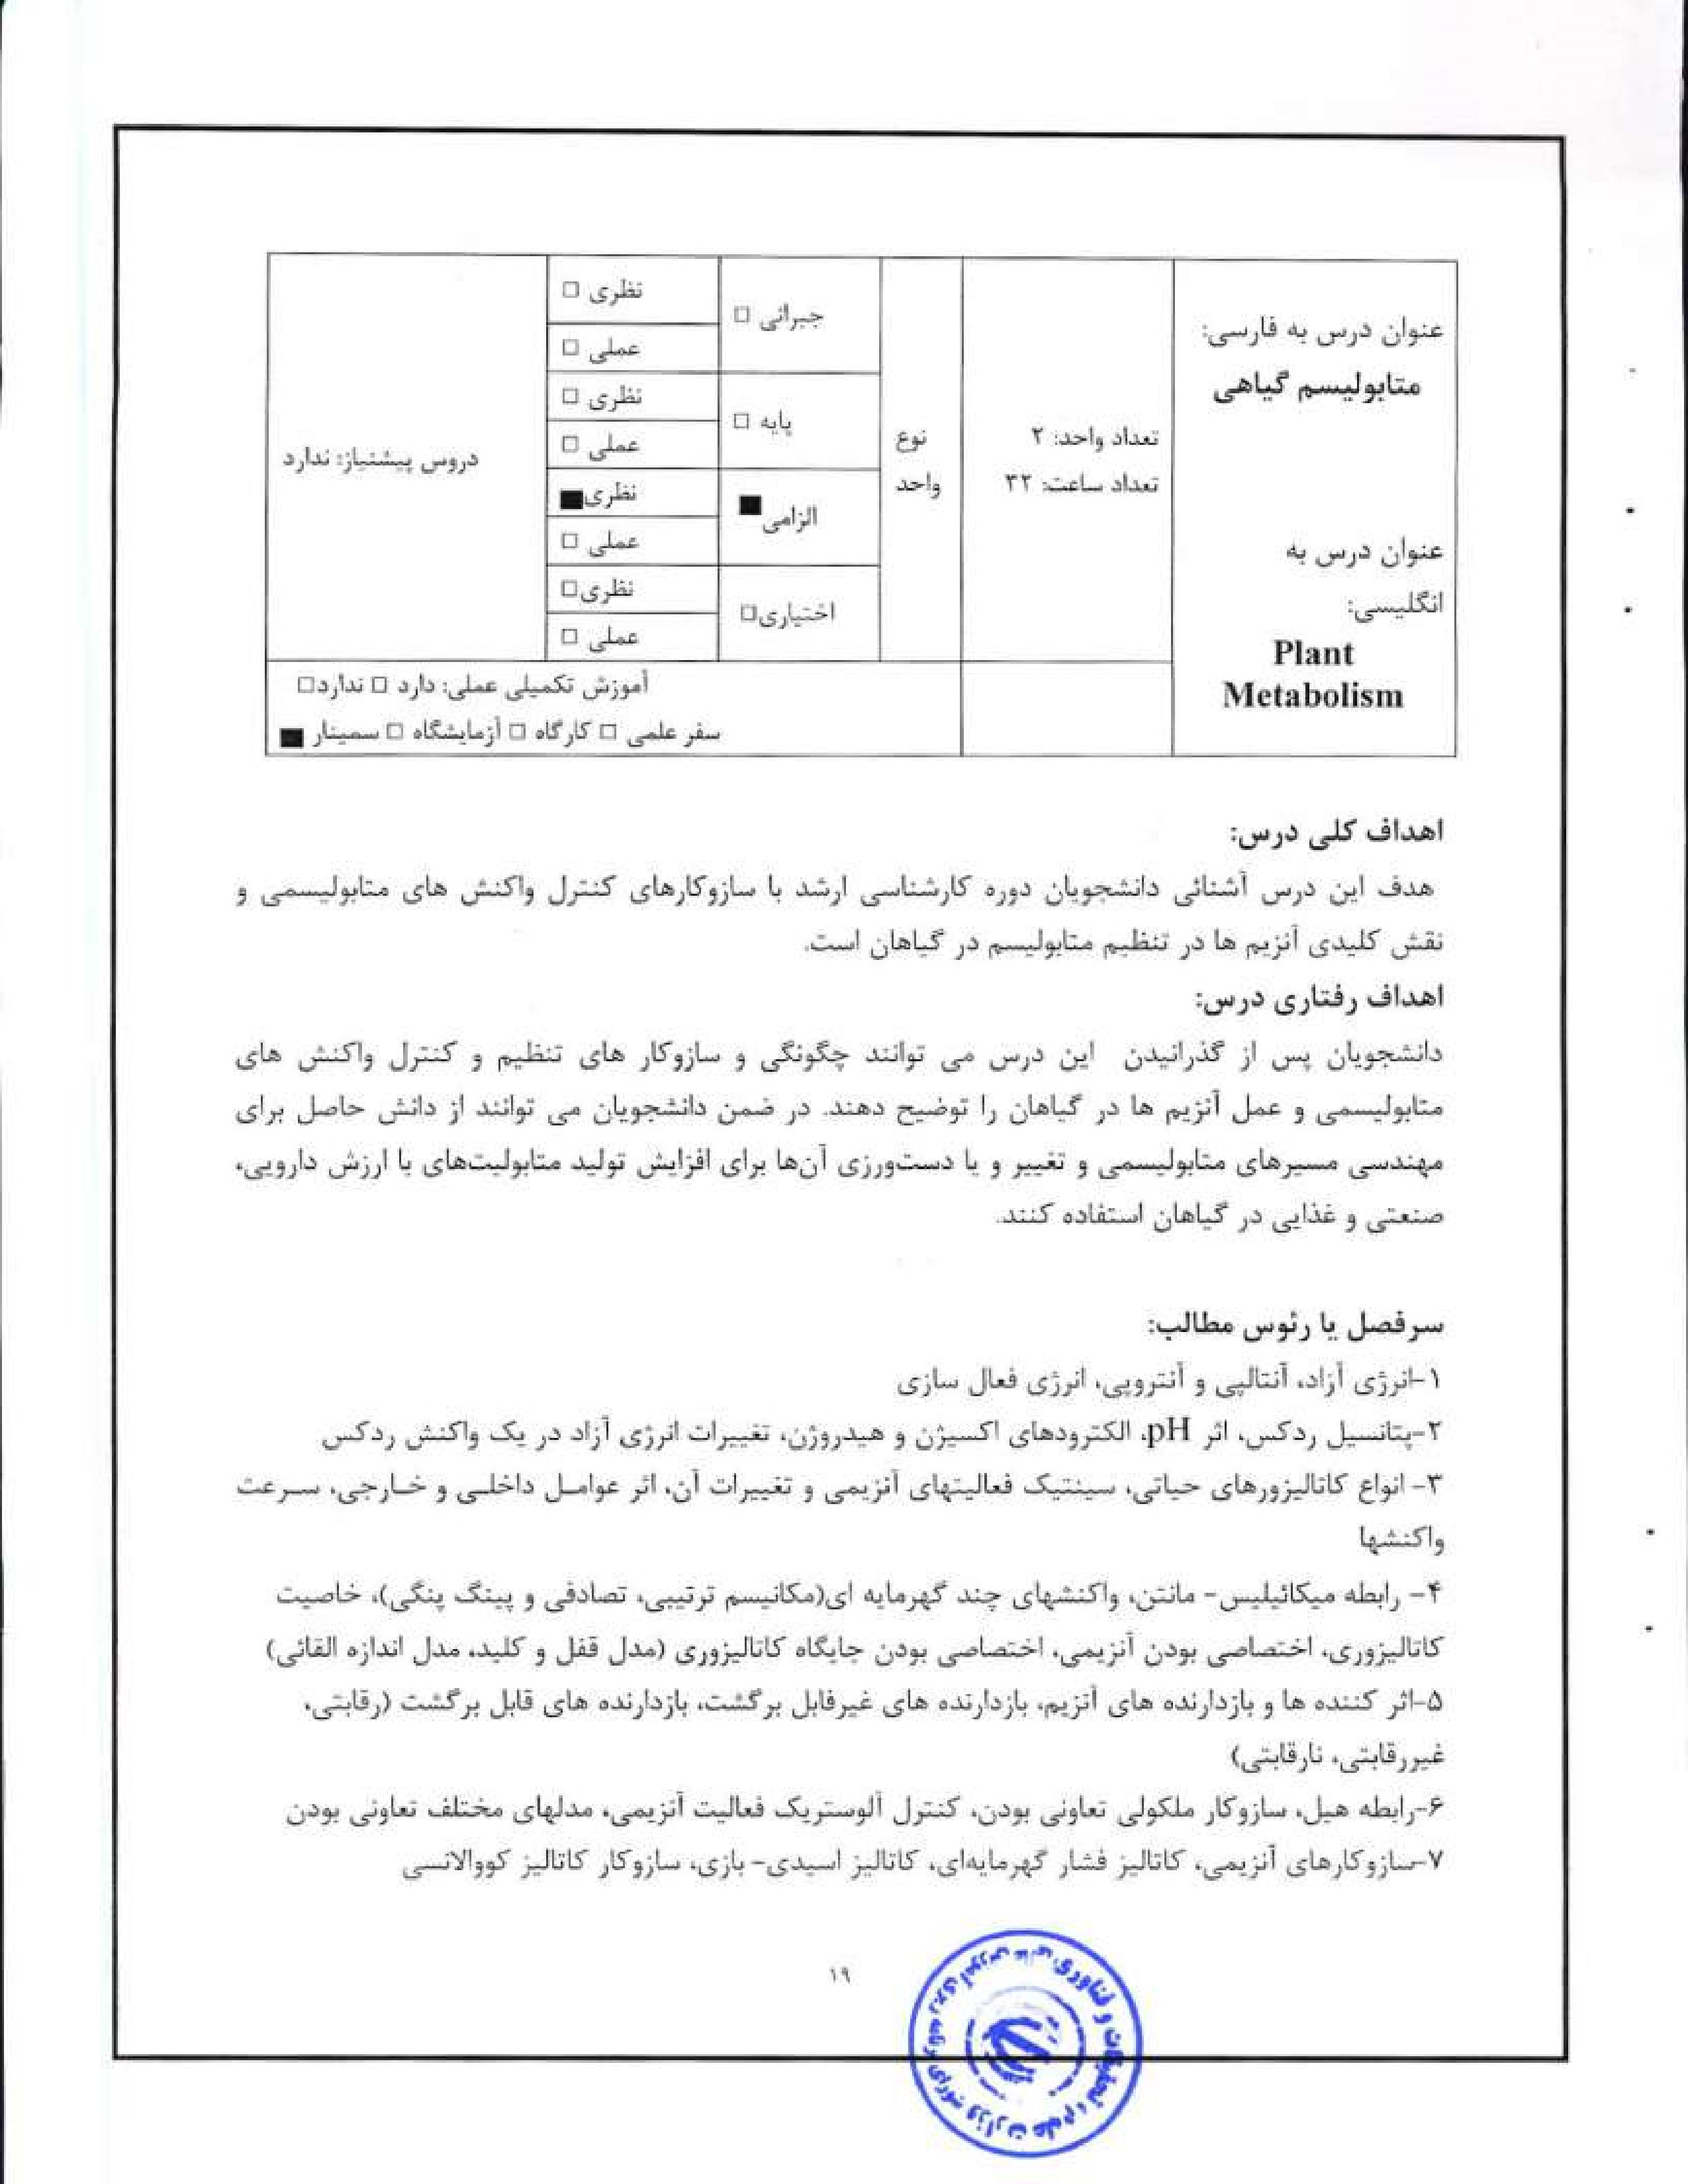
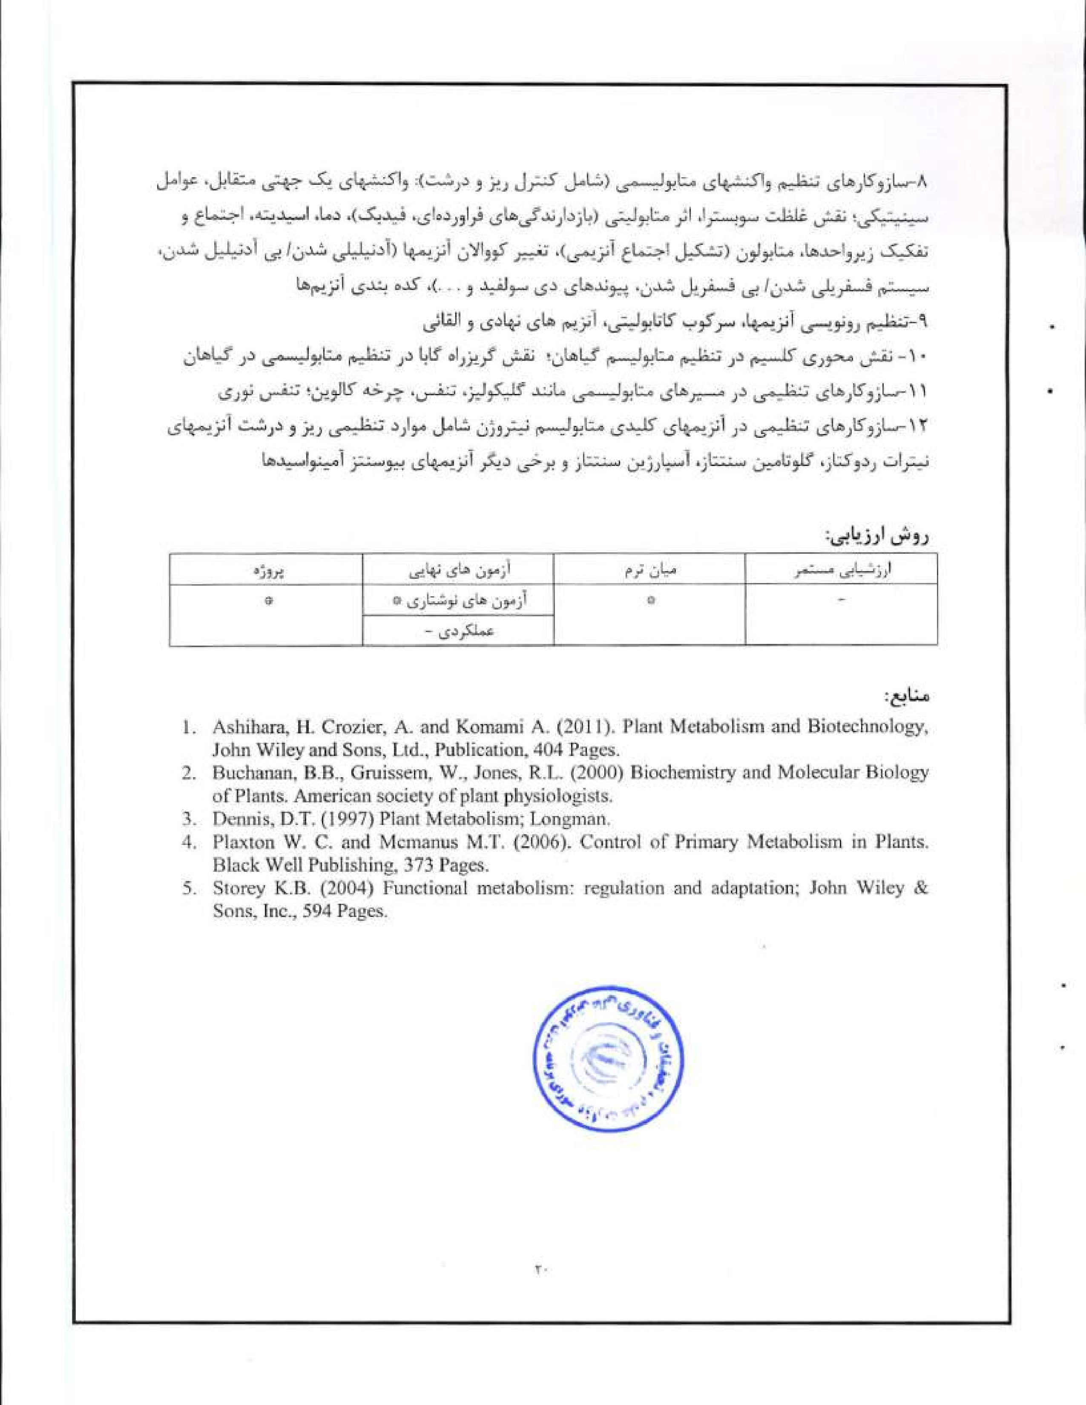
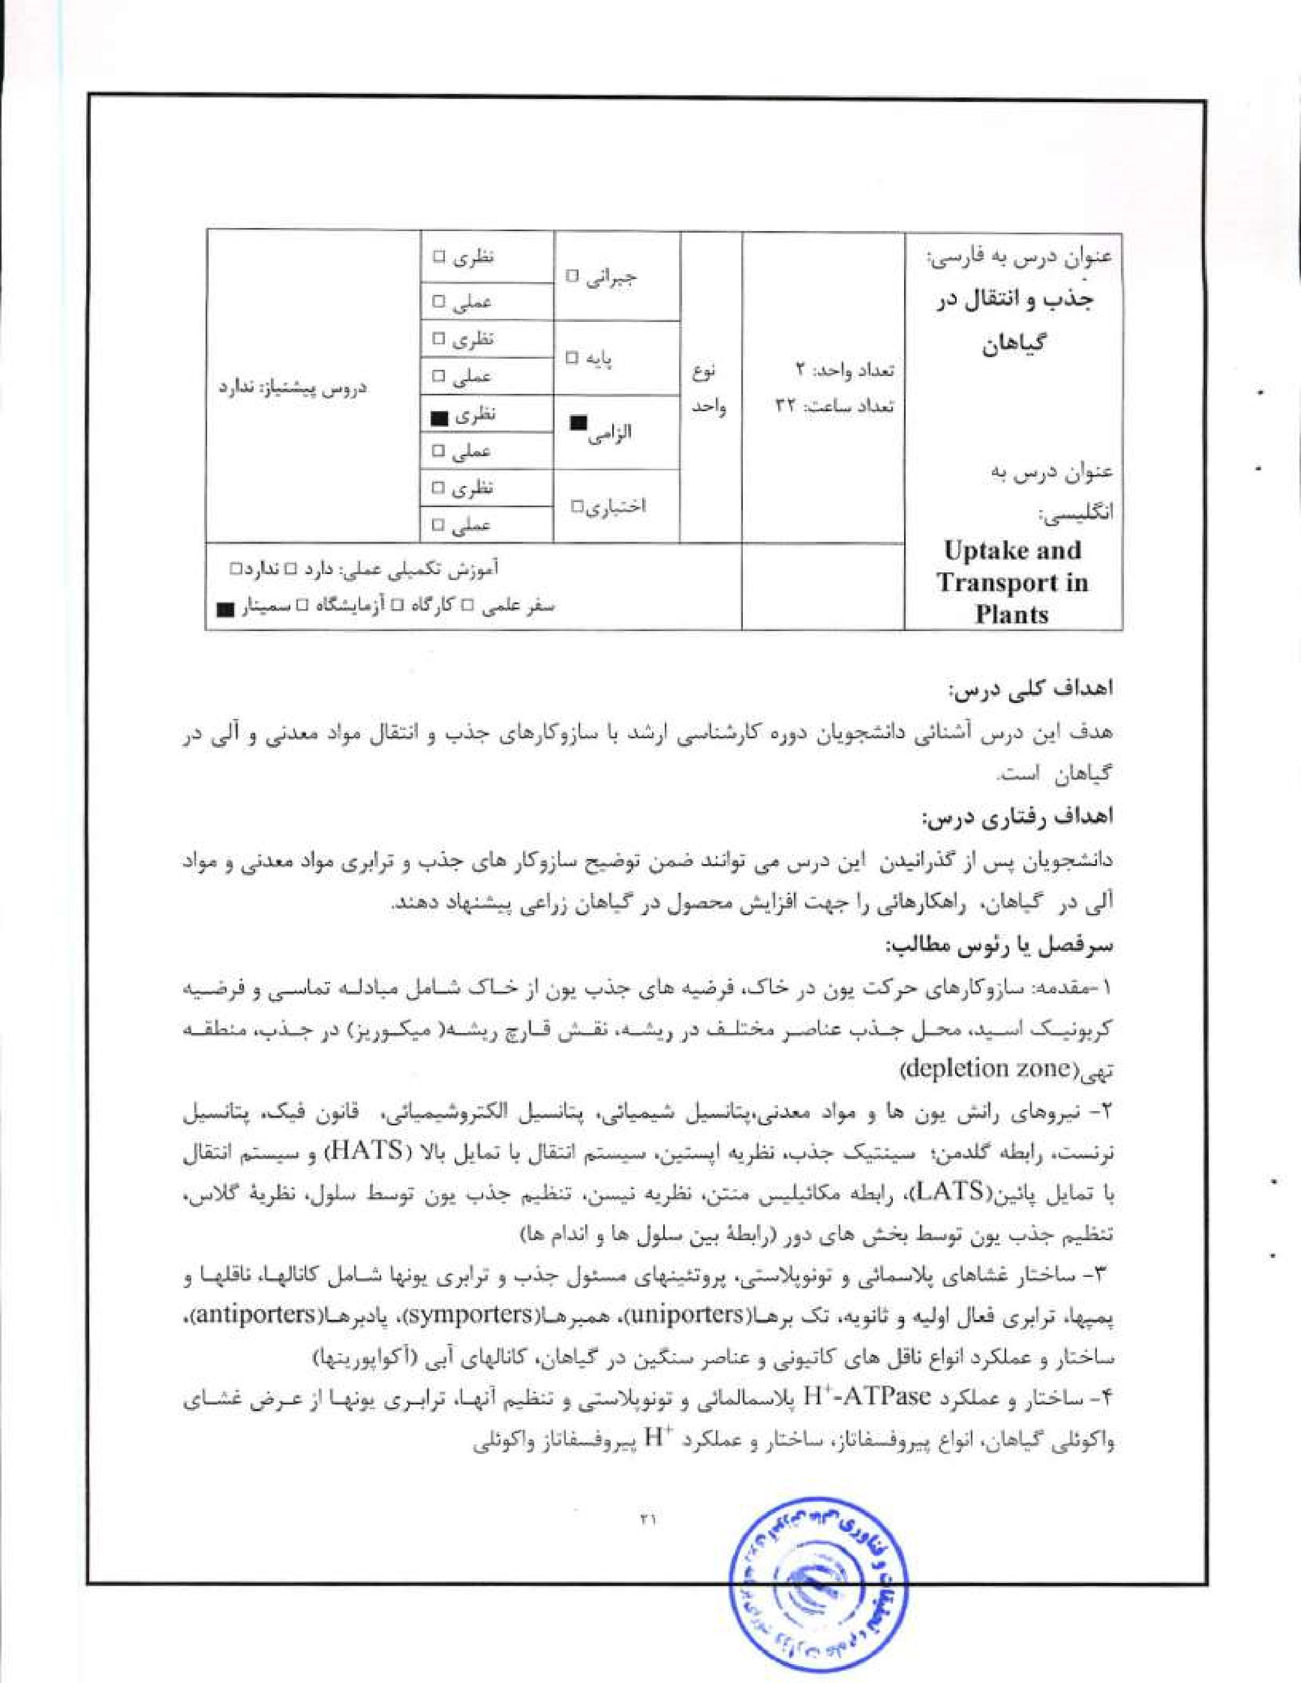
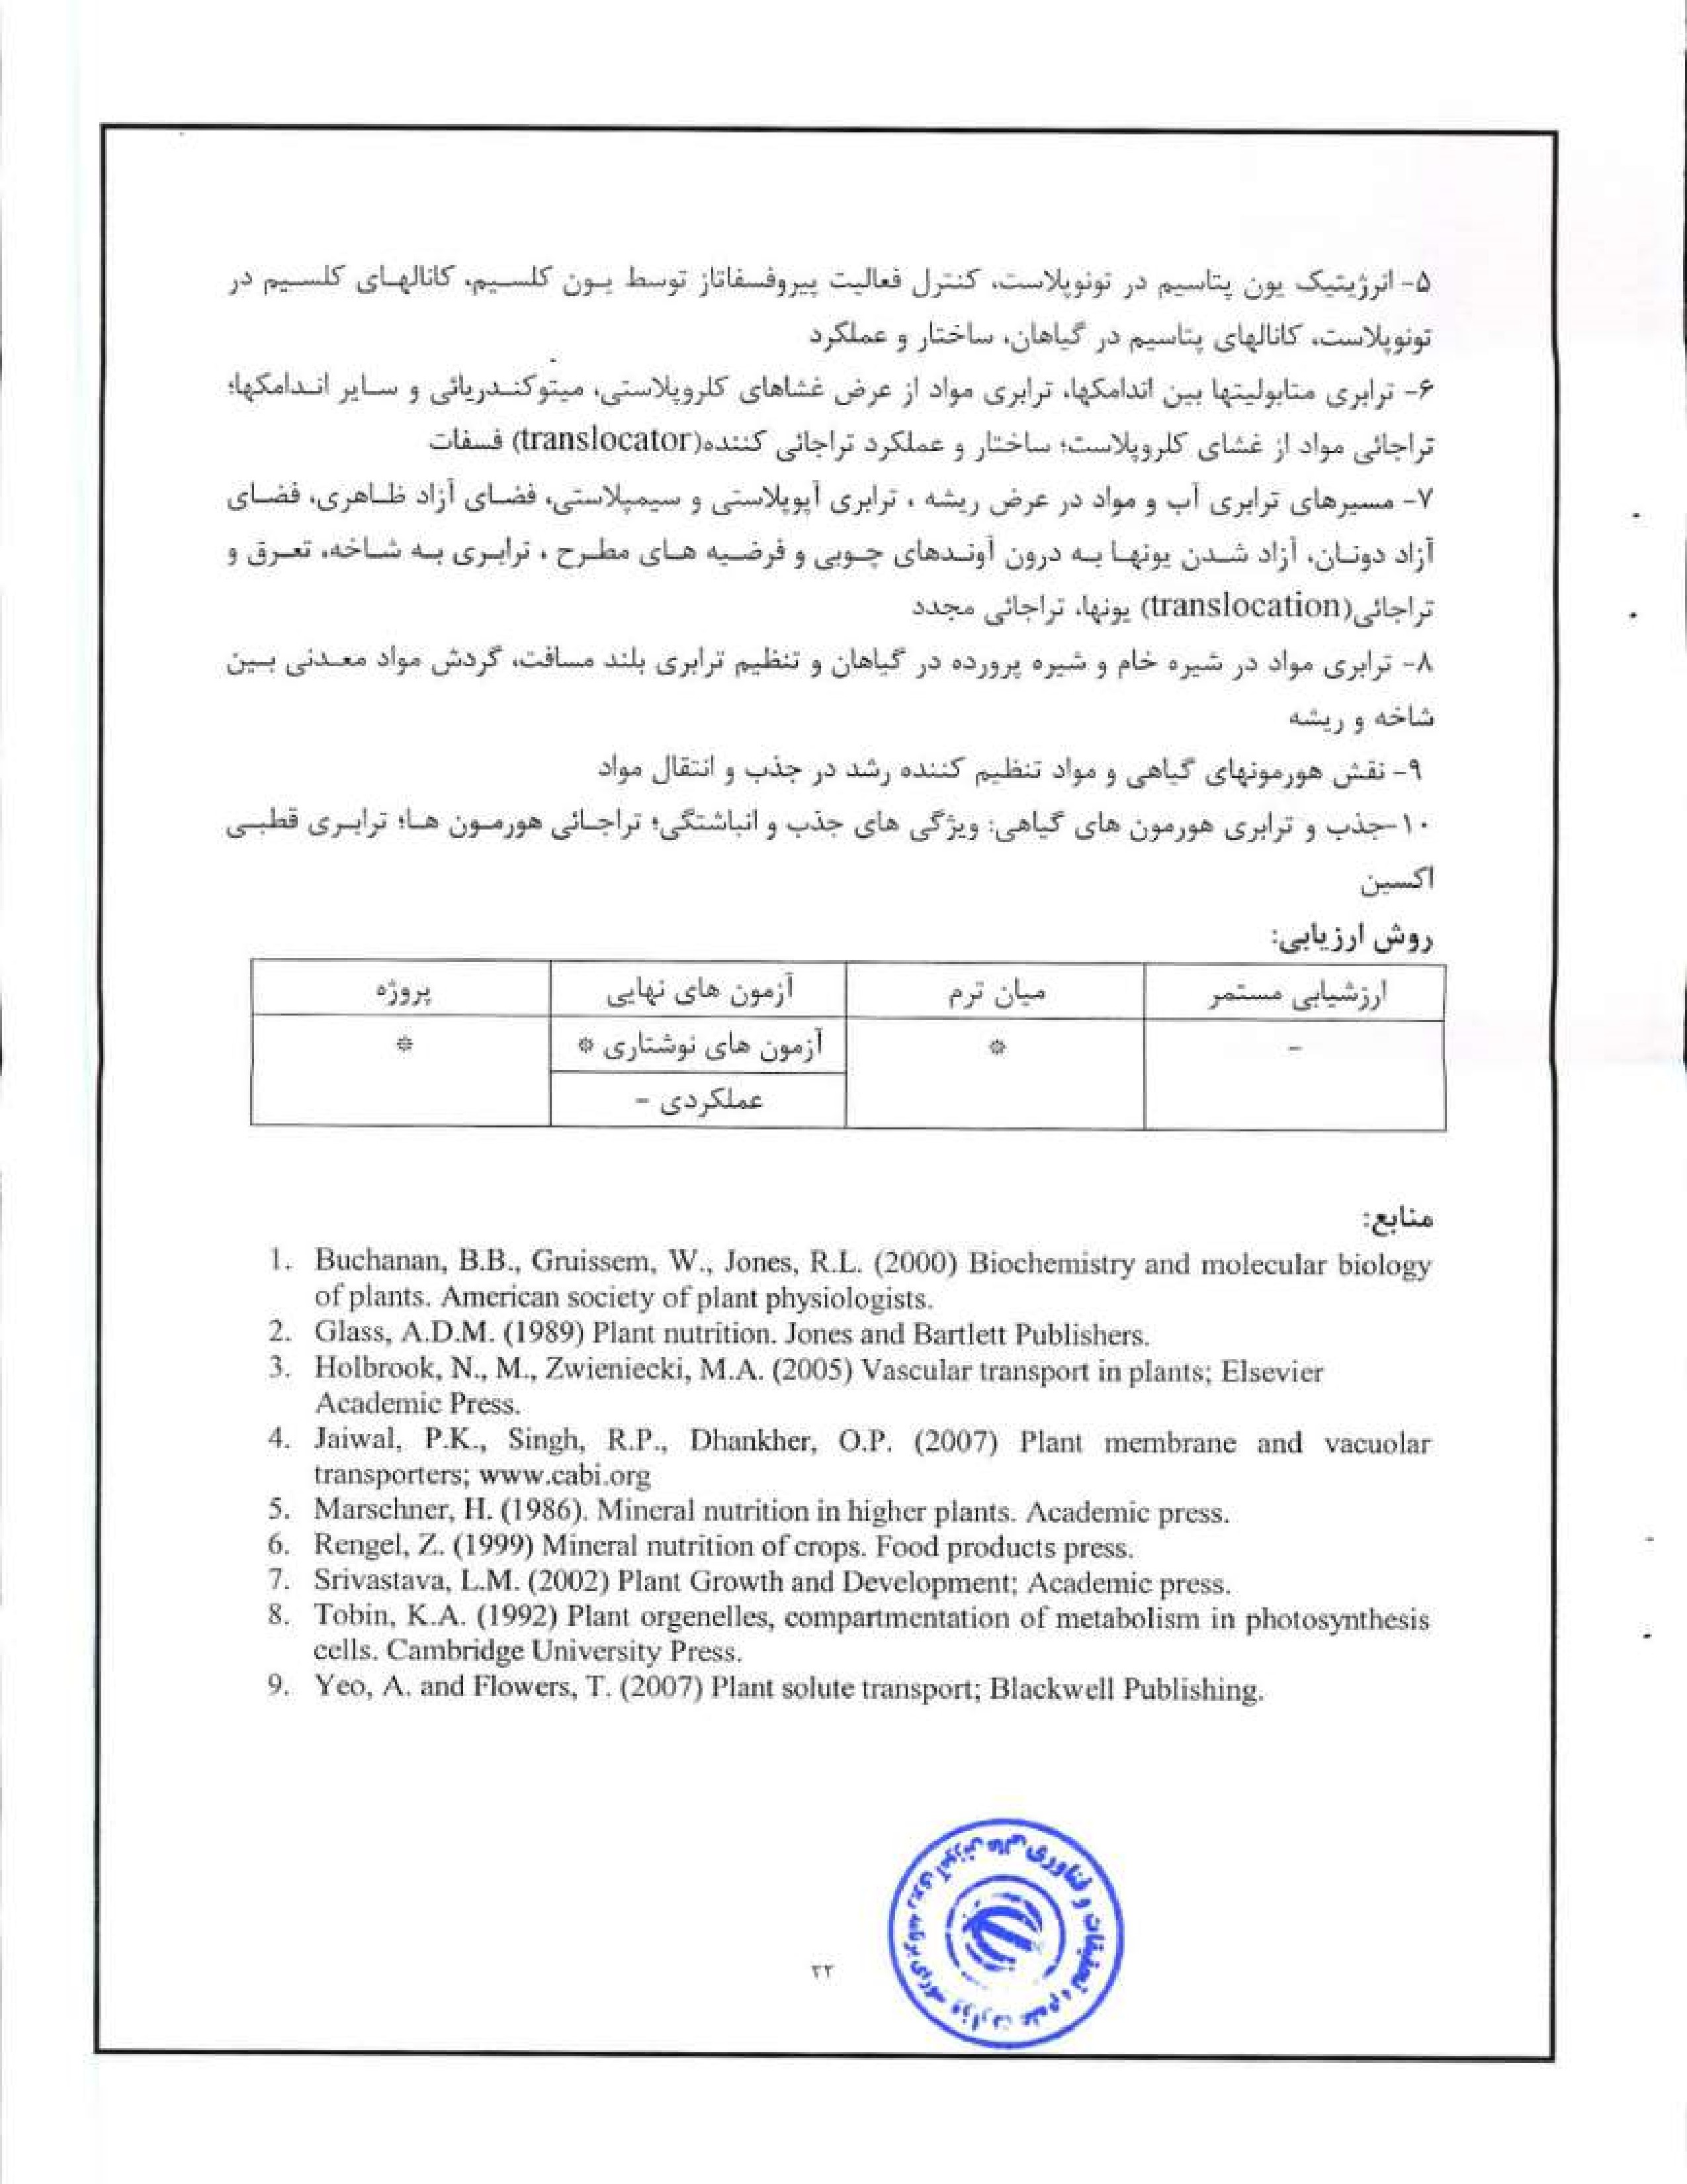
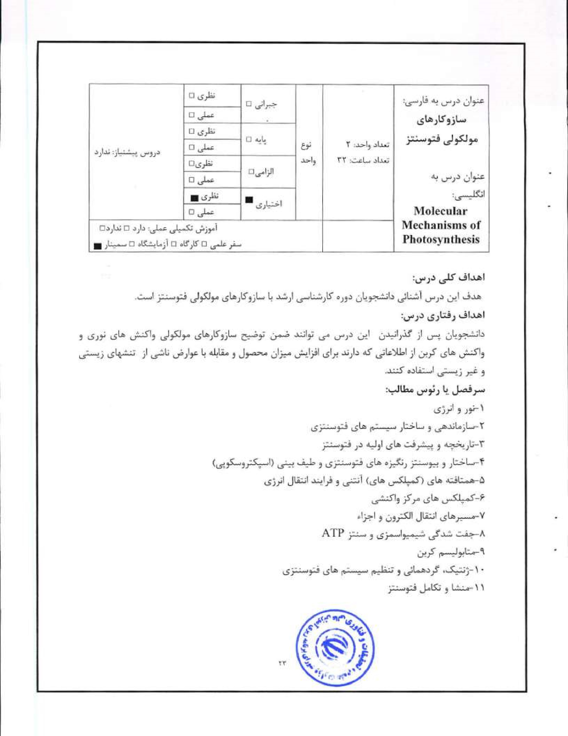


 |  |  | 
 |  | .9
1. Blankenship, R.E. (2002) Molecular Mechanisms of Photosynthesis; Blackwell,
2- Buchanan, BB., Gruissem, W.. Jones, R.I.. (2000) Biochemistry and Molecular Biology of Plants. American society of plant physiologists,
- I.eegood* Sharkey, T-D.Caemmerer, S. (2000) Photosynthesis: Physiology and Metabolism. KluwerAcademic Publisher.
- Lowlor, D. (2001) Photosynthesis. BIOS Scientific publishers Ltd.


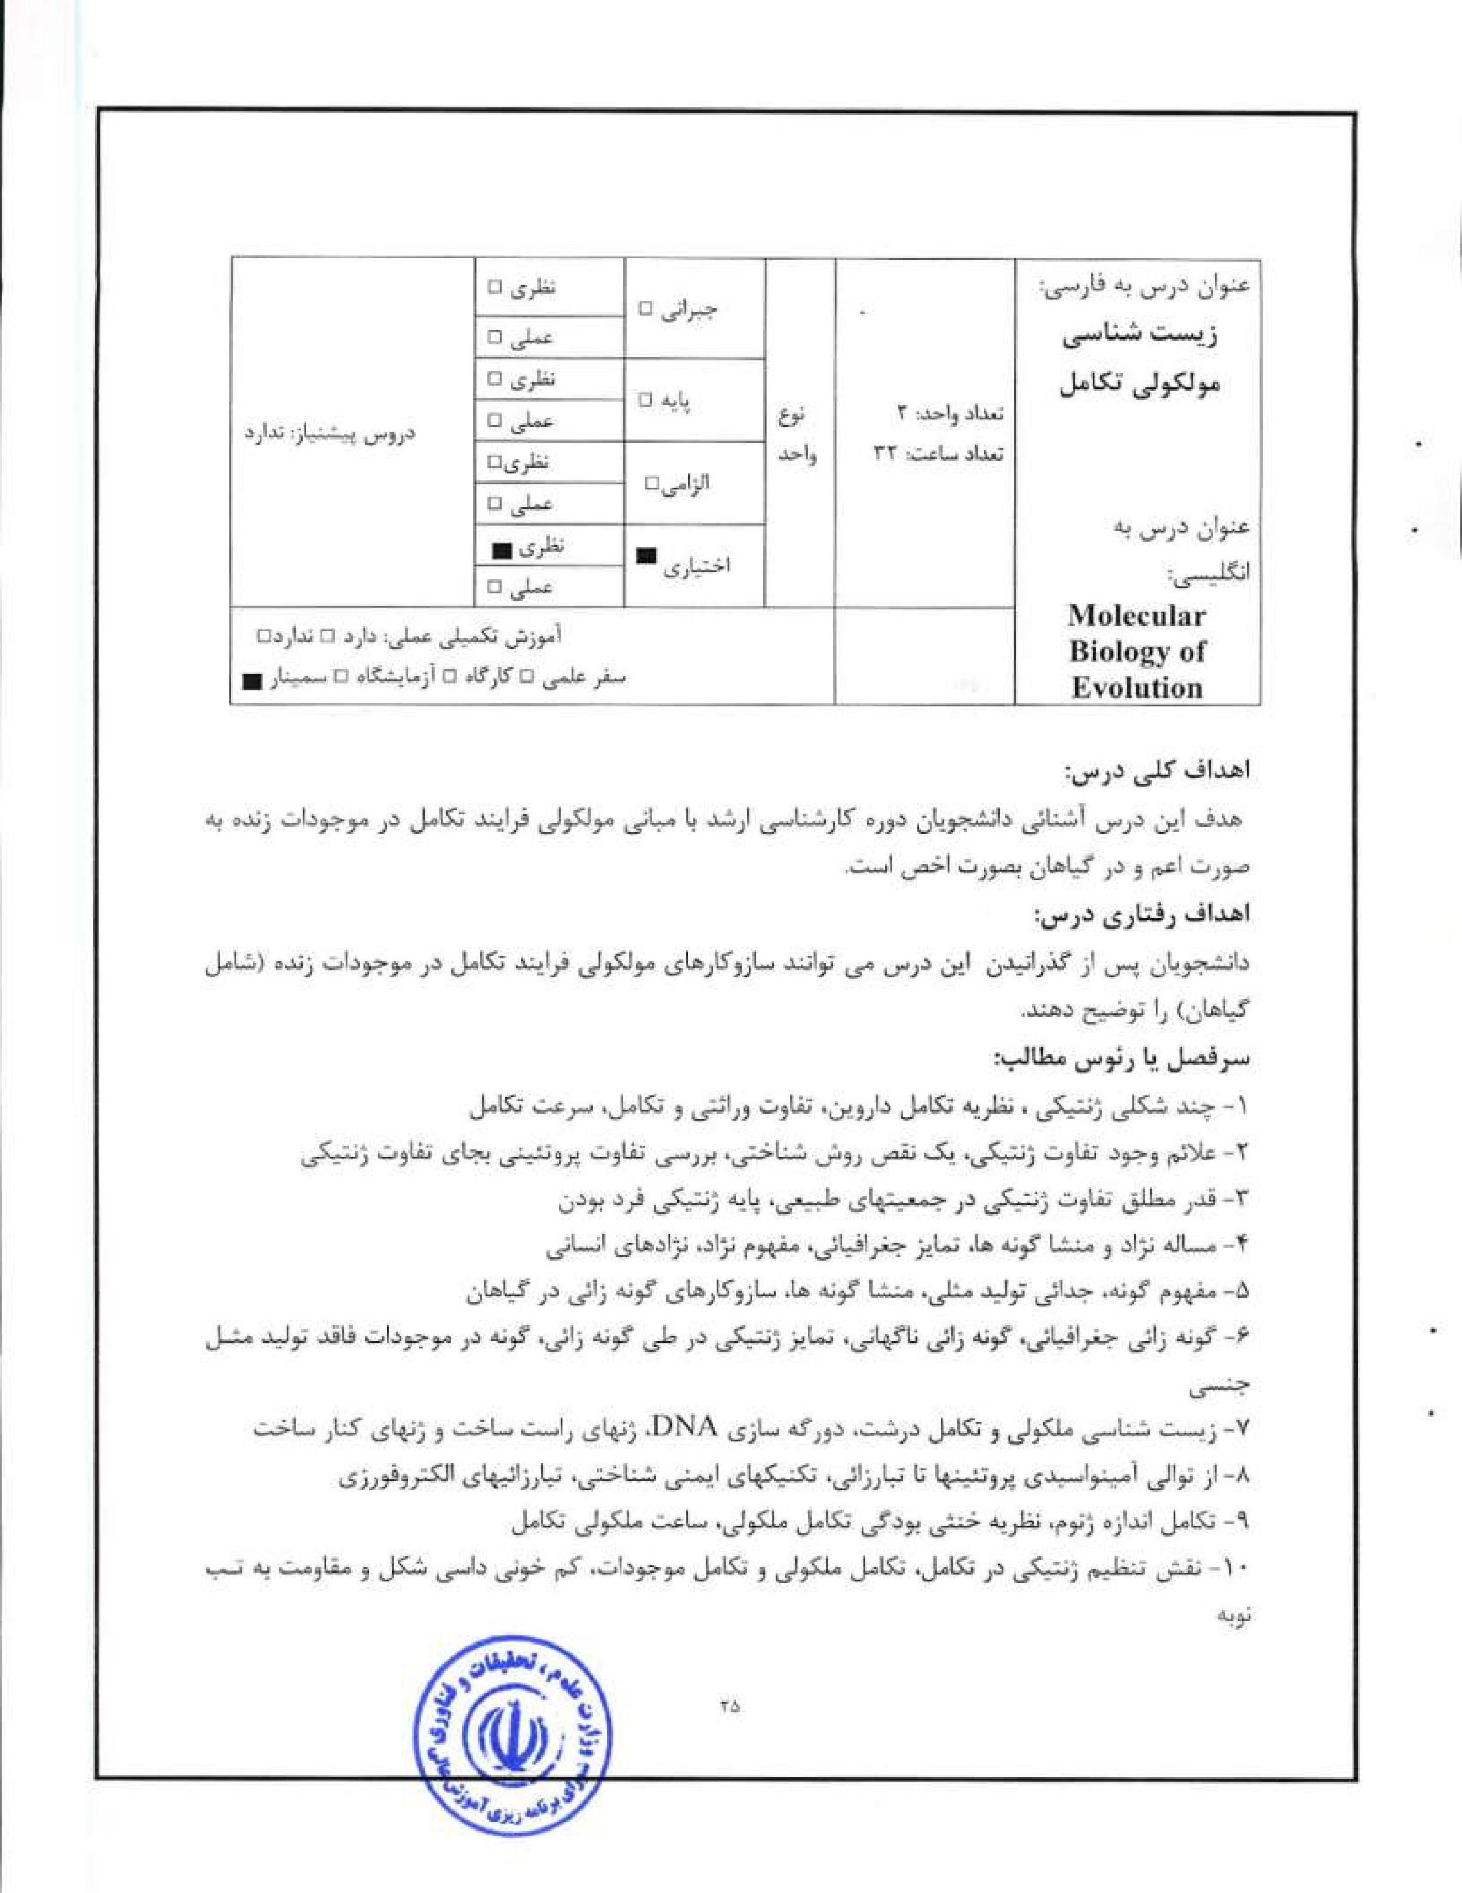
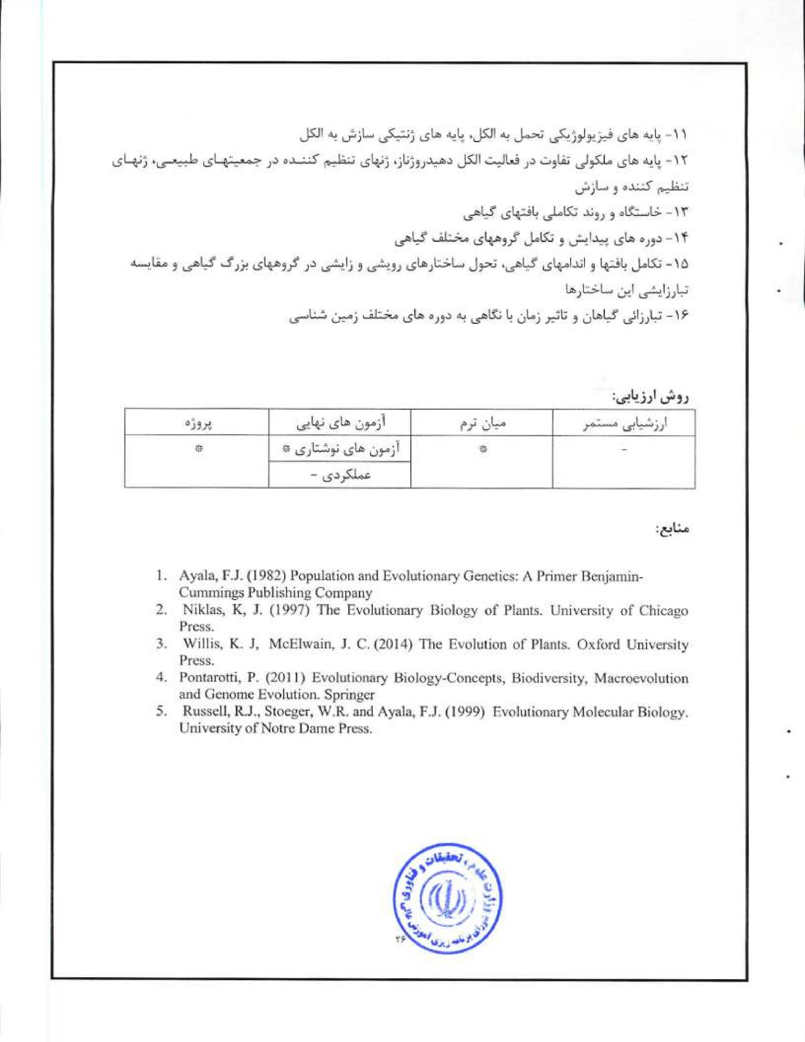
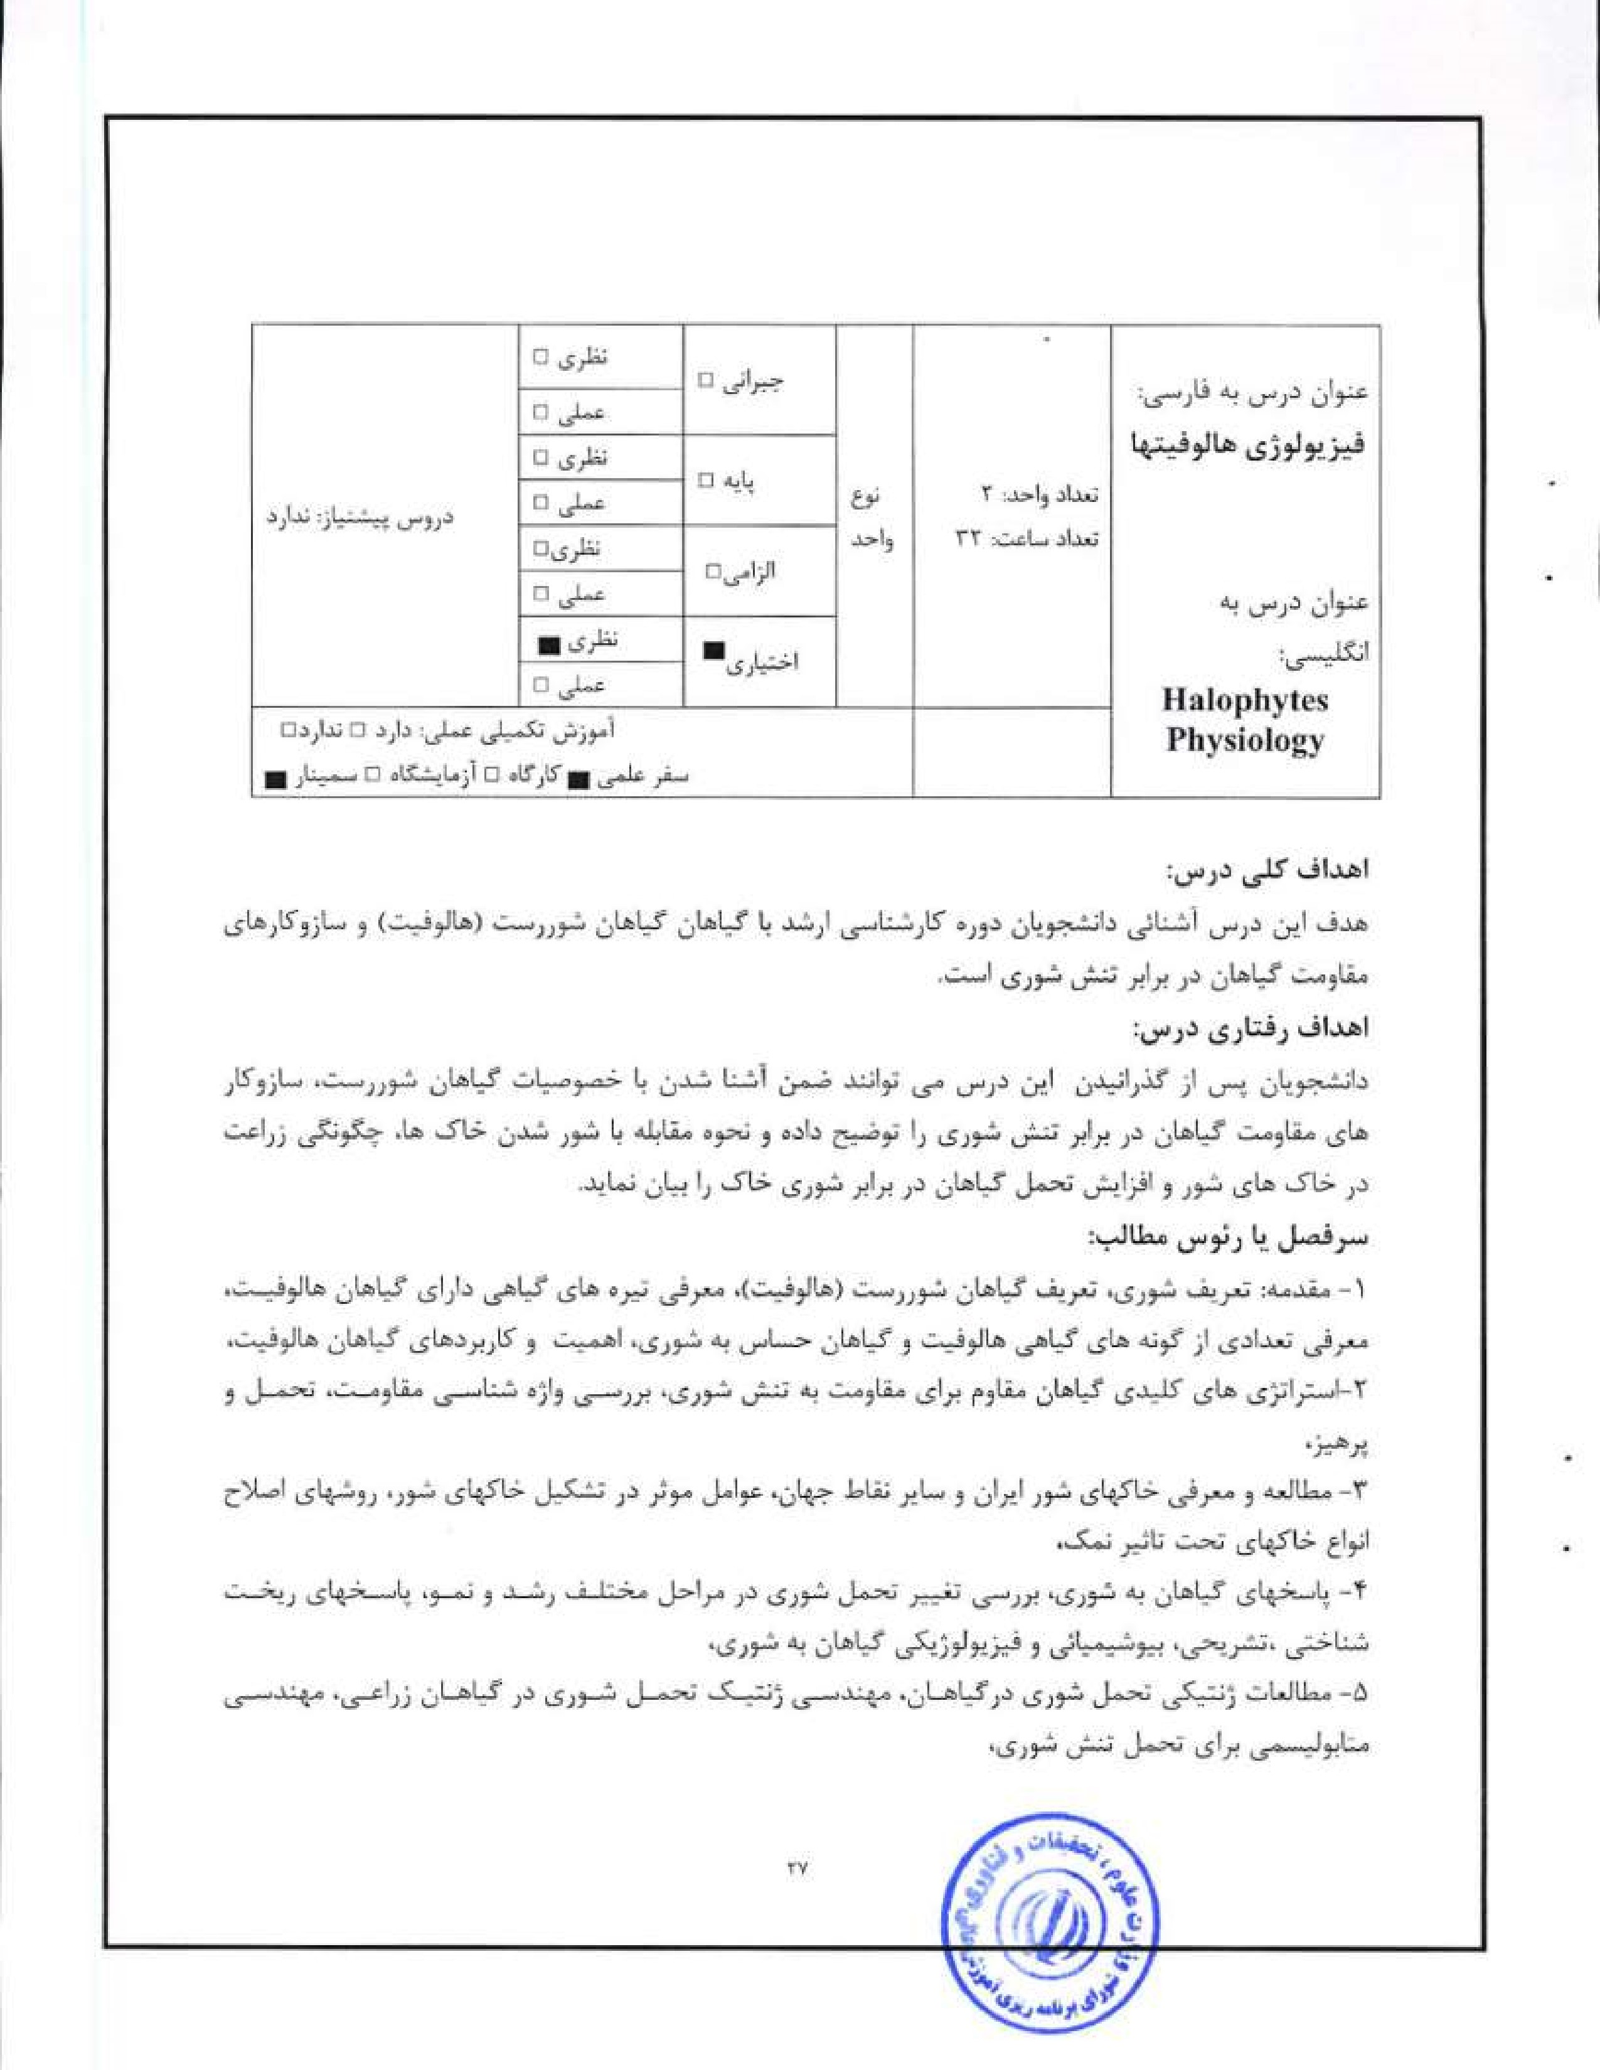

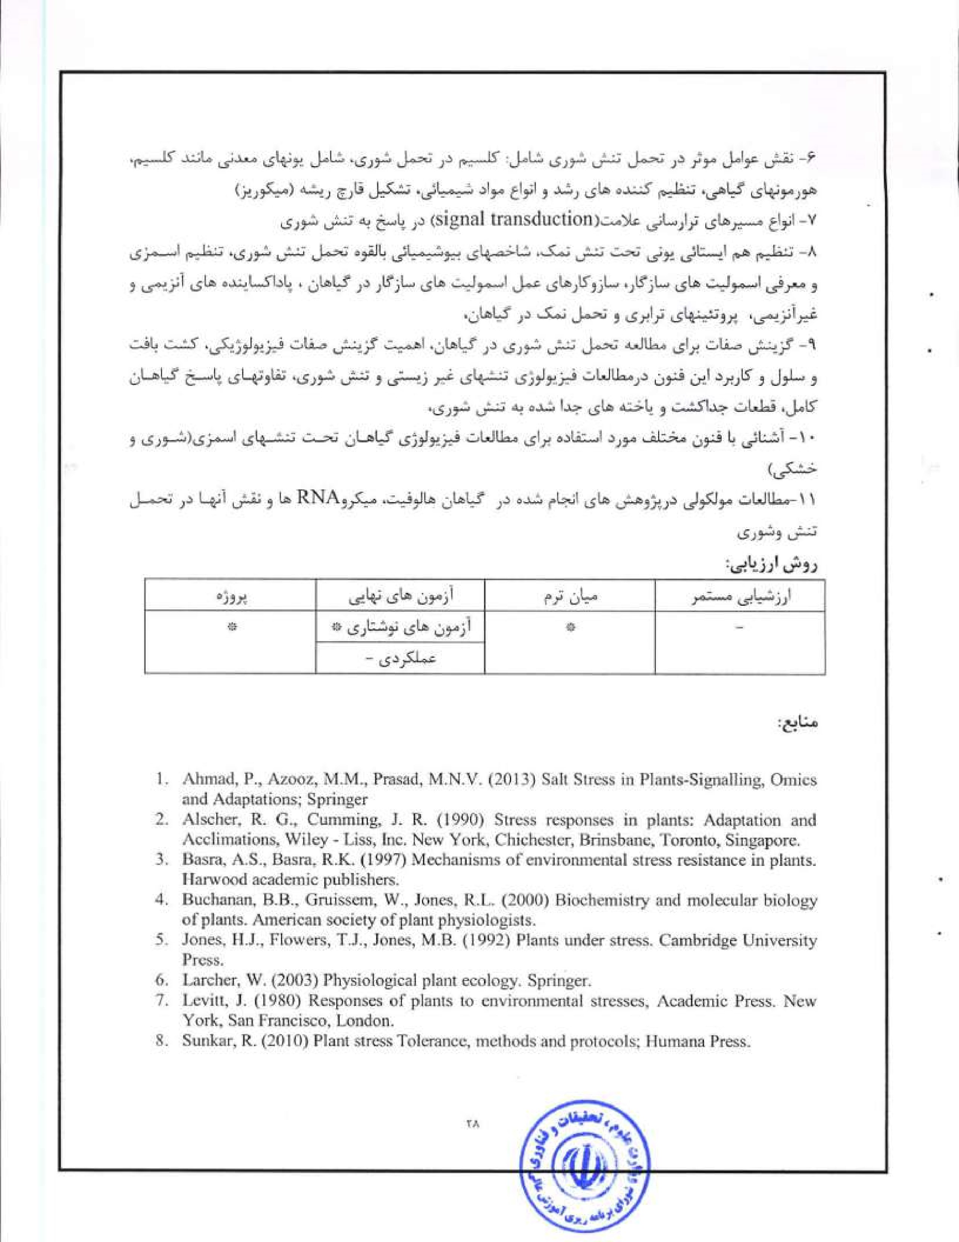

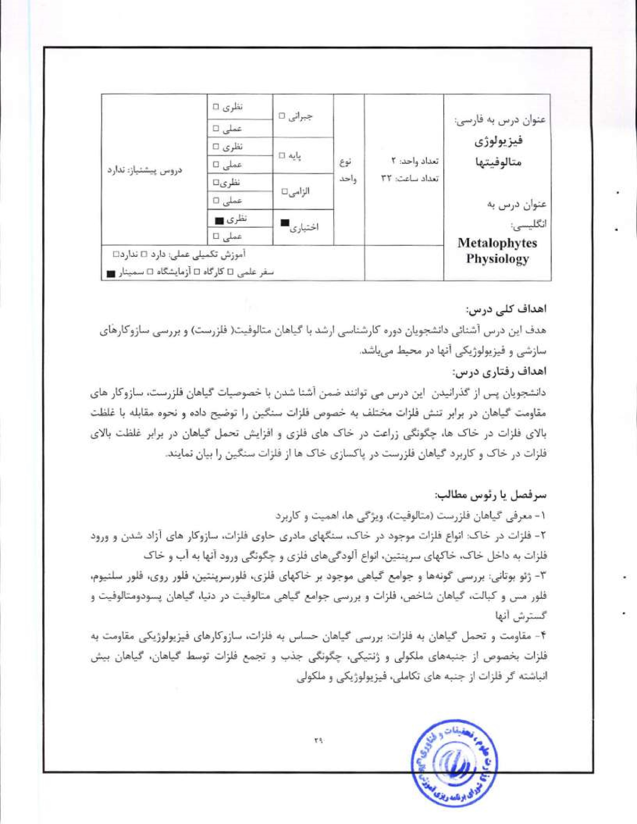
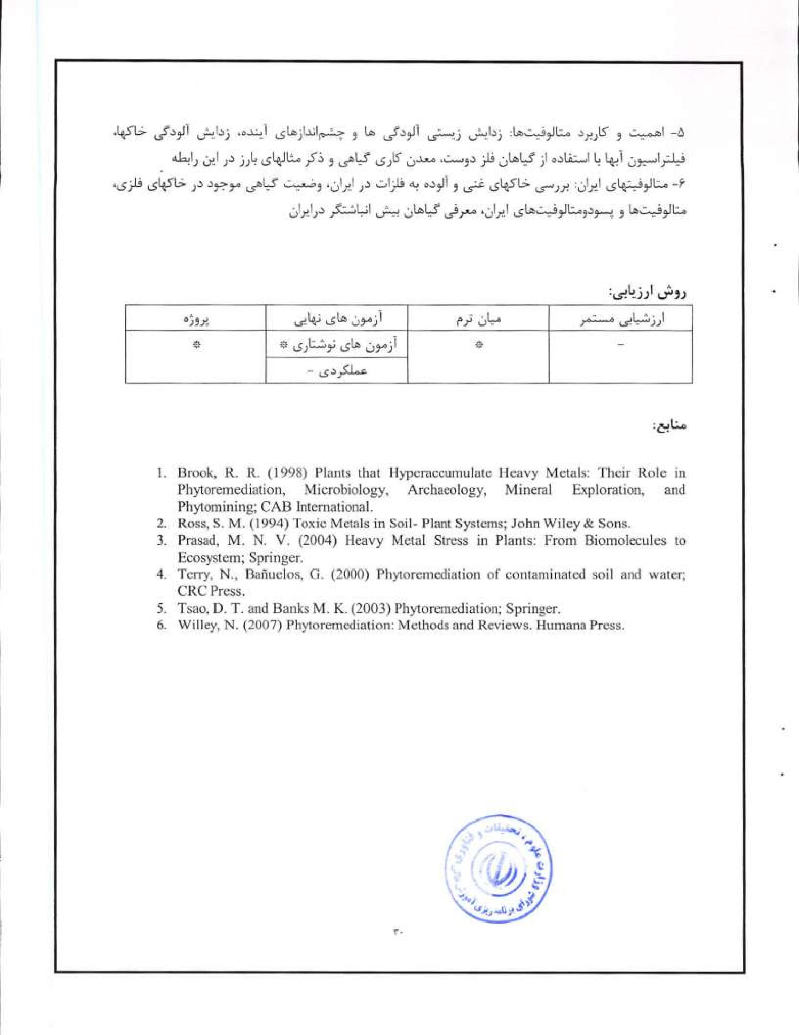
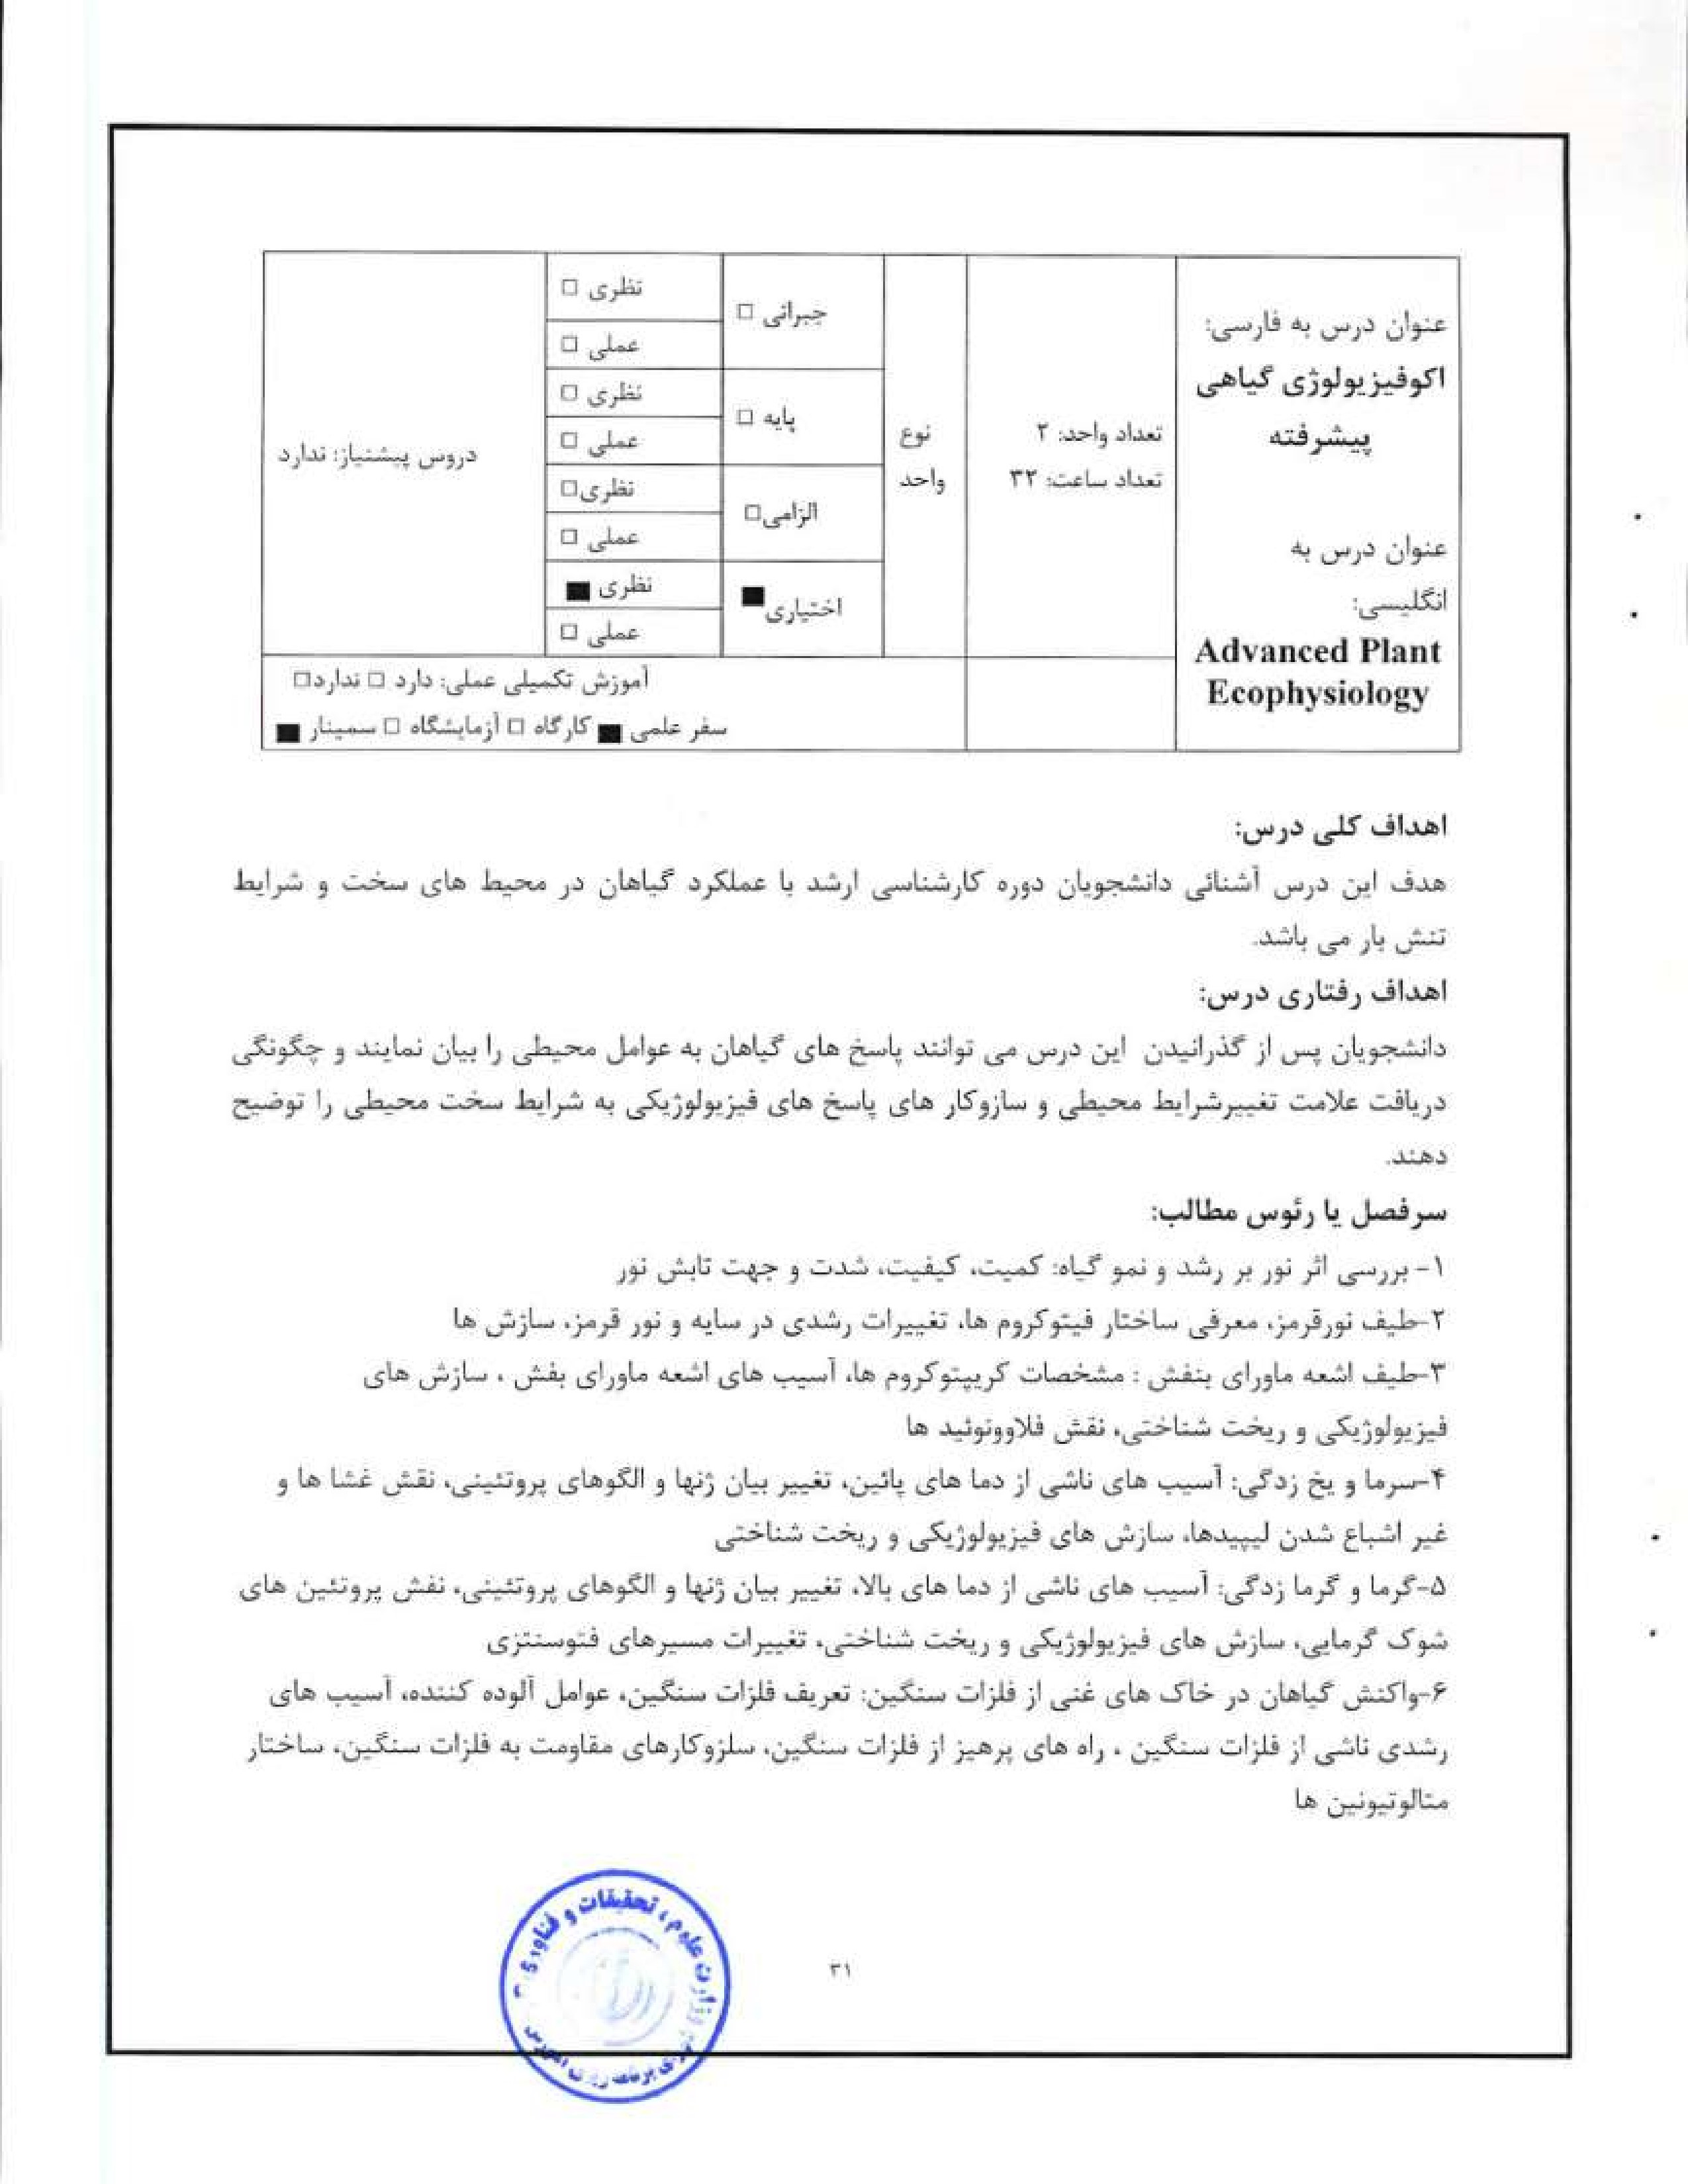
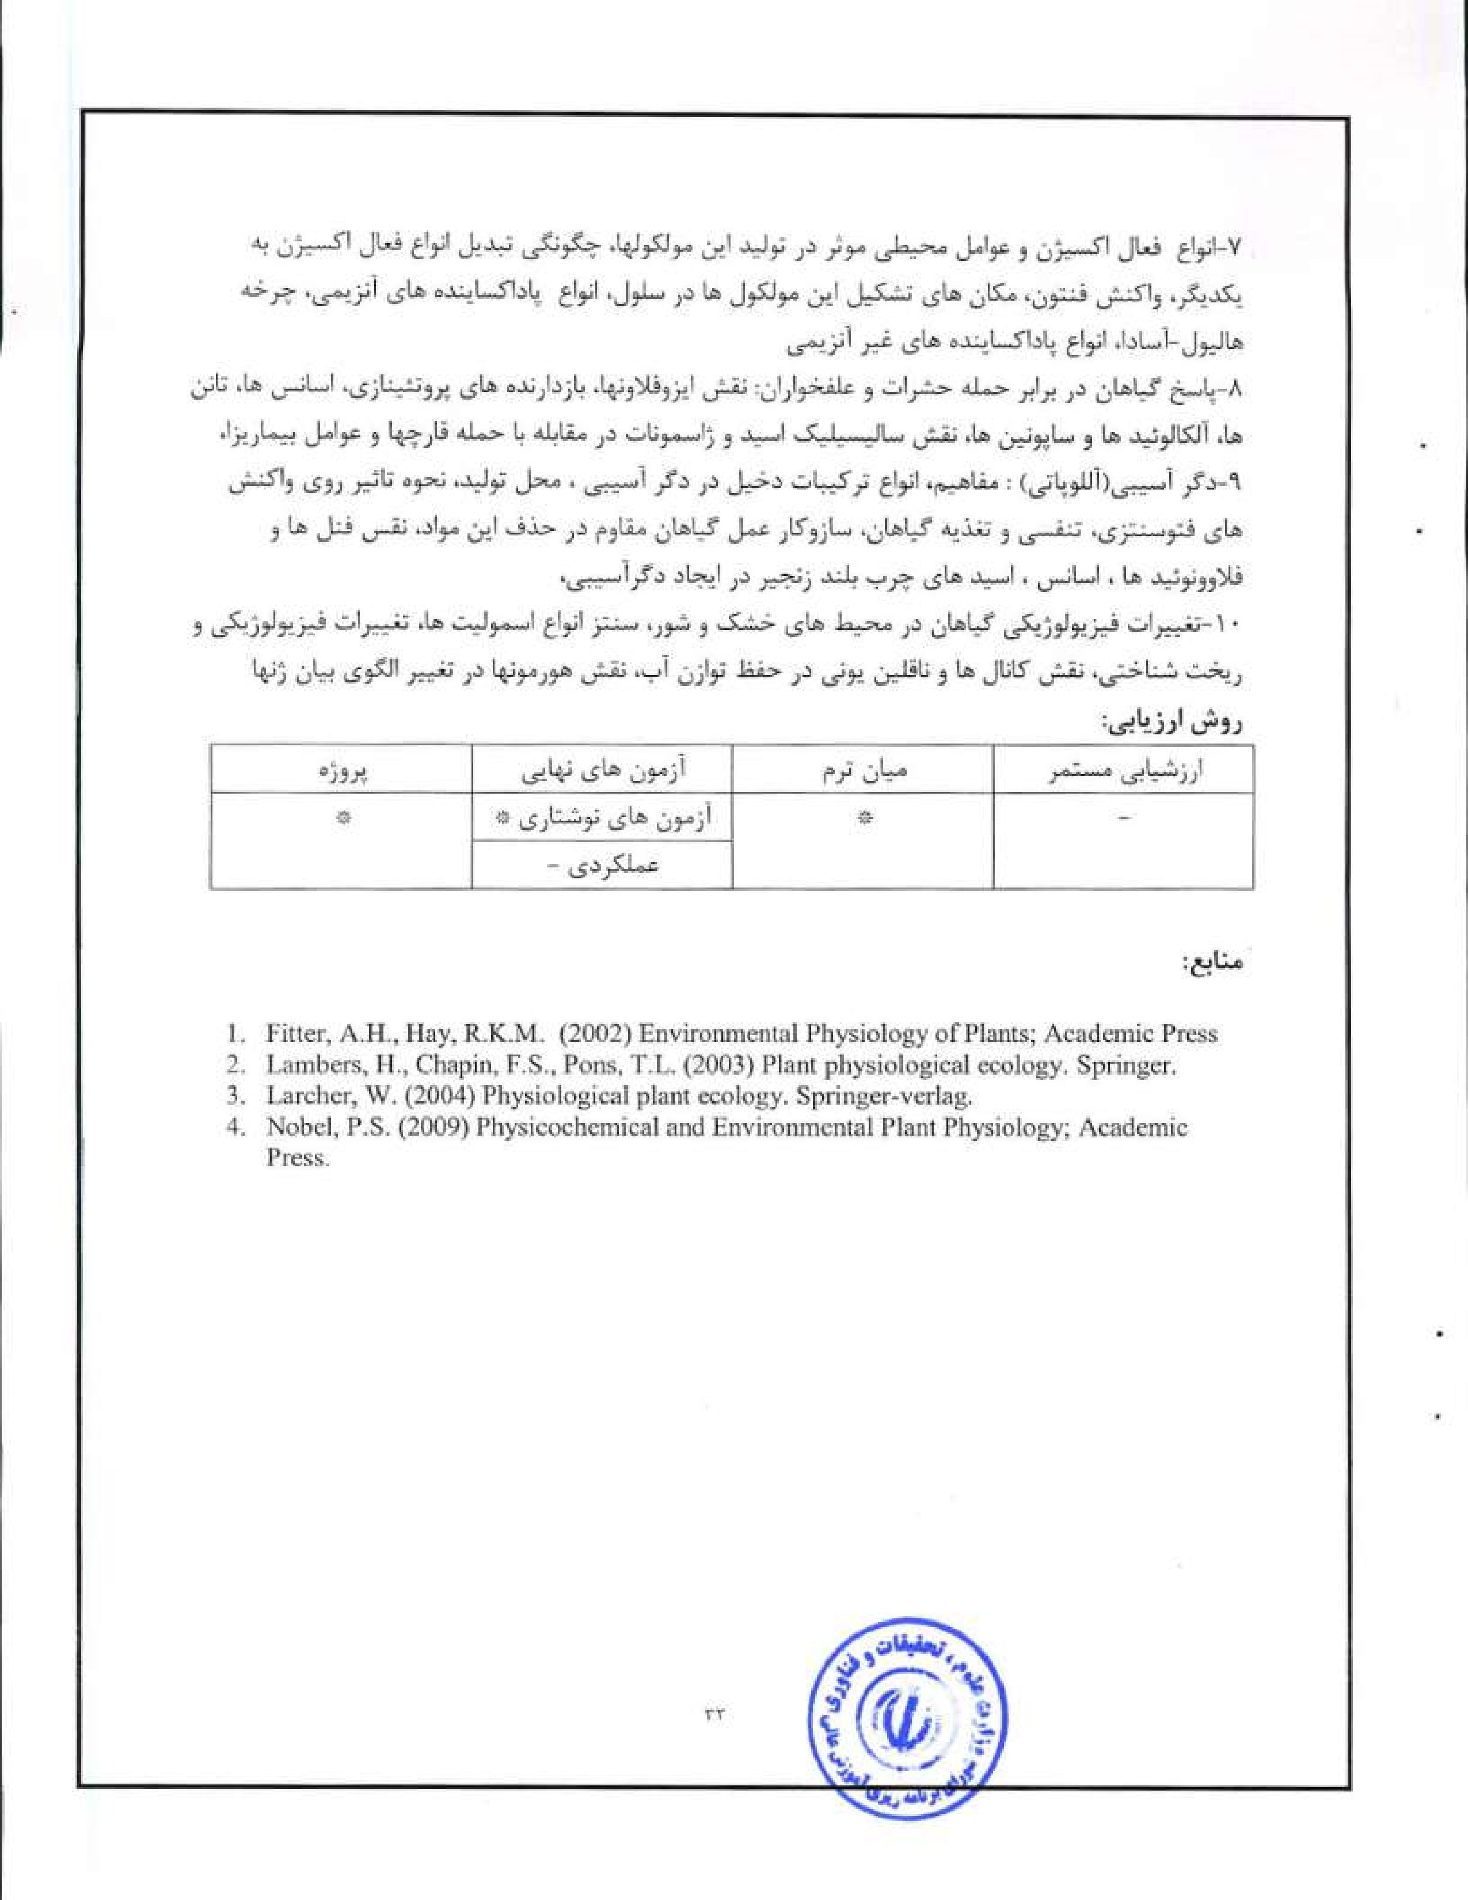
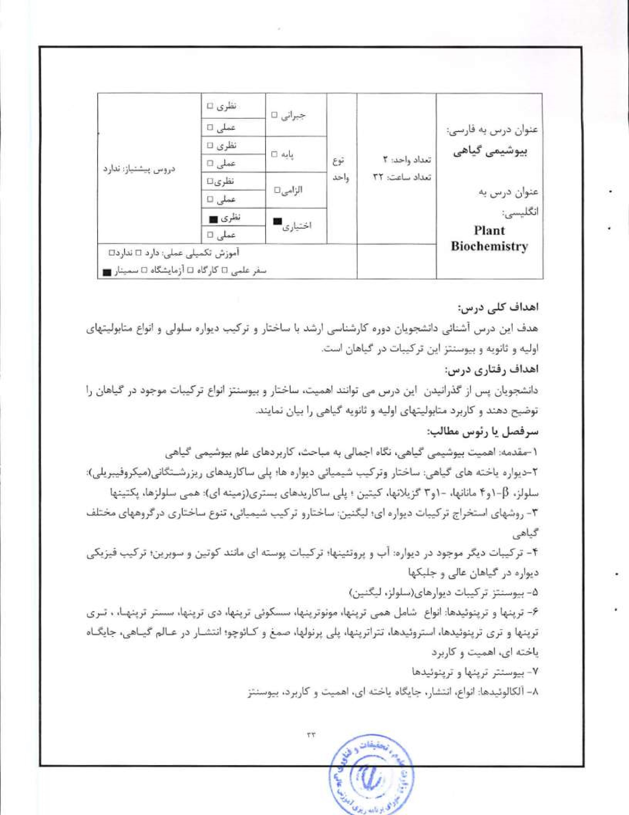

2.  3.  4. |     Buchanan, B.B„ Gnaissem, Jones, R.I.. (2000) Biochemistry and molecular biology of plants. American society of plant physiologists.  Gleason. F., Chollet, R. (2012) Plant Biochemistry; Jones and Bartlett Leaming.  Ciocxlwin, T.W., Mercer, E.I. (1990) Introduction to plant biochemistry. Pergamon press, Ileldt, IL-W. (2005) Plant Biochemistry; Elsevier.  

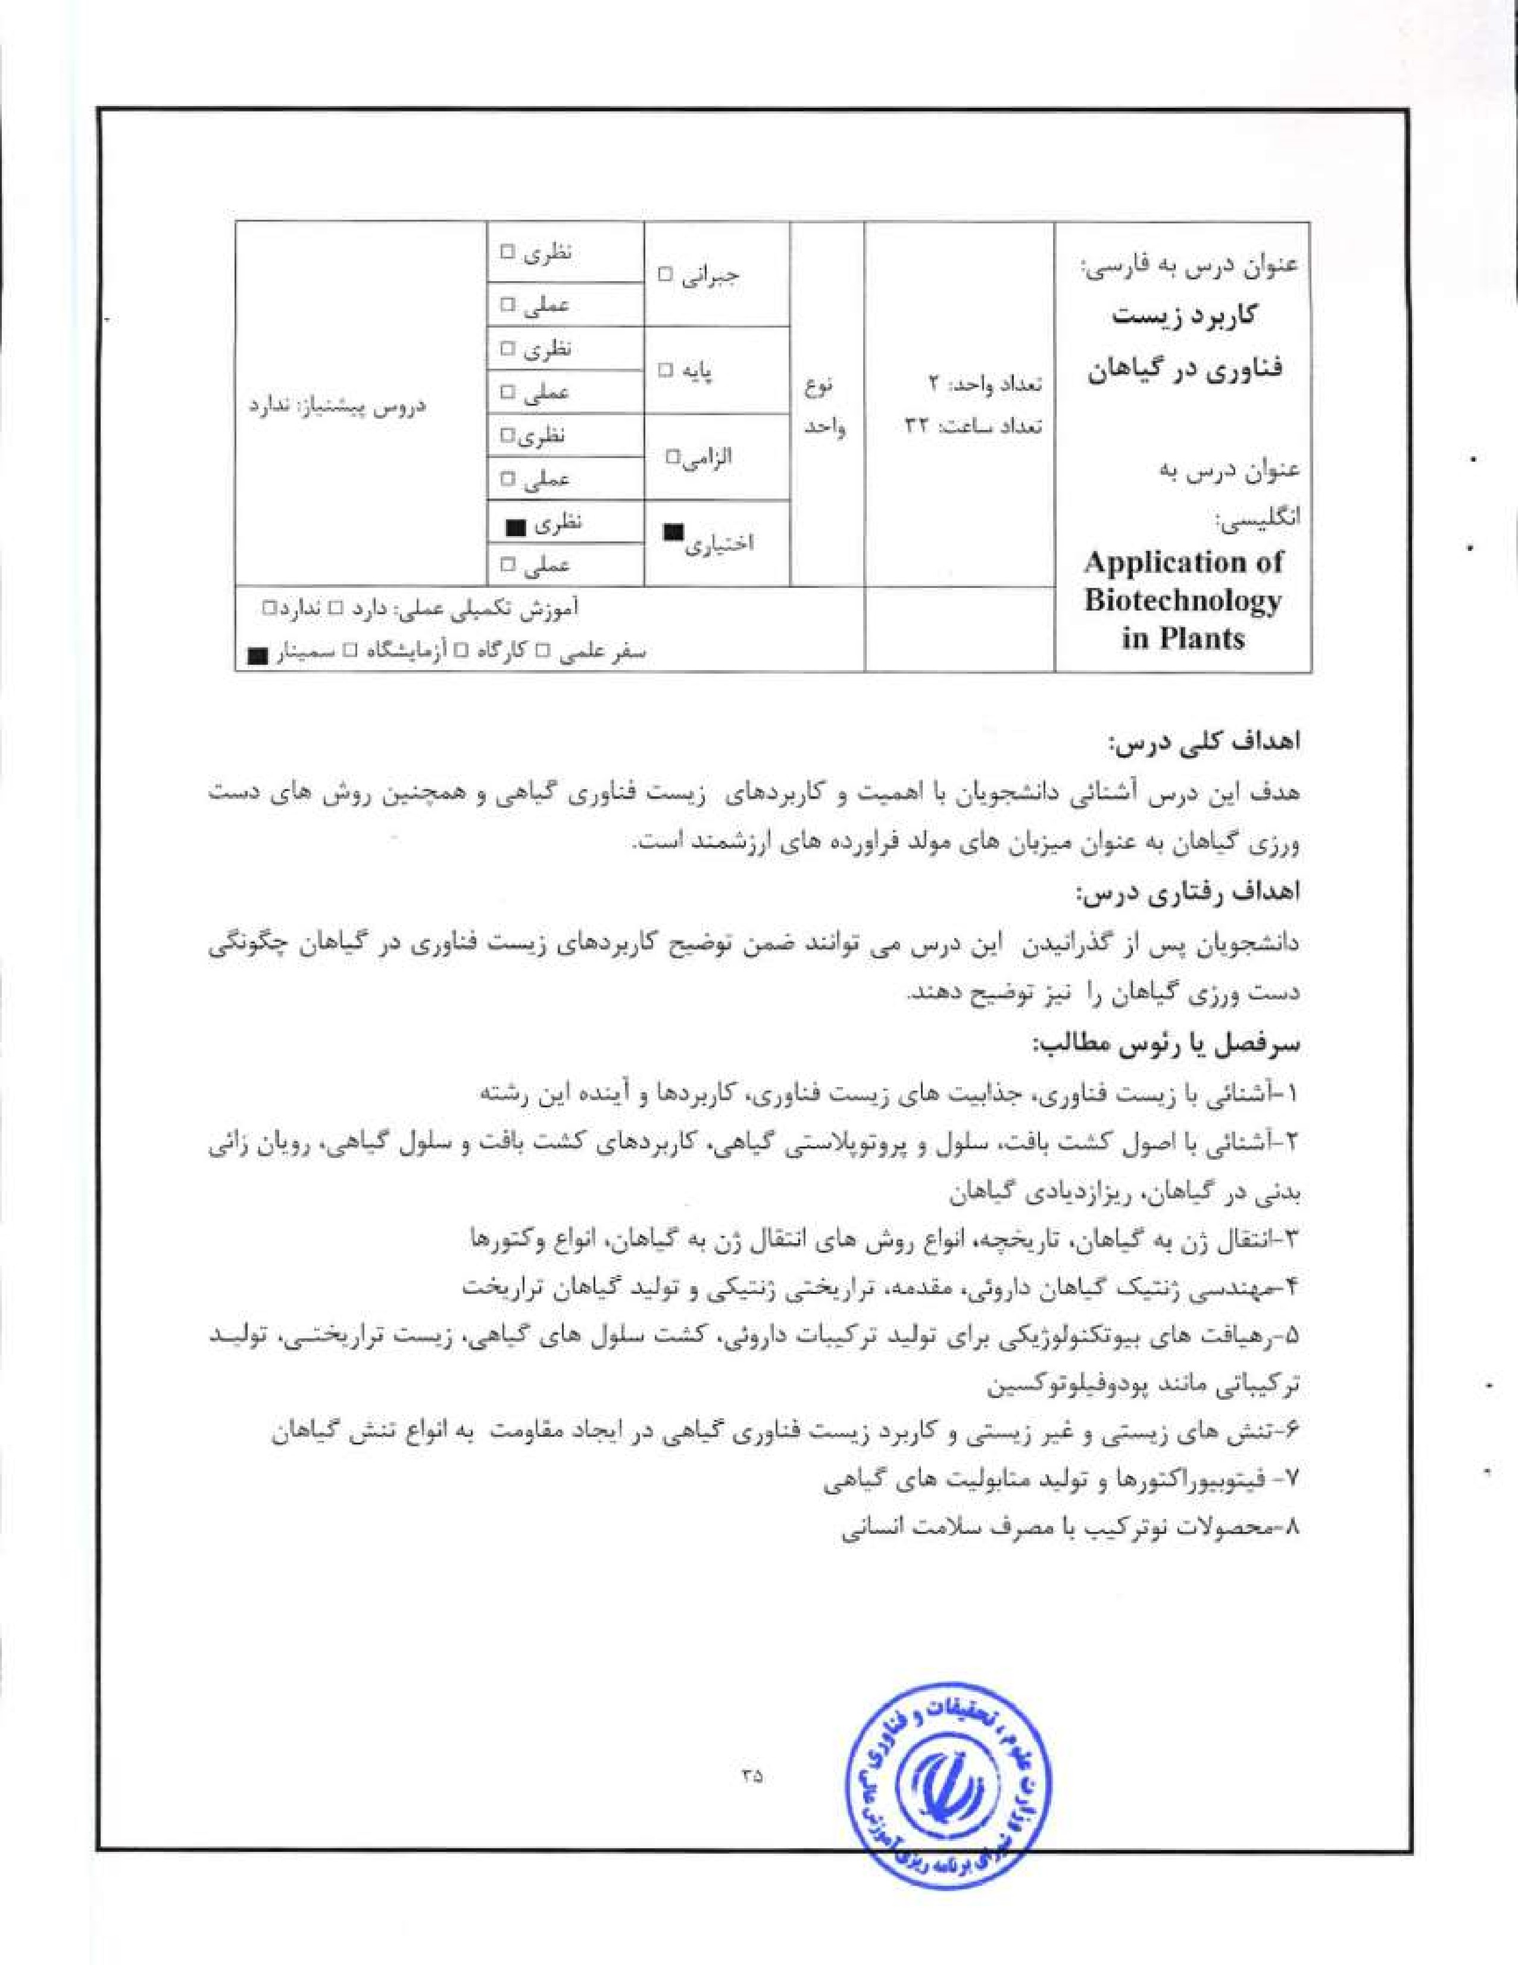


l . Kayser, Quax, WJ. (2007) Medicinal Plant Biotechnology, WILEY-VCII Verlag
GmbH & co. KGaA,
- Lorz. ll., Wenzel, G. (2005) Biotechnology in Agriculture and Forestry; Springer
- Thangadurai, D., Tang, W Song, SEQ. (2007) Plant Stress and Biotechnology; Oxford Book Company.


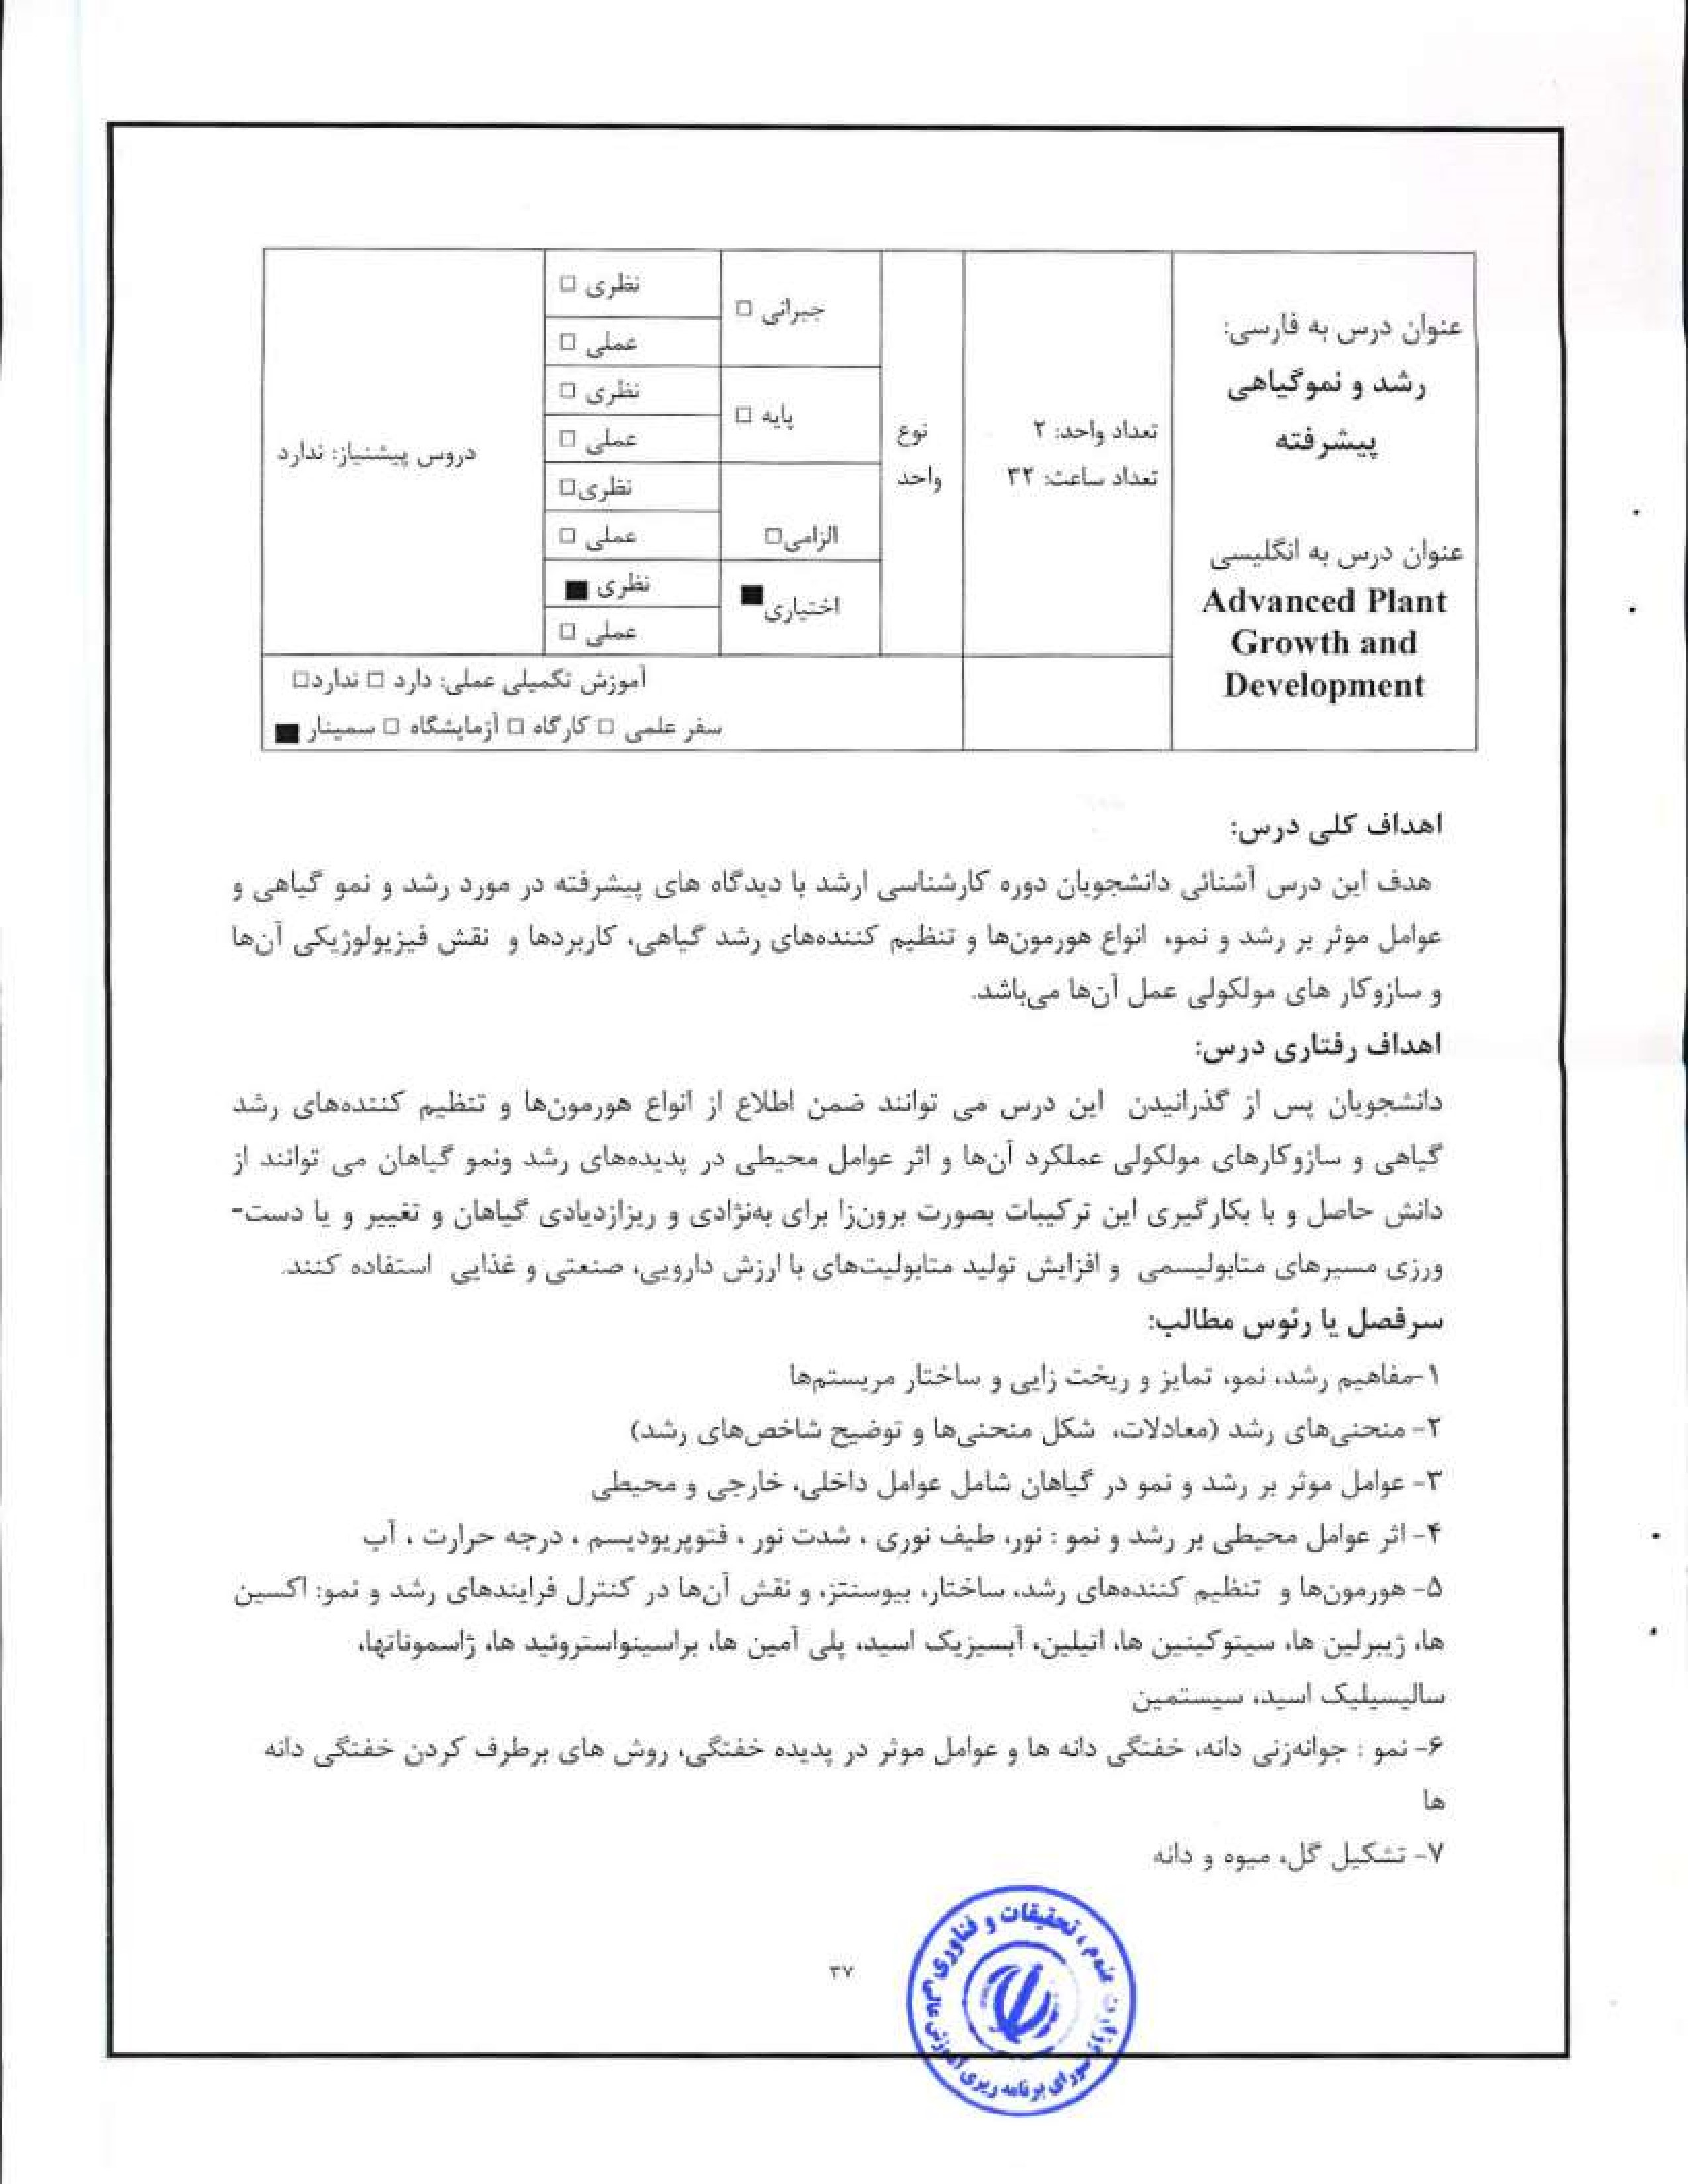

1>1.4


Leopold, AT C.. Kriedemann P. E. (1975) Plant Growth and Development. McGraw-
Hill Inc,
- Srivastava, L. M- (2002) Plant Growth and Development." Ilornwnes and EnvironmenL Academic Press.
- Fosket, D, E. (1995) Plant Grovall and Development: A Molecular Approach. Elsevier Science Ltd.
4. Leysers 0., Day, S. (2003) Mechanisms in Plant Development. Blackwell Publishing,
- opik. Rolfe, S. A.. Willis, A. J.. strcct, E. (2005) The Physiology of Flowering Plants.' Their Growth and Development. Cambridge University Press.
- Taiz. Zeiger, E. (2010). Plant l'hysiology, Fifth Edition, Sinauer Associates Inc.


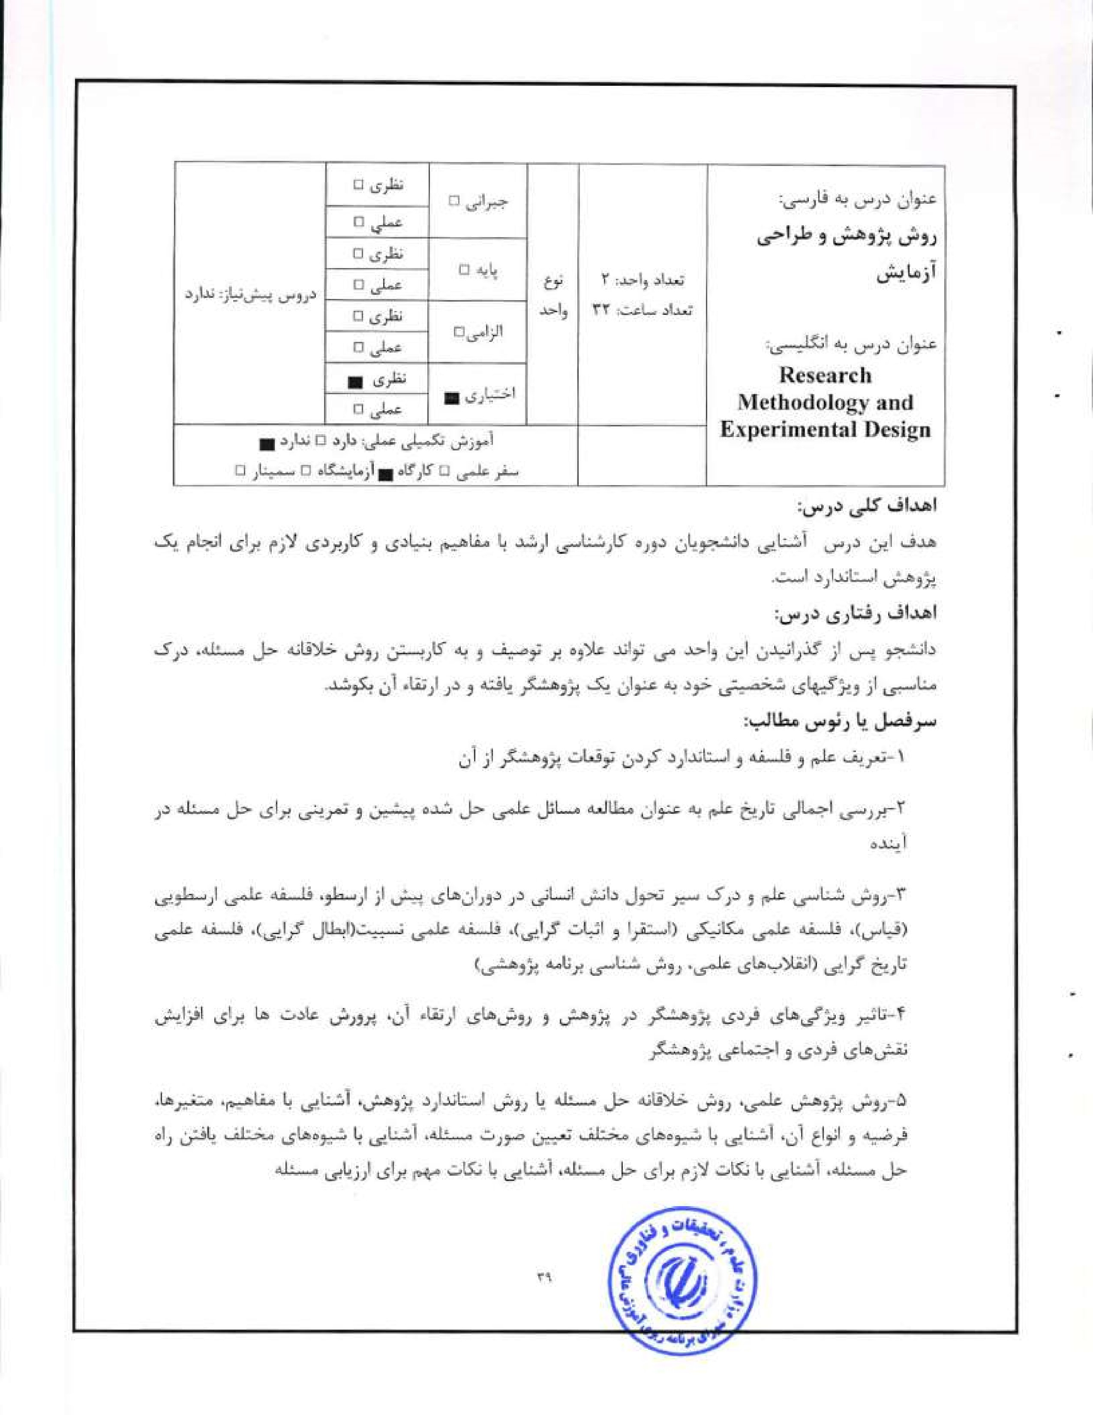
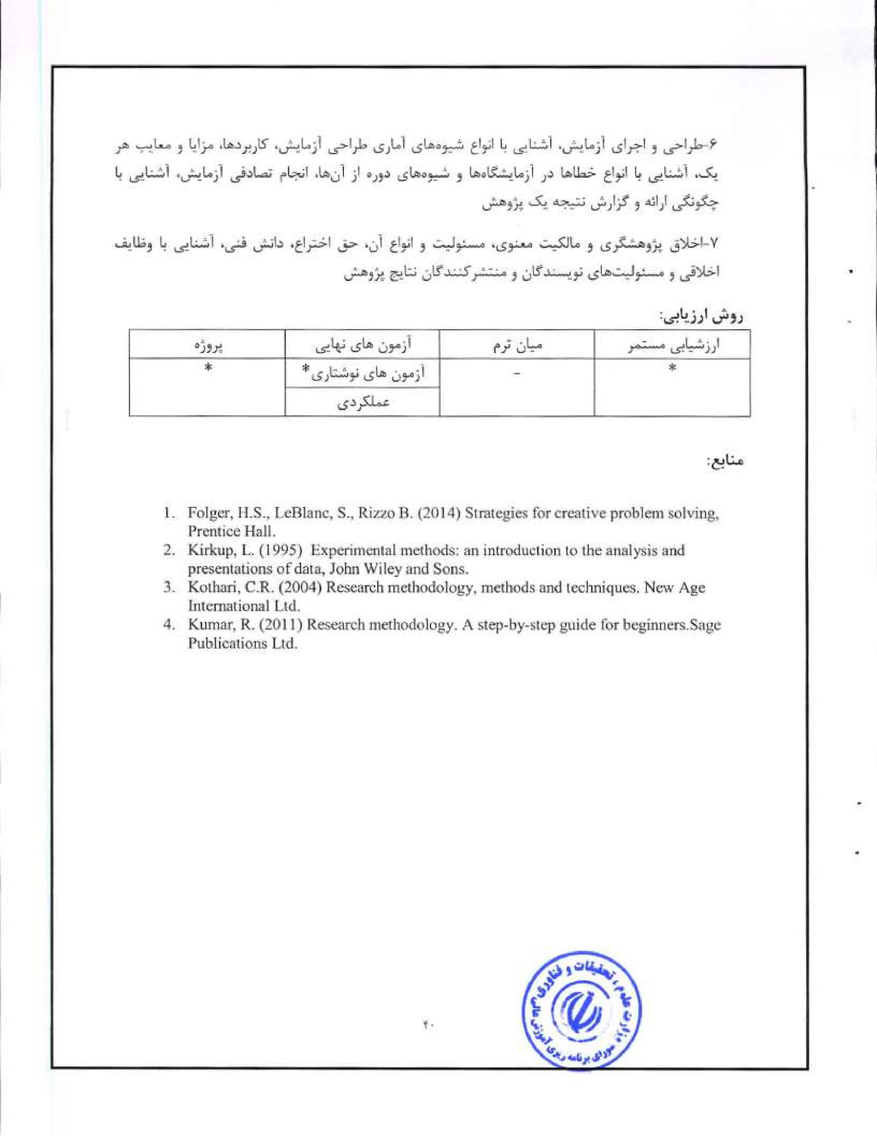
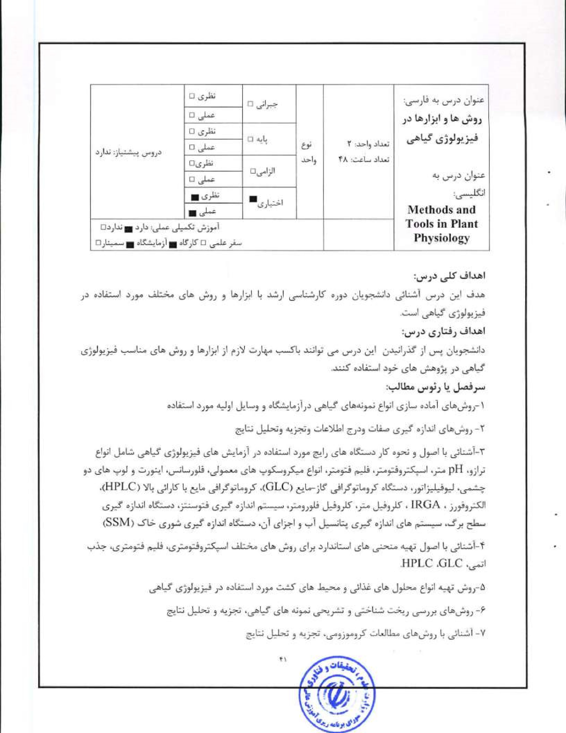
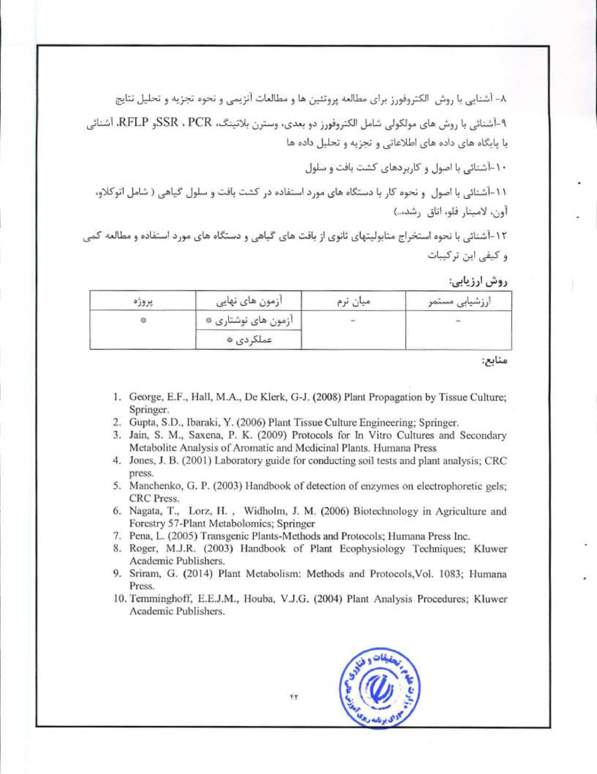
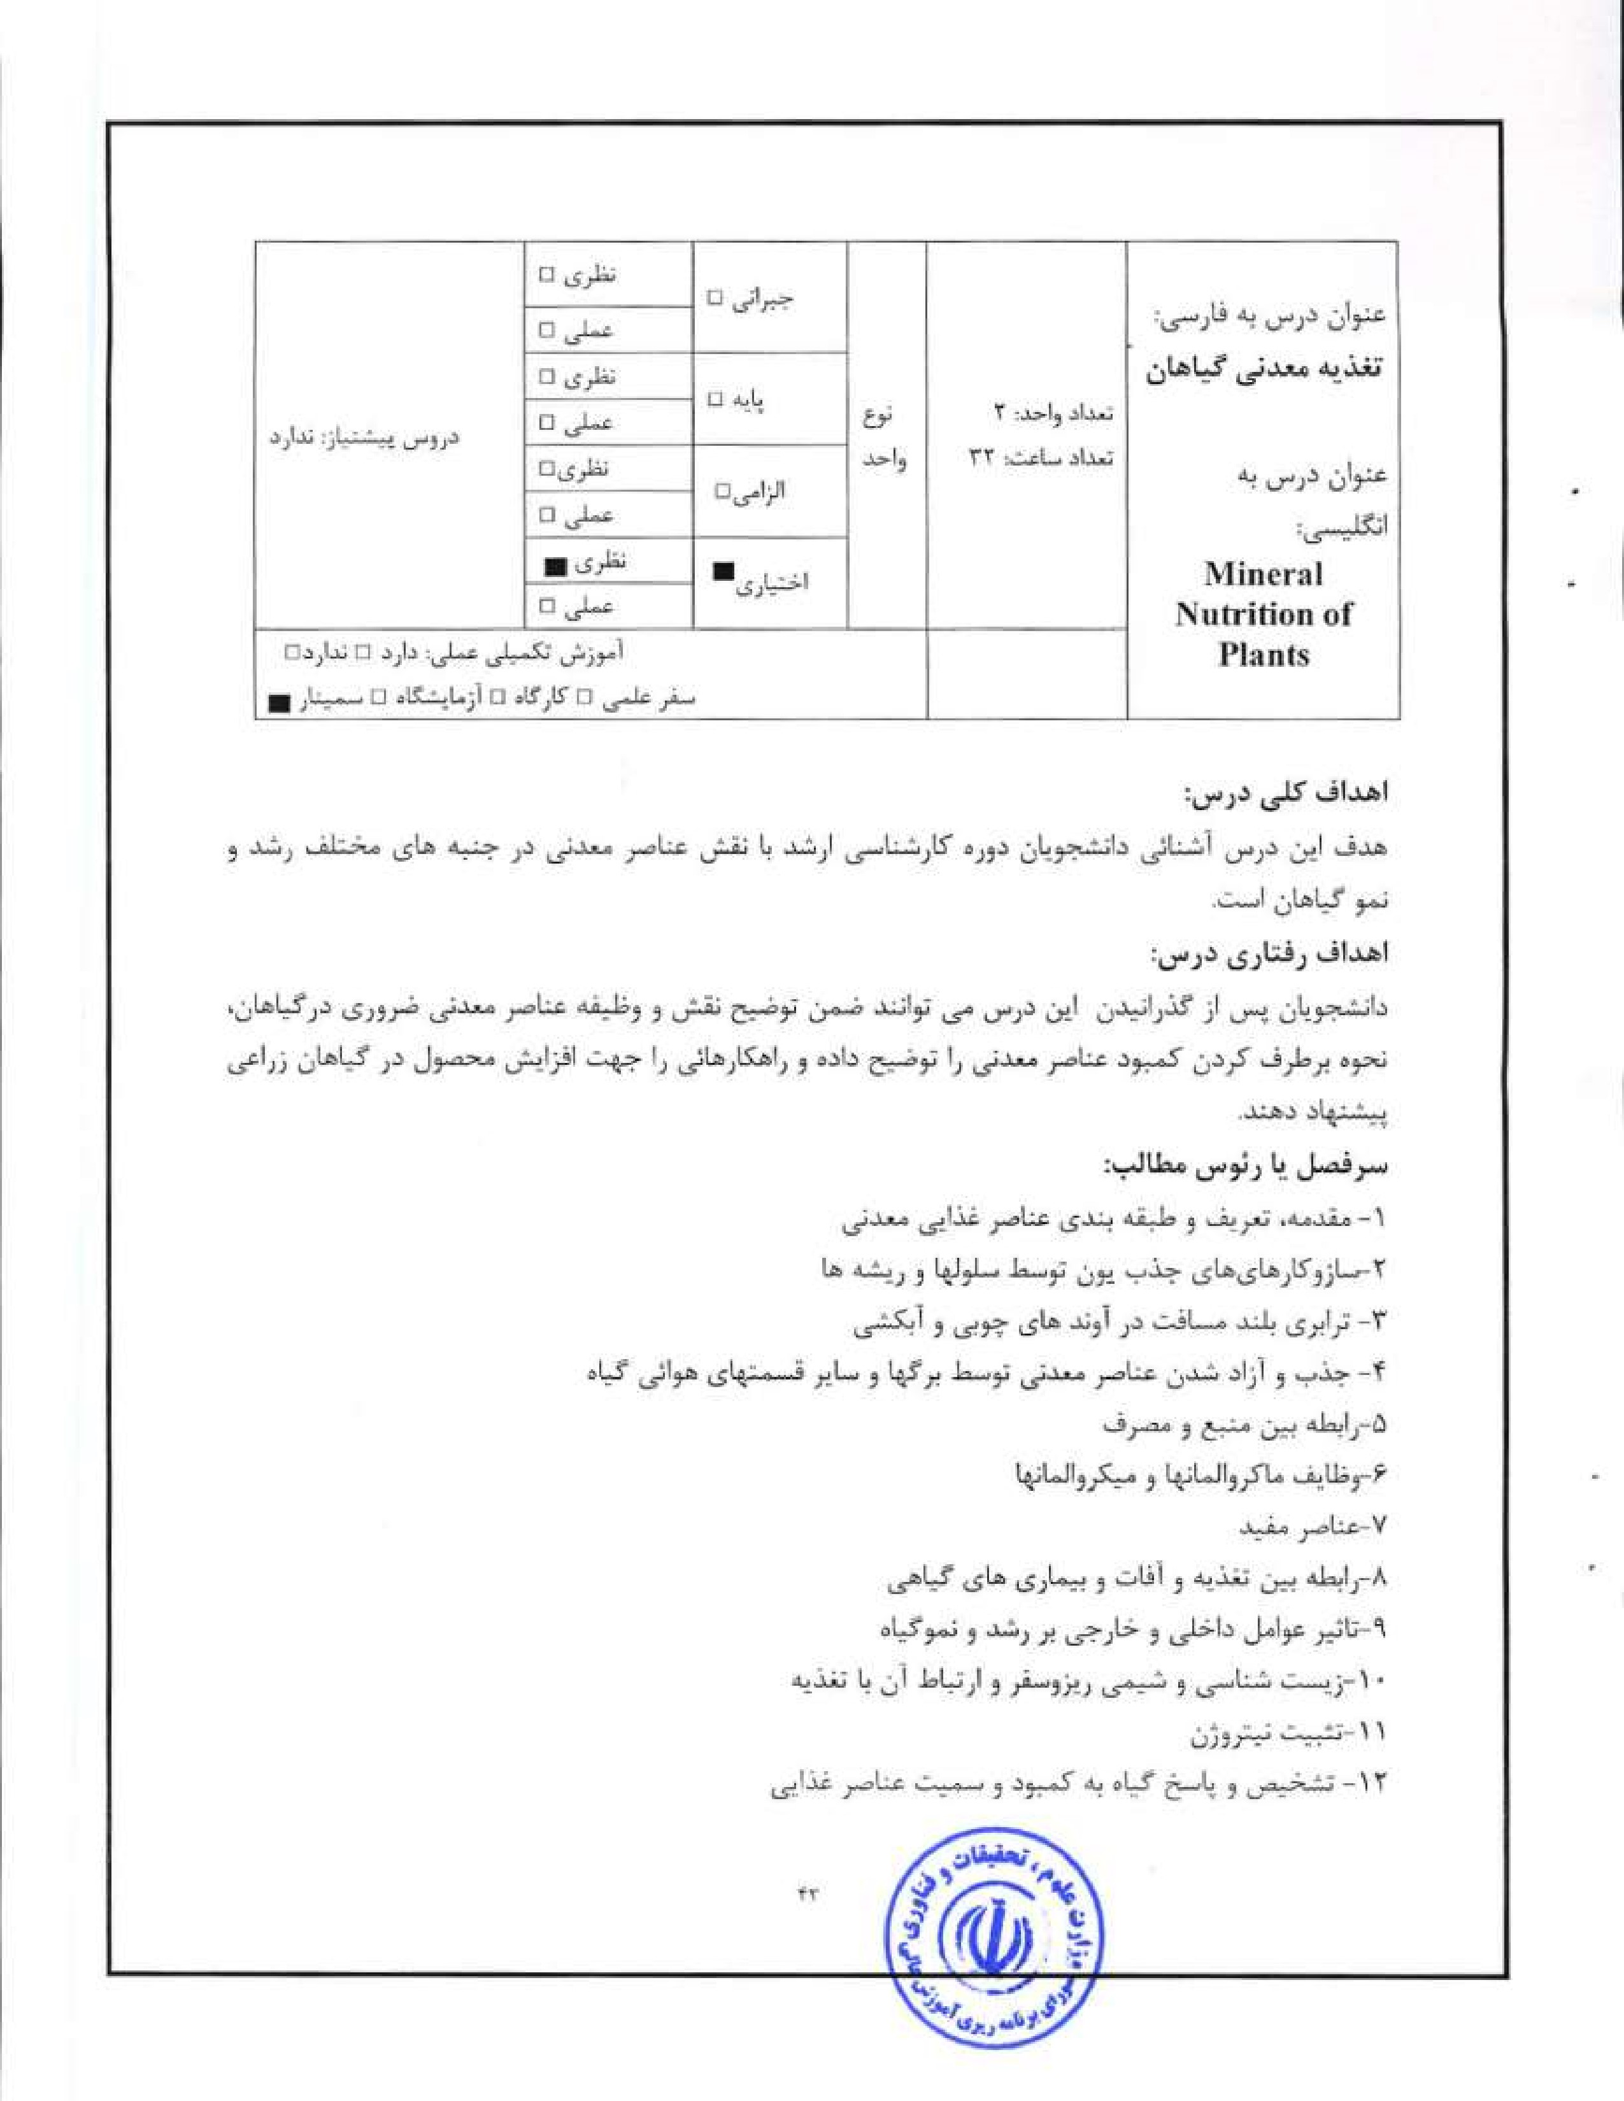


•el-a
l. Barken A. Vi, Pilbeam, D..J, (2007) Handbook of Plant Nutrition; CRC Press.
2 Broadlcy. M.R-sWhite. P, J. (2005) Plant Nutritional Genomics. Blackwell. CRC Press,
- Buchanan, B.B., Gruissem, W.. Jones, R.I.. (2000) Biochemistry and molecular biology of plants, American society of plant physiologists.
- Glass, A.D.M. (1989) Plant nutrition. Jones and Bartlett Publishers.
S. Holbrook, Zwieniecki, M,Am (2005) Vascular transpon in plants; Elsevier Academic Press.
6, Marschncr, H. (201 1) Mineral nutrition of higher plants. Academic press.
7. Rcngcl, Z (1999) Mineral nutrition of crops. Food products press
8, Epstein, Bloom, A. J, (2004) Mineral Nutrition of Plants: Principles and Perspectives.


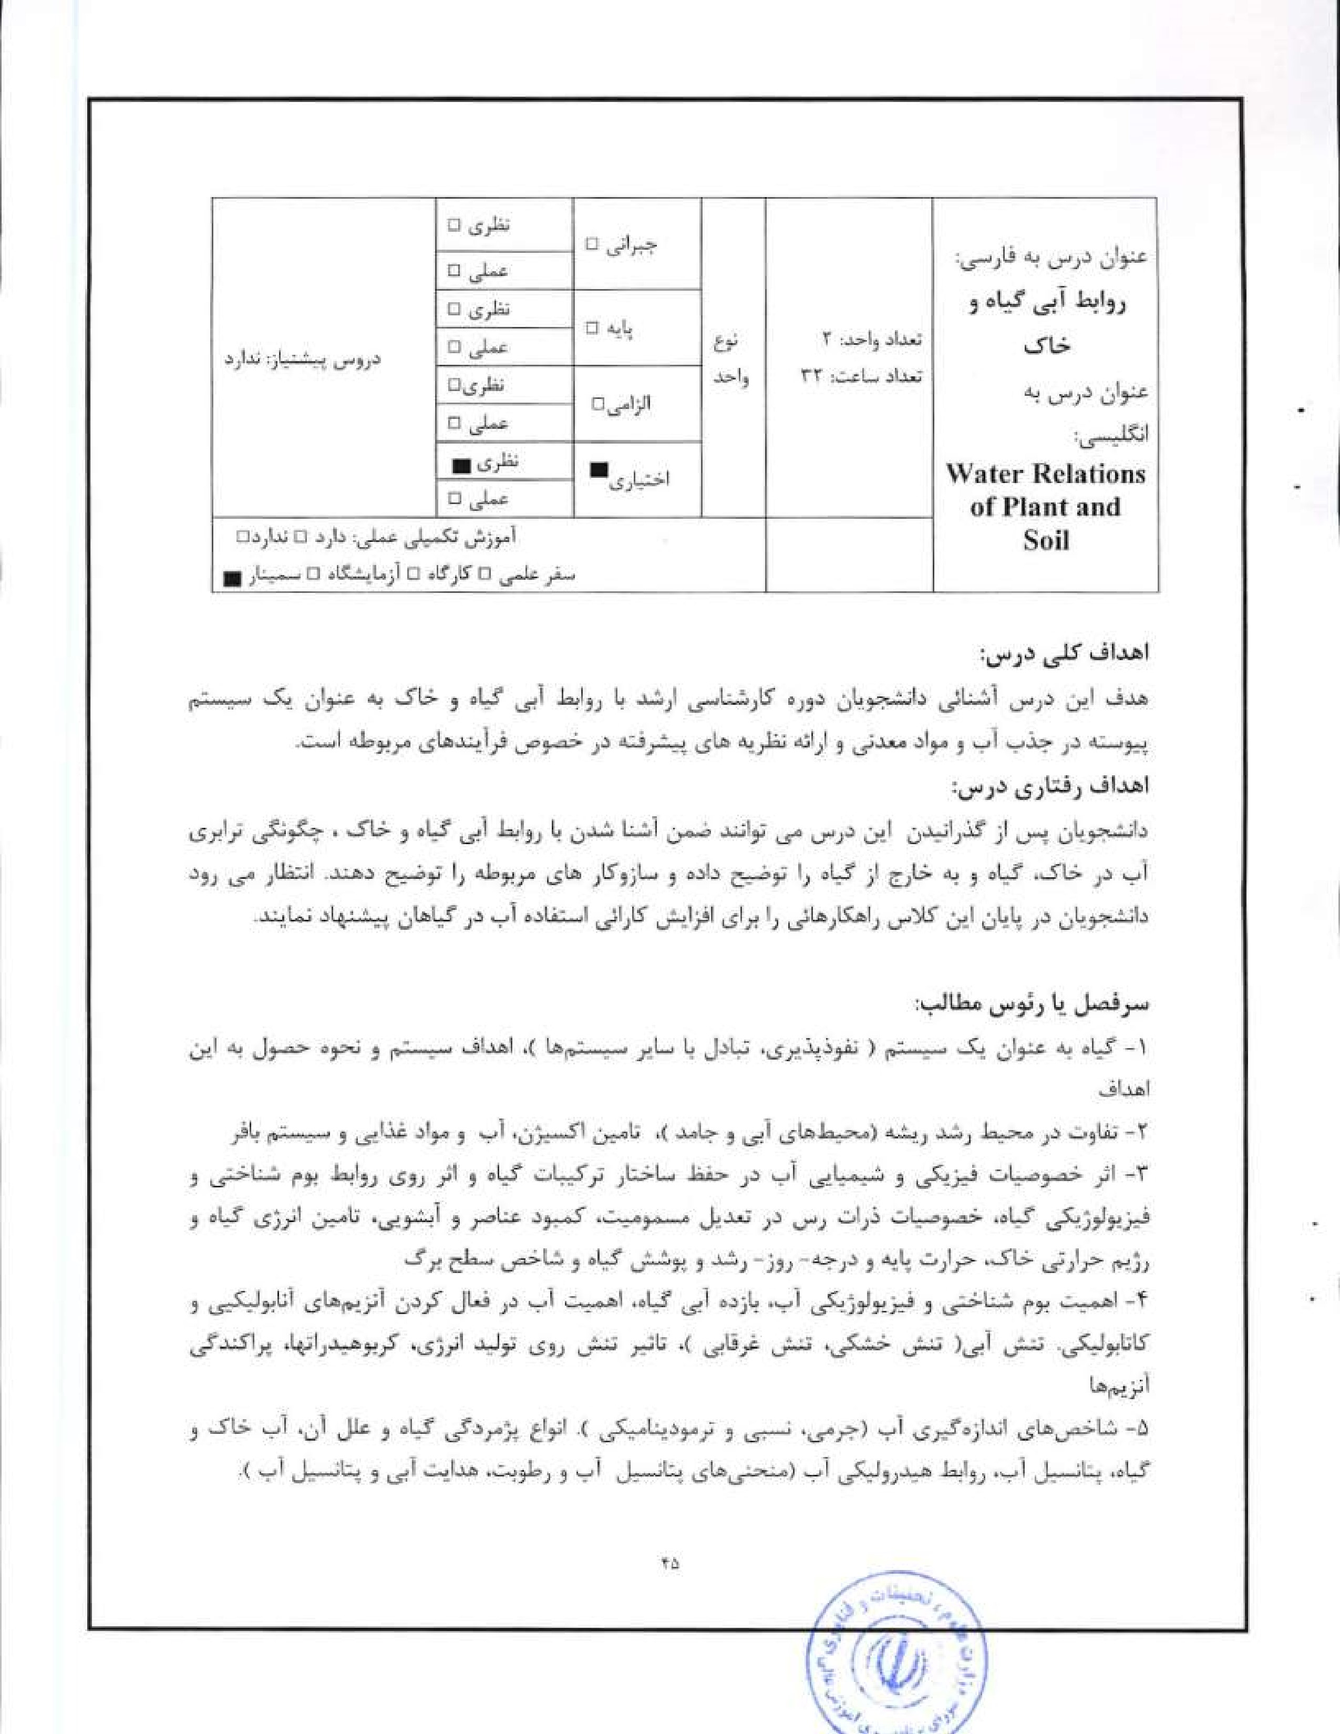
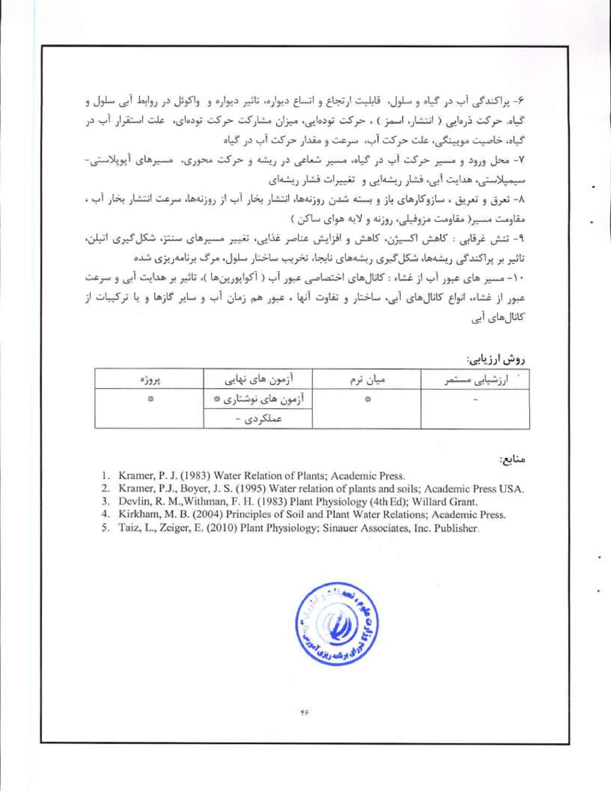
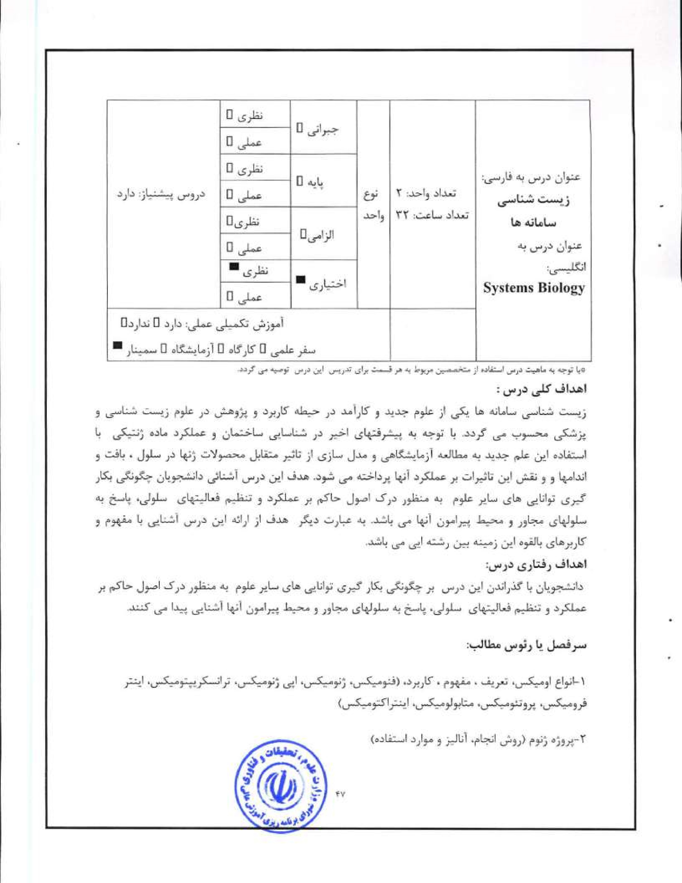
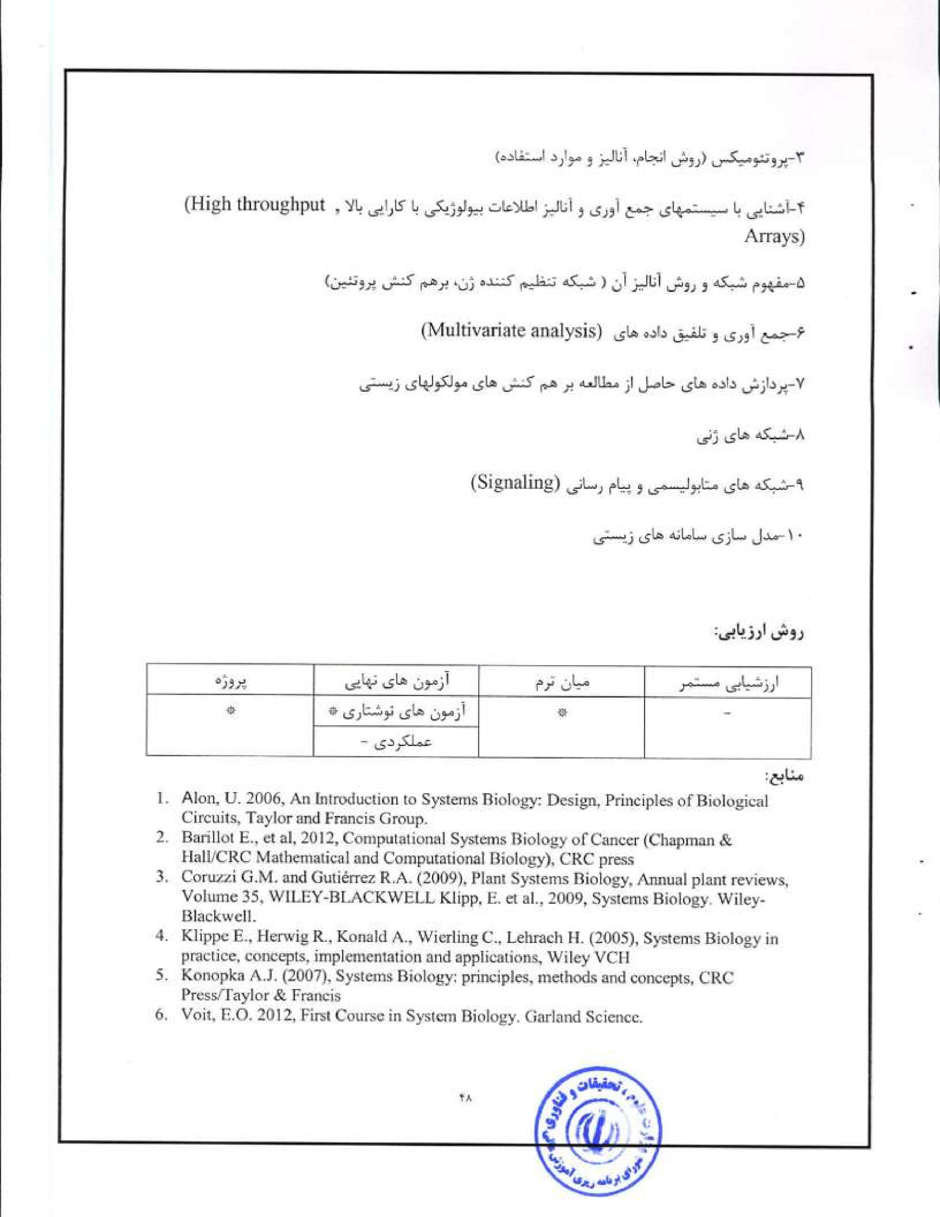
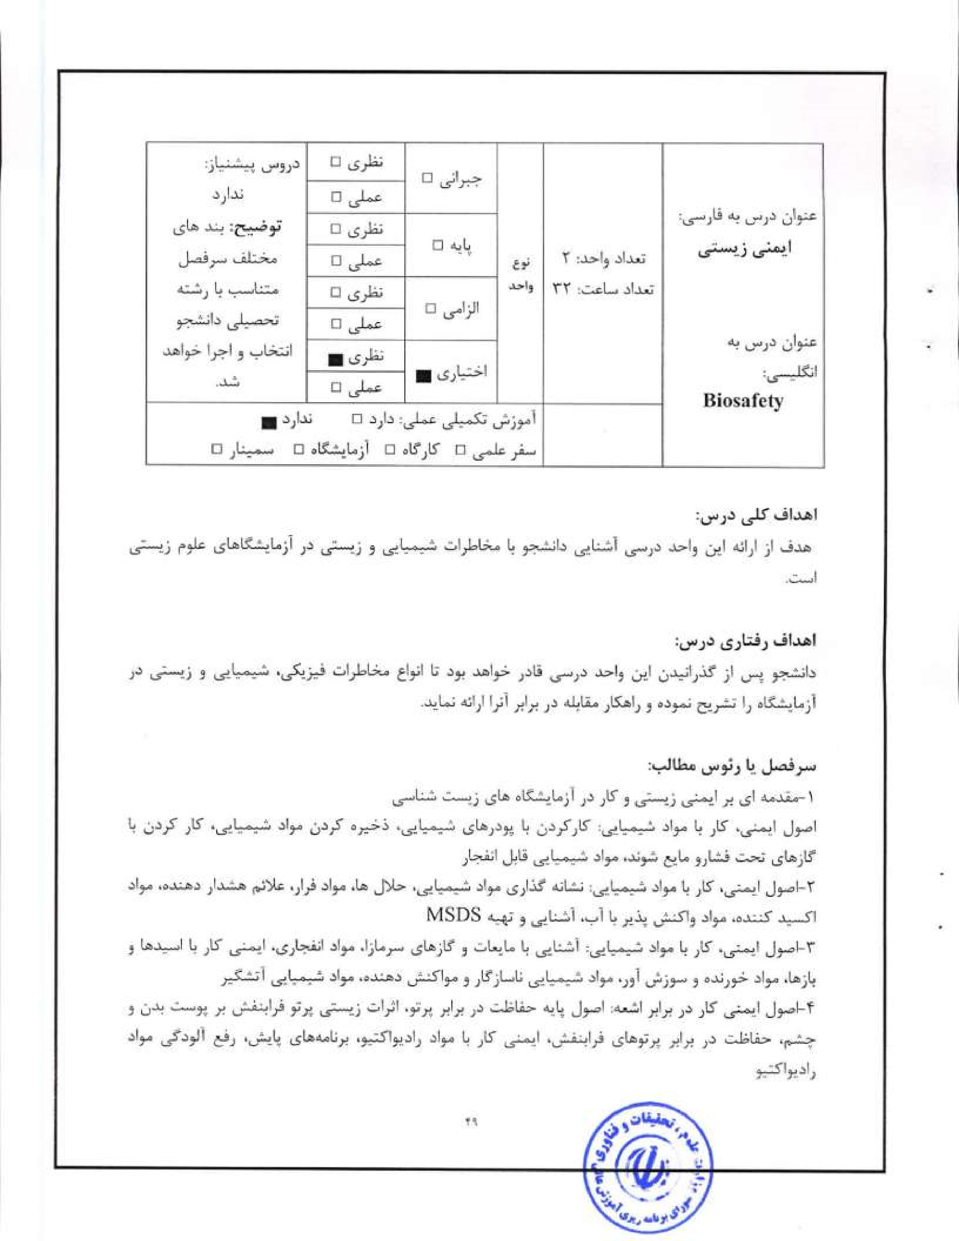
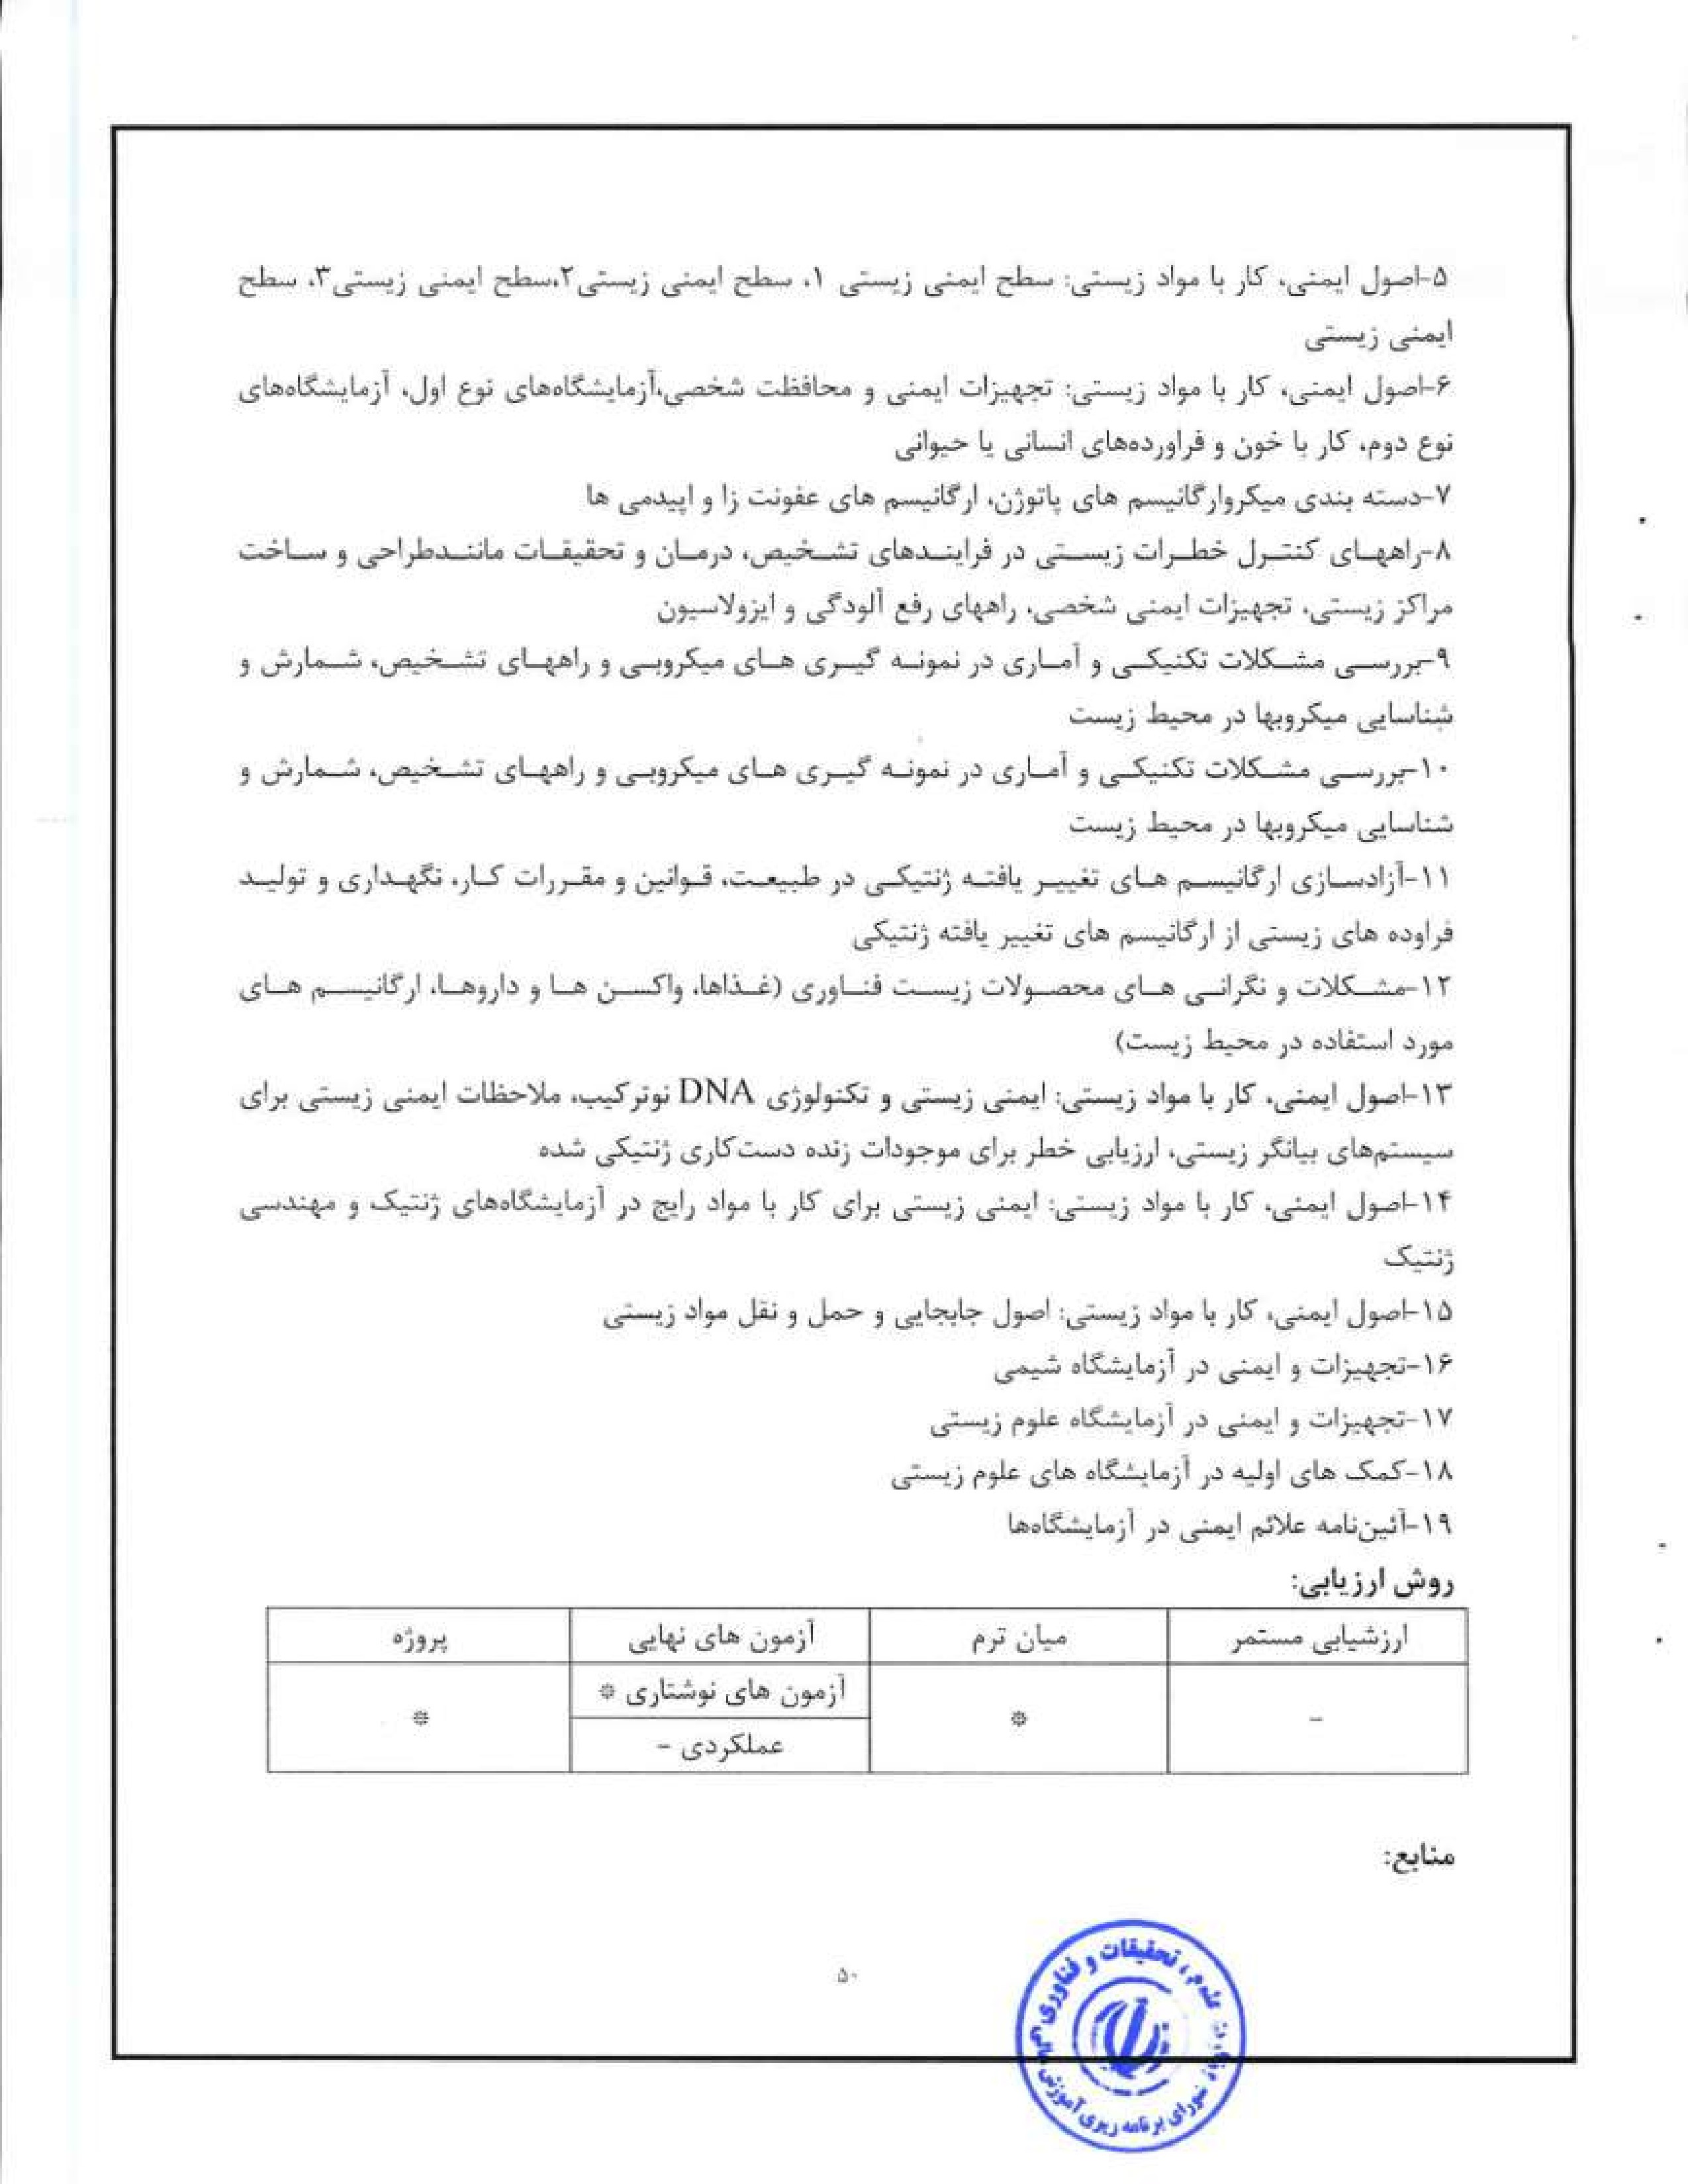

L Laboratory Biosafcly Manual. 2004; 3'åed; World Health Organization (WHO); Geneva; Switzerland-
- Biological Safety Manual. 2007; University of Pennsylvania; Pennsylvania; USA.
- *Ille Laboratory Biosafety Guidelines. 2004; Y^{d}ed; Public Health Agency of Canada; Canada.
Biosafety in Microbiological and Biomedical Laboratories; 2007; S^{h}ed, US Government Printing Office; USA.
5. Guidance on Regulations for the Transpon of Infectious Substances; 02007—2008; World
Health Organization; USA.


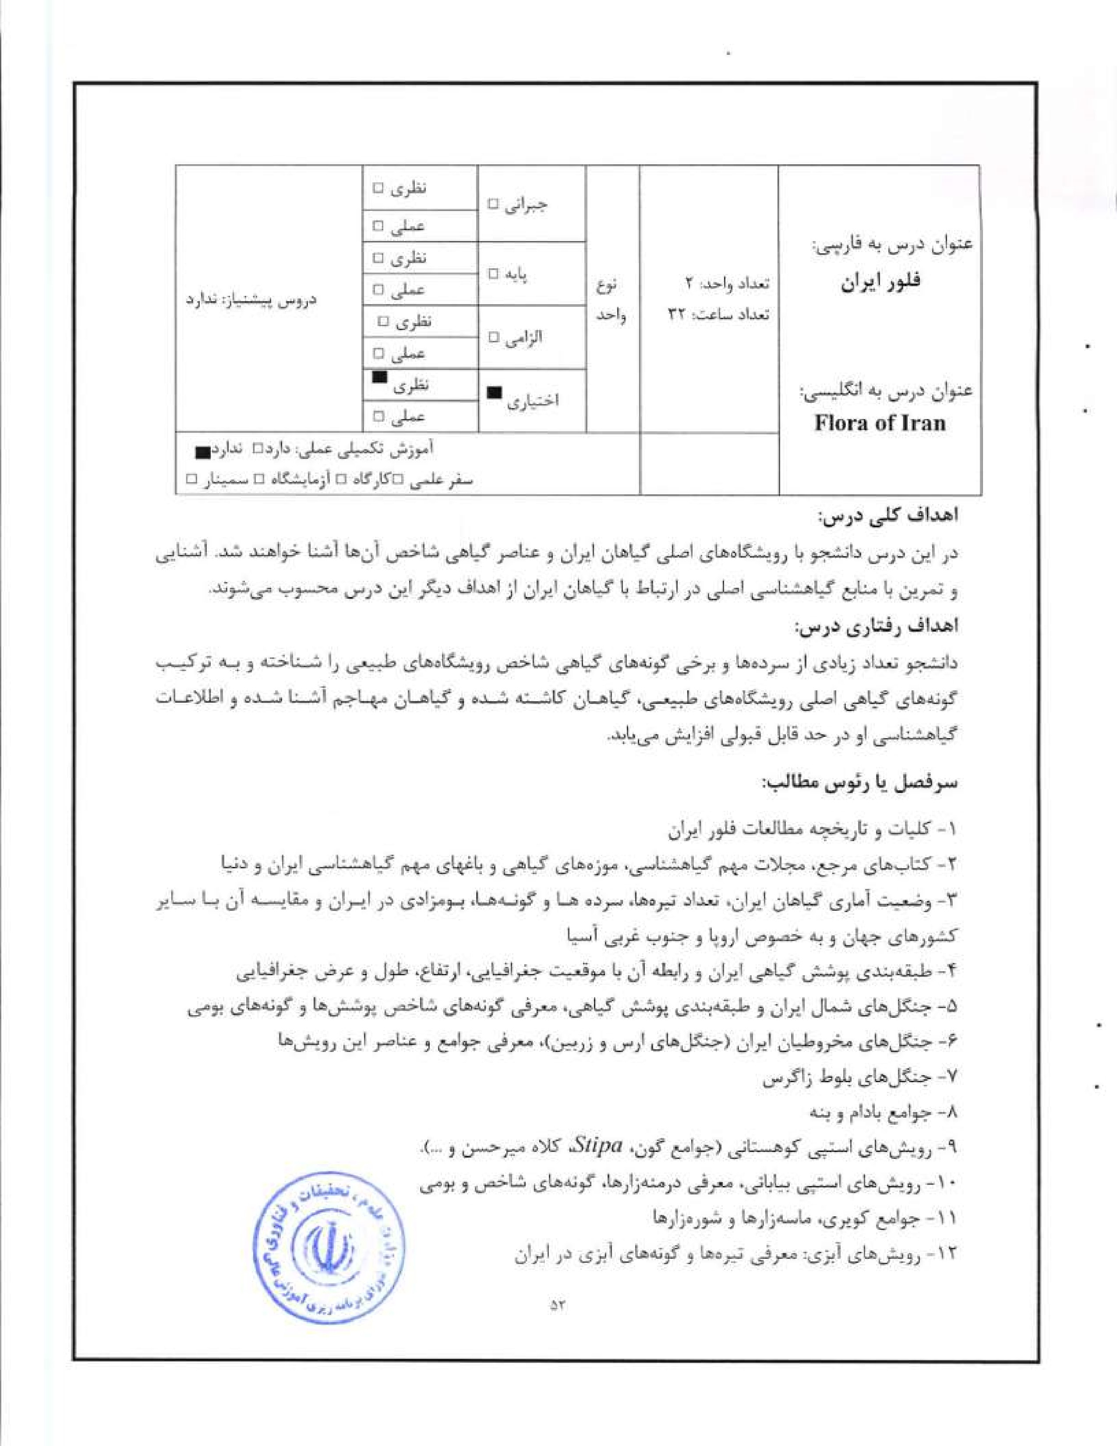
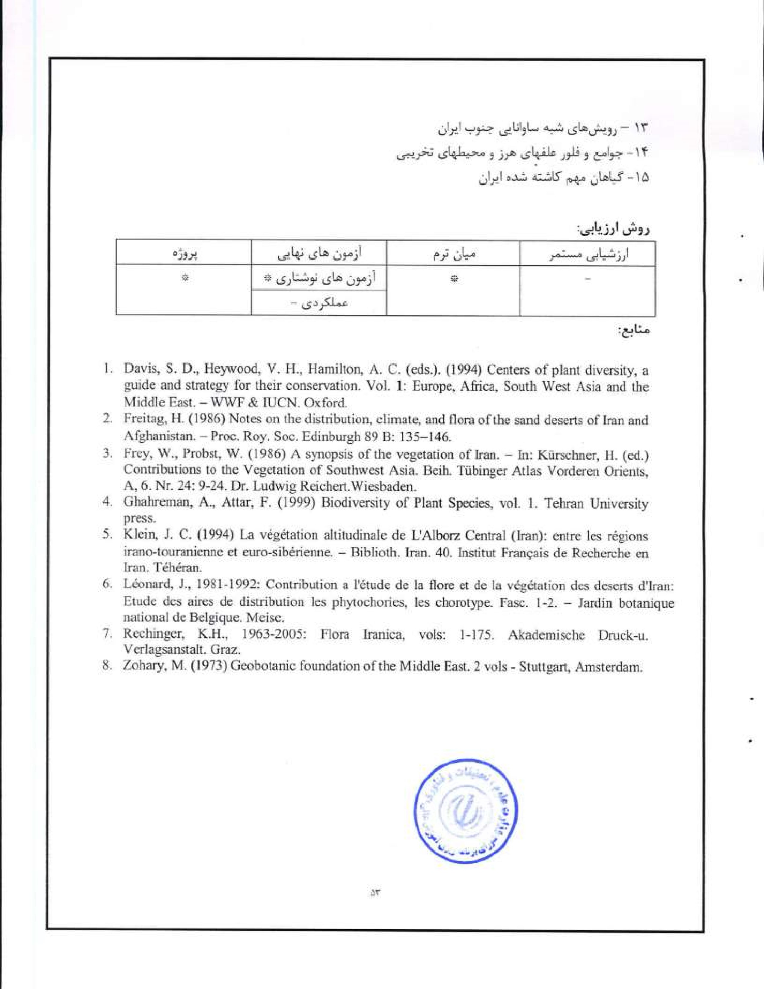
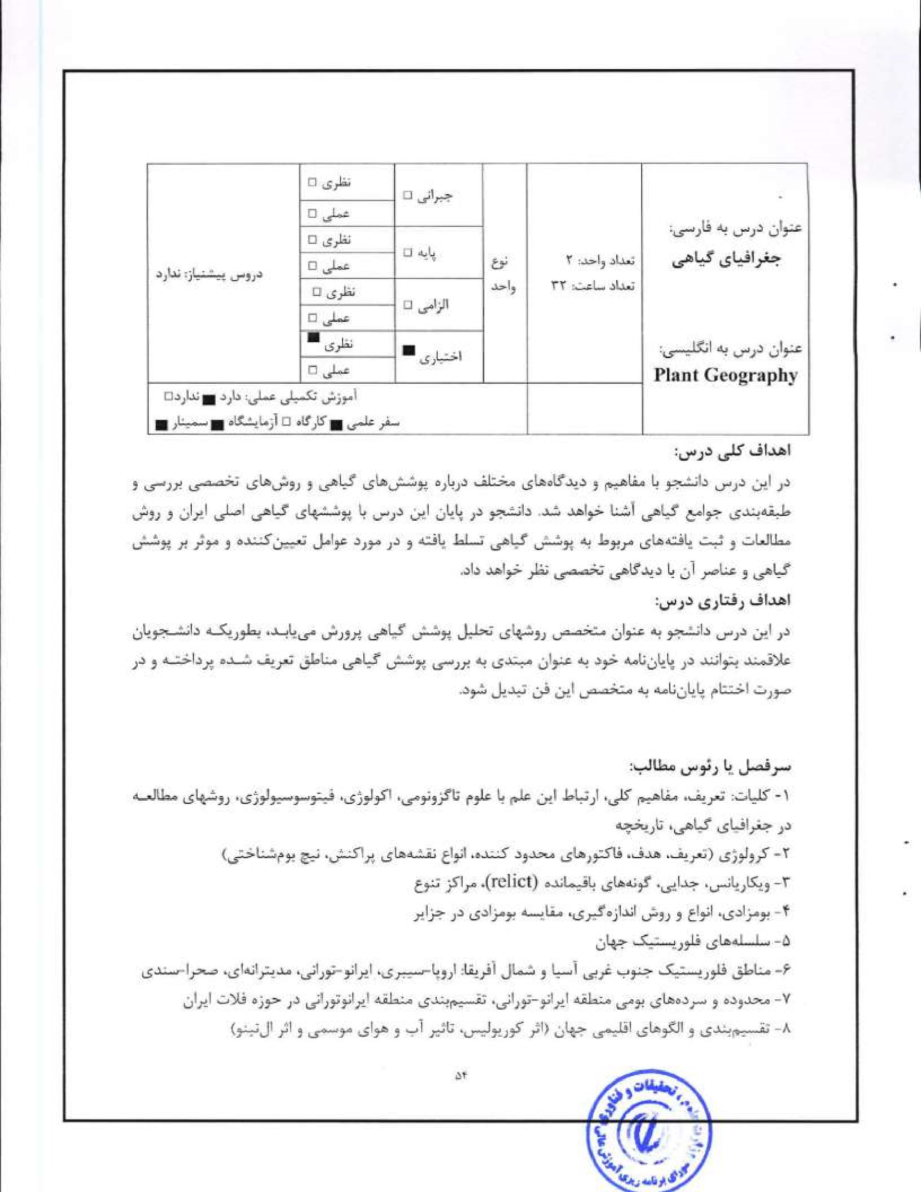








- Cox, C, Moore, (2000) Biogeography: an ecological and evolutionary approach. Blackwell Scientific Publications, Oxford,
- Freitag, H. (1986) Noles on the distribution, climate, and flora ofthc sand dcscns of Iran and Afghanistan. Proc- Roy, Soc. Edinburgh 89 B: 135—146-
- Goodall, D. W. (ed.) (1977)- world. Elsevier. New York.
Léonard, J.. 1991/1992: Contribution a l'étude de la flore et de la végétation des deserts d'lran. Etude de la végétation: Analyse phytosociologique et phytochorologique des groupments végétaux, Fasc. 10 (l 2). Jardin Botanique National de Belgique- Meise.
- Takhtajan, A- (1986) Flofstic Regions of the World. University of Califomia Press, California, (English translation from Russian).
- Zohary, M, (1973) Gcobolanic foundation of the Middle East, 2 vols. Stuttgart, Amsterdam


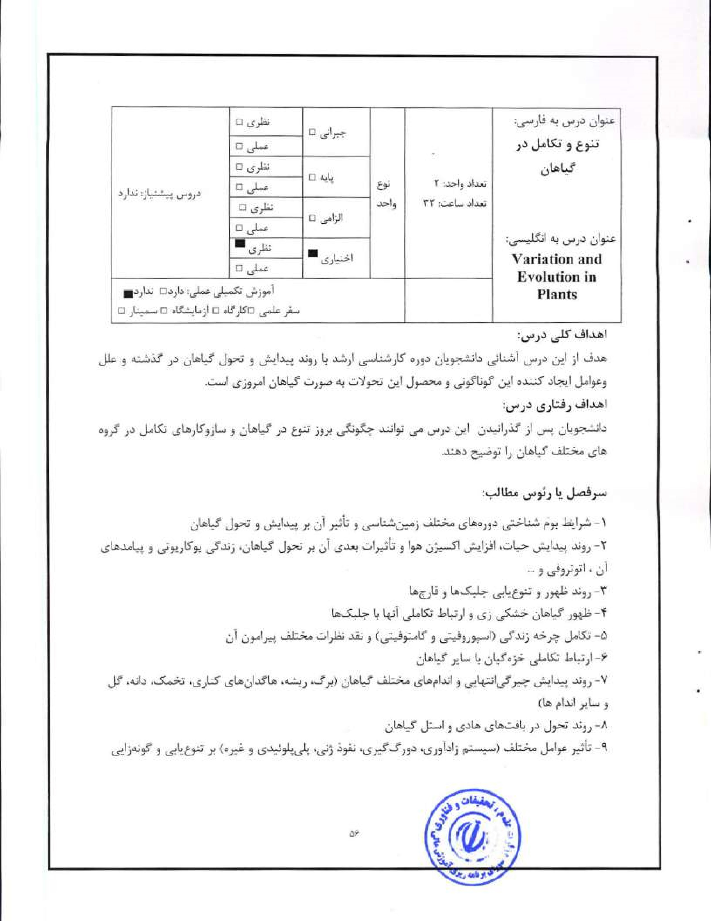

I.  2-  3-  4. |   Stewatt, N, W., Rothwell, G. W. (1999) Paleobotany and the Evolution of Plants. Cambridge University Press„  Cronquists A. (19SS) The Evolution and Classification of Flowering Plants. The New York Botanical Garden.  Wilis, K. L, McElwaint J. C. (2002) The Evolution of Plants, Oxford University Press.  Judd, W. S., Campbell, C- S.. Kellog, E. A. Stevens, 'P. F. and Donoghue, M. J. (2002) Plant Systematics; A Phylogenetic Approach (3rd Ed). Sinauer Associates.  

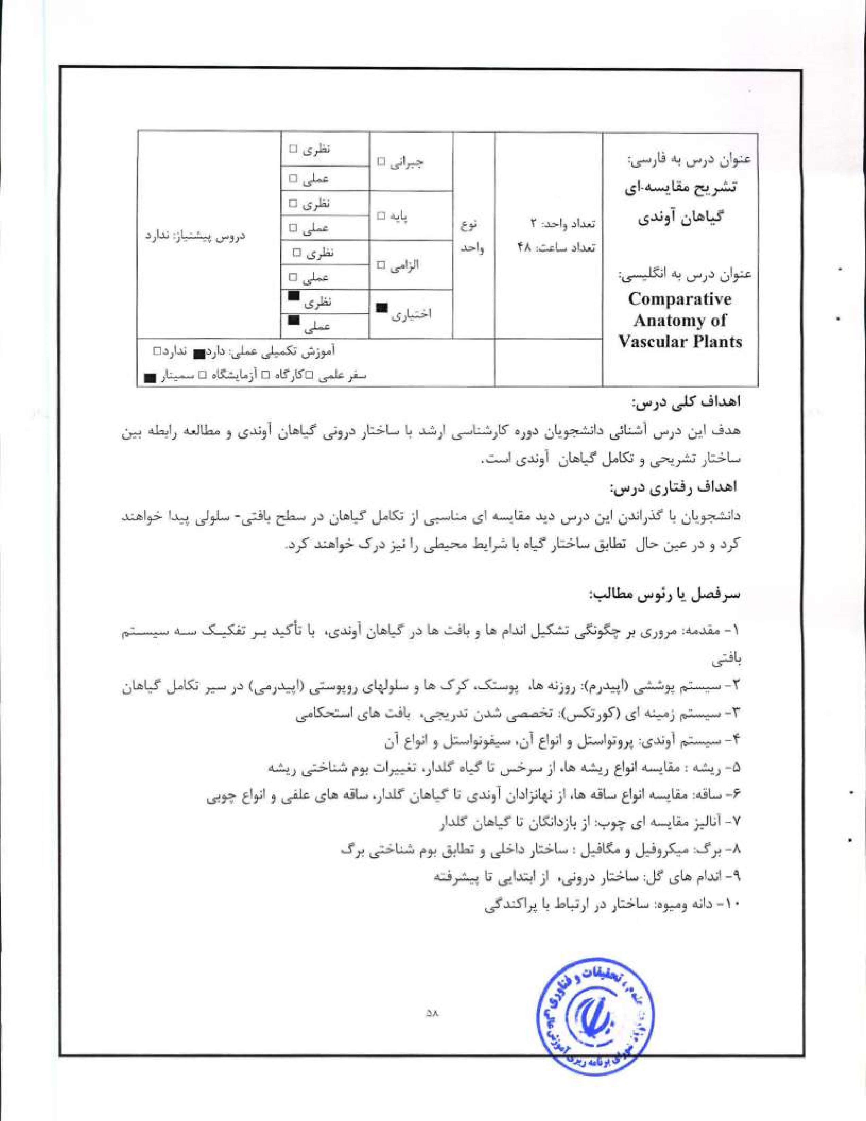


 |  |  |  | 
 | O' | GI„.S
Even, R.F. and Eichhom, S.E. (2013) Raven Biology of Plants. Eight edition.W.II. Freeman and Company Publishers.
2, Fahll, A. (1984), Plant Anatomy, Pergamon Press, Oxford.
- Mauscth, J.D. (1988) Plant Anatomy. The BenjamiWCumn1ings PublishingCompany% Menlo Park. Calif.
- Peterson. R.L., Peterson, C.A., Melville, LH- (2009) Teaching Plant Anatomy through Creative Laboratory Excereises. NRC Press, Canada,


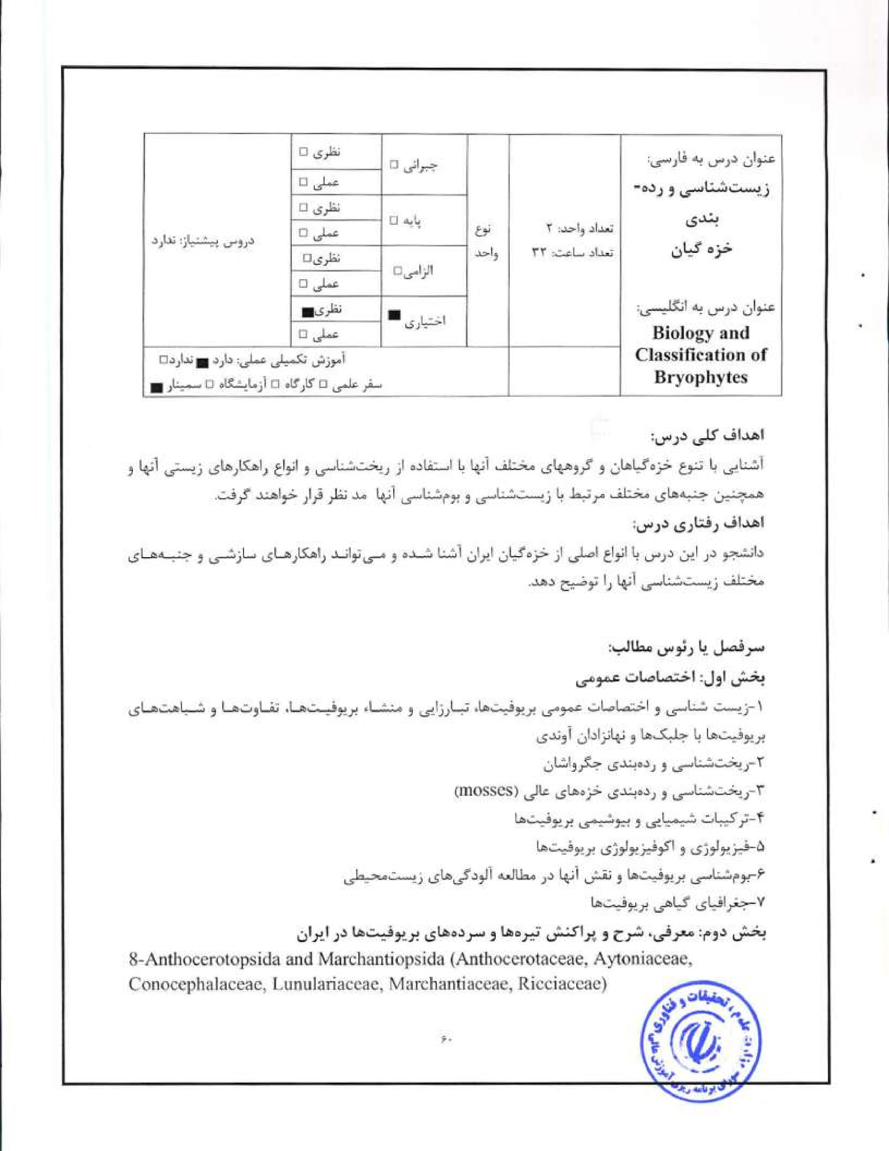

9*Jungermaniopsida (Frullaniaceae, Jungermanniaceae, Metzgeriaceaes Pellaiceae, Porellaceae, Radulaeeae)
1 0-Bryopsida l: Polytrichaceae, Timmiaceaet Encalyptaeeae, Funariaceae
I I -Bryopsida Il: Grimmiaceae, Fissidentaceae, Dicranaceae, Orthotrichaceae
12-Bryopsida Ill: Pottiaceae
13-Bryopsida IV: Amblystegiaceae, Leskeaeeae, Brachytheciaeea„
1 4-Bryopsida V: Bryaceae, Mniaceae Plagiotheciaceae
1 5-Bryopsida VI; Ilypnaceae, Leucodontaceae, Neckeraceae

Frey, W Kürschner, (1991) Conspectus Bryophytorum Orientalium et ArabicorumBryophtorum Bibliotheca 39: I-181.
- Kiirschner, H. (2001)Towards a bryophyte flora of Ibe Near and Middle East. 3, An artificial key to the Anlhocerotopsida and Ilepaticophytina of the Near and Middle East. Nova Hedwigia 72: 161-200.
- Puri, P. (1981) Bryophytes: Morphology, Growth and Differentiation. Atma Ram & Sons, Dchli* Lucknow.
Shaw, A, J., Goffinet, B. (2000) Bryophyte Biology. Cambridge.
- Smith. G. M. (1983) Cryptogamie Botany (Bryophytes and Pteridophytes) Il, r^{d}, Me Graw-llill, London.
- Smith, A.J.E„ (1990) 'Ille Mosses Flora of Britain & Ireland.


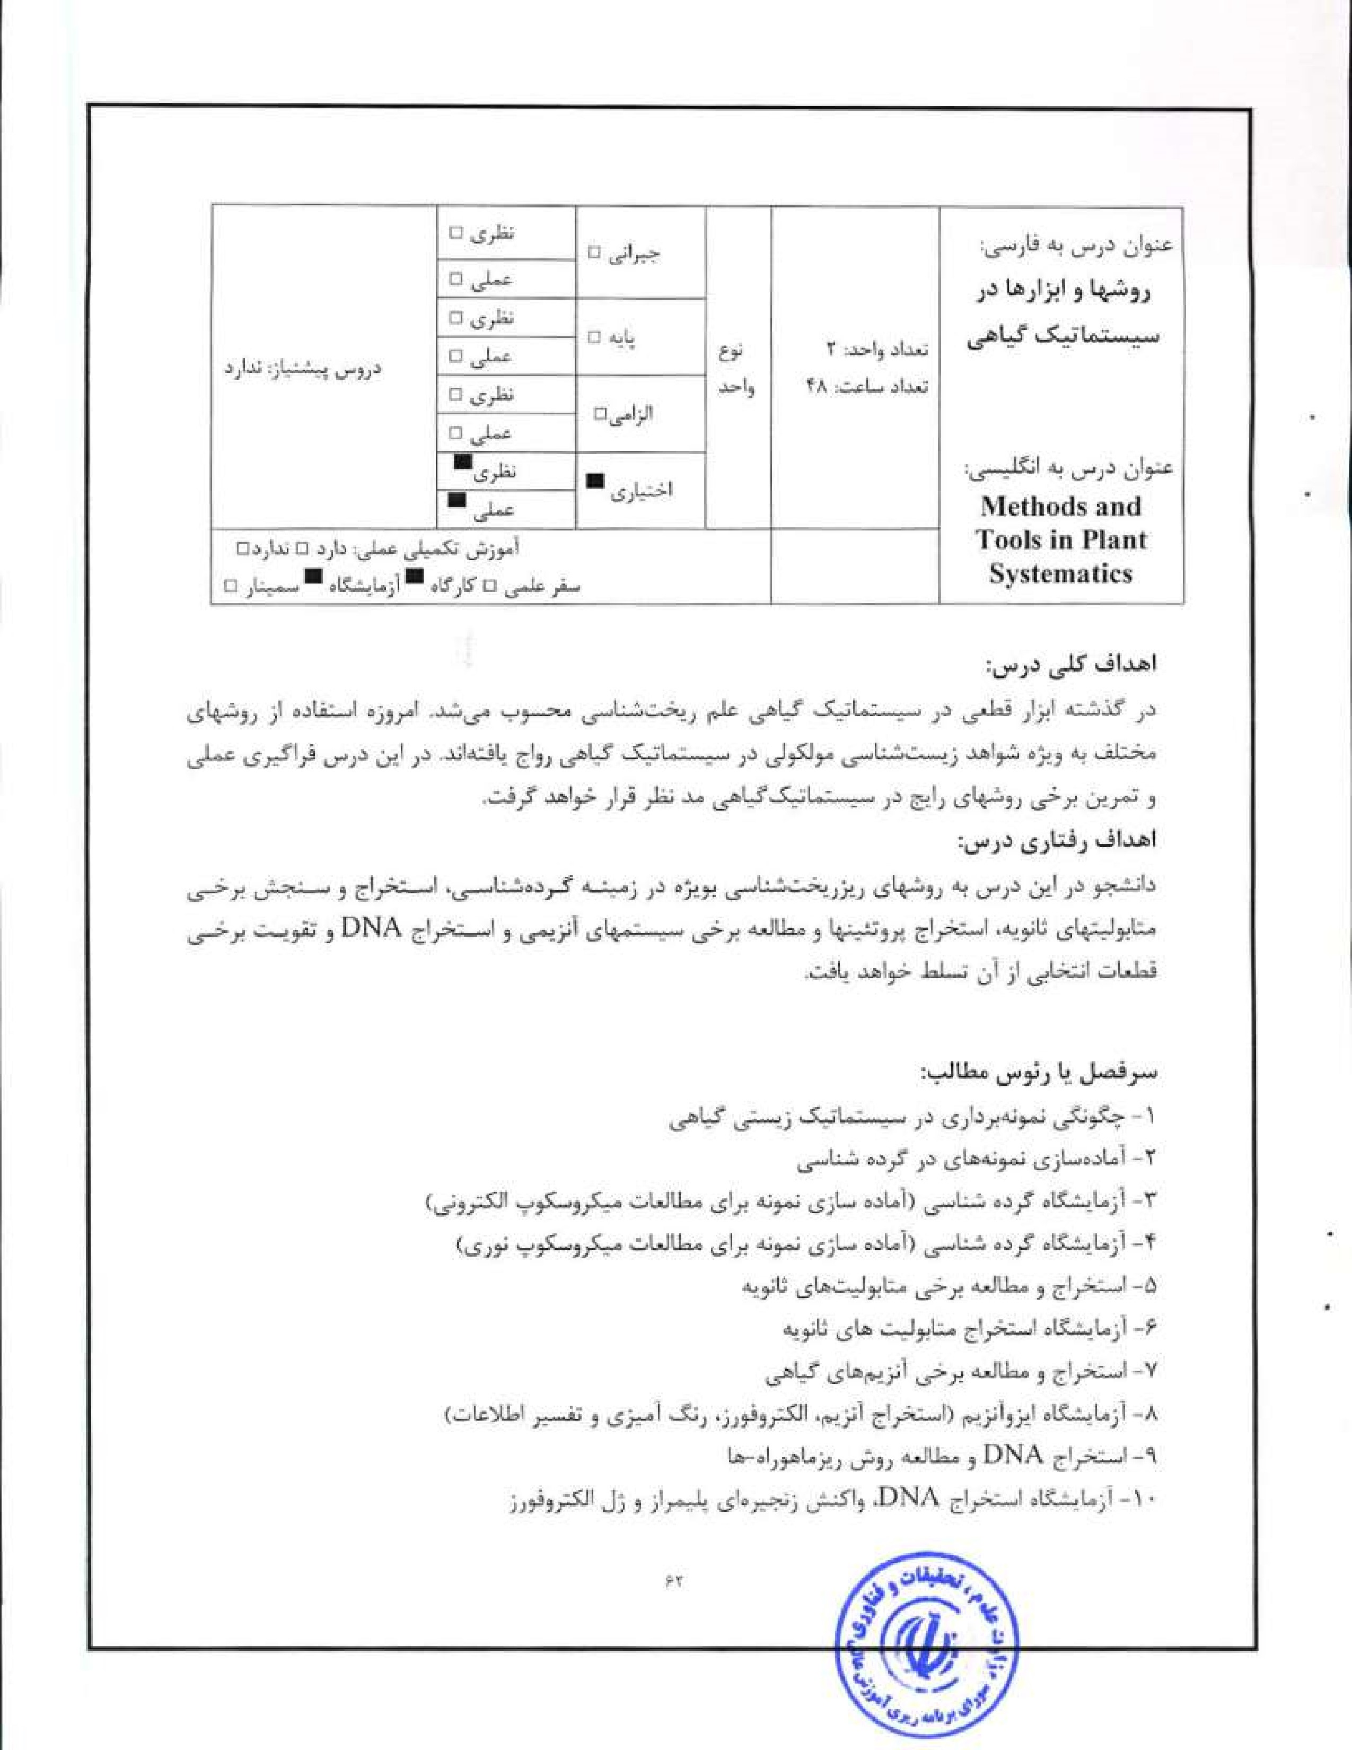


l . Cronqist, A. (1988) The evolution and classification of flowcring plants. 2nd ed. New York Botanical Garden.
- Judd, W-S., Campbell, C-S-, Kellogg, EA., Stevens; P. Donoghue, _M.J- (2007) Plant Systematics: A phylogenelie Approach. Simuer Associates Inc., -Sunderland,
- Simpson, Mi (i, (2009) Plant systematics, 2"^{d} ed., Elsevier Academic Prcss.
- Soltis, D.E„ Soltis, P.S., Doyle, .LJ. (1998) Molecular Systematics of plants Il: Kluwer Academic Publishers. Boston.
5. Stace, C.A. (1980) Plant taxonomy and biosystematics, University Park Press, Baltimore.
6. Stuessyt T. F. (2008) Plant Taxonomy: The Systematic Evaluation of Comparative Data, Columbia University Press.


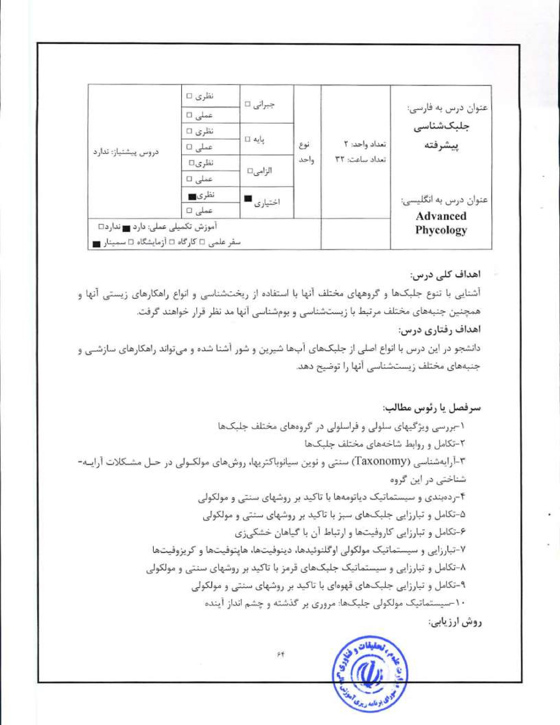


Brodie, L, Lewis. J. (2007) Unravelling the Algae: The Past. Present, and Future of Algae Systematics. Systematics Association Special Vol. 75.CRC Press.
- Barsanti. L.. Gualtieri, P. (2005) Algae,' Anatomy, Biochemistry, and Biotechnolog CRC Press,
- Bhattacharya, D (1998) Origins of Algae and %eir Plastids; Springer-Verlag.
- Lee, Rw E. (2008) Phycology (4th Ed.) Cambridge University Press.



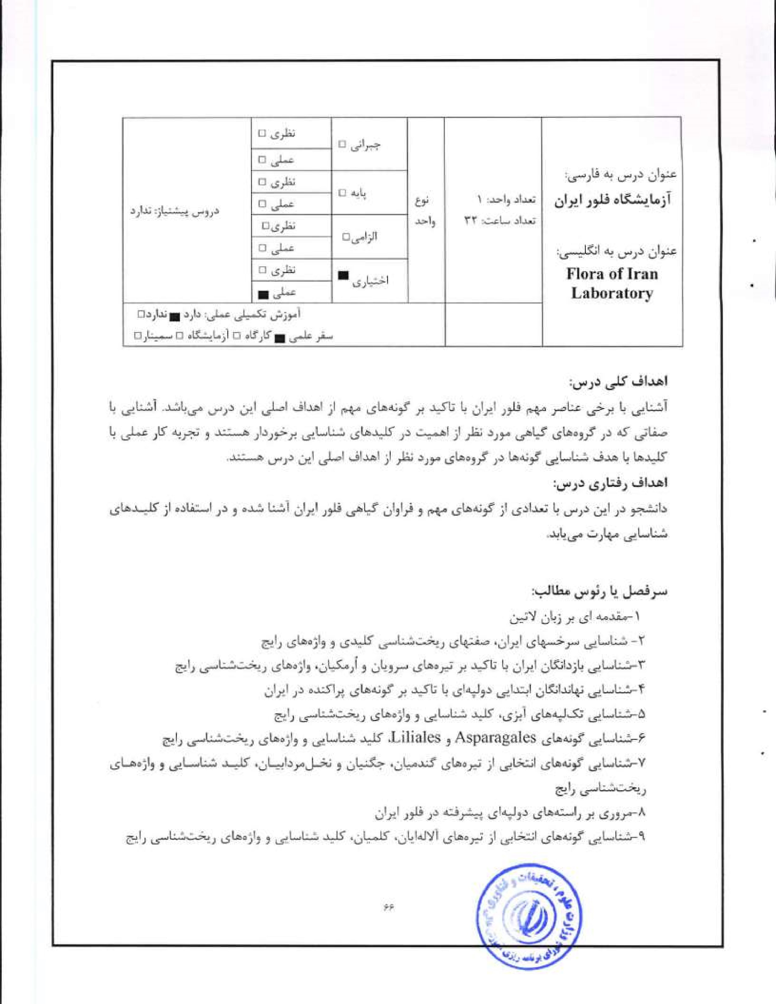
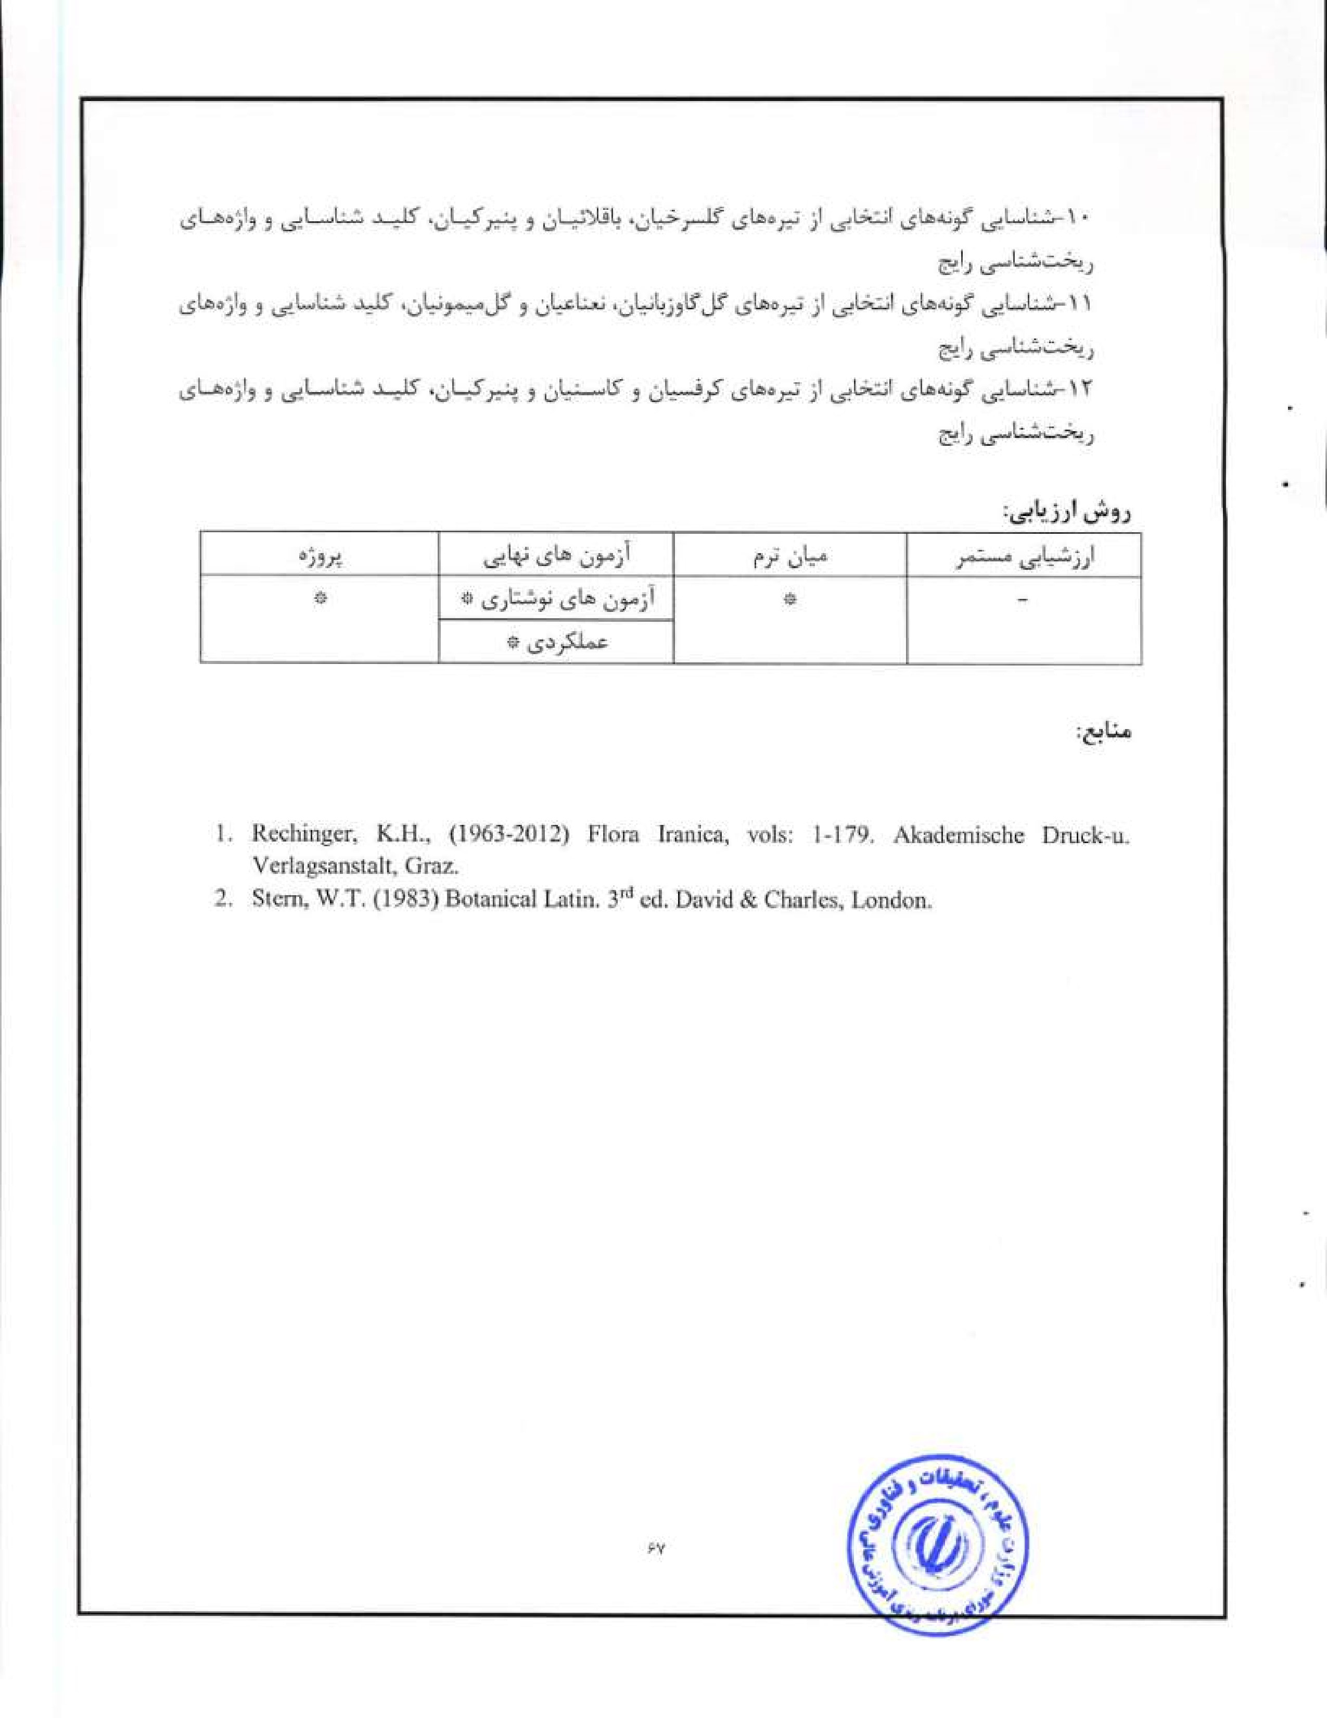
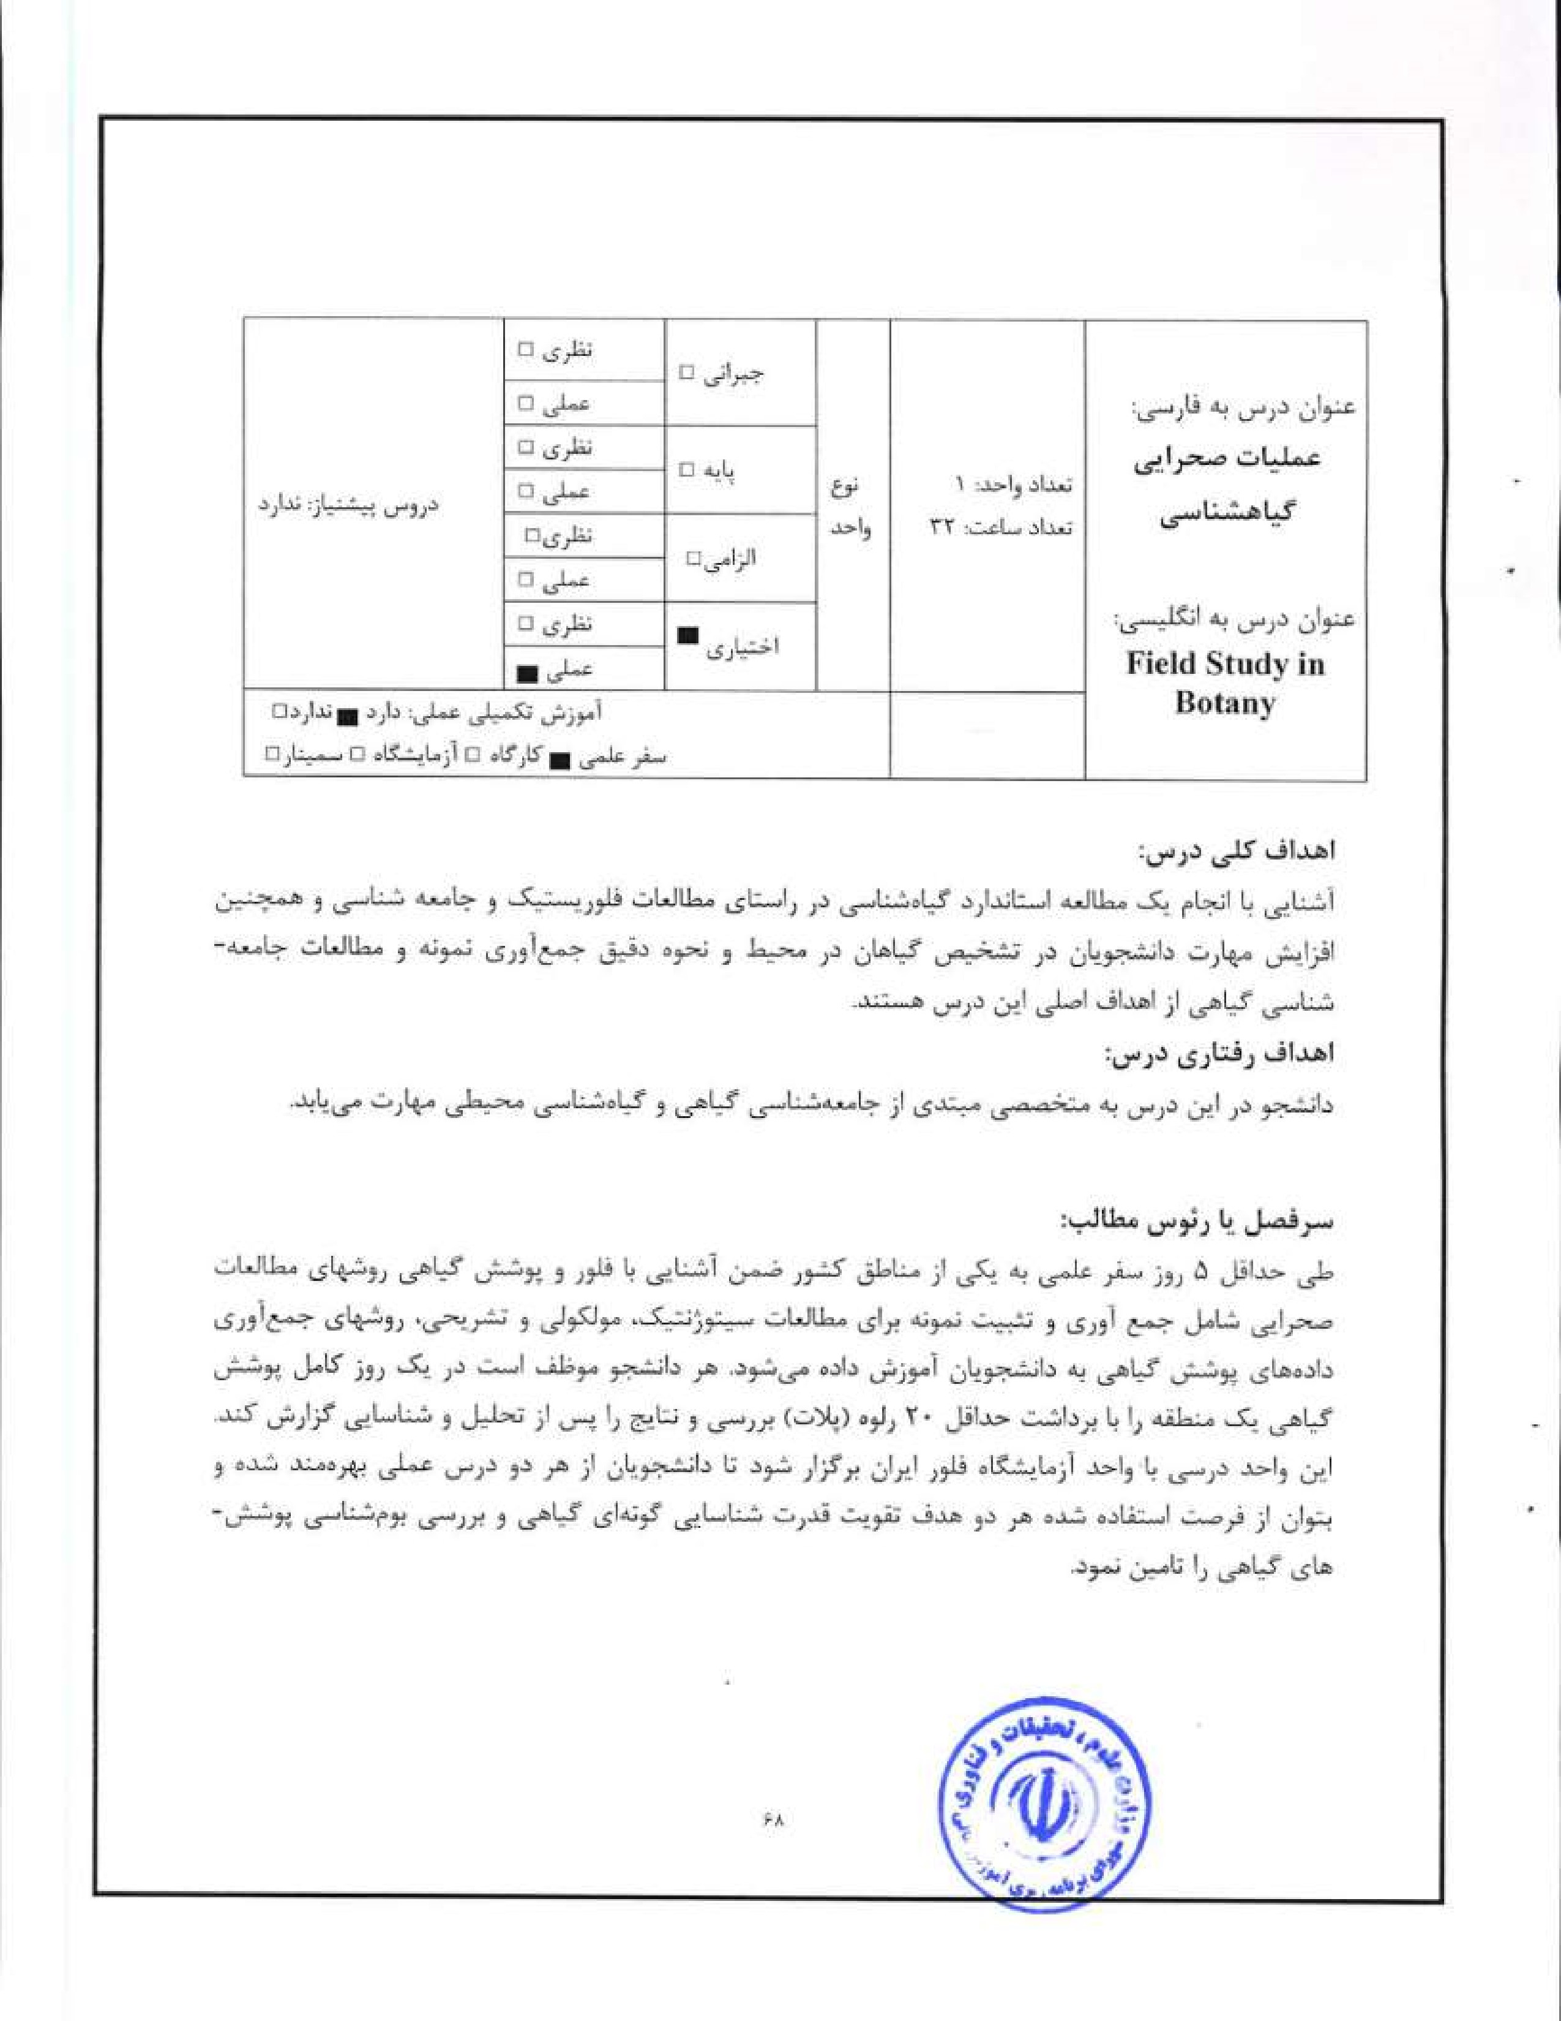


l. Mueller-Dombois, D. , Ellenberg, H. (1974) Aims and Methods of Vegetation Ecology.
Wiley, New York,
2. van der Maarel, E. (2005) Vegetation Ecology. McGraw Hill, London.


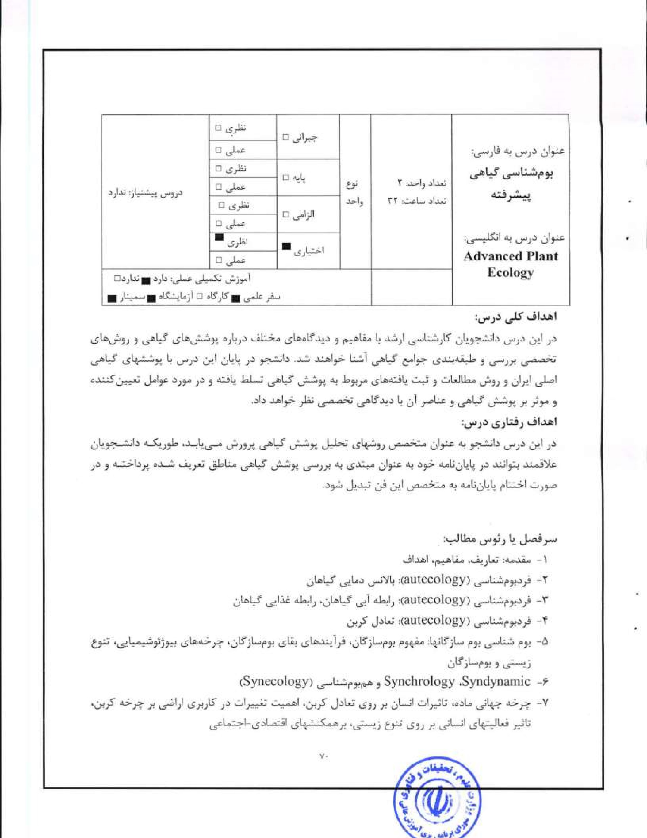

2. |   Schulze, E.D., Beck, E., Müller-Hoheinsteiny K. (2005) Stuttgart,  Gureviteh, J.. Schemer, SaMr„ Fox, G.A. (2006) Associates Inc., Sunderland, MA. | Plant IEeology. Springer,  ecology of plants, 2⁰⁶ ed. Sinauer  

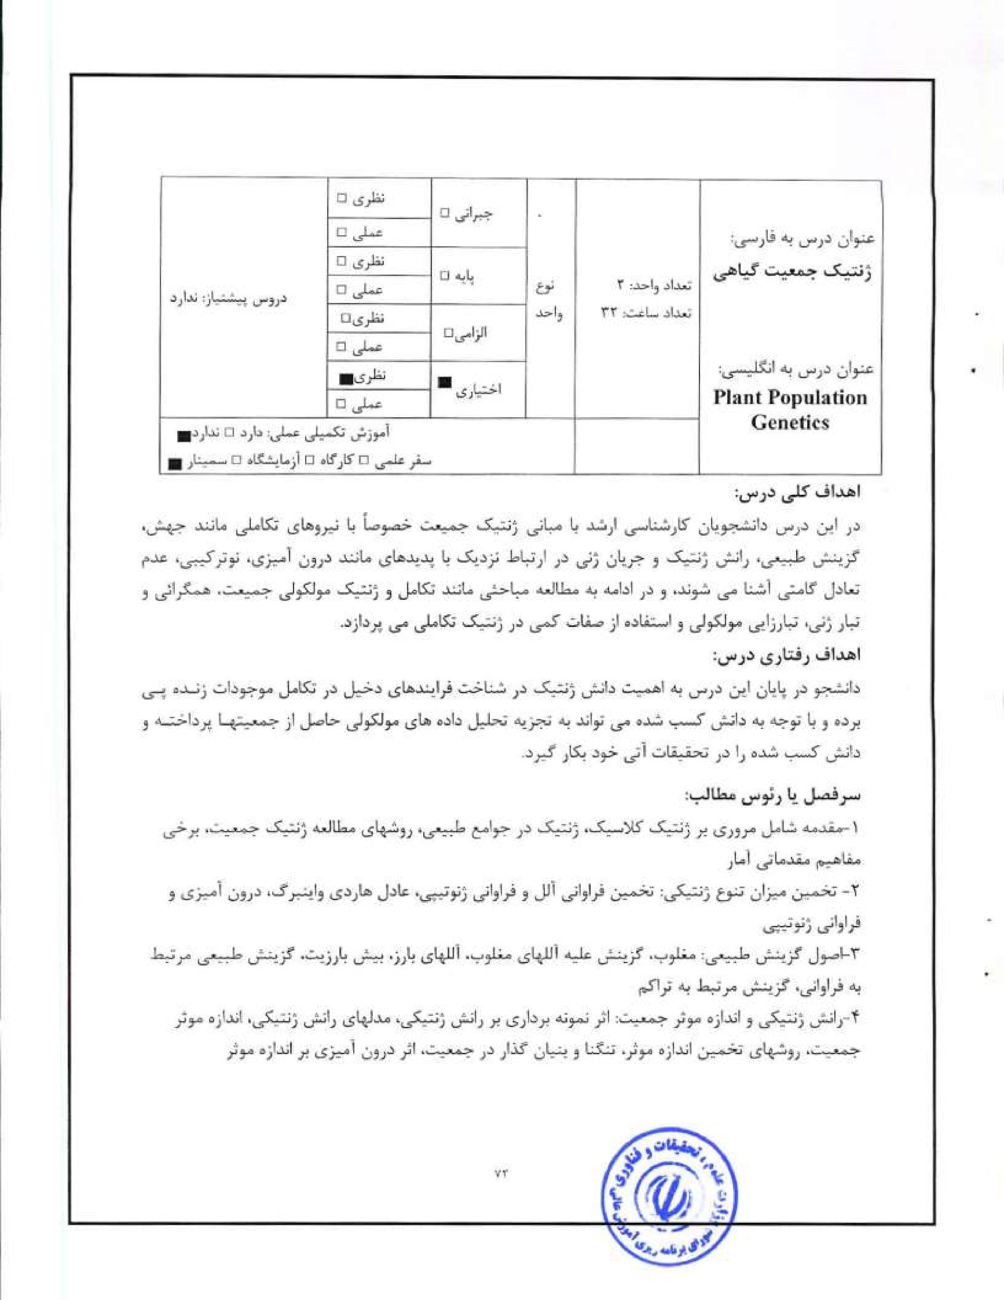
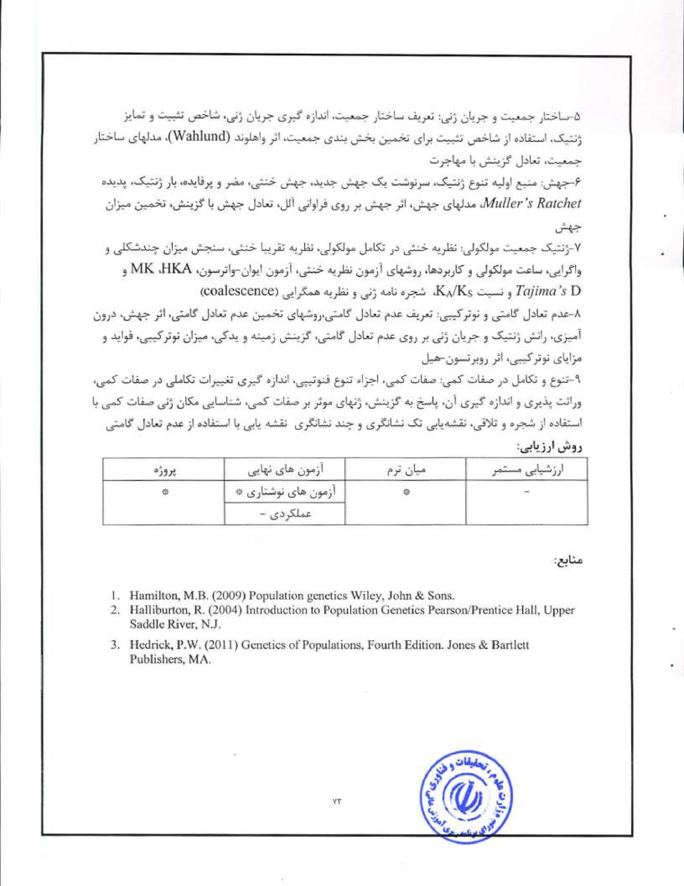
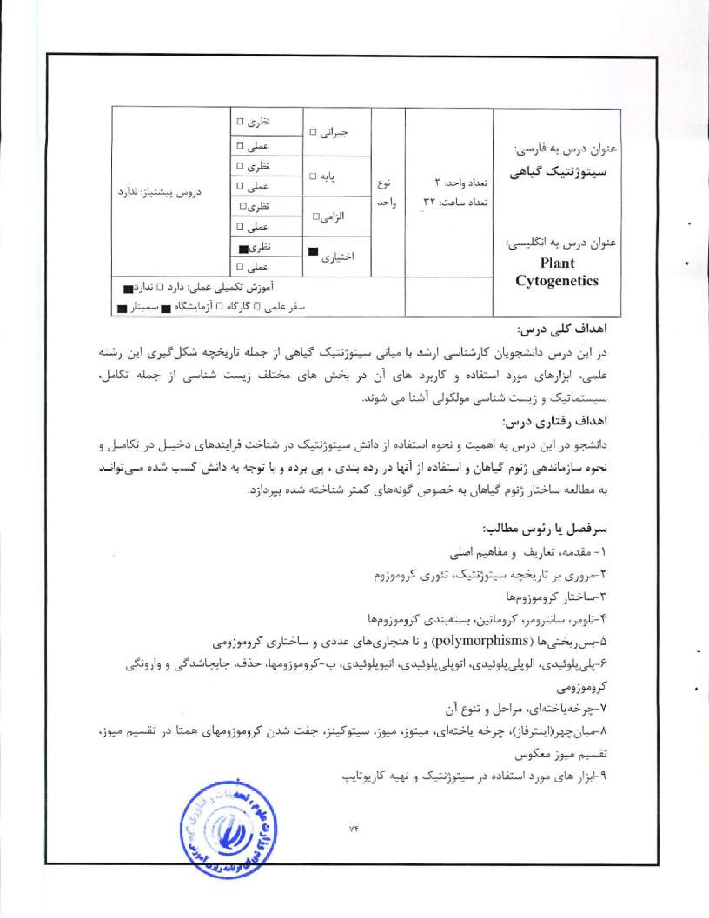


(G-banding,
C-banding,
Immunostaining
CGH,


I. Gupta. P. K. (2013) Cytogenetics: An Advanced Study, ed.
2. Slace, C.A. (t 989) Plant Taxonomy and Biosystematics, 2nd edi Edward Arnold. London.


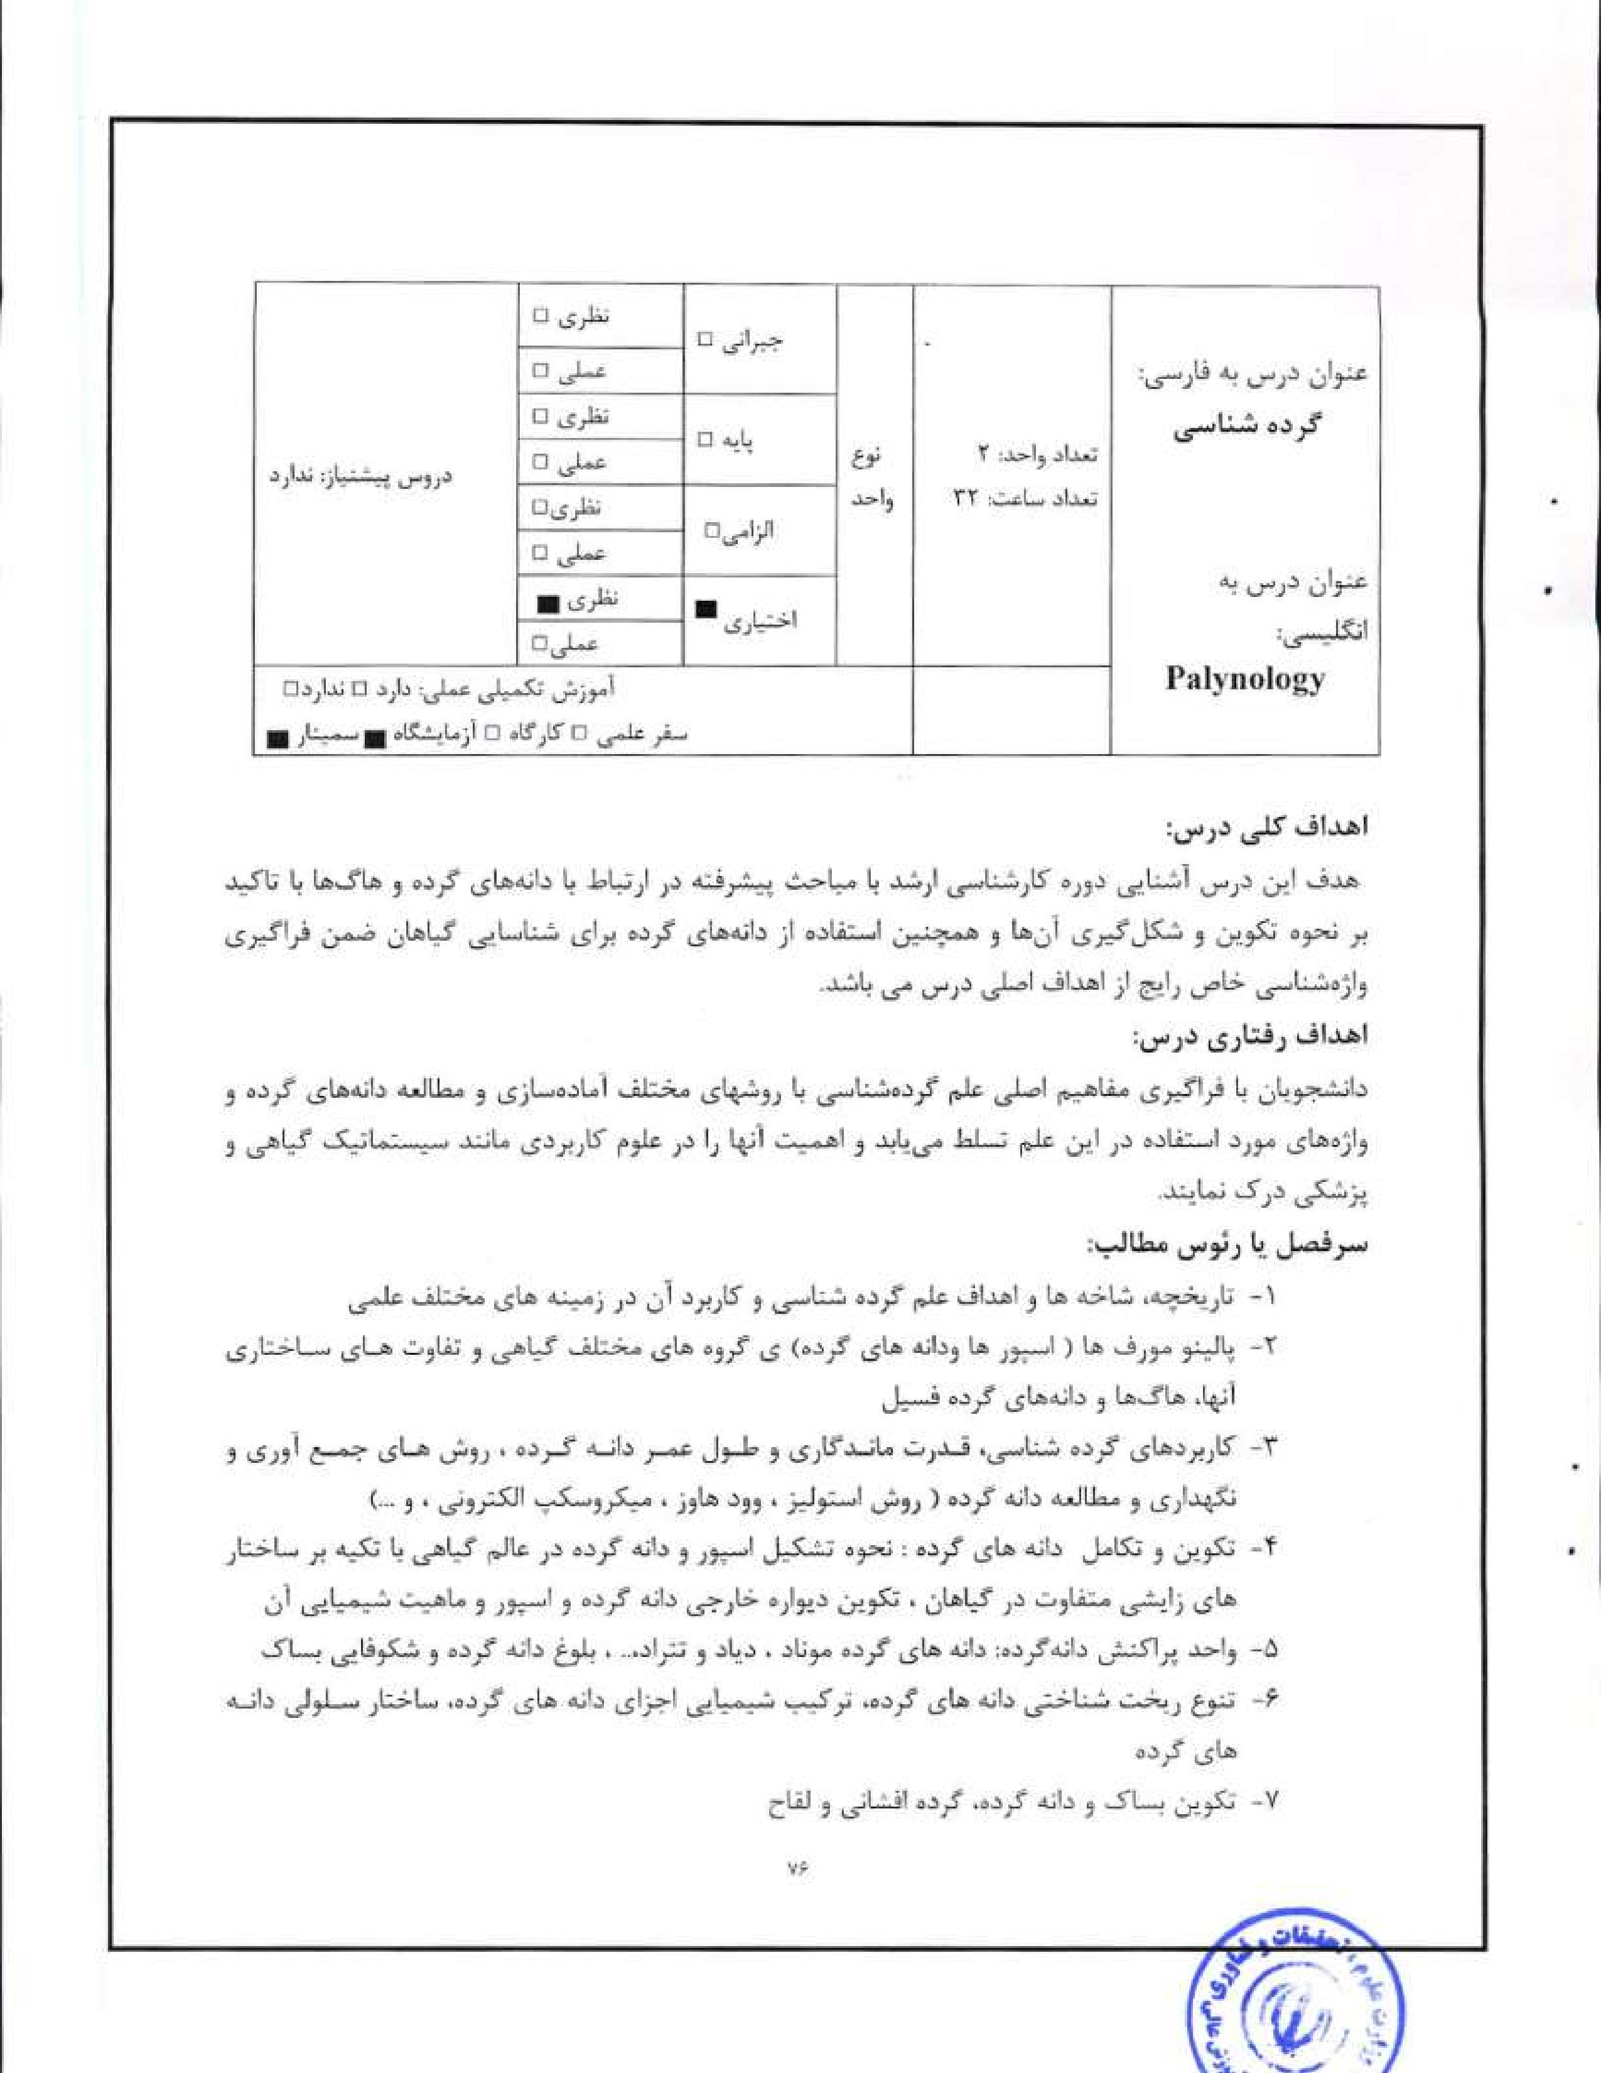
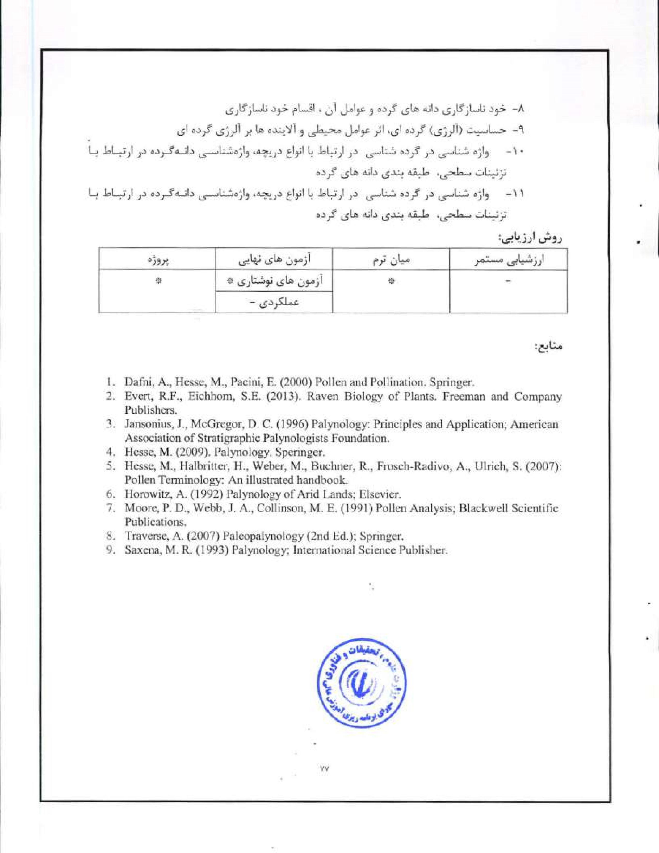
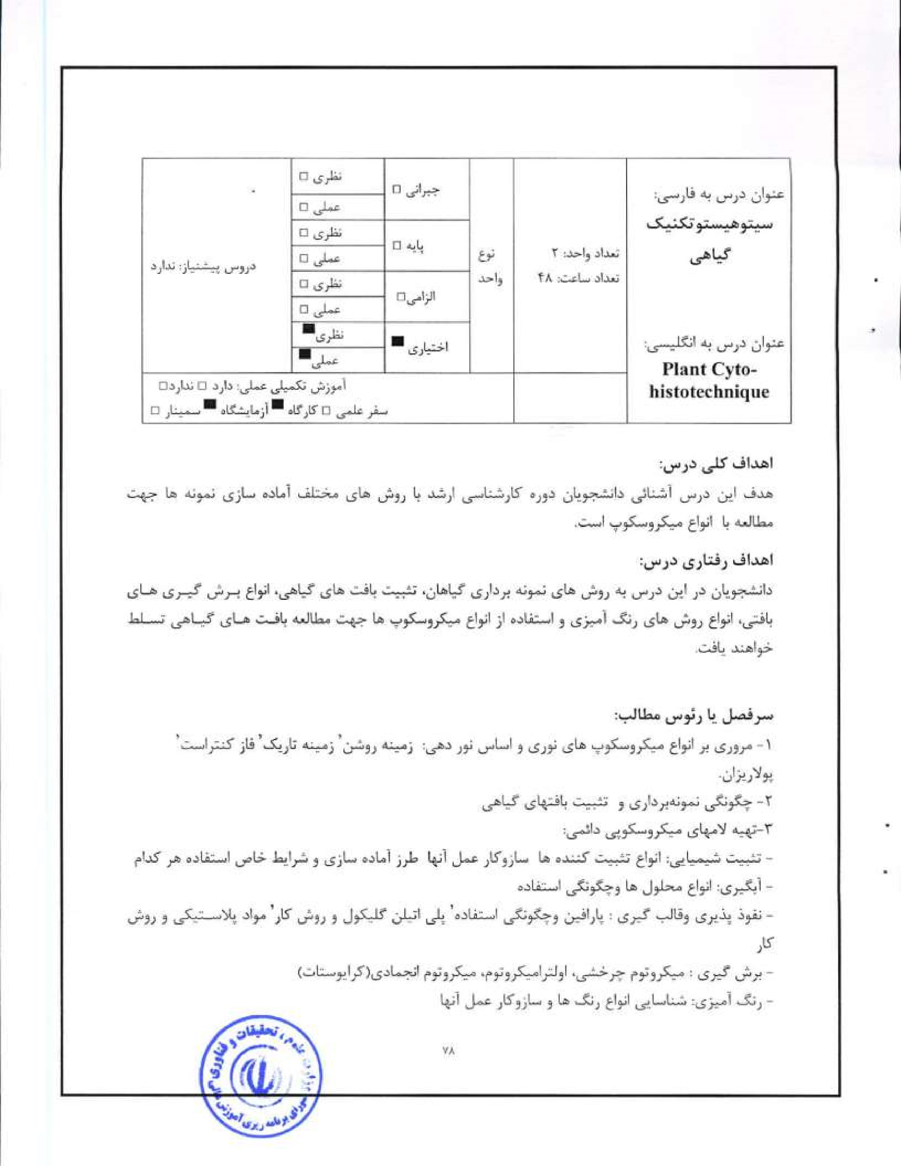
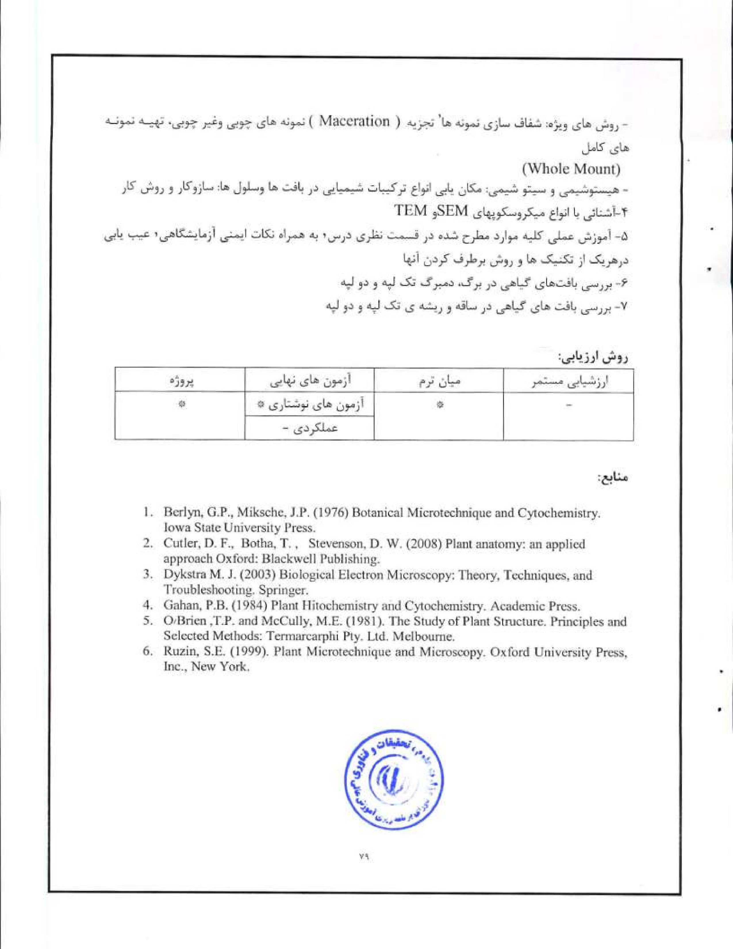
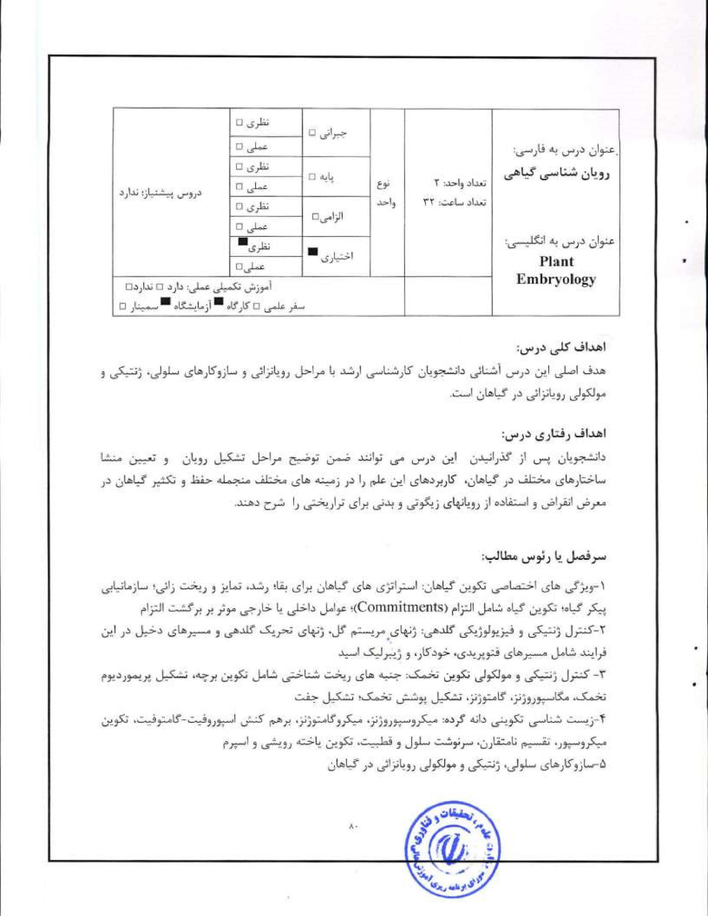
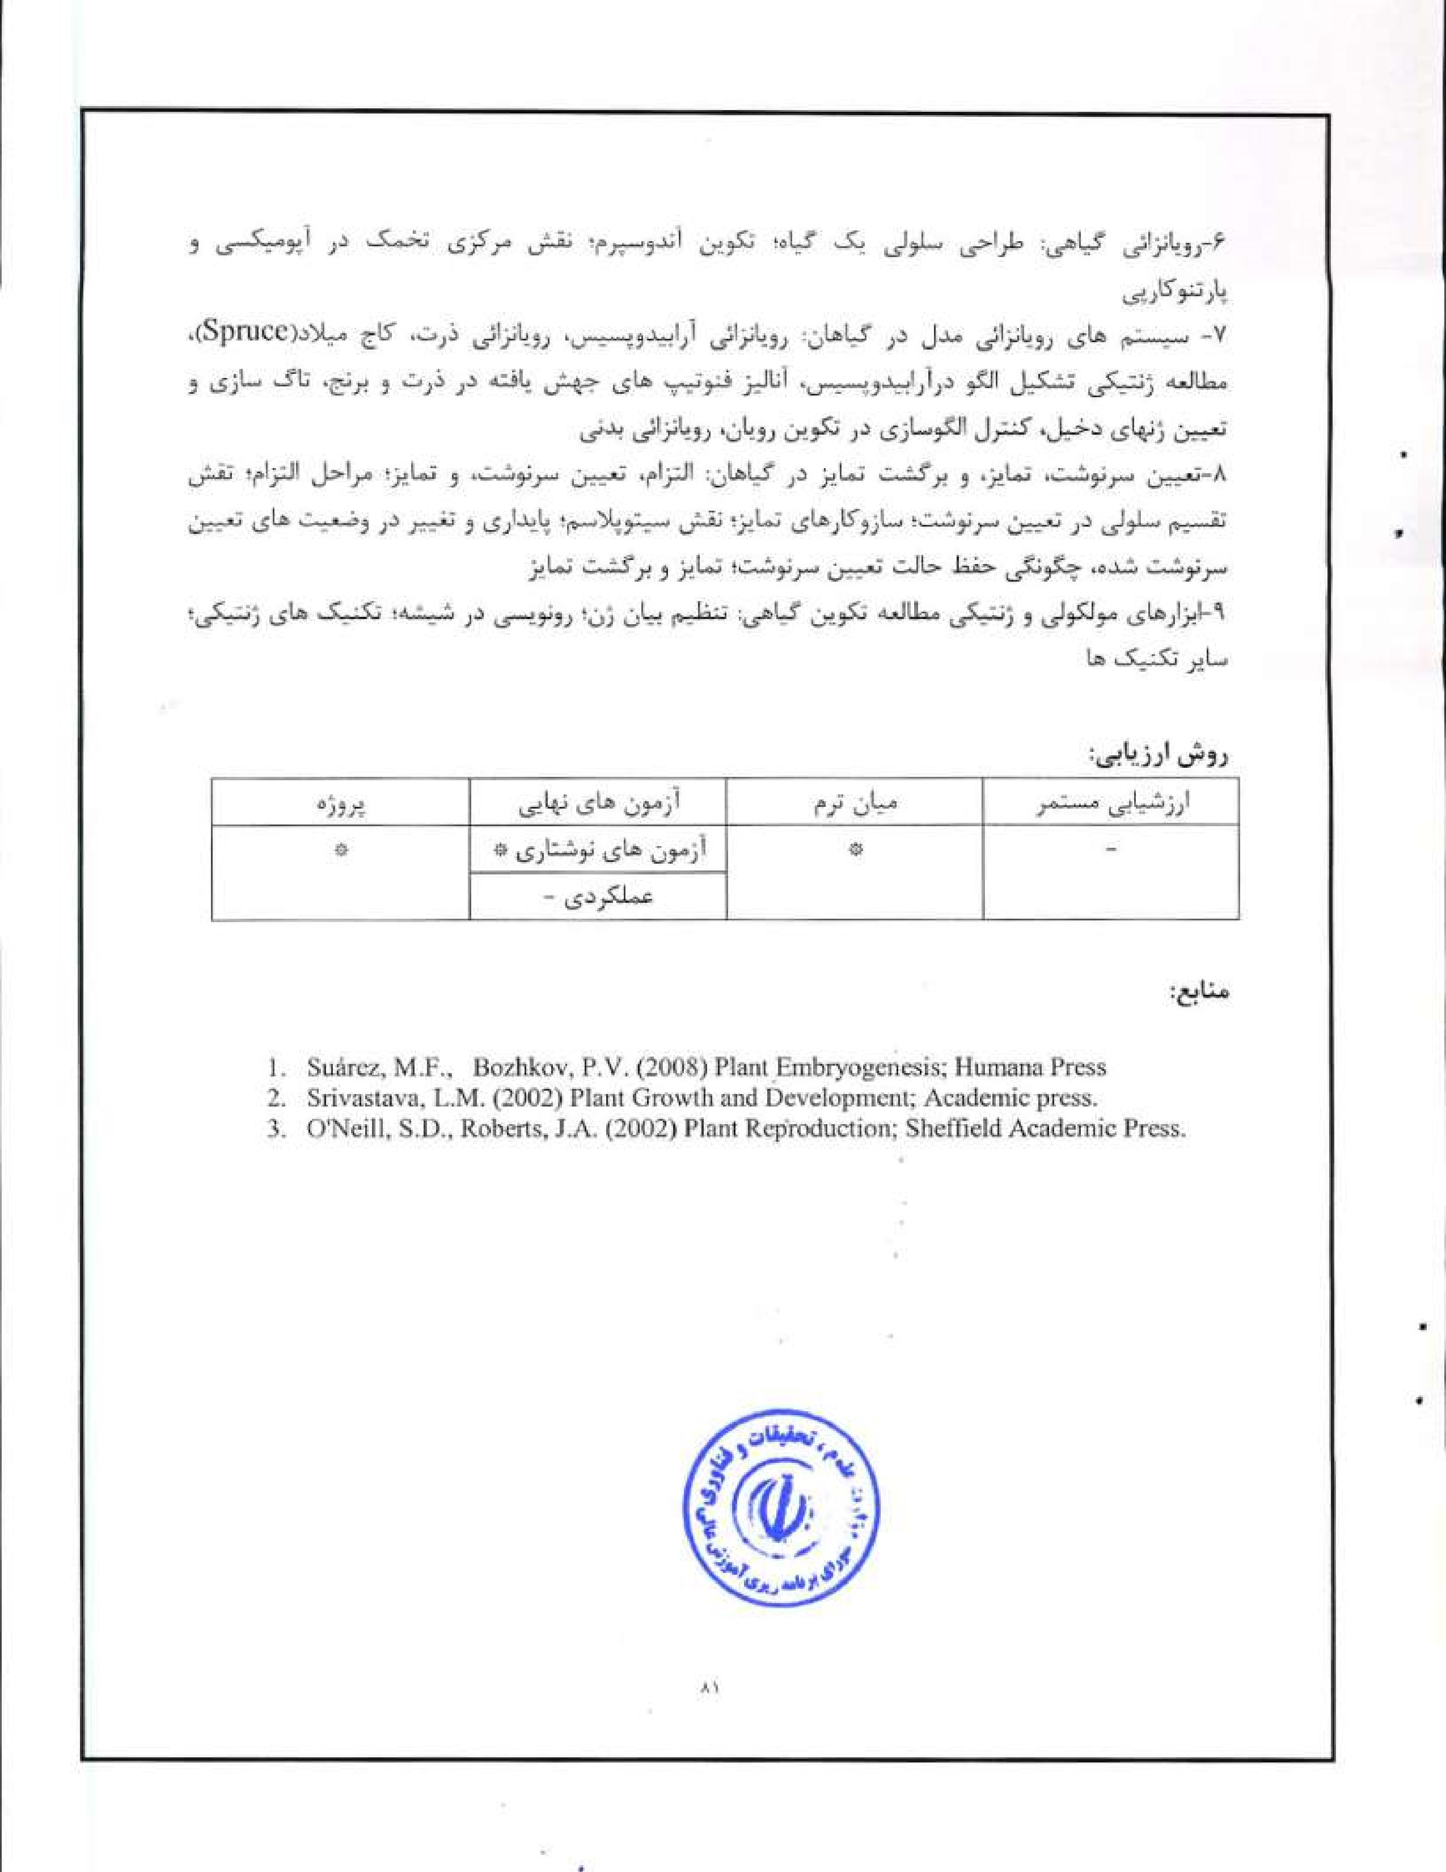
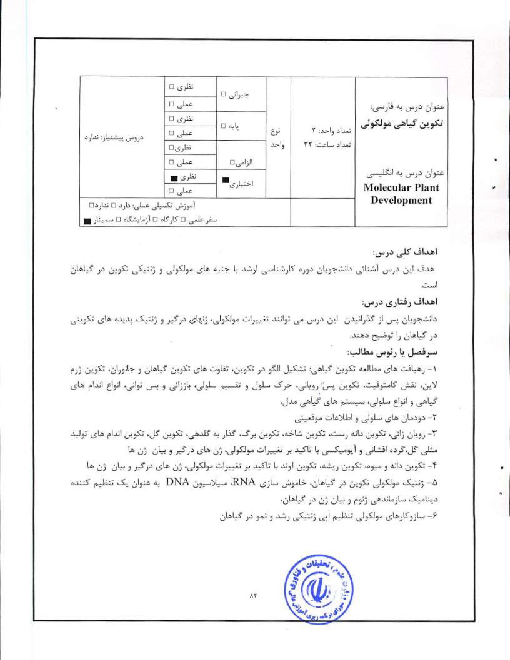

l .  2.  3.  5.  6. |   Fosketf D.F.. (1994) Plant growth and development: a molecular approach. Acedemic Press, ,S.IL (2000) Molecular Genetics of Plant Development. Cambridge University  Press.  Mutphy, TiM., Thompson, W.F. (1988) Molecular plant development- Prentice Ilall Pua, E-C, Davey, M,Rm (2010) Plant Developmental Biology— Biotechnological Perspectives —Volume; Springer.  Taiz. L. and Zeigert E. (2010) Plant Physiology, Fifth Edition, Sinauer Associates Incorporated.  Westhoff, P. (1998) Molecular plant development: from gene 10 plant. Oxford University  Press  

