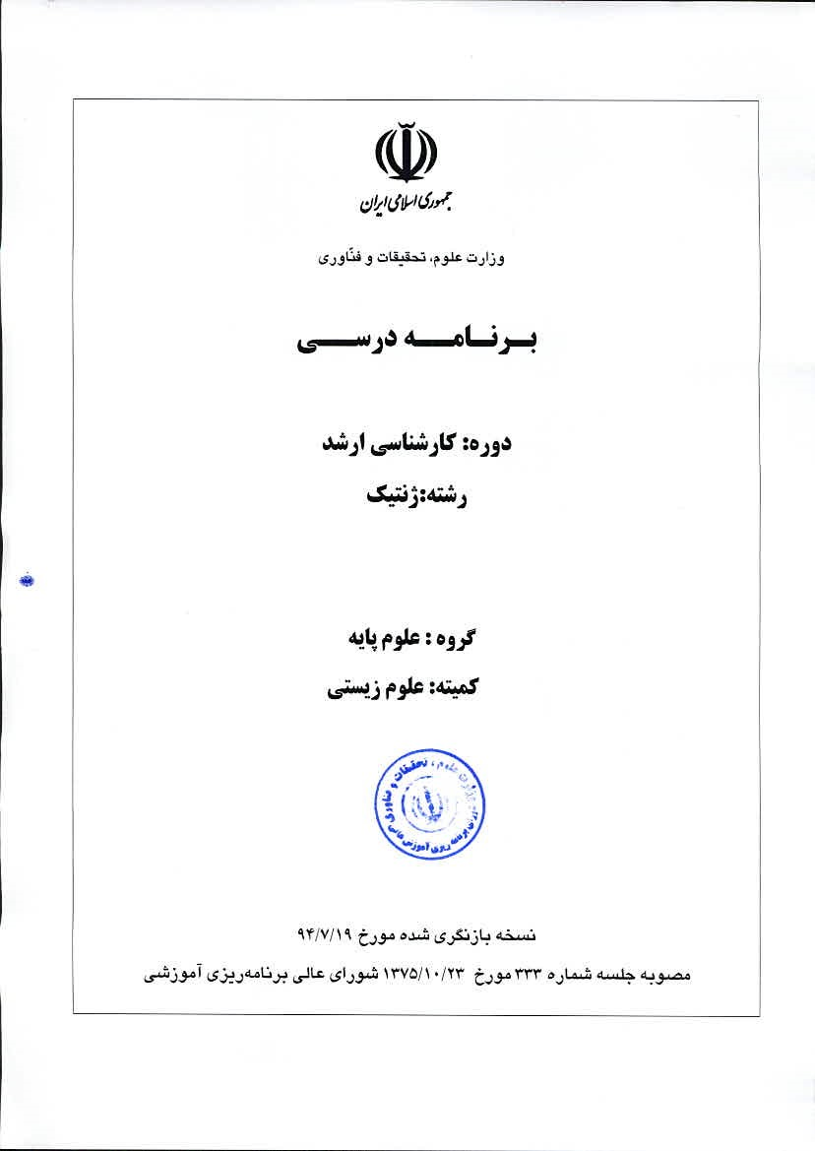
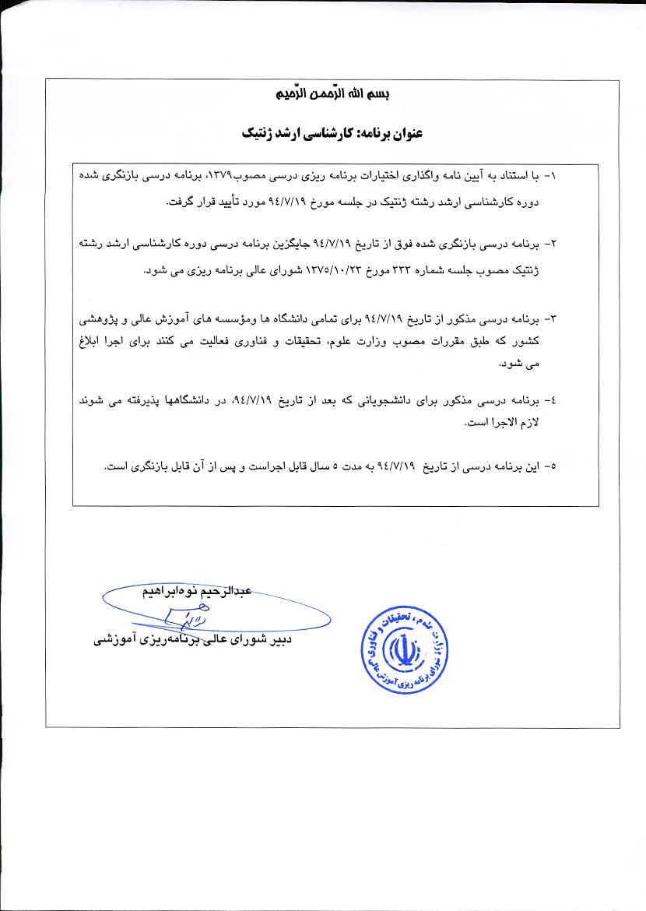
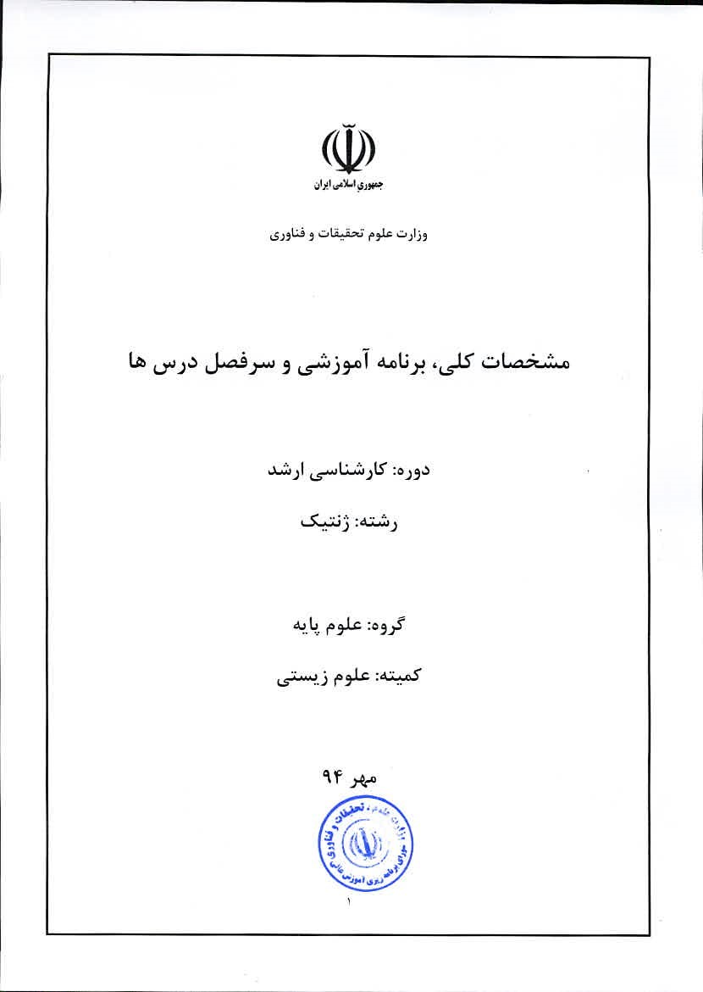

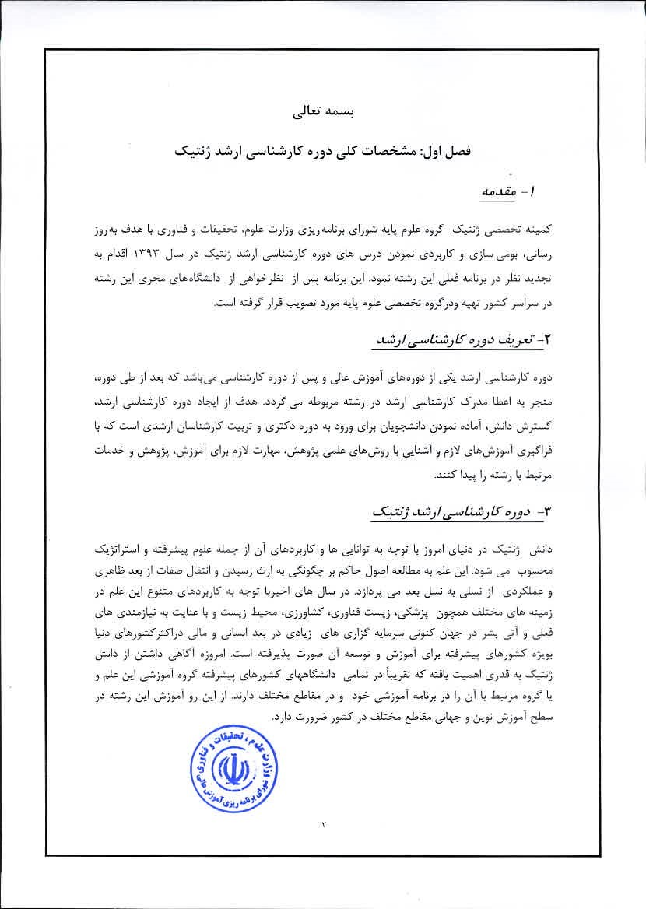
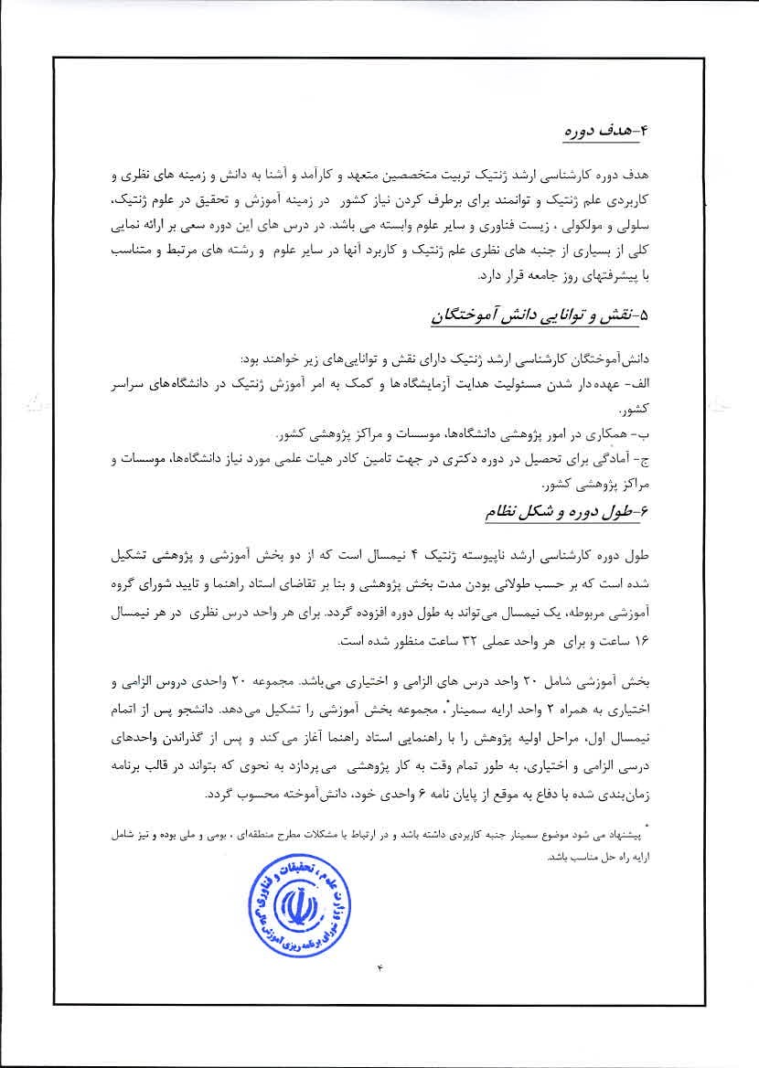
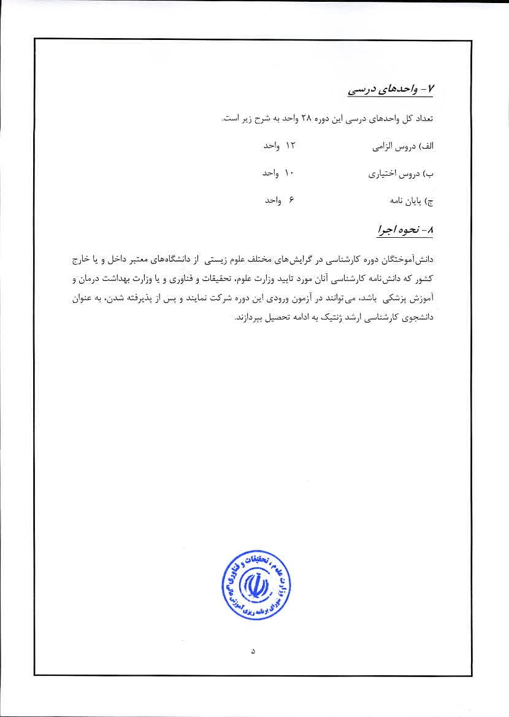

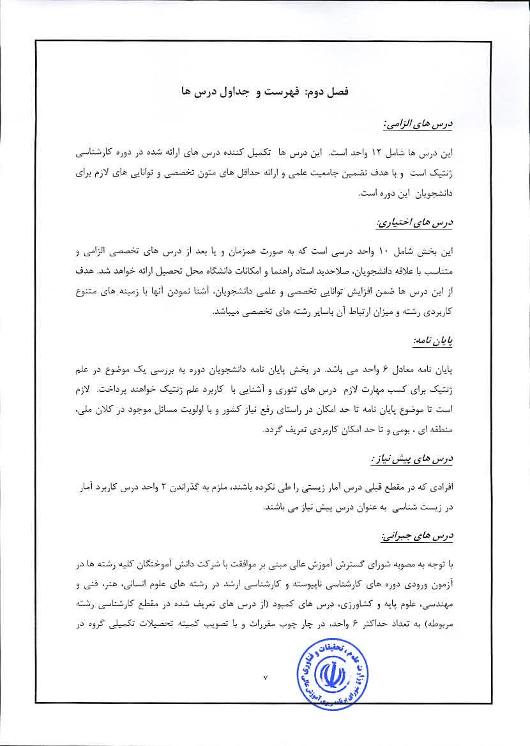
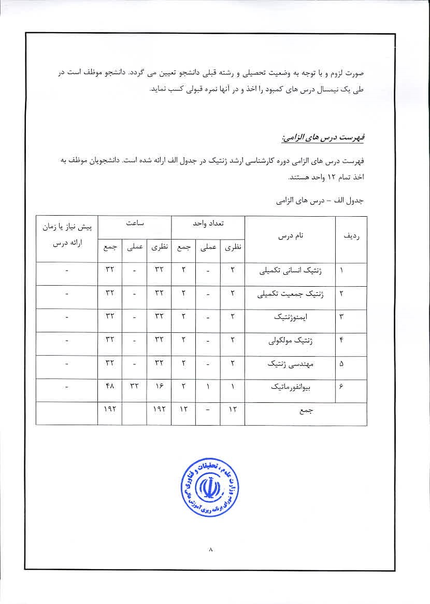
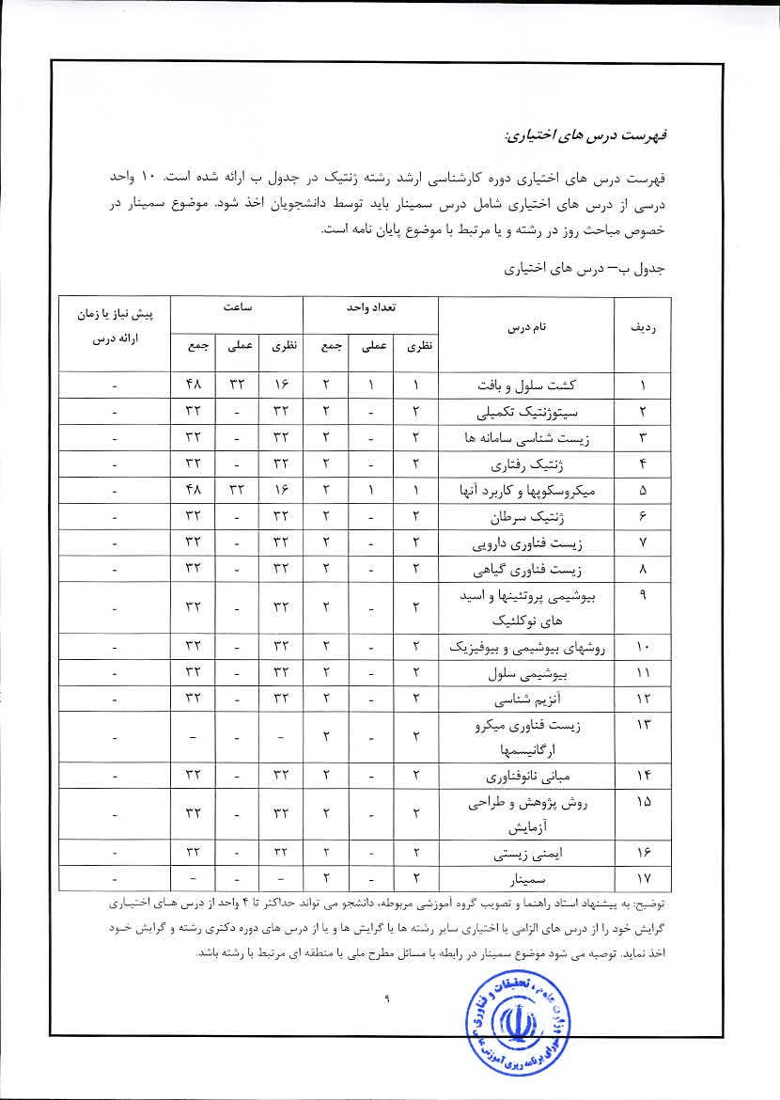

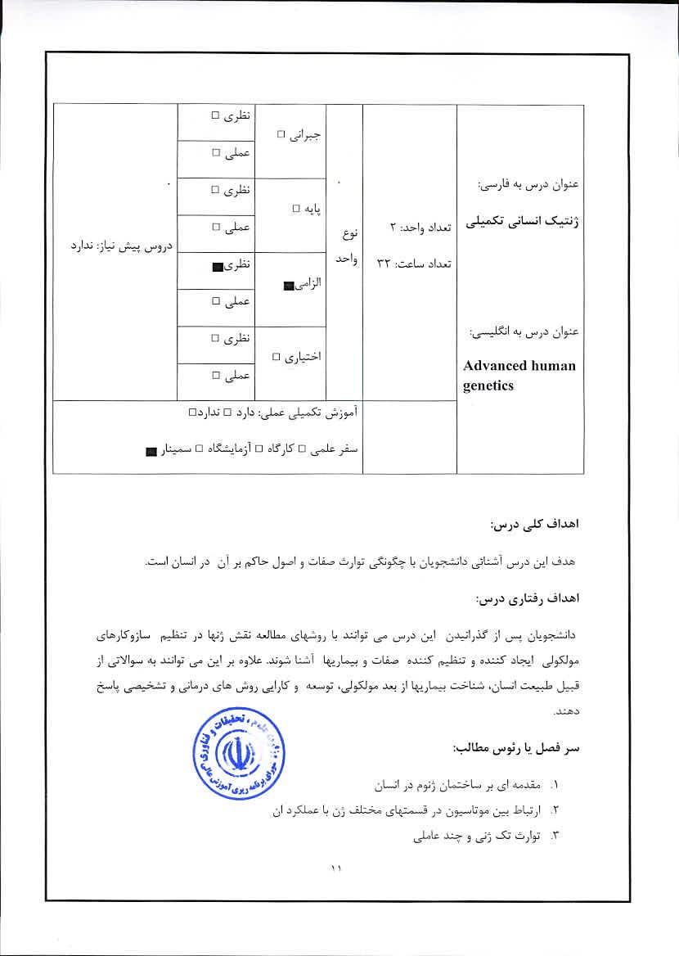

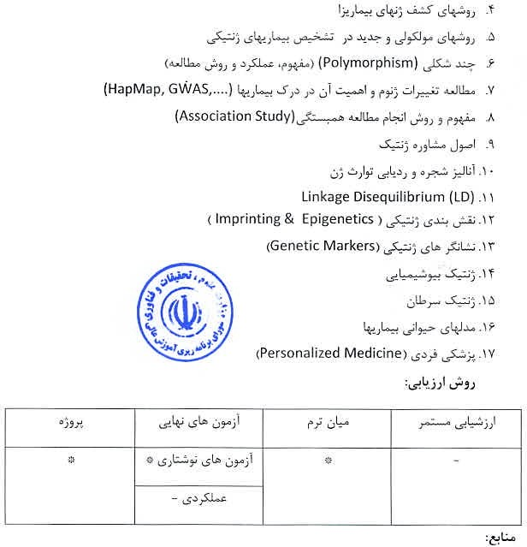
Strachan T. and Read A.P., 2011, Human Molecular Genetics 4, Garland Science/Taylor & Francis Group.
2_ Lewis R., 2012, Human Genetics, Concepts & ApplicationscMcGraw-Hill.
- Sudbery p. 2009. Human Molecular Genetics, 3rd edition, Pearson/Benjamin Cummings.
- Gillham N.W„ 2011, GeneS, Chromosomes, and Disease, Pearson Education.
S. Bruce R., Korf, Mira B. Irons, 2012, Human Geneticsand Genomics, 4th Edition, Wiley-Blackwell.
6. Speicher M.R.„ Antonarakis S.E. , Motulsky A.G., 2013, Vogel and Motulsky's Human Genetics, Problems and Approaches. Springer.
7. Nussbaum R.L, Willard H.F., Hamosh A., 2015, Thompson & Thompson Genetics in Medicine, Edition, Elsevier-

 | ロ5声 |  |  |  |     Ad、'anced population genetics
 | ロび声
 | ロ声
■ し-ーロ。よしロ。ピ)ロ」上~・
℃当ドげにい一
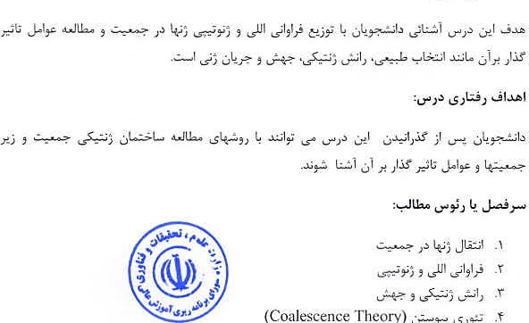
(Coalescence
Theory)
下
こ
ニ
)
戸

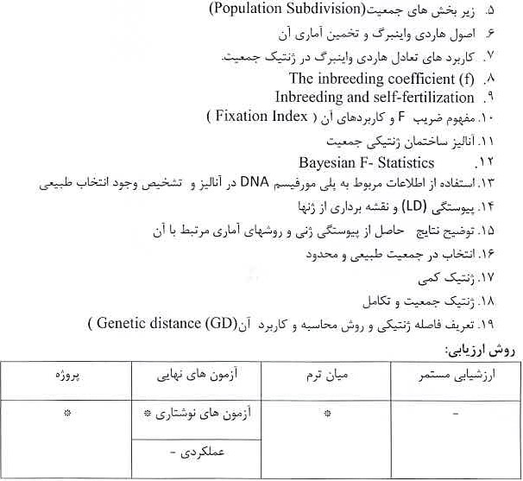
Rasmus Nielsen R. and Slatkin M., 2013, An introduction to population Genetics: Theory and Application, Palgrave Macmillan
2. Gillespie J. P., 2010, Population Genetics: A Concise Guide. Johns Hopkins University Press
Relethford J ,H., 2012 Human Population Genetics, Wiley.
Hedrick P. W. 2011, Genetics of Populations, Jones and Bartlett.
Halliburton R., 2004, Introduction to Population Genetics. Benjamin Cummings.
6. Hartl D. L, Clark A.G., 2006, Principles ofPopulation Genetics, Sinauer Associates, Inc_


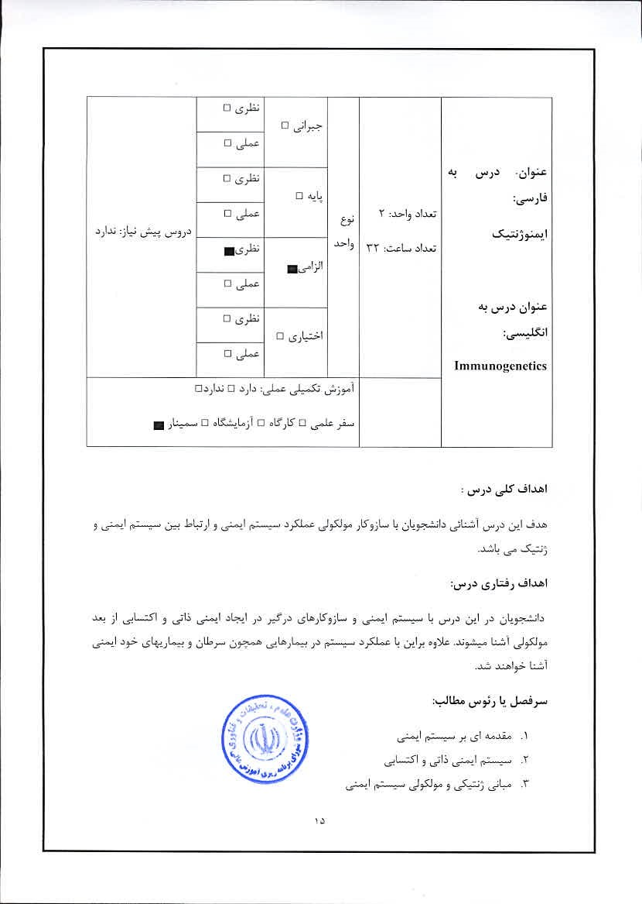

(Major Histocompatibility 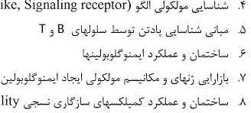
.(Toll
—like,
Signaling
receptor)
J*SJY
Complex)


Frank T. C. 2012, ImmunogeneticS, Method and applications in clinical practice, Humana Press.
- Murphy K., 2014, Janeway's Immunobiology. Taylor & Francis.

- Albert B., et. al., 2014, Molecular Biology ofthe Cell, Taylor & FranciS.

 |  |  |  |  |   M “ ⅲ田 genetics  ・
 |  | ロ山し
 | 
ロもロも,し、」ナ。&」しみjナ

工
、
エ
ー
長
4
こ
ナ
」
メ
5
ア
・
光
。
こ
し
」
←

 こ)げ覽こア」げョメ3区Jナし し二 。」
し
」
ゝ
し
メ
」
ラ

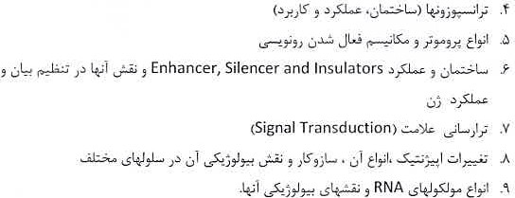
 | LSI-a |  | LSI
Snustad p., and Simmons M. J 2012 Principles Of Genetics, Wiley.
- Krebs J. E, et al. 2014. Lewin's Genes XI, Jones & Barlett Learning.
- James D. , Watson, et al, 2013, Molecular Biology of the Gene. Benjamin-Cummings Publishing Company.
4. Brown T. A., 2012.1ntroduction to Genetics, : A Molecular Approach, Garland Science
5. Weaver R, F. 2011, Molecular Biology, McGraw-Hill.
6, Albert B., al., 2014, Molecular Biology ofthe cell, Taylor & Francis.


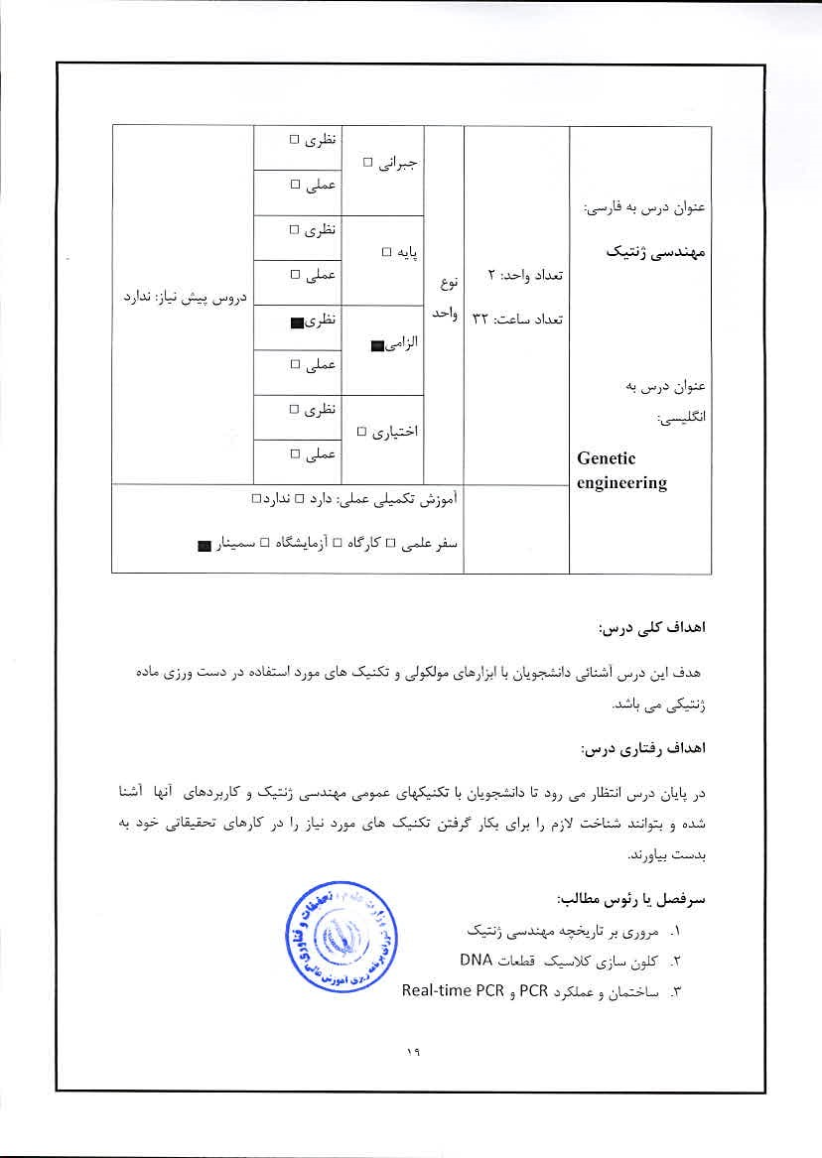

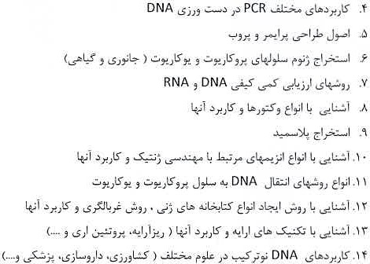

l, Brown, T.A., 2013, Gene Cloning and DNA Analysis: An introduction, WileyBlackwell.
- Primrose S. B. et al, 2013, Principles or Gene Manipulation and Genomics, Christopher Howe.
- Sambrook J., and Russell D. W-, 2006, Molecular Cloning (A Laboratory Press.
- Chauhan A., Vanna A. , 2009, A Textbook of Molecular Biotechnology.


 |  |  |  |  |     Bioinformatics
 | ロ5 | ロもし
 | ロび洋

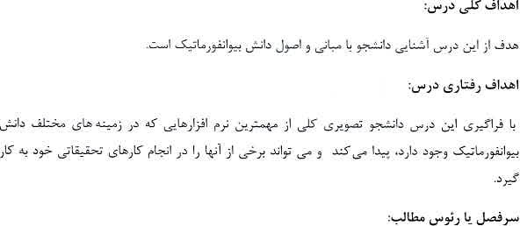
(Linux 3ニー第CommendLⅲじこ」- 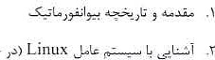
ー
与
,


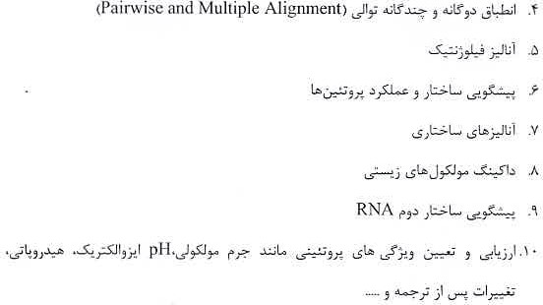

Mount. D.W.. 2001 , Bioinfonnatics: Sequenceand Genome Analysis, Cold Spring Harbor Laboratory press, New York.
2- Lesk, A.M., 2002, Introduction to Bioinformatics. Oxford, New York.
- Baxevanis, A.D. and F.F.F. Ouellette. 2001, Bioinformatics: A Practical Guide to the Analysis of Genes and Proteins, Wiley-Interscience, New York.
- Tsai, C.S. 2007, Biomolecules, Introduction to Structure, Function and Informatics.A John Wiley & Sons, Inc., Publication.


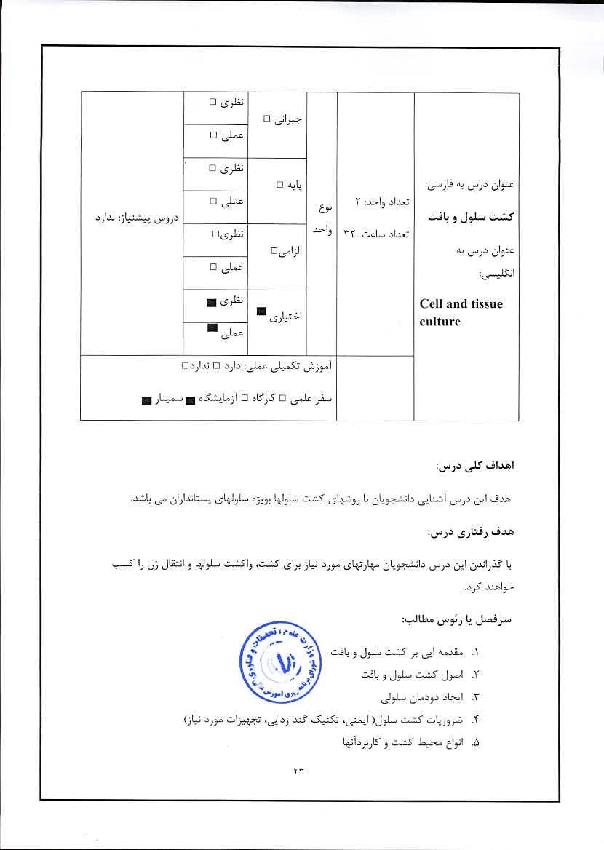
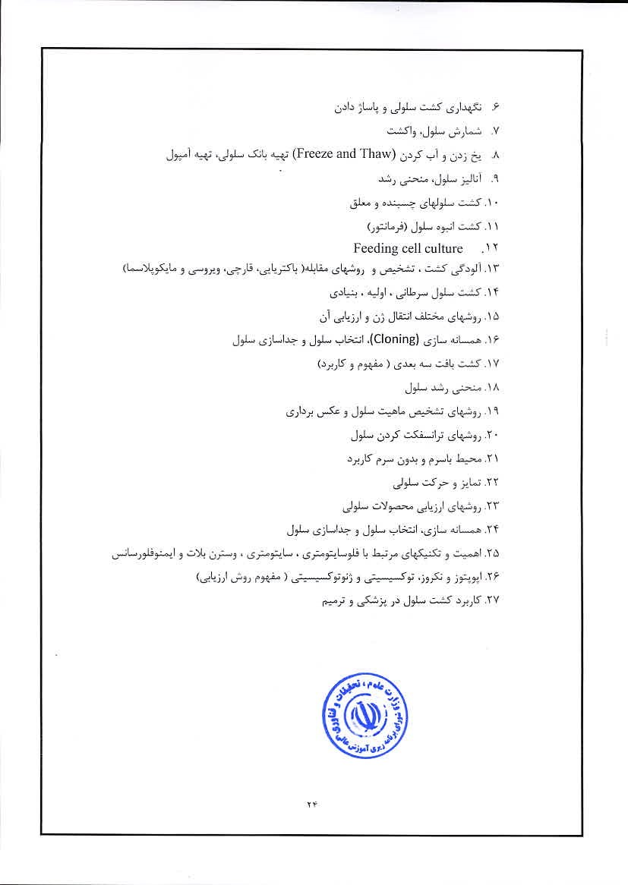


Aschner, M., Sunol, C. and Bal-Pricem, A. 2009, Cell Culture Techniques, Sprin ger.
2, Maureen A. Harrison and Ian F. Rae, 2010, General Technique Of Cell Culture, Cambridge University Press.
3. Freshney I Re, 2011, Culture of Animal Cells: A Manual Of Basic Technique and Specialized Applications, Sixth Edition, Wiley.


 |  |  | とア | 〒てによ立し」 |   Advanced cytogenetics

」
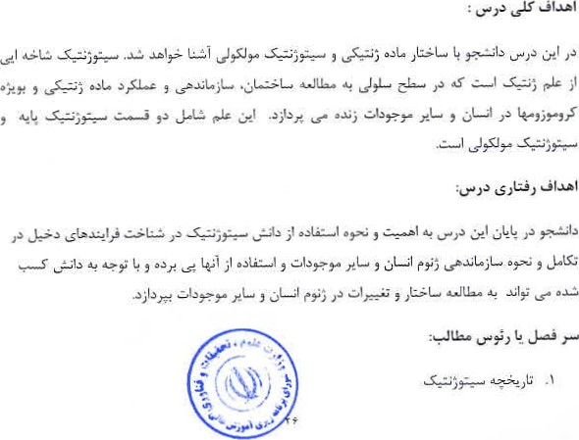

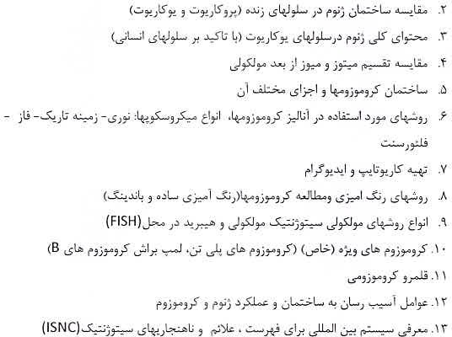

Ram, M. 2012, Fundamentals of Cytogenetics and Genetics,
Padma Tirunilai, 2012, Recent Trends in Cytogenetic Studies: Methodologies and Applications.
- Schmid M. 2013, Cytogenetic and Genome Research, ,
- Kargere, S. 2013, principles of Clinical Cytogeneties. Springer.
5, Qurban A. , 2012, Cytogenelies: Genomics and Molecular Techniques.
6. Gillham N.W., 2011, Genes, Chromosomes, and Disease, Pearson Education. Krebs J. E, et al., 2014. Lewin's Genes Jones & Barlett Learning,


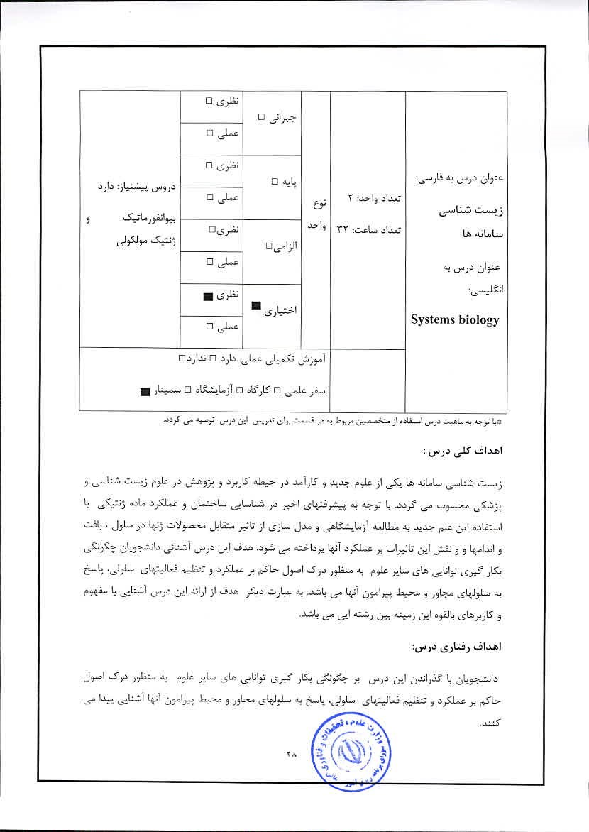
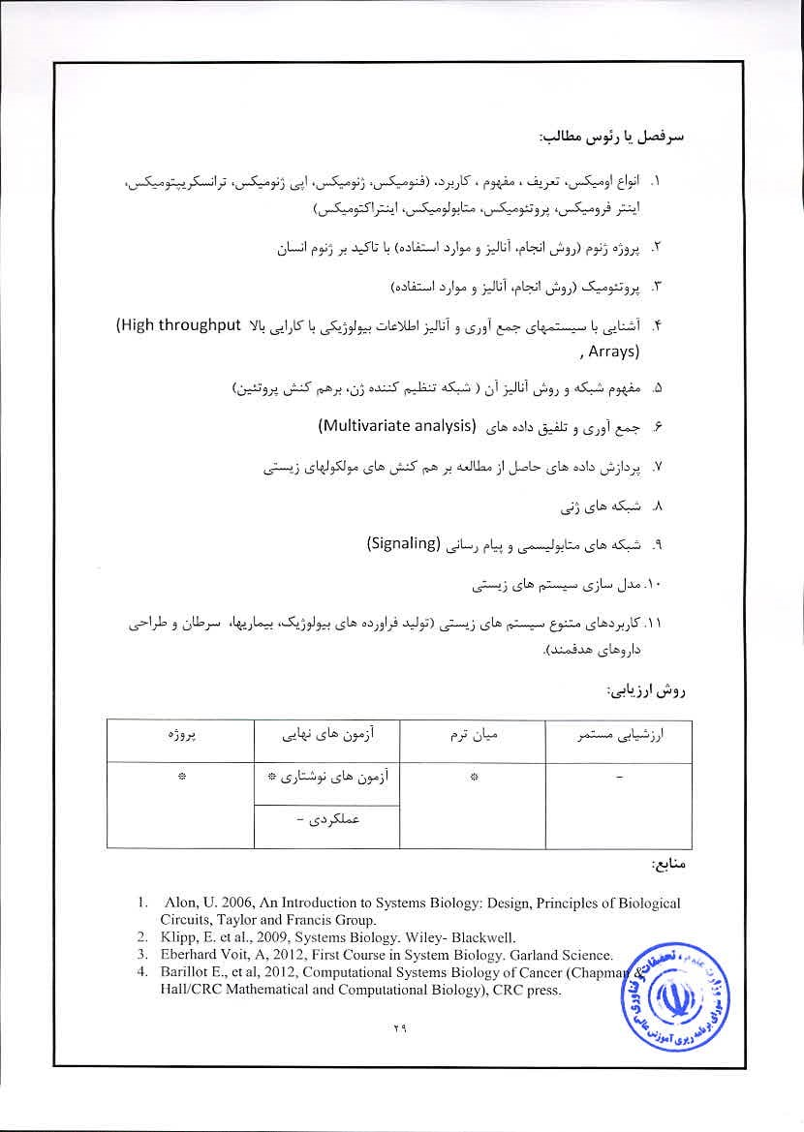

 |  |  |  |  | B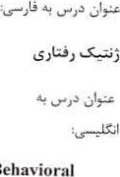曲” io「 genetic、


し丿しき)にい一


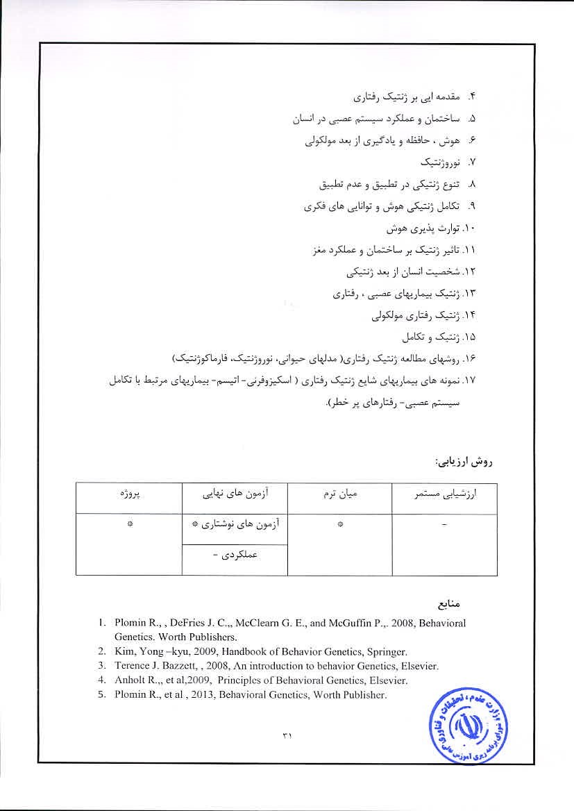
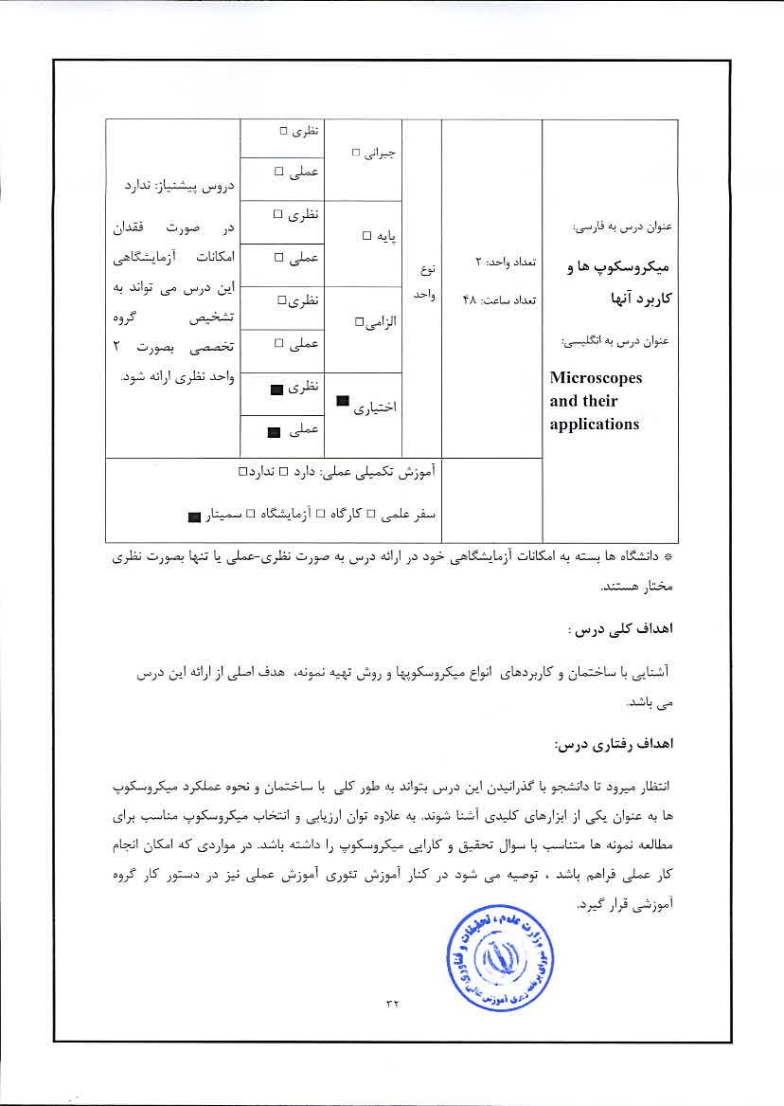

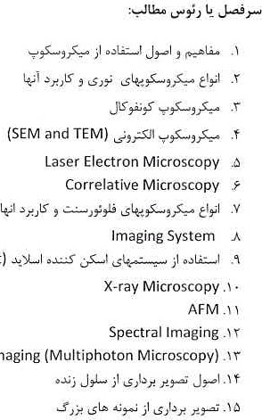
(FLIM, FRAP and FCS)
Deep
Tissue
imaging
(Fluorescence with high Throughput)

Robbins B. , 2011, Microscope,
Rogers K.,2006, The Osborne Complete Book of the Microscope
- Williams D. B.2009, Transmission Electron Microscopy: A Textbook for Materials Science, Springer.

- Bhushan B. , 2011, Scanning Probe Microscopyin Nano science and Nano technology, Springer.
- Pawley J.B., 2012, Handbook of Biological Confocal Microscopy, Springer.

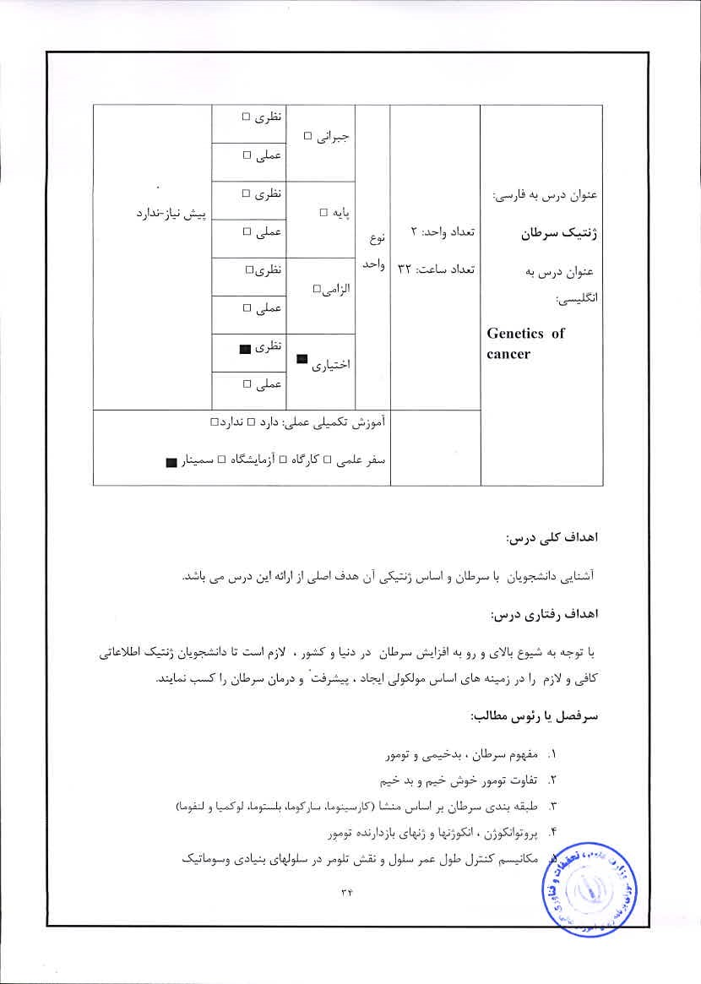

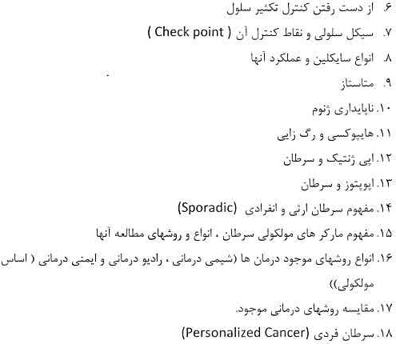

Cowell J 2001, Molecular Genetics OfCancer, 'l'aylof & Francis.
21 Strachan T., and. Read A. p., 2011, Human Molecular Genetics4.Garland Science/ Taylor& Francis Group.
- Chung l). C., Haber D. A. , 2010, Principals of Clinical Cancer Genetics, Springer.
- Sudbery P., 2009, Human Molecular Genetics, Pearson/Benjami1i Cummings.

- Bunz F., 2010, Principles Of Cancer, Springer.
6. Dyer M. , 2011, Cancer and Development, Elsevier.
Neidle S., 2013, Cancer Drug Design and Discovery, Elsevier.
Prendergast Jaffee E.. 2013, Cancer Immunotherapy, Elsevier,

 | ロ声 |  |  |  |   Drug biotechnology
 | ロ5洋
 | ロ5声
 |  | 

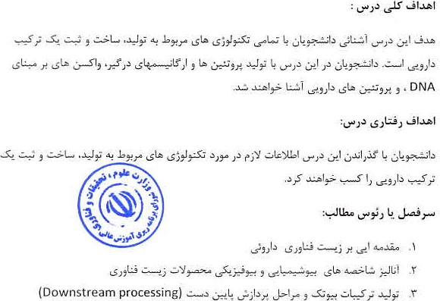
こ
こ
己
し
」
シ
し
戸
導
ツ

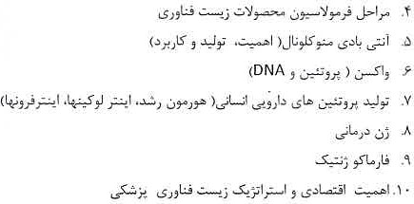

DaanJ. A. Crommelin, SindelarR. D., Meibohm B, 2013, Pharmaceutical Biotechnology: Fundamentals and Applications, Springer.
- Guzman, Carlos A.; Feuerstein, Giora 2009.Pharmaeeutica1 Biotechnology, Series: Advances in Experimental Medicine and Biology, Springer.
- Kokate C. , Pramod H. J.,et al, 2012, Textbook OfPharmaceutical Biotechnology, Elsevier.
- Walsh G. , 2013, Pharmaceutical Biotechnology: Coneeptsand Applications, Wiley.


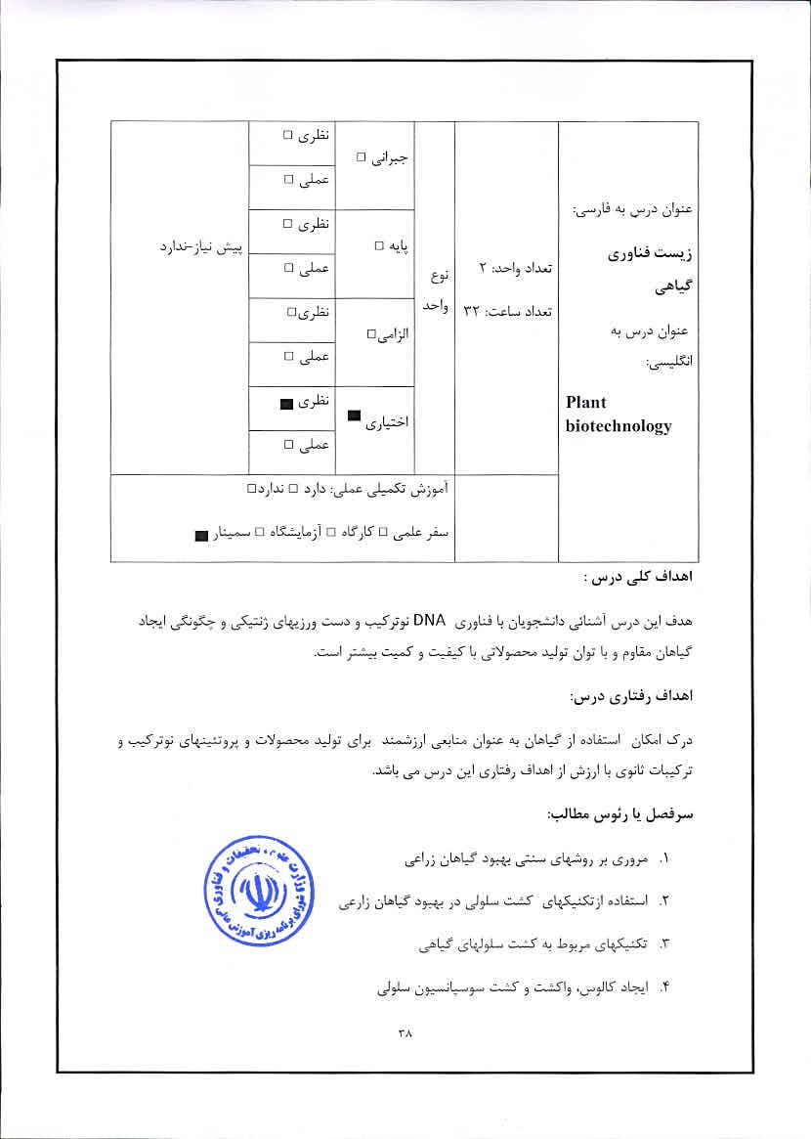

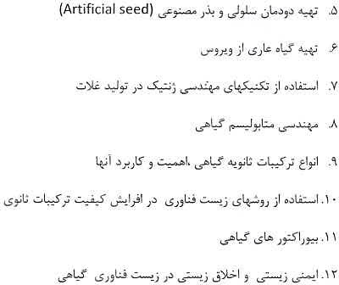

Christou, P., Klee 2004, Hand Book of Plant Biotechnology, John Wiley & son.
2. Altman A. , Hasegawa p. 2012, Plant Biotechnology and Agriculture:prospects for the21 Century, Academic press.
Chawla H. S. , 2009, Introduction to Plant Biotechnology, Science Publisher.
4. Slater A, Scott N. W Fowler M. R., 2008. Plant Biotechnology, OxtOrd university press.


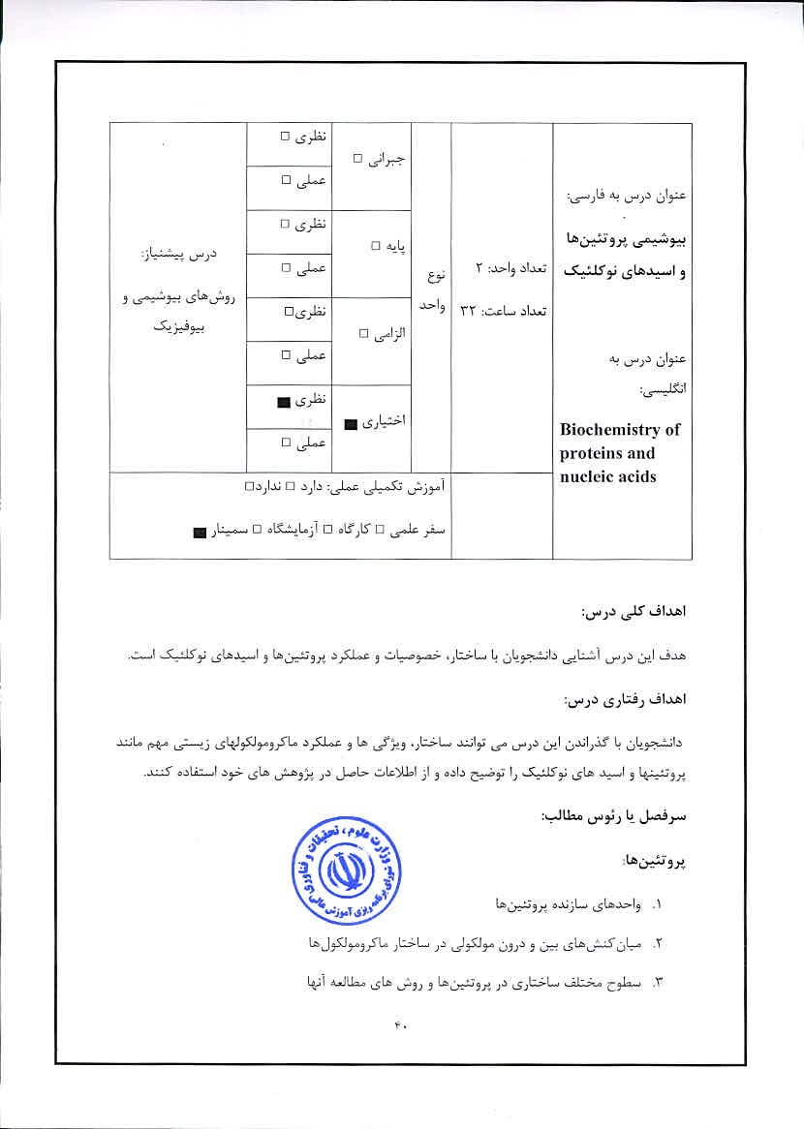



. Branden C. and Tooze J., 1999, Introduction to Protein Structure; 2nd Ed., Garland Pub. Inc., New York.
- Walsh G., 2002, Proteins: Biochemistry and Biotechnology, Wiley, New York.
- Creighton T.E., Proteins: Structures and Molecular Properties, Wiley, New York.
- Bloomfield, V .A., Crothers D.M.and Tino-co Nucleic Acids: Structures, Properties, and Functions, Umv Science Books, California.
- Neidle, S., 2008, Principles of Nucleic Acid Structure, Academic Press.
- Creighton T. E., 2010, The Biophysical Chemistry ofNucleic Acids & Proteins, Helvetian Press. 

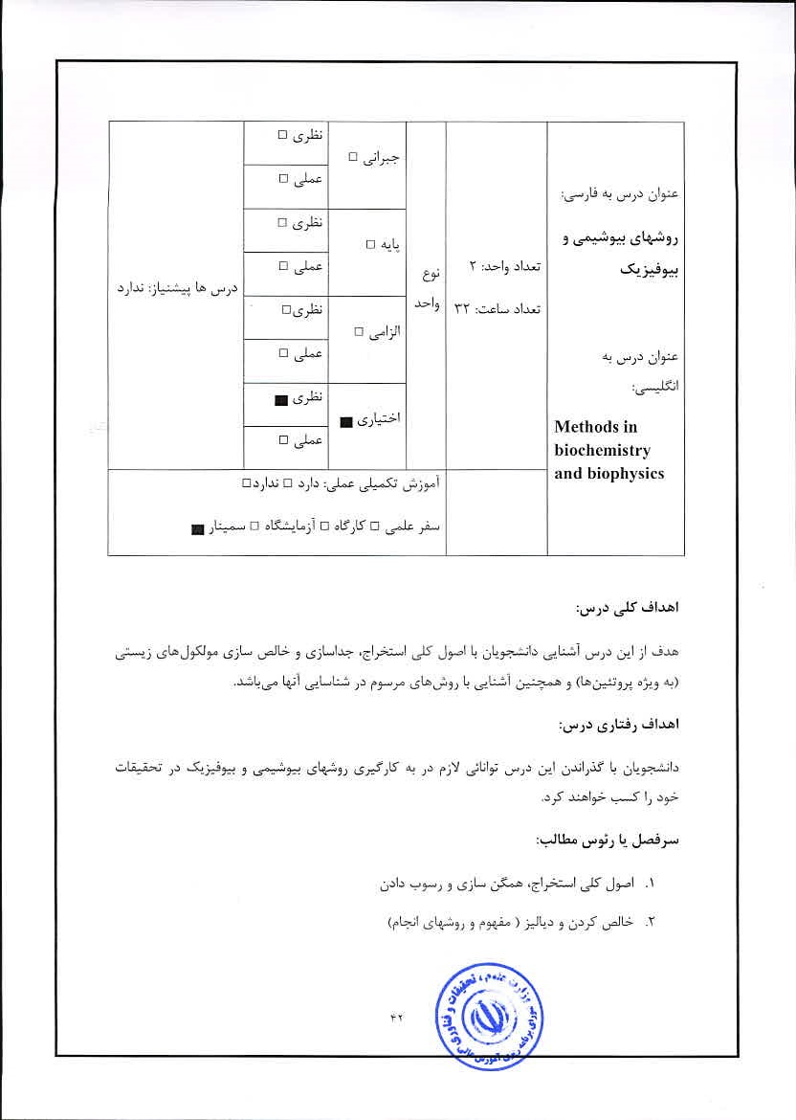

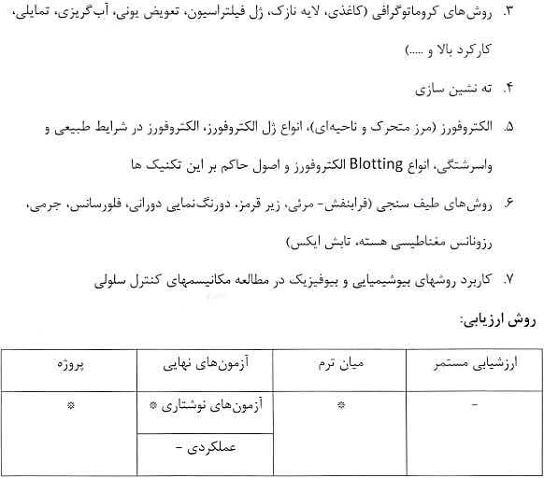
Sheehan D, , 2009, Physical Biochemistry: Principles and Applications, John Wiley Sons Ltd.
Freirelder 1982, Physical Biochemistry. Appliéations to Biochemistryand Molecular Biology, Ed. W.Il. Freeman & Company, New York.
- Holde Keli. van, Johnson W .C. and Ho, I'S. 2000, Ptineiples of Physical
Biochemistry, Ed, Pearson Prentice Hall, New Jersey, 2006.4- R. Boyer, Modem Experimental Biochemistry, Prentice Hall.
- Harris DC, 2011, Quantitative Analysis; W.H. Freeman & co.
- Creighton 2010, The Physical and Chemical Basis Of Molecular Biology. Helvetian press.
- Buxbaum E_, 201 1 , Biophysical Chemistry of Proteins: An Introduction to Laboratory Methods, Springer,


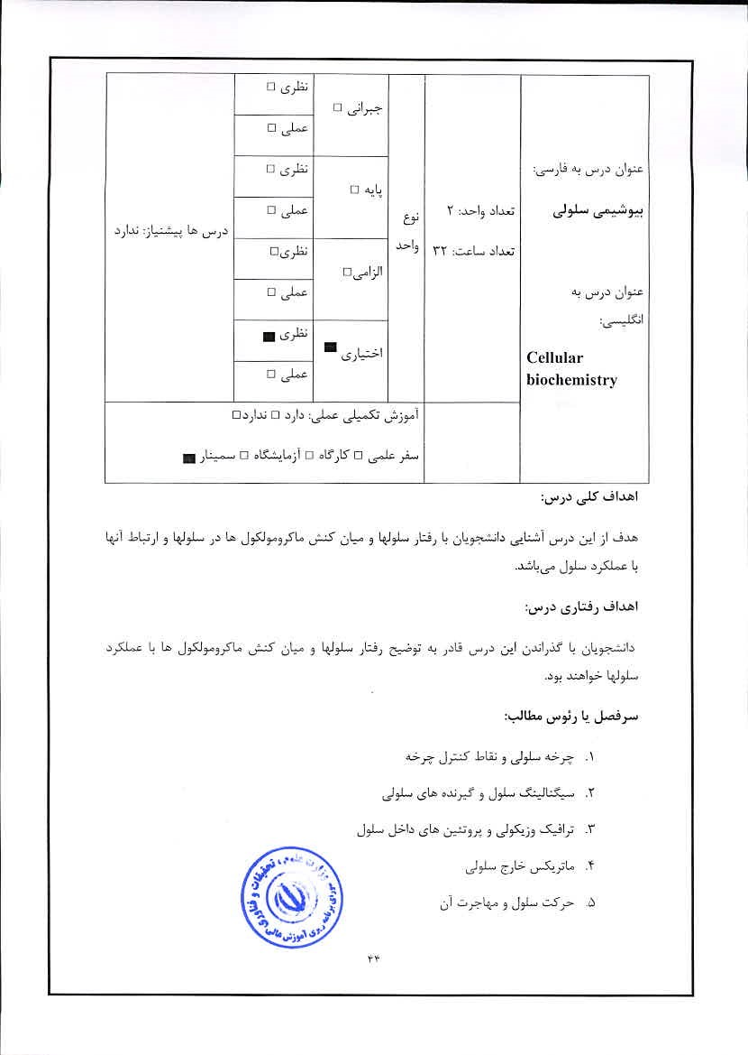

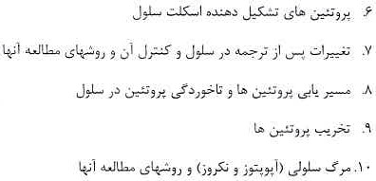

-l , Albetts B, Johnson A. , LewisJ., Raff M.. Roberts K. , and WalterP„2007, Molecular .Biology of the Cell, 5th Ed., Garland Science Publisher.
Helmreieh E-J.M., The Biochemistry Of Signaling. Oxford University Pre".
_3. Karp G. 2013, Cell and Molecular Biology: Concepts and Experiments (Karpf Cell and Molecular Biology), Wiley Publisher; 7th Ed,
4. Krauss 2006. Biochemistry Of Signal Transduction and Regulation, John Wiley

S. Bolsover S.R., Shephard White A_ and JS., 2011, Cell Biology: A Short Course, John Wiley Sons Publisher.

 |  |  |  |  |   をし丿0こ唇:ニ  Enzymology
 |  | ロし


:しをド)し」)にい一

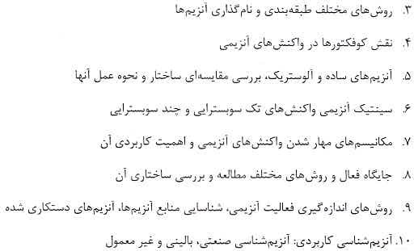

l. Marangotii A. G. , 2003, Enzyme Kinetics: A Modern Approach, John Wiley & Sons Inc;, New York.
- Palmer 1991, Understanding Enzymes, 3rd Ed., Ellis Hot-wood Limited, New York.
- Copeland R.N. 2000. Enzymes: A practical introduction to structure„mechanism, and data analysis, 2nd Ed., Wiley-VCH, New York,
- V__ 2004, Comprehensive Enzyme, Kinetics Kluwer Academic Publishers, Loudon.
- Yan-Kahn Land HerveG„ 2010, Molecular and Cellular F.nzymology, Springer-Verlag, Berlin Heidelberg 

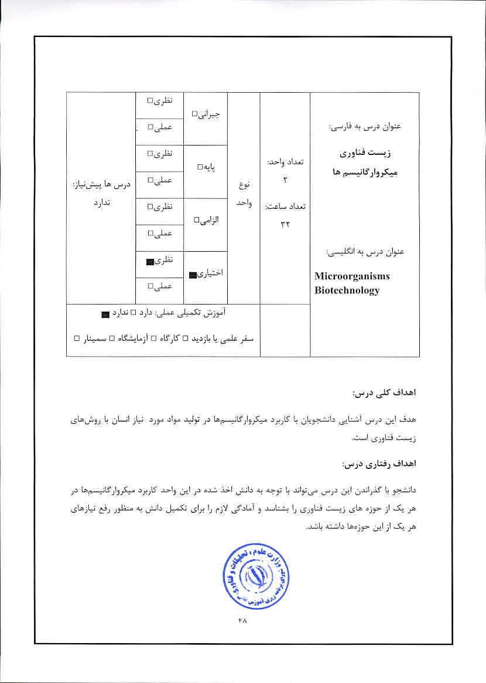

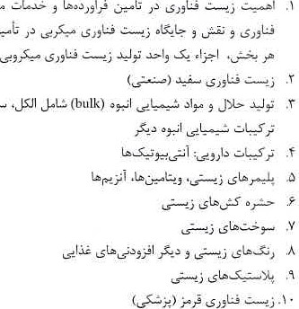
丿ヒえ。し、ト~、」)いもナ戸しL」)」)ナ。こし」一し。もゞド
。
し
-
。
こ
こ
ー
一
し
当
も
,
こ
し
5
”
”
こ
一一第ゞ宀」幻毒に
なこや、。なユに0。」・エつ0 )に」し匕アデ5ムこア-い
第し上デメョDN齢0、」ナ-。J。孱
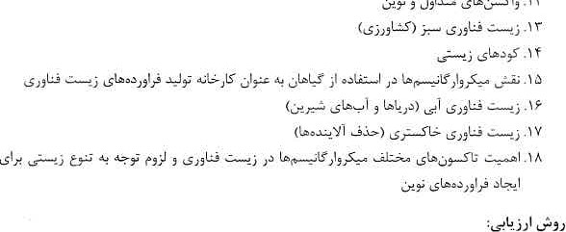第ゞ- 5こ宀」も.1了
ま
0


2.  3.  4. | Okafor, N. 1997, Modern Industrial Microbiology and Biotechnology, Science Publishers, Inc.  Glazer, A.N. and Nikaidoy H. 2007 , Microbial Éiotechnology- Fundamentals Of Applied Microbiology, Cambridge University Press.  Lee Y. K. 2006, Microbial Biotechnology. pribcipals and applications, World Scientific.  Singleton P. 2006, Bacteria in Biology, Biotechnology and Medicine; Wiley.  

 |  |  |  | 「て:こェ0L3 |   Fundamentals of nanotechnology
 | ロ5声 | ロし
■もしロもセ1し←新」ナ討画 L。ーロ。区ーしロ。げ」ISロ= .・
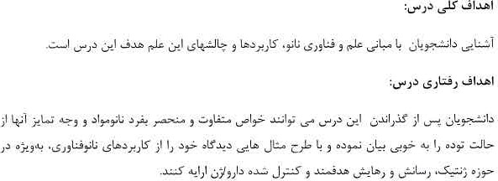



も凵当ニ」うし才ャ、・と。宀・い
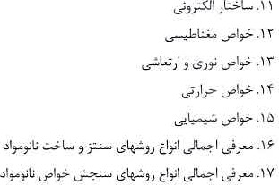
DNA Nanotechnologyし上ヒ」0人び”。こしし与し一い
 | しナ。引 |  | し1


Filipponi L., and Sutherland D.. 2013, Nanotechnologies, Principles, Applications, Implications and Hands-on Activities. European Union.
- ShoseyOV O. 2008, Nanobiotechnology, Biolnspired Devices and Materials Of the Future, Humana Press Inc.
- Sitharaman 13_, 2011, Nanobiomaterials Handbook, CRC Press,
- Br'echignac C., Houdy p., Nanomaterials and Nanochemistry, Springer.
- Edwards S. As, 2006, The Nanotech pioneers, Wiley.
6- Nil! K., 2006, Glossary of Biotechnology and NanobiotechnologyTerms, CRC press.
7. Zuccheri Cl., and Samori B., 2011, DNA Nanotechnology Methods and Protocols, Springer.
Ju H., Zhang X.. Wang L, 2011, NanoBi0sensing, Principles, Development and Application, Springer.
- Goodsell, D. S., 2004, Bionanotechnology, Lessons from Nature, Wiley-Liss, Inc.
- Yao N., and Wang Z L, Handbook of Microscopy for Nanotechnology, Kluwer Academic Publishers,


 |  |  |  |  |   Research methodology and experimental design

